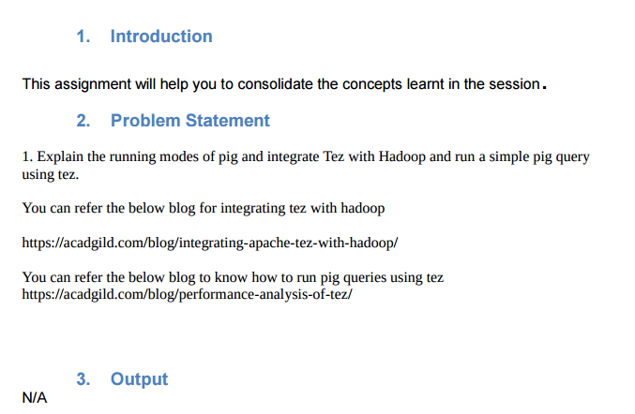

**RUNNING MODES IN PIG**

**a) MapReduce/Hadoop Mode**

1. Here Pig jobs run as a series of MapReduce jobs picking the input and output paths from HDFS.

2. Input file has to be copied in HDFS in case of Map reduce mode. Type the command pig or pig –x mapreduce to run Pig in MapReduce Mode.

**b) Local Mode**

1. Here the entire Pig job runs as a single JVM picking the local Unix path for execution.

2. Input file has to be kept in local file system in case of local mode.

3. Type the command pig or pig -x local to run Pig in Local Mode.

**DATASET**

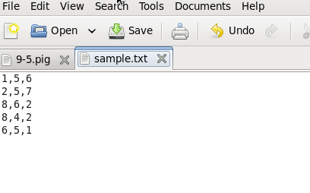

**PROGRAM**

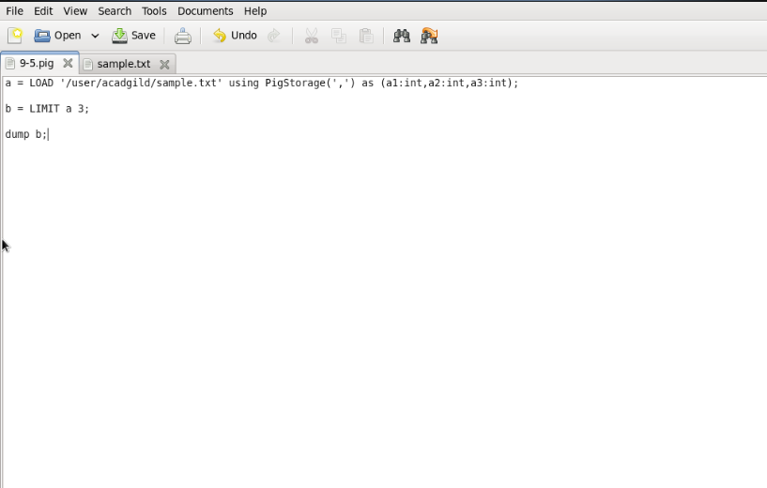

**EXECUTION COMMAND**

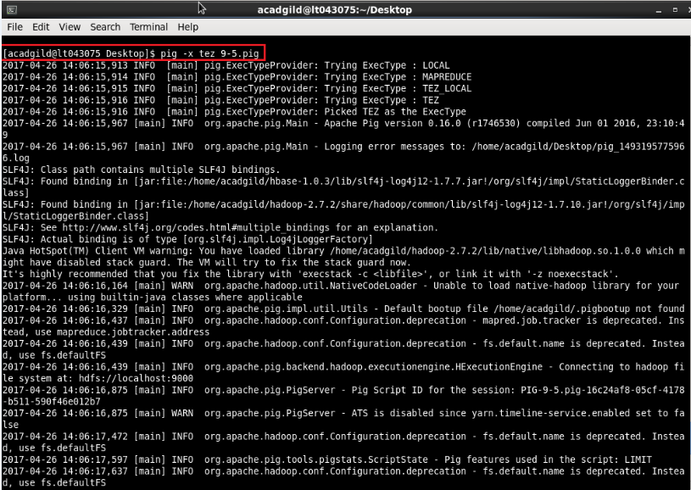

**OUTPUT**

