**Q. Write a mapreduce program to remove commas present inside the double quotes.**

**Driver class:**

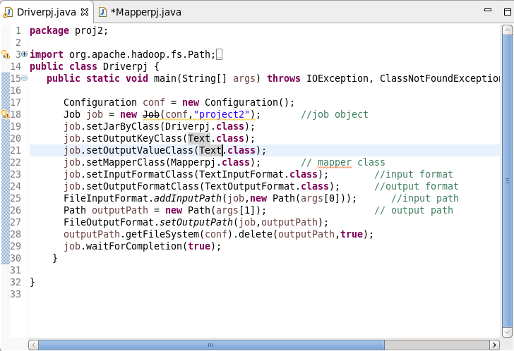

**Mapper Class:**

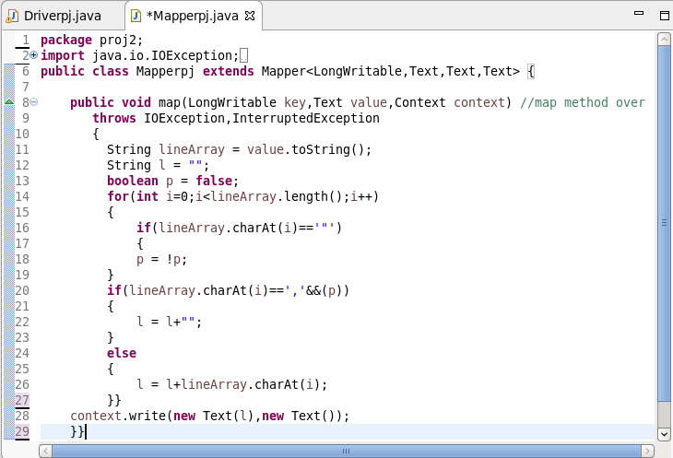

**jar file:**

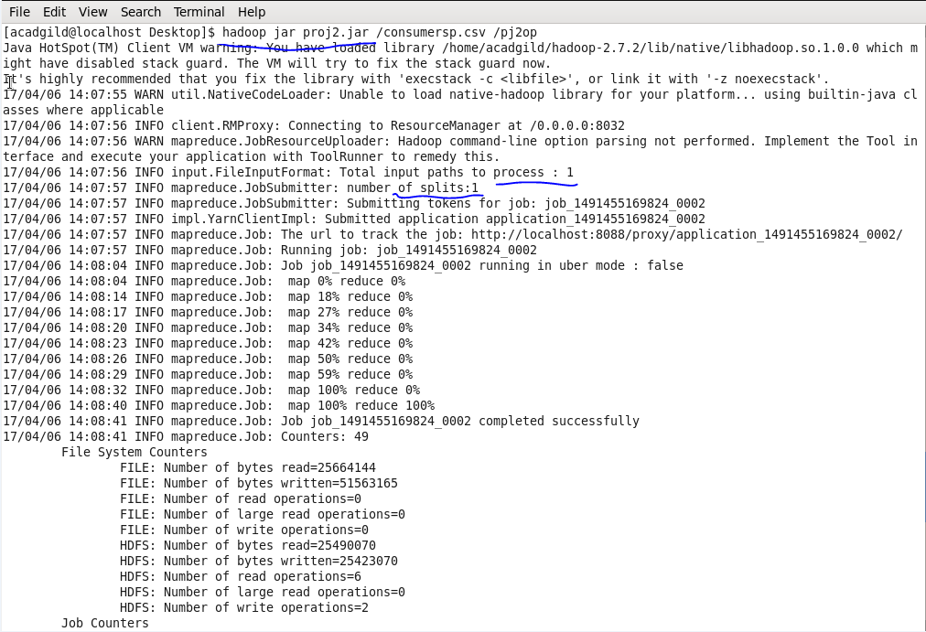

**Output:**

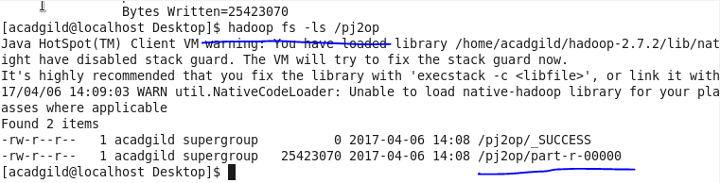

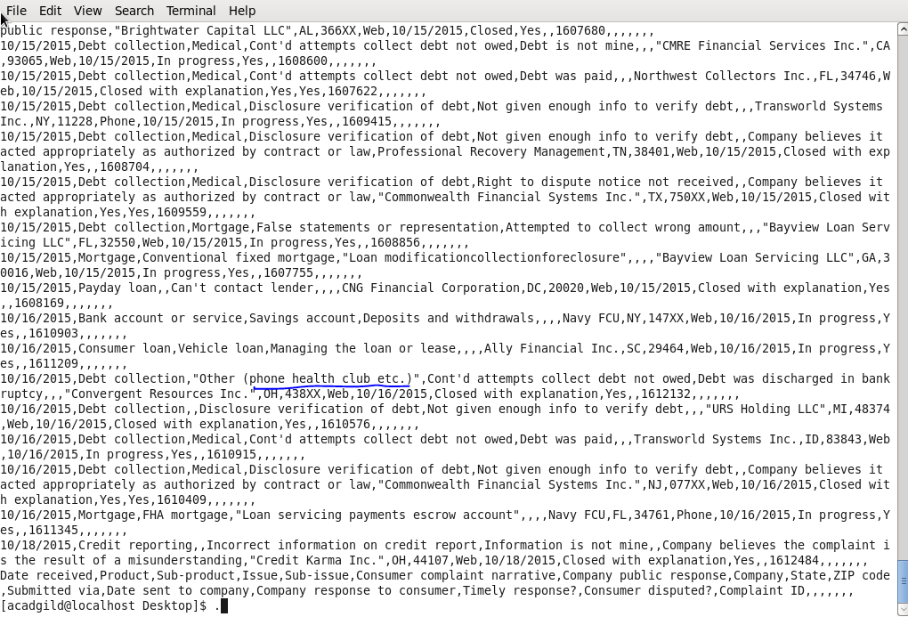

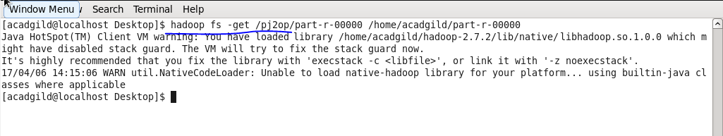

**Q.1. Write a pig script to find no of complaints which got timely response.**

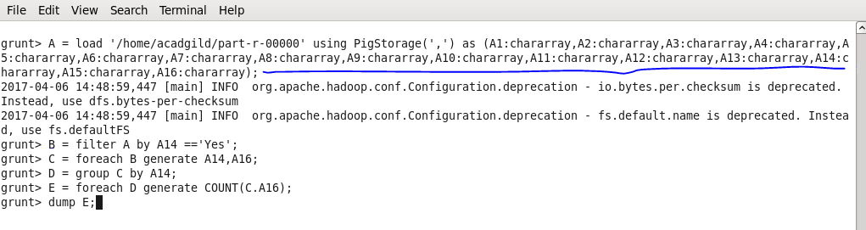

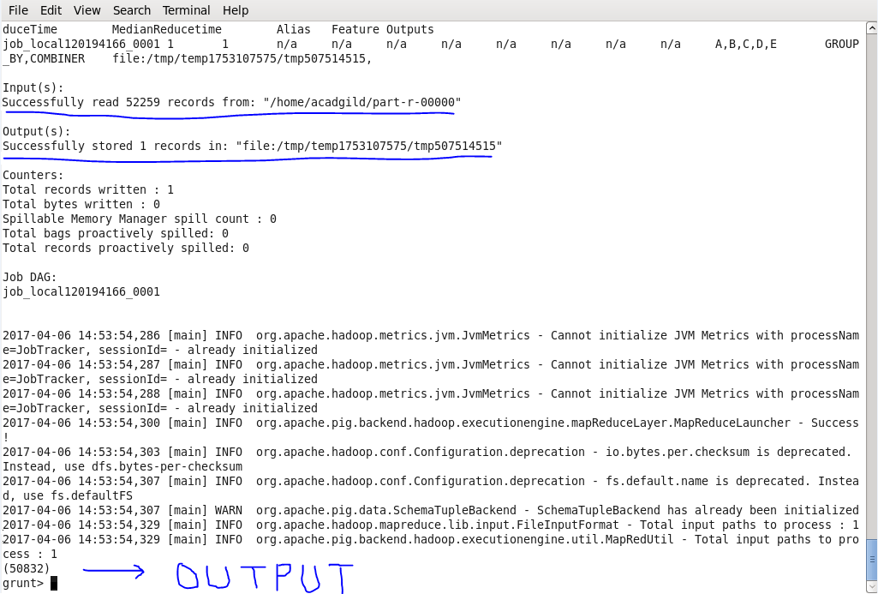

**Q.2. Write a pig script to find no of complaints where consumer forum forwarded the complaint same day they received to respective company.**

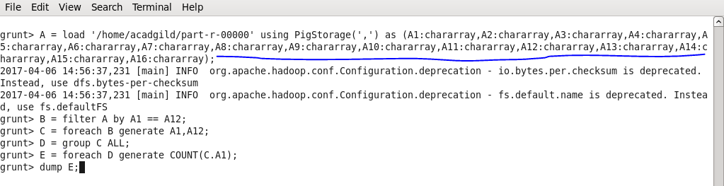

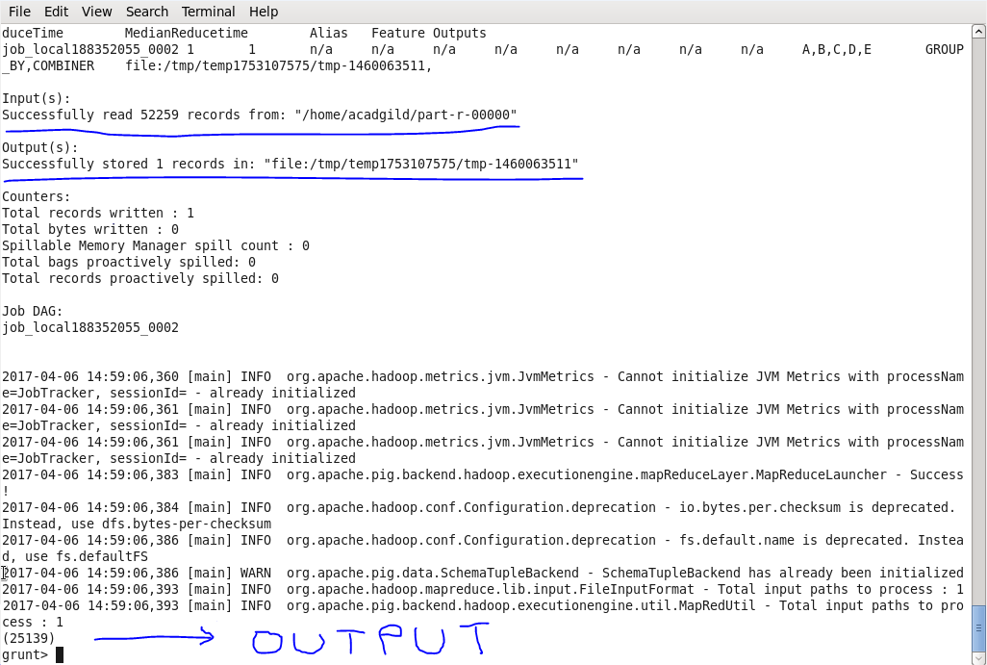

**Q.3. Write a pig script to find list of companies topping in complaint chart (companies with maximum number of complaints).**

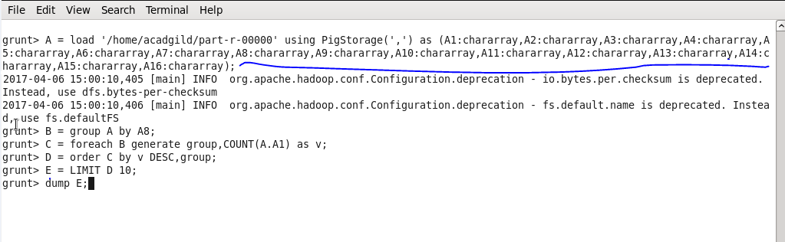

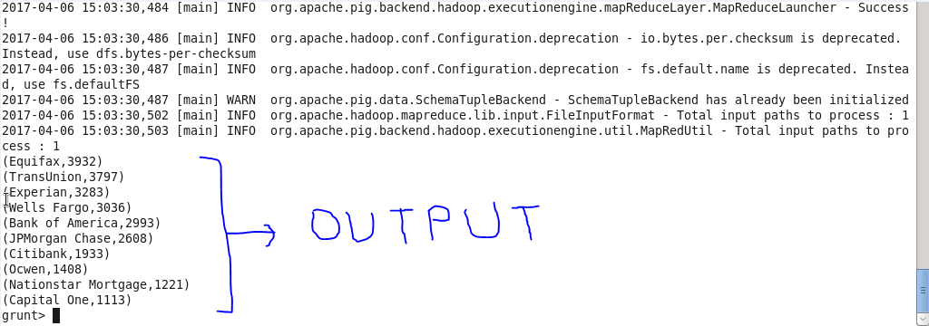

**Q.4. Write a pig script to find no of complaints filed with product type has "Debt collection" for the year 2015.**

