**Input:**

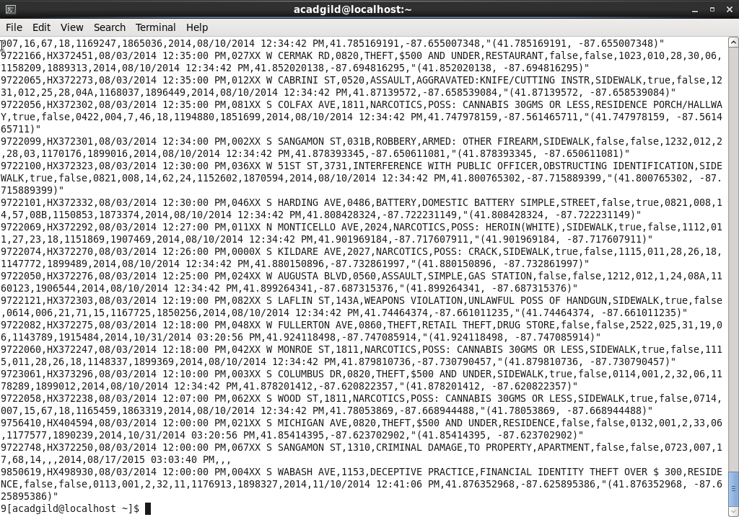

**Solution By PIG:**

**Q.1. Write a mapreduce and pig program to calculate the number of cases investigated under each FBI code.**

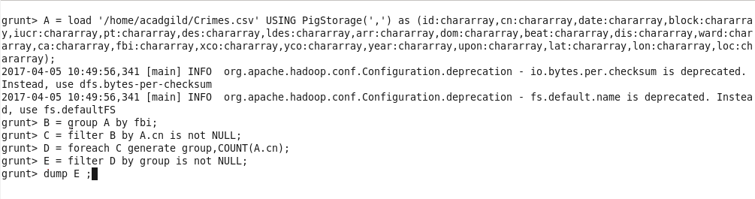

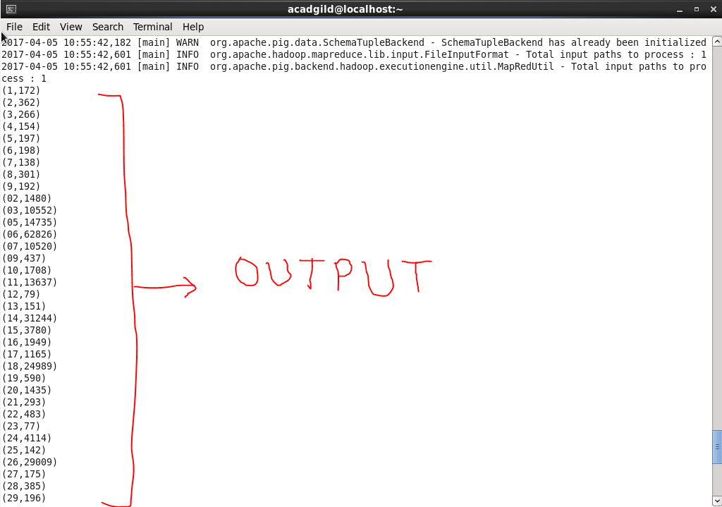

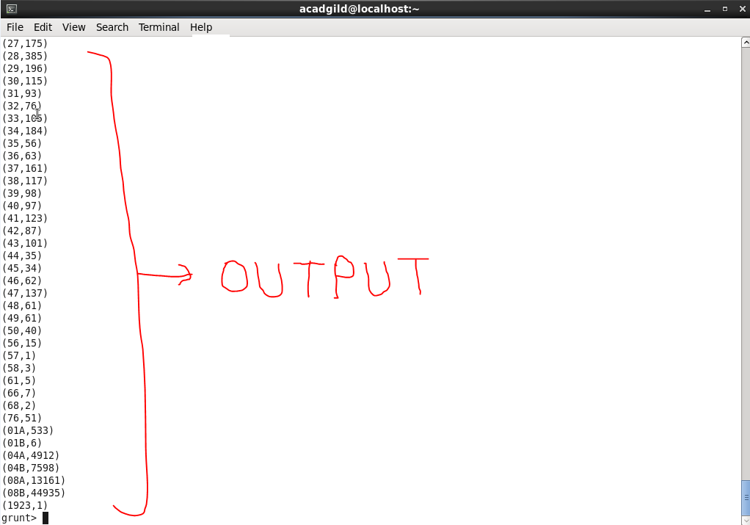

**Q.2. Write a mapreduce and pig program to calculate the number of cases investigated under FBI code 32.**

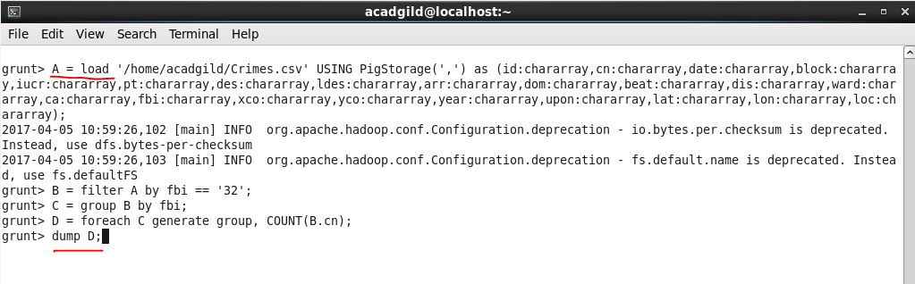

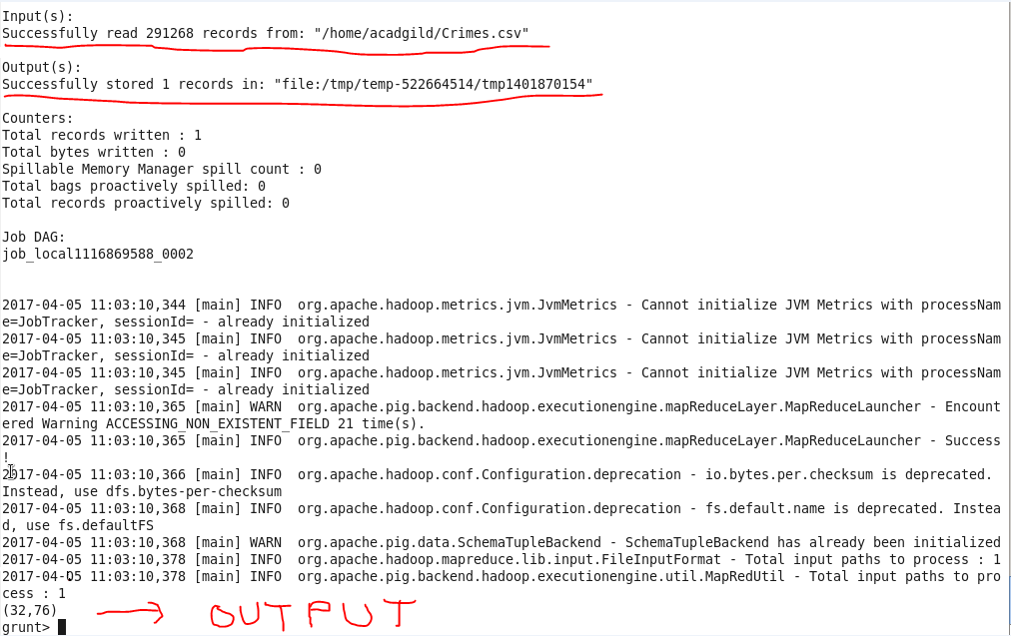

**Q.3. Write a mapreduce and pig program to calculate the number of arrests in theft district wise.**

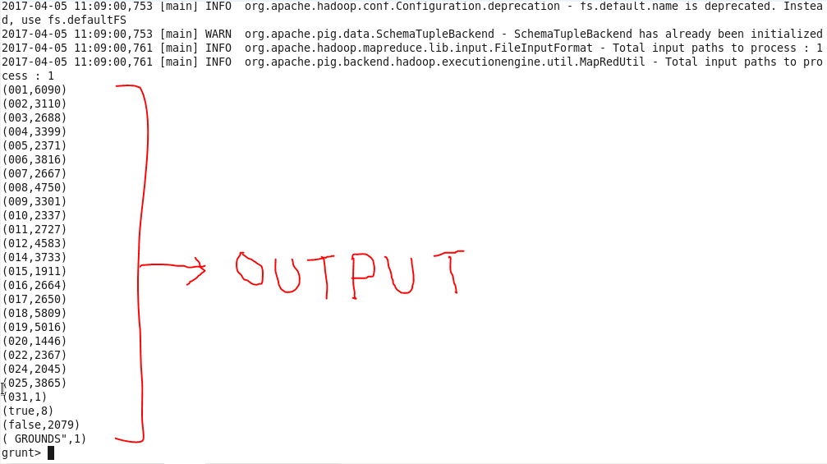

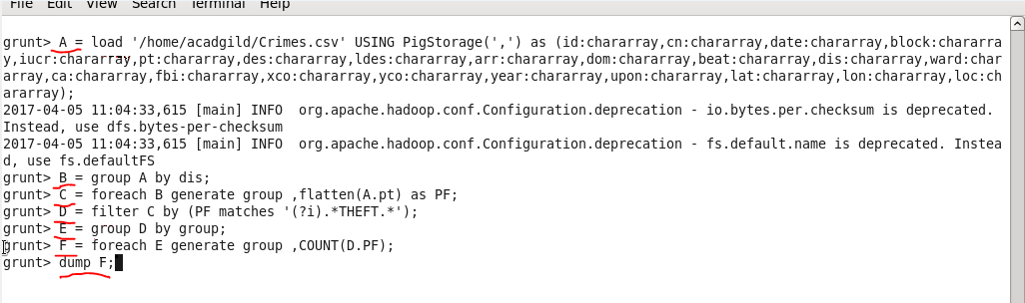

**Q.4. Write a mapreduce and pig program to calculate the number of arrests done between October 2014 and October 2015.**

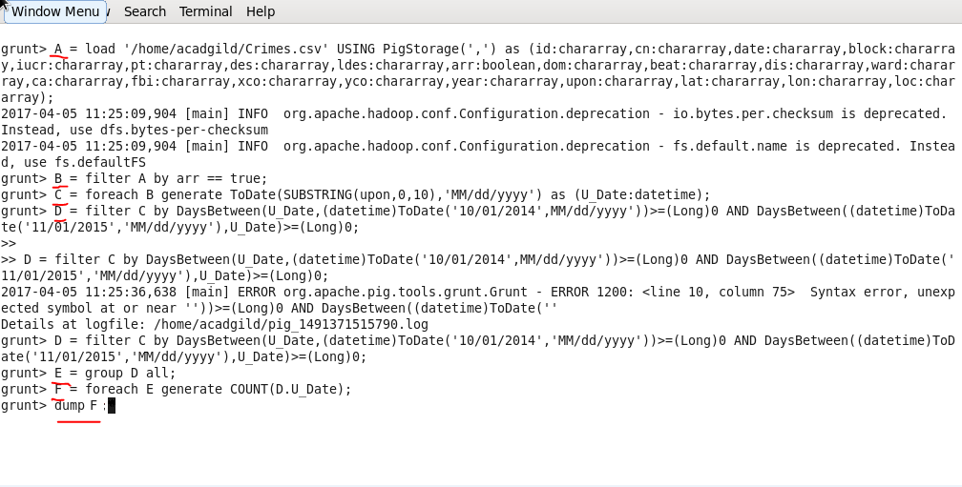

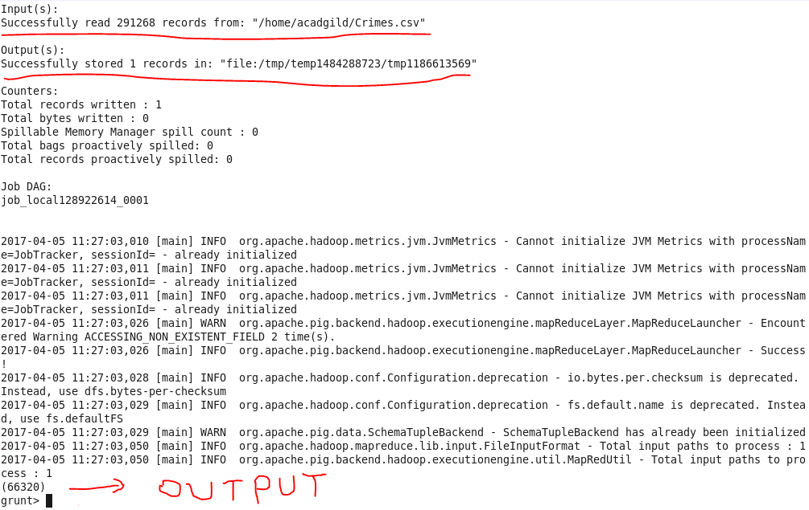

**Solution By MapReduce:**

**Driver**

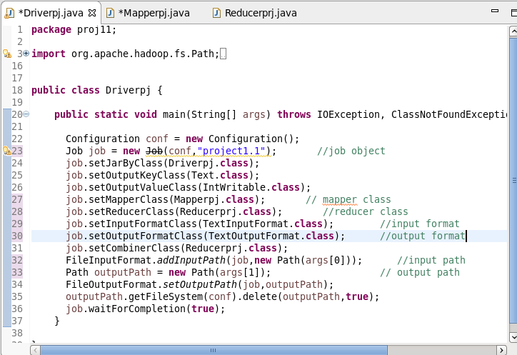

**Reducer:**

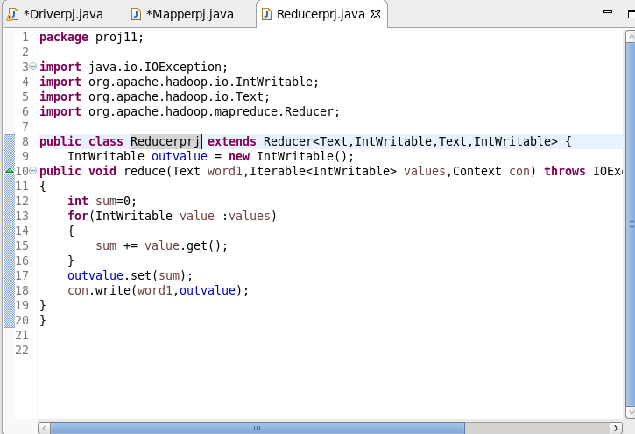

**Mapper and Output for every question:**

**Q.1. Write a mapreduce and pig program to calculate the number of cases investigated under each FBI code.**

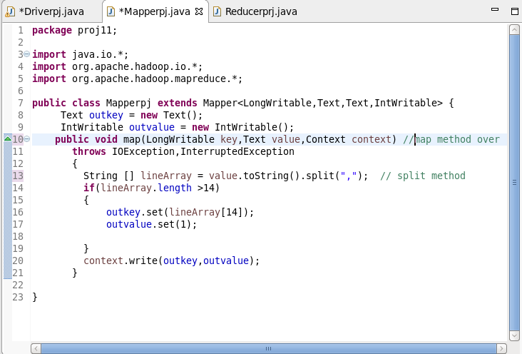

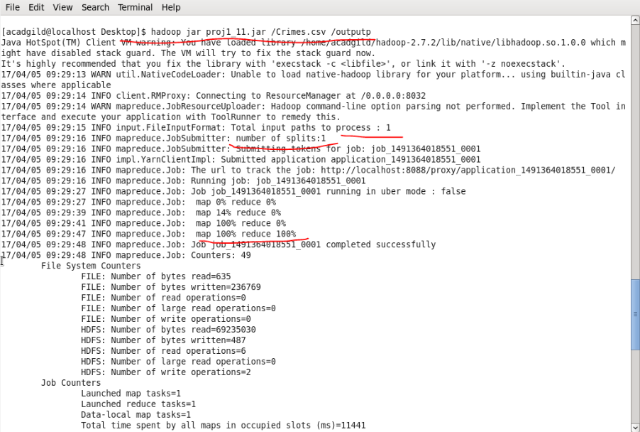

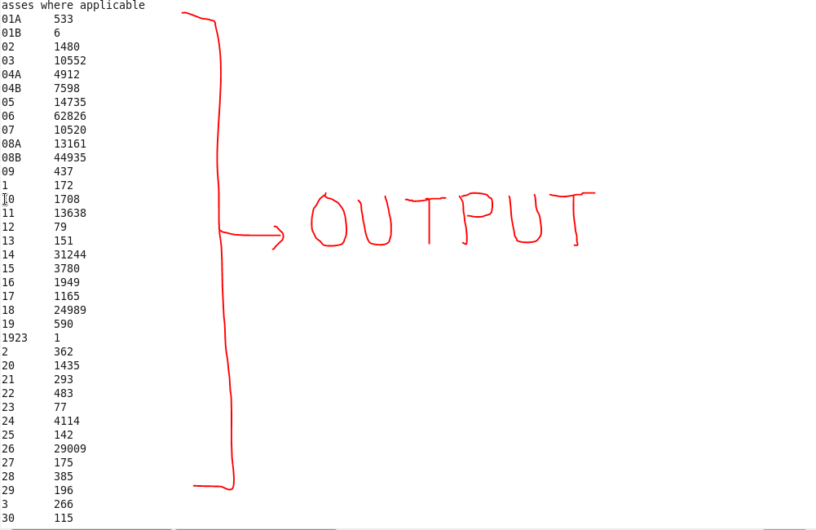

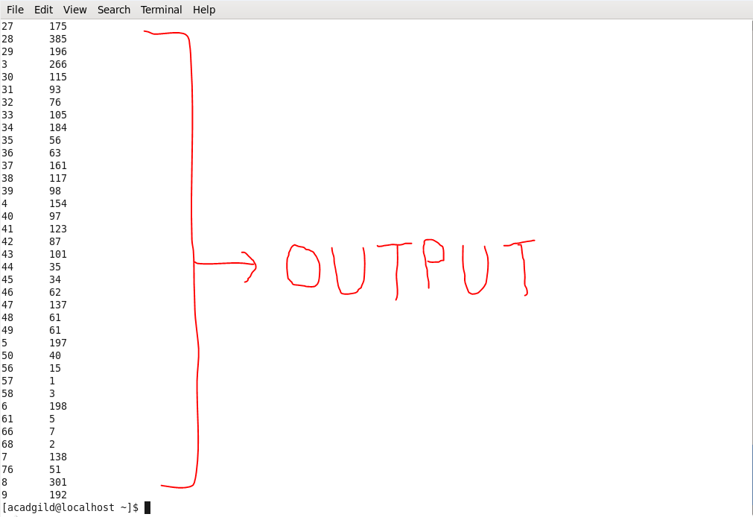

**Q.2. Write a mapreduce and pig program to calculate the number of cases investigated under FBI code 32.**

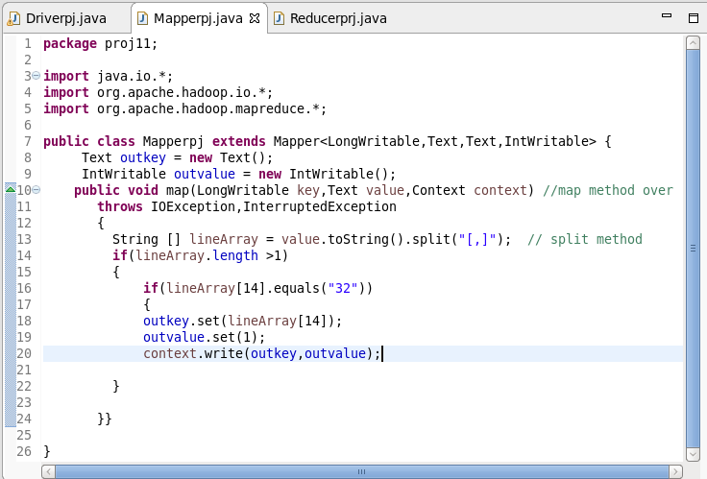

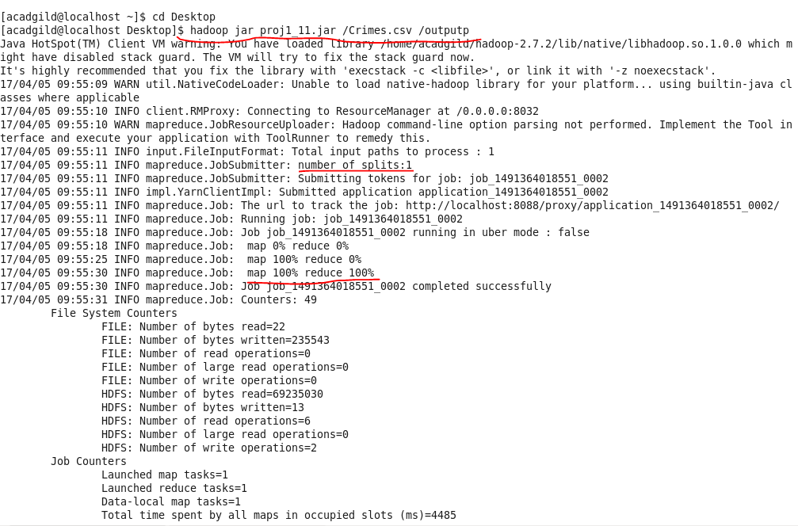

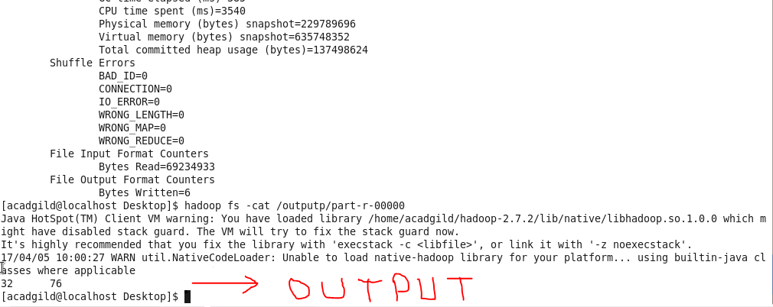

**Q.3. Write a mapreduce and pig program to calculate the number of arrests in theft district wise.**

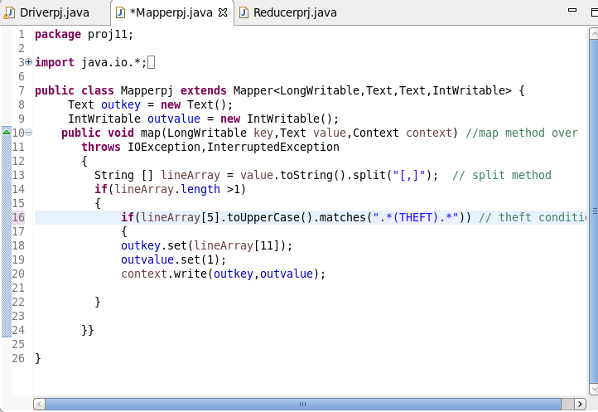

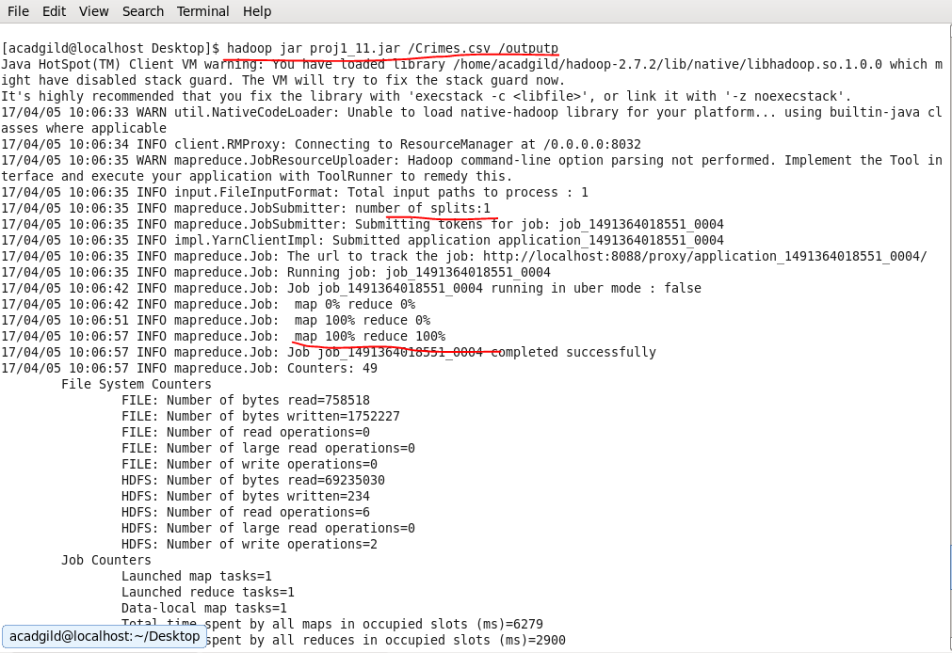

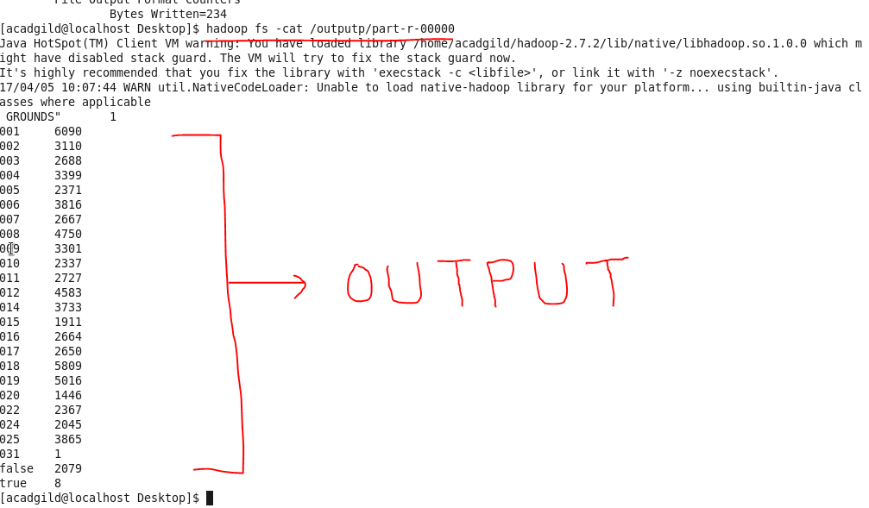

**Q.4. Write a mapreduce and pig program to calculate the number of arrests done between October 2014 and October 2015.**

