**10.1)**

**TO FIND THE WORD COUNT:**

**CONTENT OF FILE:**

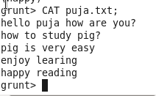



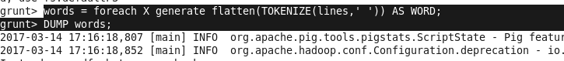

**OUTPUT OF FLATTEN:**

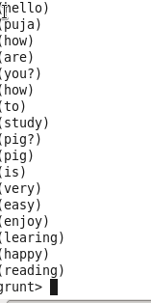

**OUTPUT OF GROUP:**

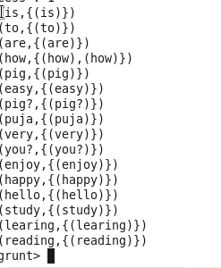

**OUTPUT OF WC:**

