**Assignment16.1**

**Using Distributed cache joining the two datasets and finding out the number of temperature variations in each country using mapreduce.**

**Driver**

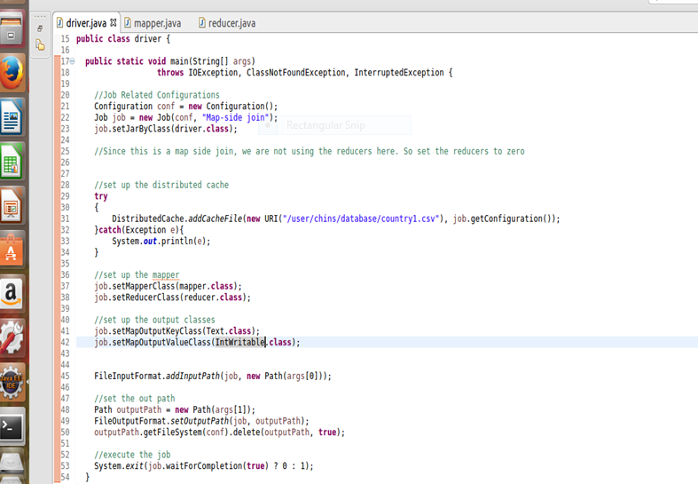

**Mapper**

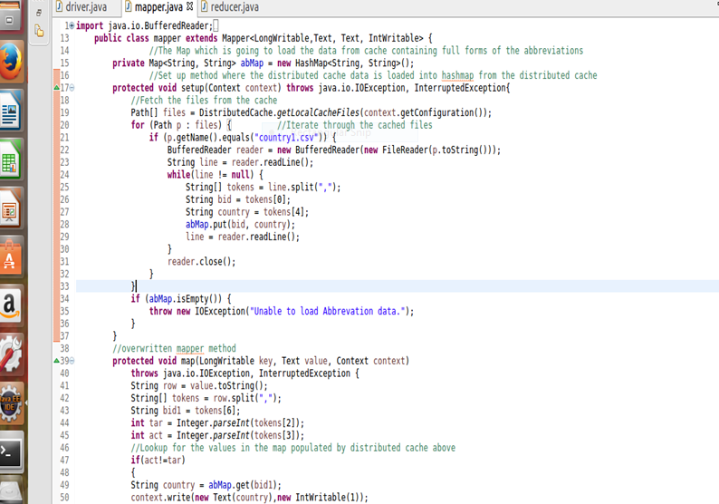

**Reducer**

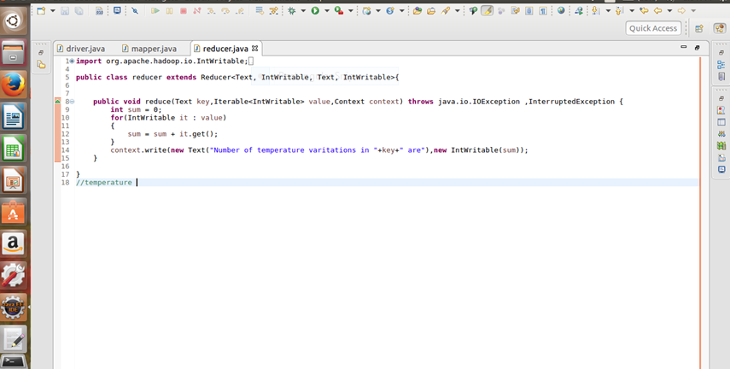

**Output**

