**ASSIGNMENT16.5**

**DRIVER**

**USED DISTRIBUTED CACHE AS IT IS USED FOR KEEPING ALL MAPPER MACHINES**

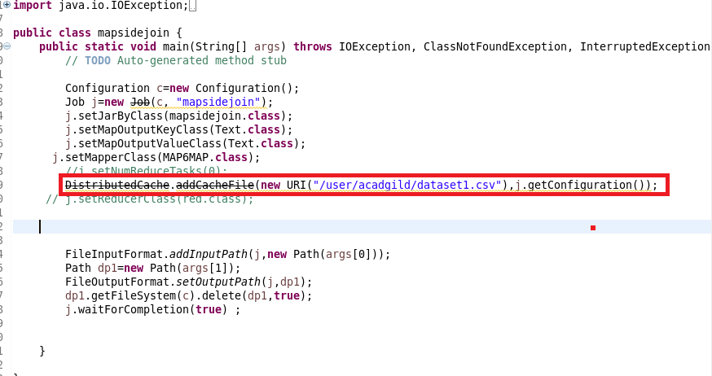

**MAPPER**

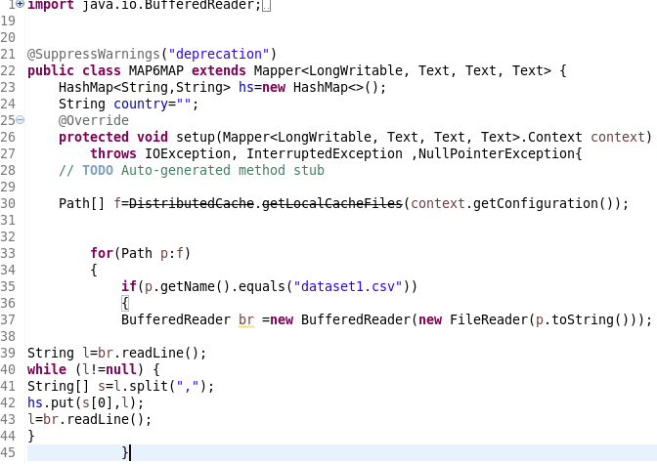

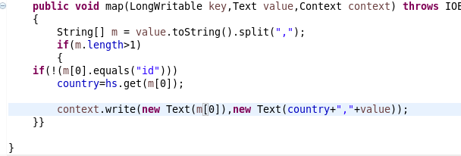

**RUNNING JAR**

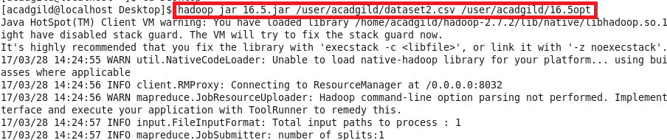

**OUTPUT**

