**ASSIGNMENT 6.3:**

**A)**

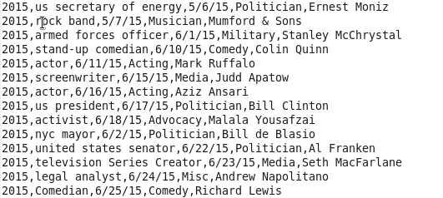

**REDUCER :**

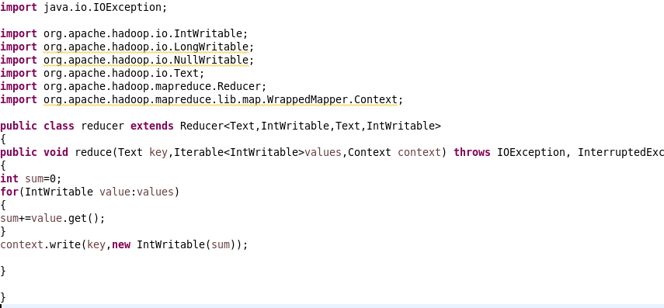

**DRIVER :**

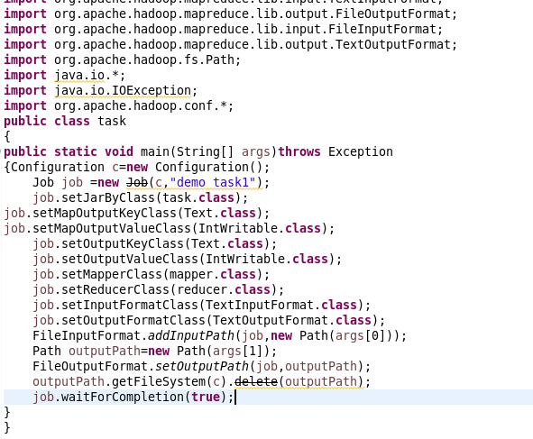

**MAPPER:**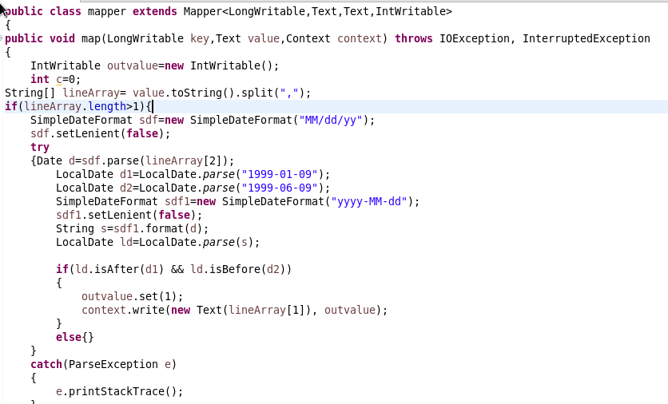

**COMMANDS:**

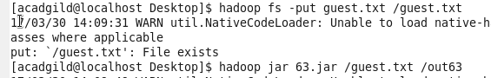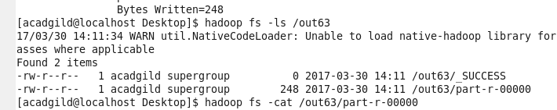

**OUTPUT:**

