1. LOAD:

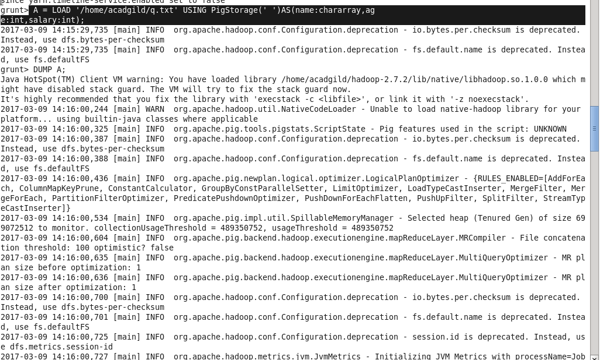

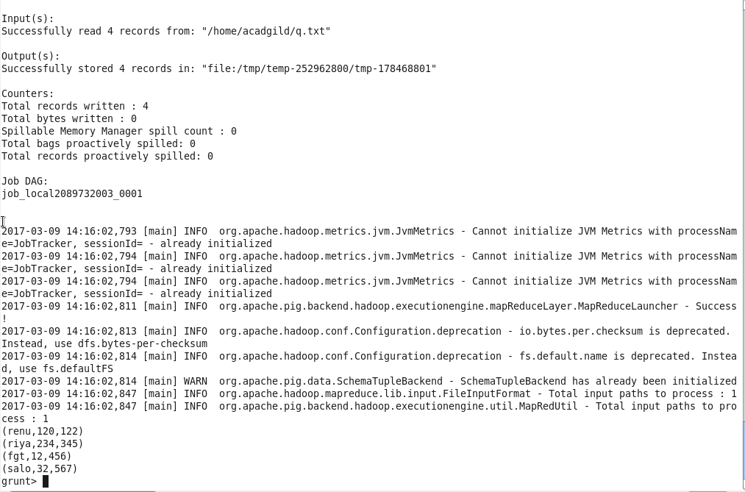

1. STORE:

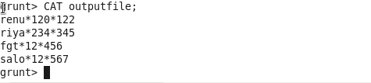

1. DUMP:
2. FOREACH:

INPUT:

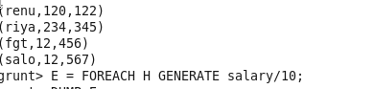

OUTPUT:



1. GROUPBY:

INPUT:

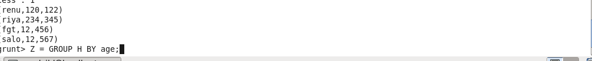

OUTPUT:

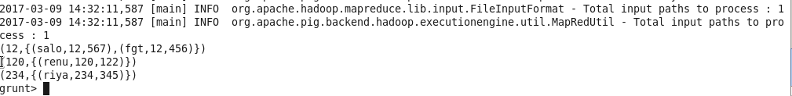

1. FILTER:

INPUT:

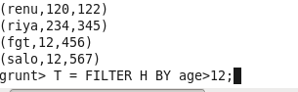

OUTPUT:

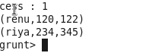

1. ORDERBY:

INPUT:

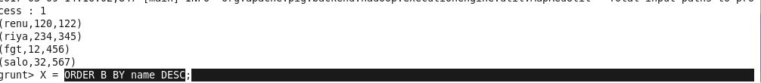

OUTPUT:

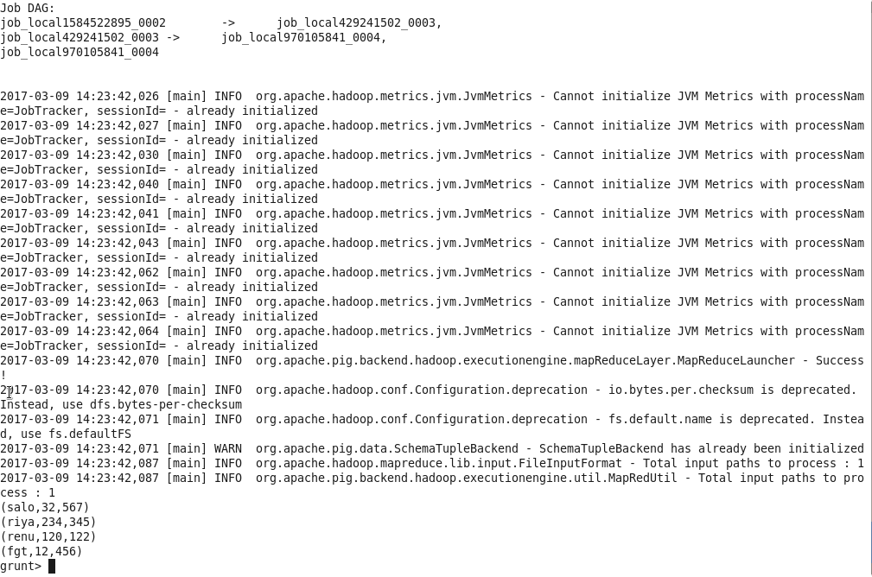

1. DESCRIBE:

OUTPUT:

C:\Users\613000\Desktop\describeout.PNG

1. LIMIT :

INPUT:

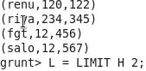

OUTPUT:

C:\Users\613000\Desktop\limitout.PNG