## **Part 1.1**

**CREATE SCHEMA logbook CHARACTER SET = utf8 COLLATE = utf8_general_ci;**

**USE logbook;**

## **Part 1.2**

**CREATE TABLE IF NOT EXISTS credentials (**

**ID TINYINT NOT NULL AUTO_INCREMENT,**

**Firstname VARCHAR(100) NOT NULL,**

**Lastname VARCHAR(100) NOT NULL,**

**Username VARCHAR(100) NOT NULL,**

**Password VARCHAR(100) NOT NULL,**

**Email VARCHAR(100) NOT NULL,**

**PRIMARY KEY (ID)**

**) ENGINE = innoDB CHARACTER SET = utf8 COLLATE = utf8_general_ci;**

## **Part 1.3**

**CREATE TABLE IF NOT EXISTS logbookEntries (**

**ID TINYINT UNSIGNED NOT NULL AUTO_INCREMENT,**

**date DATE NOT NULL,**

**time TIME NOT NULL,**

**text VARCHAR(100) NOT NULL,**

**PRIMARY KEY (ID)**

**) ENGINE = innoDB CHARACTER SET = utf8 COLLATE = utf8_general_ci;**

## Registration Page

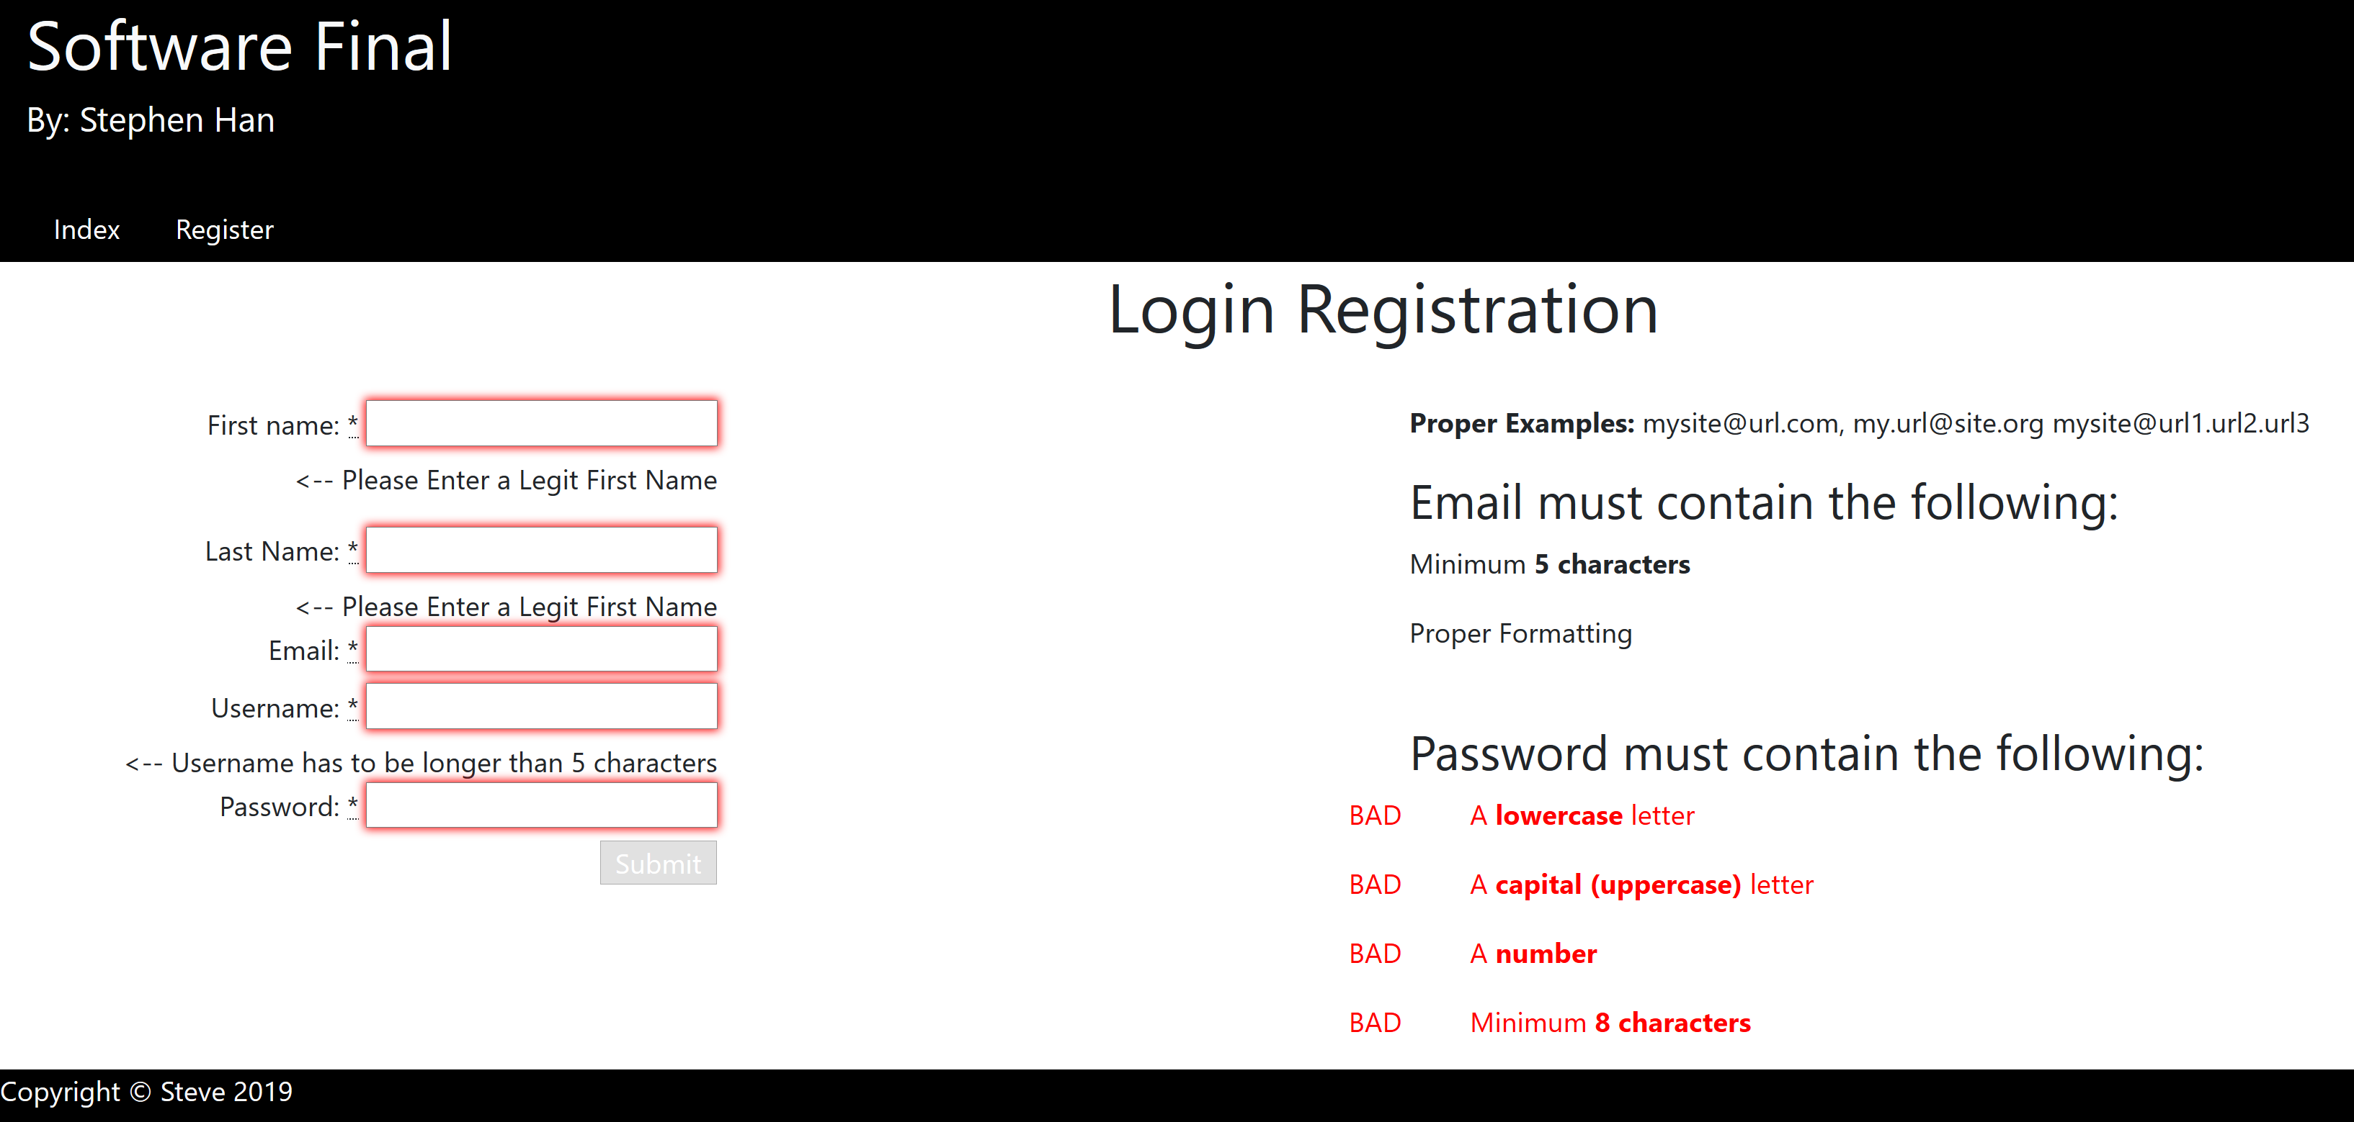

## Logged in as GUEST

* Different layout than USER

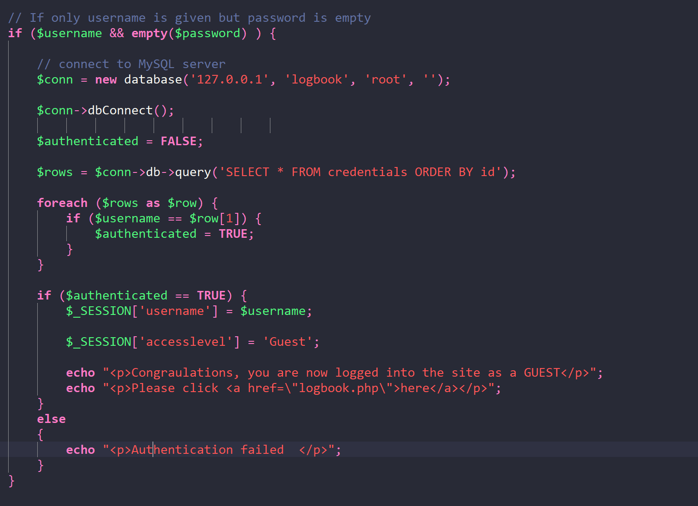

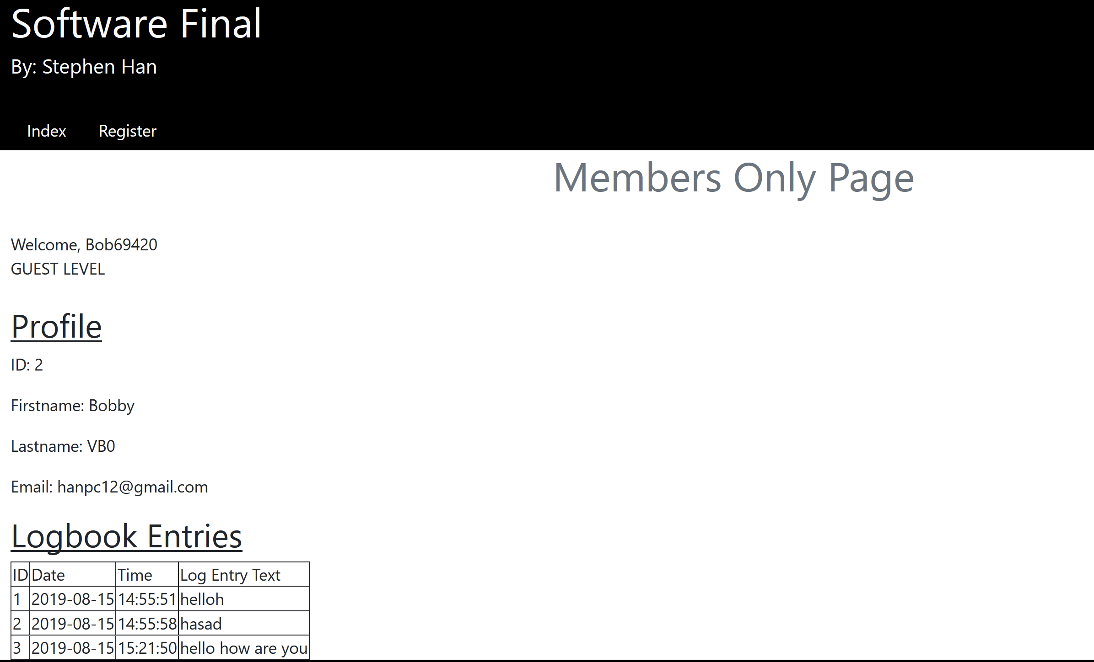

## Logged in as USER

* Different layout than Guest

