SQL Joins Exercise
PART 1
QUESTION 1
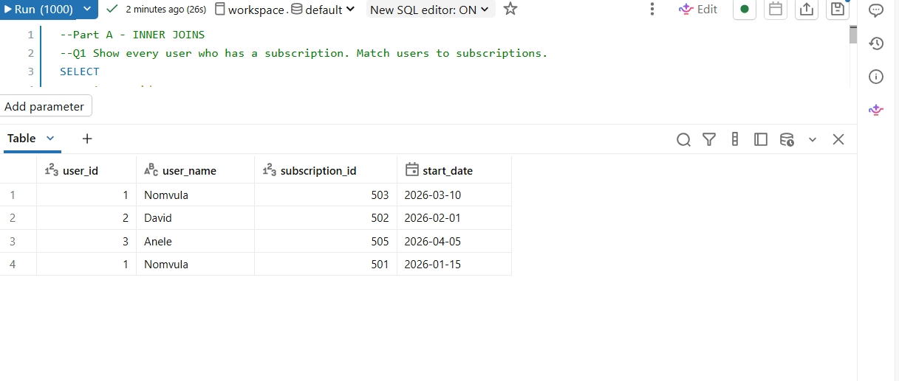
QUESTION 2
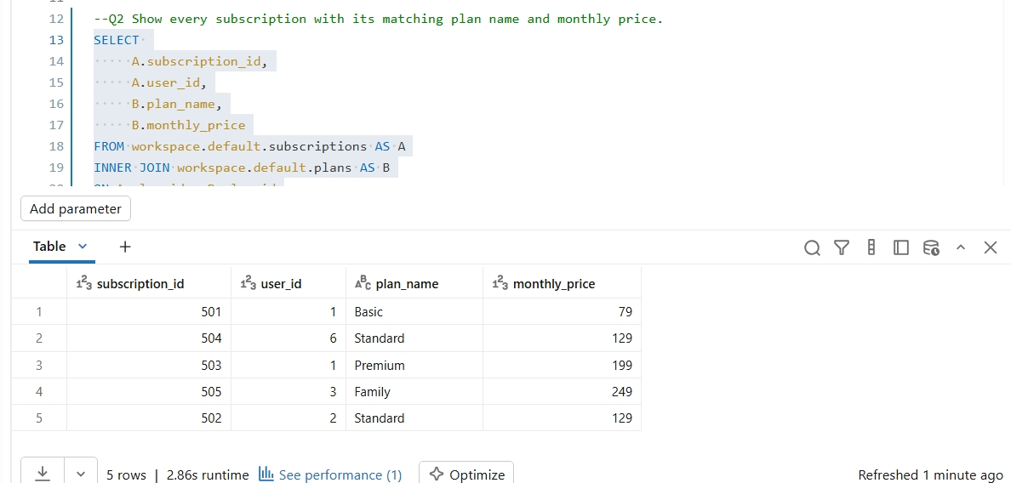
QUESTION 3
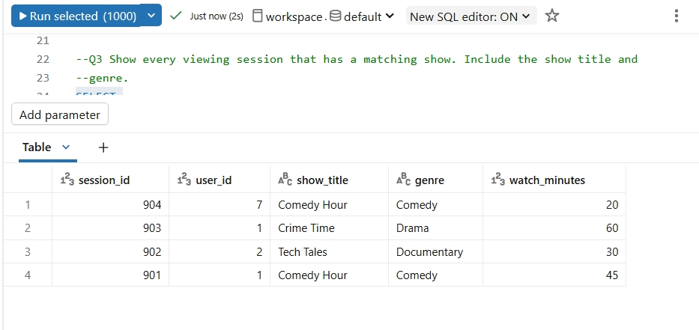
QUESTION 4
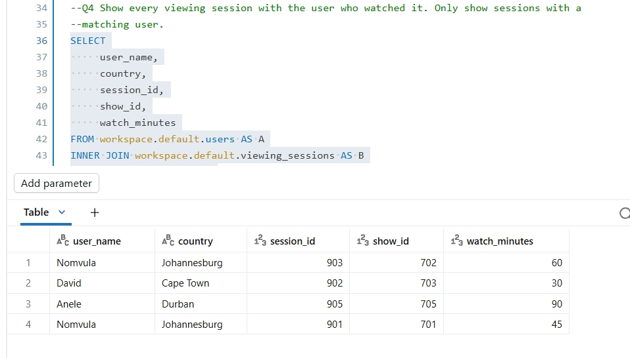
GUESTION 5
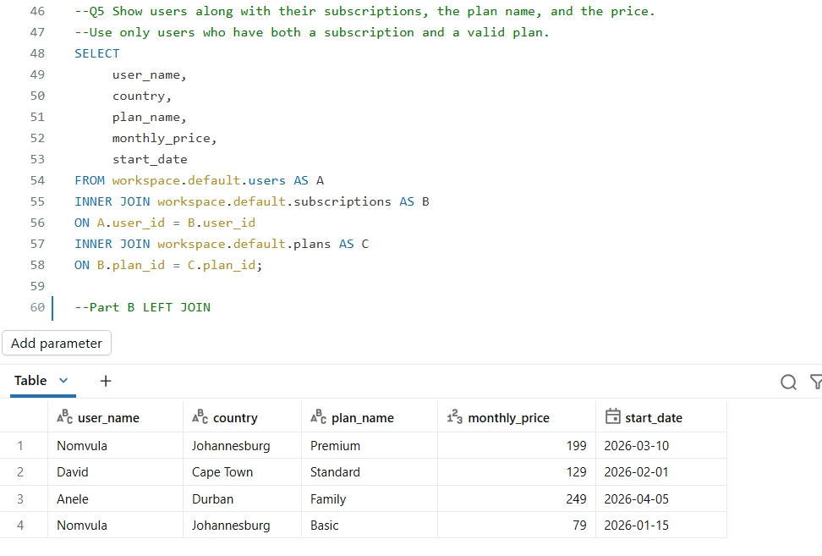

QUESTION 6
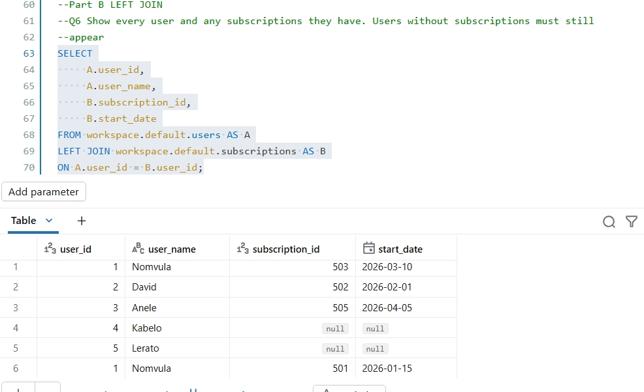
QUESTION 7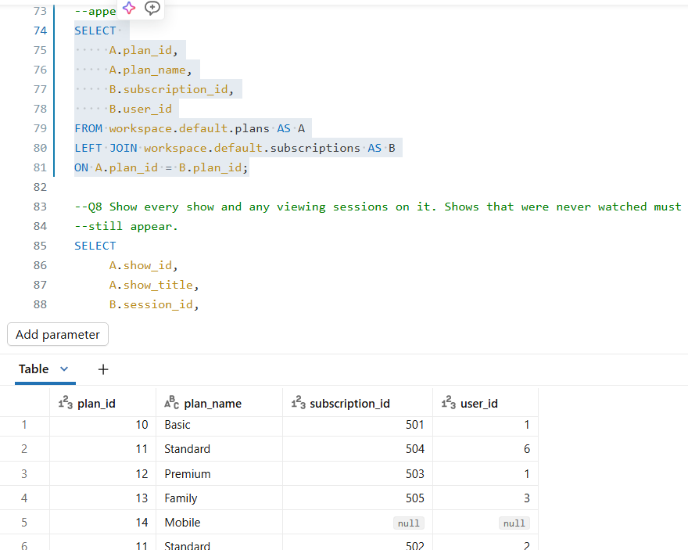

QUESTION 8
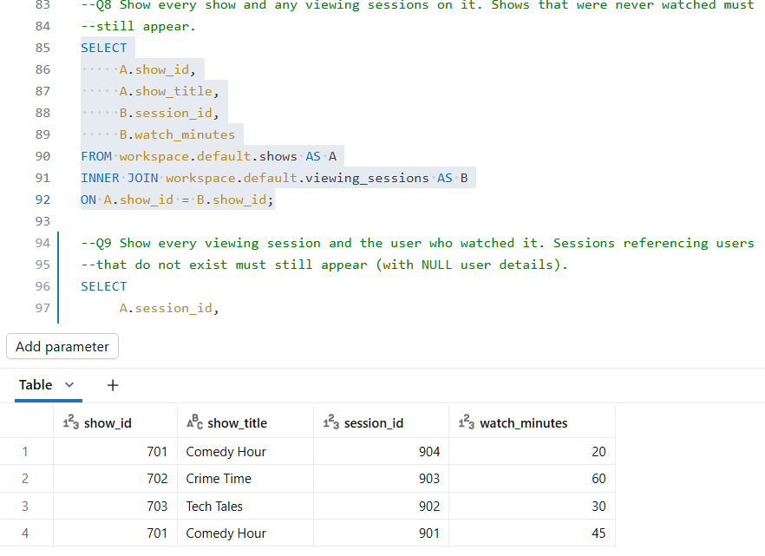
QUESTION 9
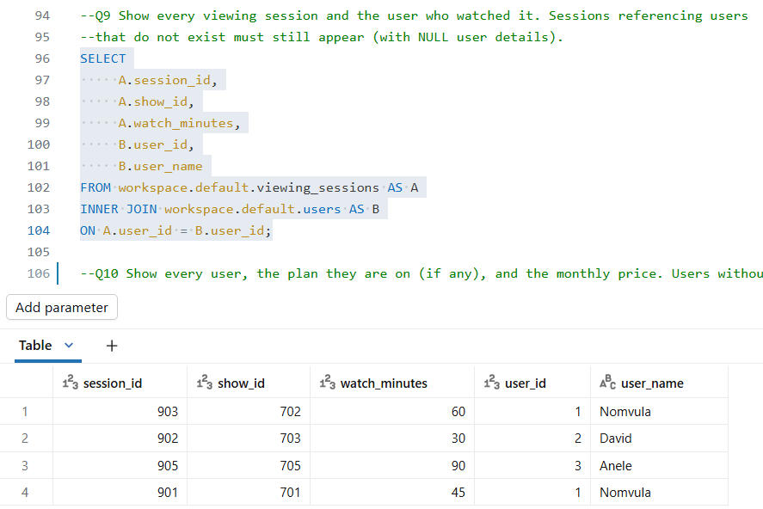

QUESTION 10
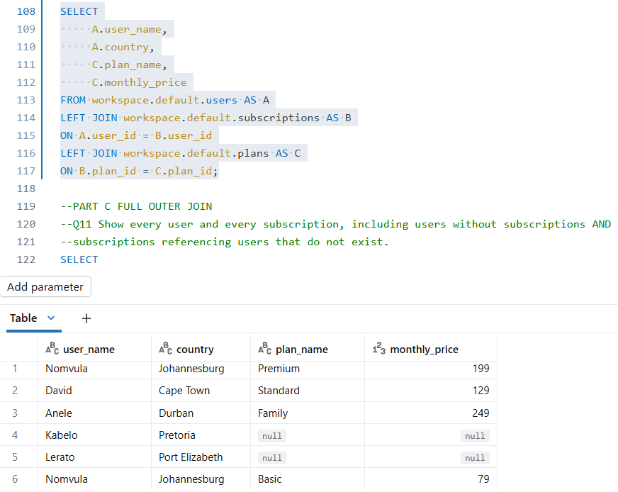
QUESTION 11
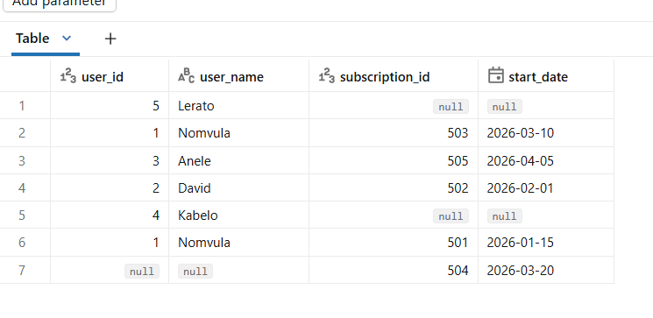
QUESTION 12
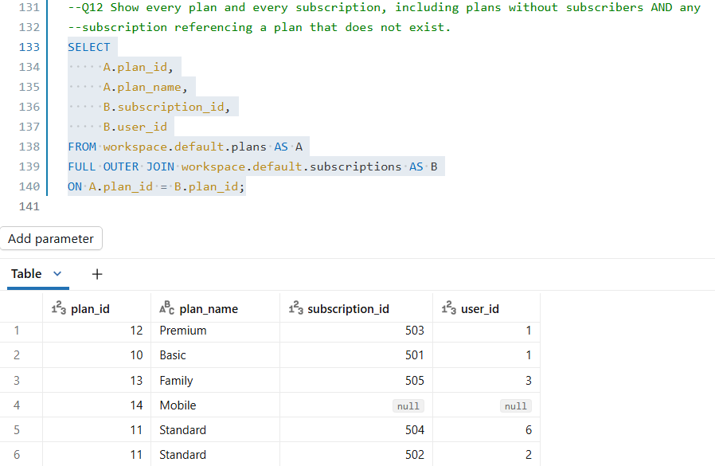

QUESTION 13
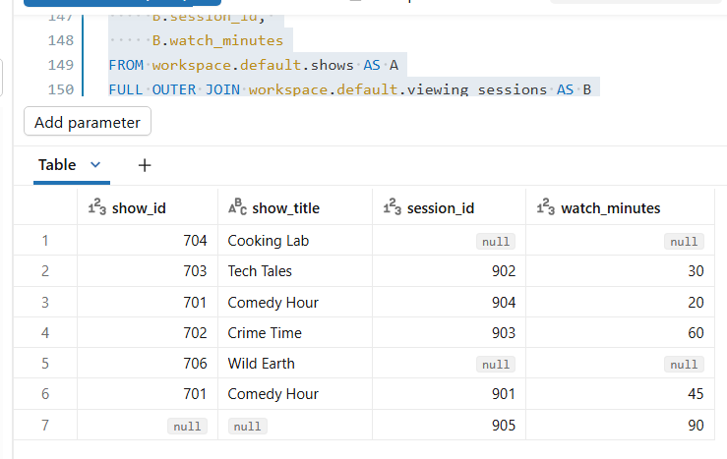
QUESTION 14
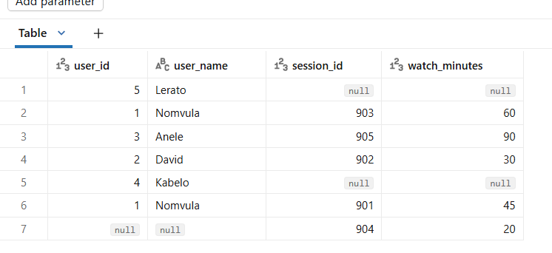
QUESTION 15
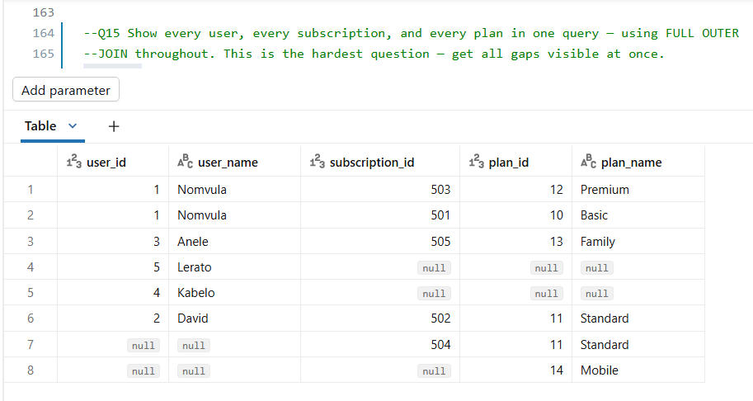
This assignment was completed using Databricks Community Edition as the SQL environment. The tables were created using SQL commands and populated using CSV datasets. All queries were written and tested in Databricks using SQL syntax to practise INNER JOIN, LEFT JOIN, and FULL OUTER JOIN operations.

