BUILDING A RETAIL SALES DATA AGENT ON DATABRICKS
Prepared by: Sthandiwe Mncube
Student Number: 2805001379
Course: BrightLearn Data Analytics with SQL (April intake)
Submission Date: 24 May 2026

1. Introduction
This project focuses on building a Retail Sales Data Agent using Databricks.
The purpose of the agent is to analyse retail sales data and answer business-related questions using artificial intelligence and data analysis techniques.
The project demonstrates how AI can help businesses understand customer behaviour, product performance, and sales trends to support decision-making.

2. Objective
The objective of this project is to create a functional Data Agent connected to a retail sales dataset in Databricks. The agent should be able to answer business questions accurately and provide useful sales insights based on the dataset.

3. Dataset Description
Column Name | Description
Transaction ID | Unique number for each transaction
Date | Date of the sale
Customer ID | Unique customer identifier
Gender | Gender of the customer
Age | Customer age
Product Category | Product type purchased
Quantity | Number of items bought
Price per Unit | Cost of one item
Total Amount | Total transaction amount

4. Dataset Upload
The retail sales dataset was uploaded into Databricks using the “Create Table” and “Upload File” option. The dataset preview was checked to confirm that all records and columns were imported successfully.
Upload dataset
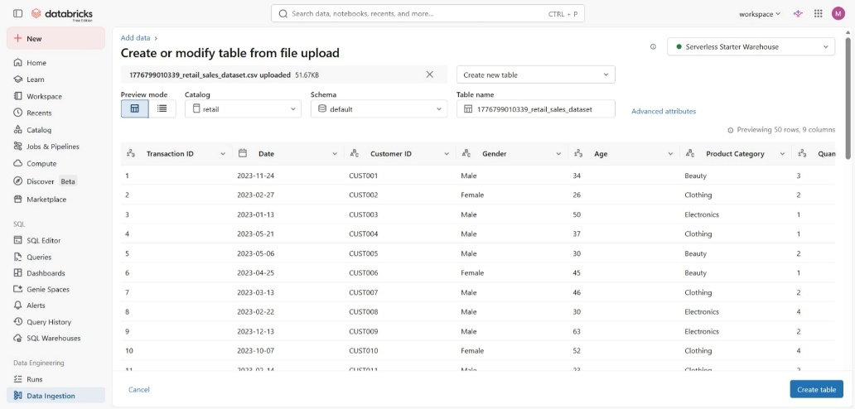
Data preview
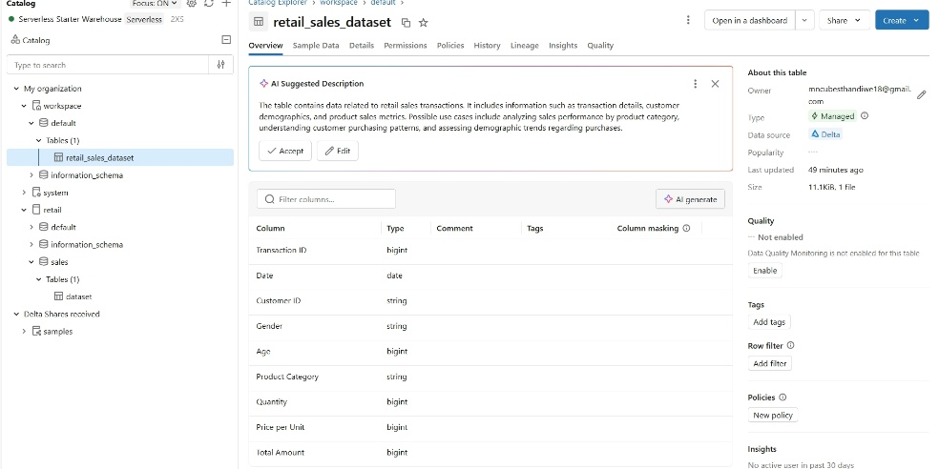
File Location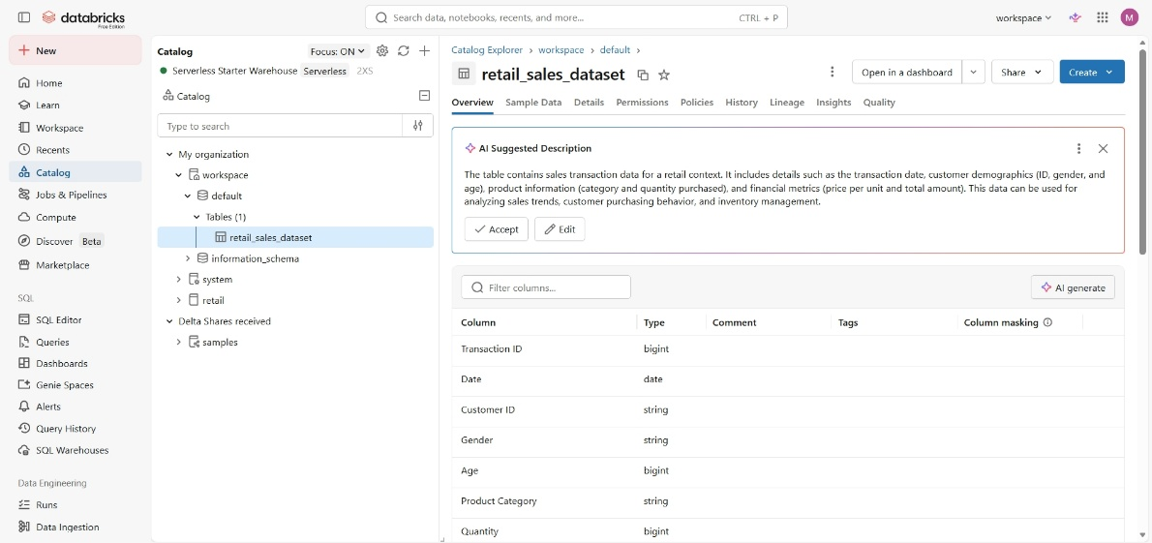

5. Dataset Review
The dataset was reviewed to understand the structure and quality of the data. The columns included customer information, sales values, product categories, and transaction dates. No major missing values were identified. The dataset can be used for sales analysis, customer analysis, and trend analysis.
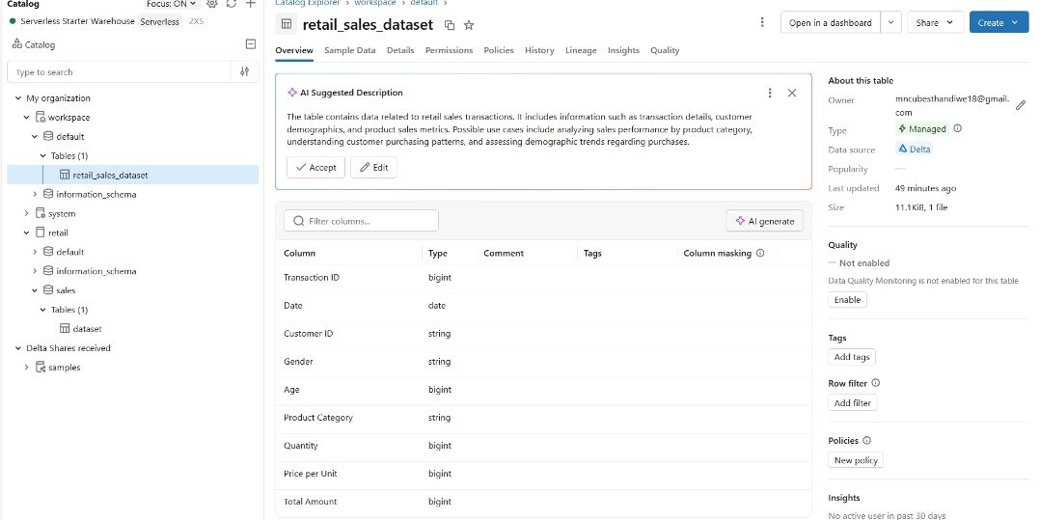

6. Data Agent Creation
A Data Agent named “Retail Analytics Agent” was created in Databricks and connected to the retail_sales_dataset table.
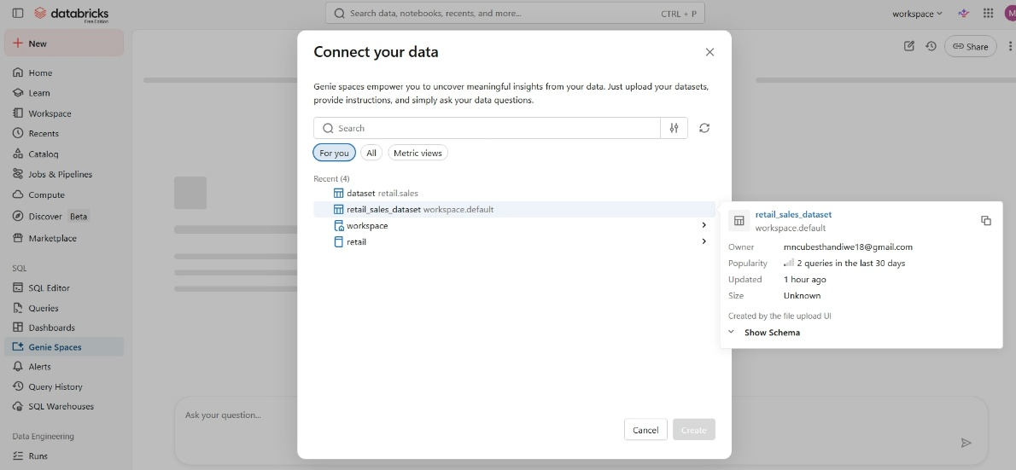

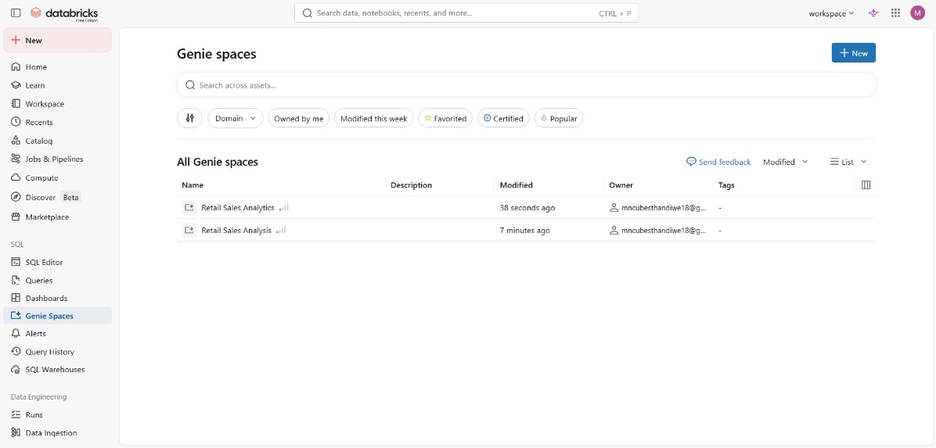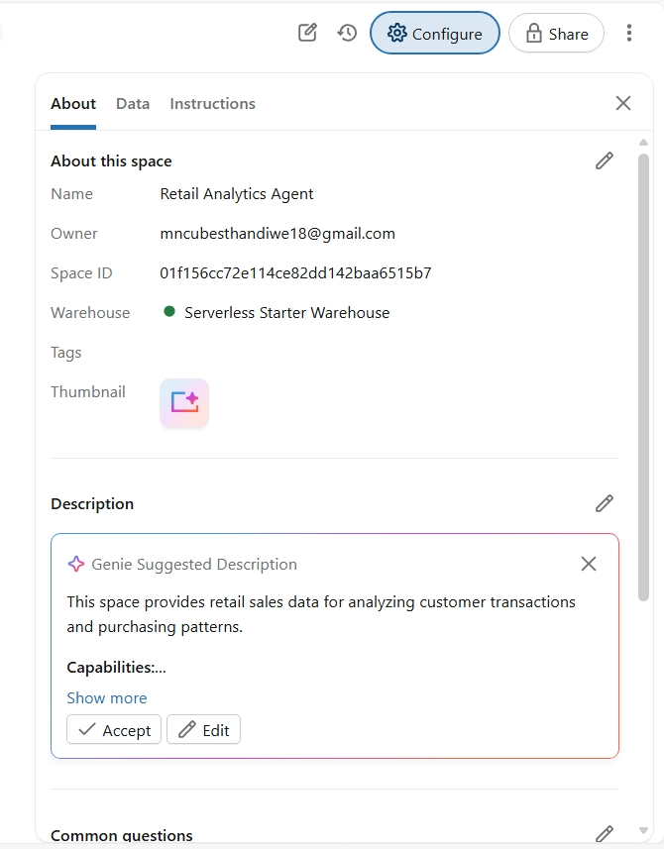

7. Agent Instructions
The following instructions were created to guide the behaviour of the Data Agent and ensure that it provides accurate, professional, and data-driven responses.
Instructions
The Retail Analytics Agent is created to help users understand the retail sales data from the retail_sales_dataset table. The agent should answer questions about sales, products, customers, and business performance using the dataset provided.
The agent should help business users understand things like:
- which products have the highest sales,
- which customers buy the most,
- sales trends over time,
- customer demand by age or gender,
- and which product categories perform better than others.
The agent must only use information from the dataset and should not make up answers or give fake numbers. If information is missing or the question is unclear, the agent should say so or ask the user to explain the question better.
Answers should be clear, short, and easy to understand. The agent should use simple business language and include numbers or comparisons where needed.
If the data shows important trends or patterns, the agent can give short business recommendations based on the results. Recommendations should only be based on the data available.

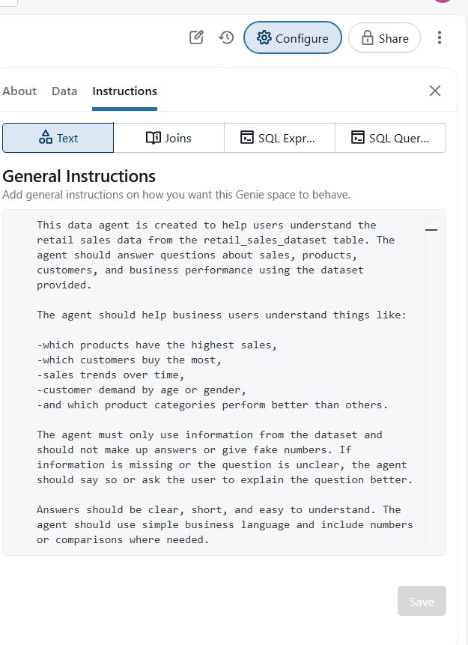
8. Testing the Agent with 10 Questions
Question 1
What is the total sales revenue generated?
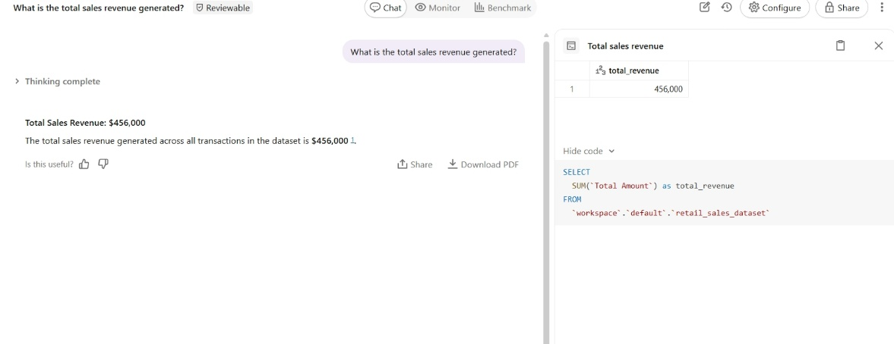
Question 2
Which product category had the most sales?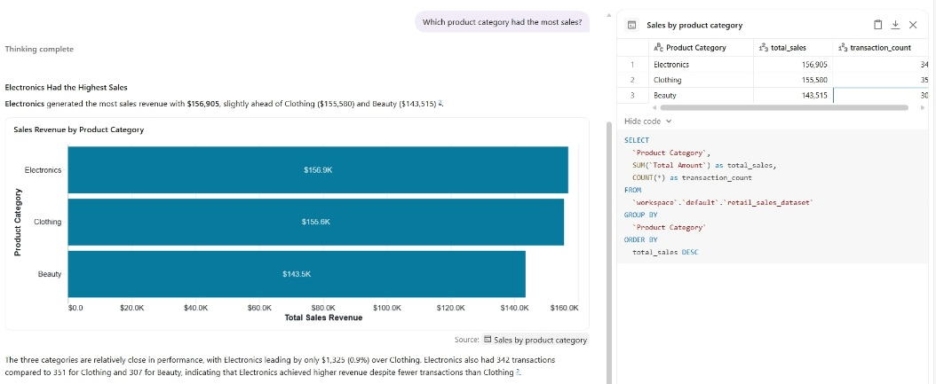

Question 3
What is the average value of a transaction?
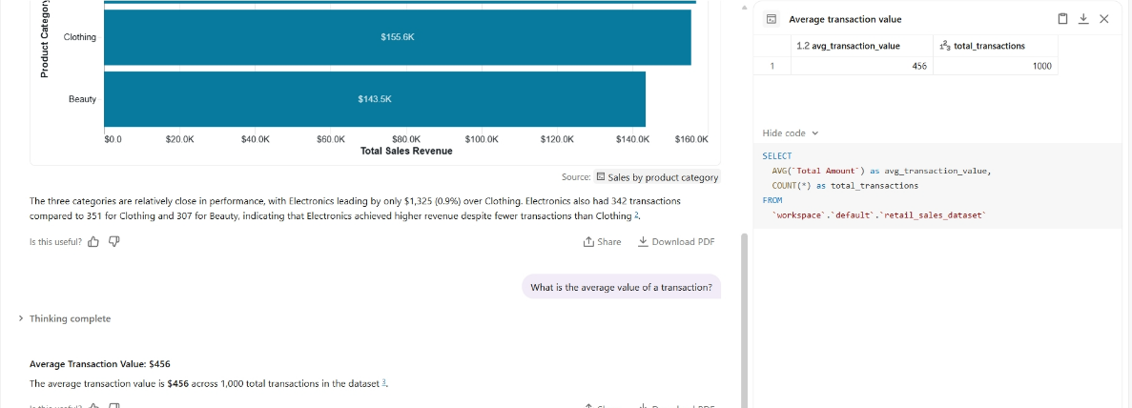
Question 4
Which gender spent the most money?
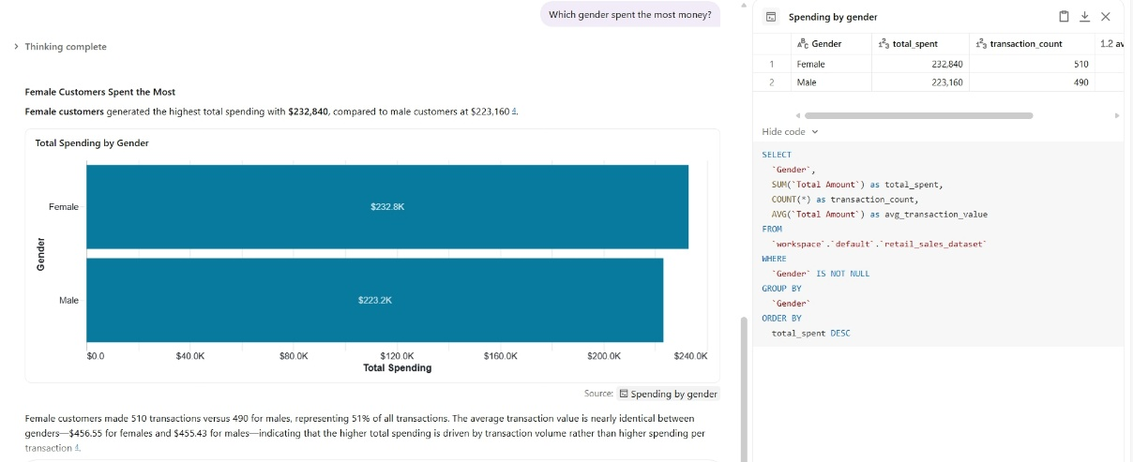
Question 5
Which product categories are most bought?
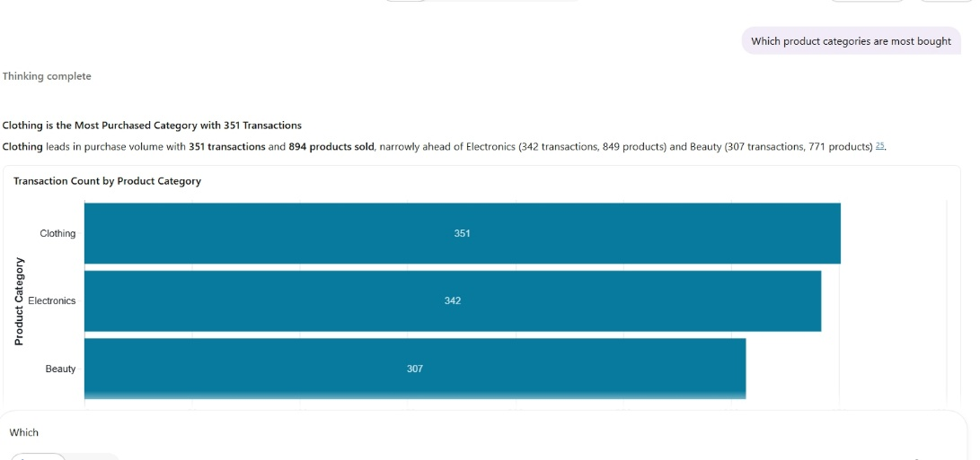
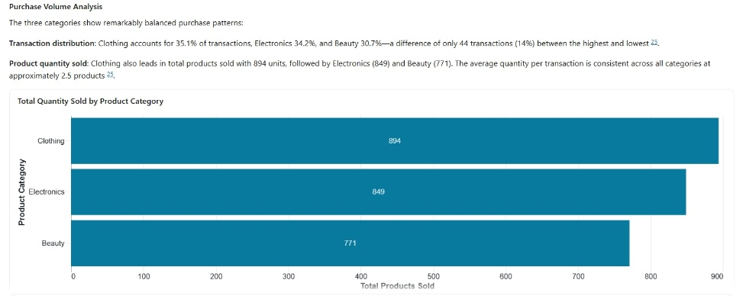
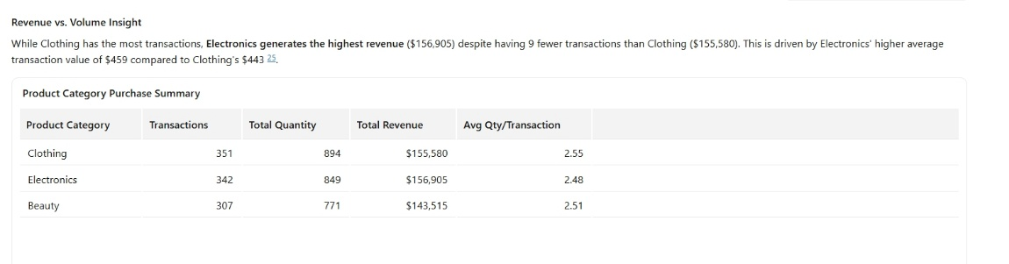
Question 6
Which gender buy most clothing?
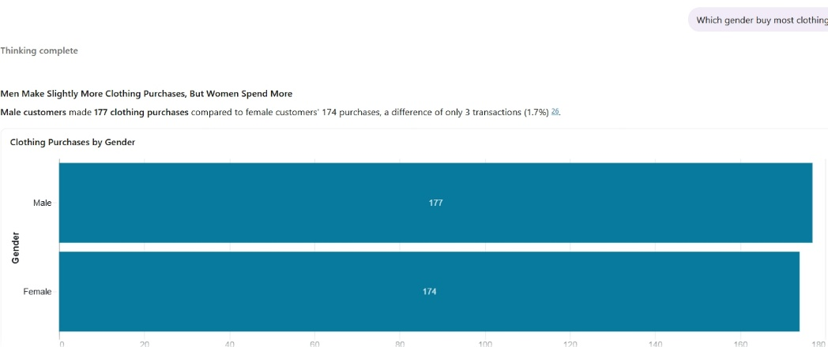
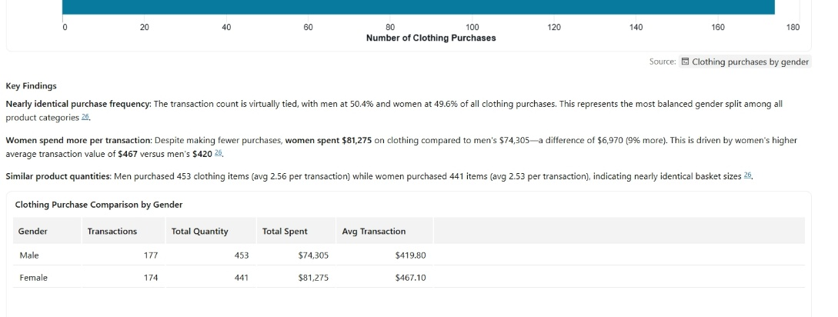
Question 7
Which age group make the highest revenue?
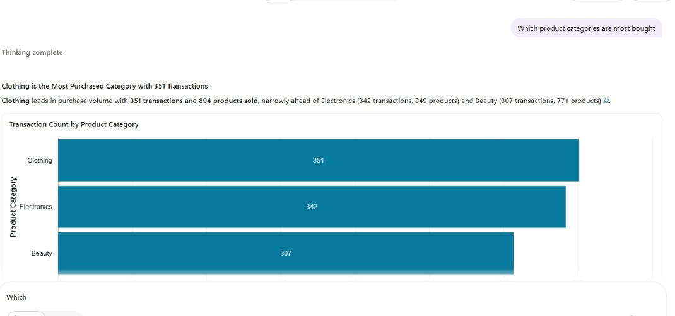
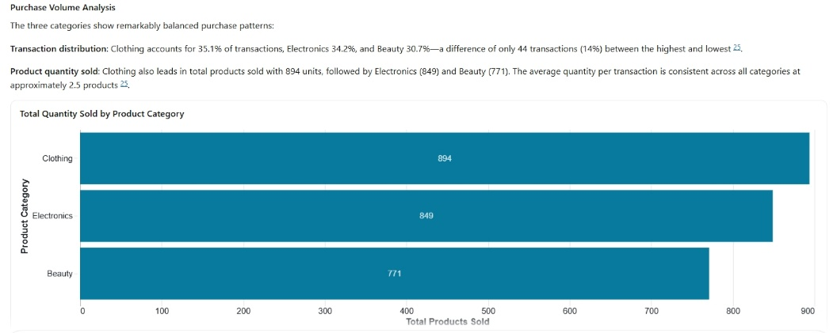
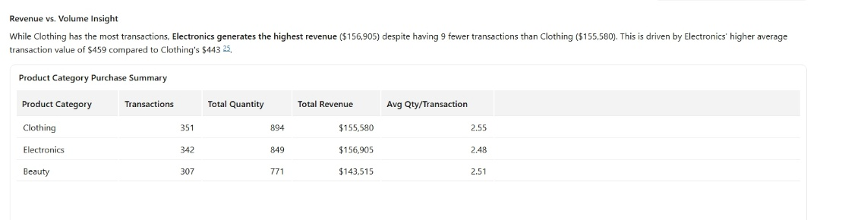
Question 8
Which age group has the highest customer demand?
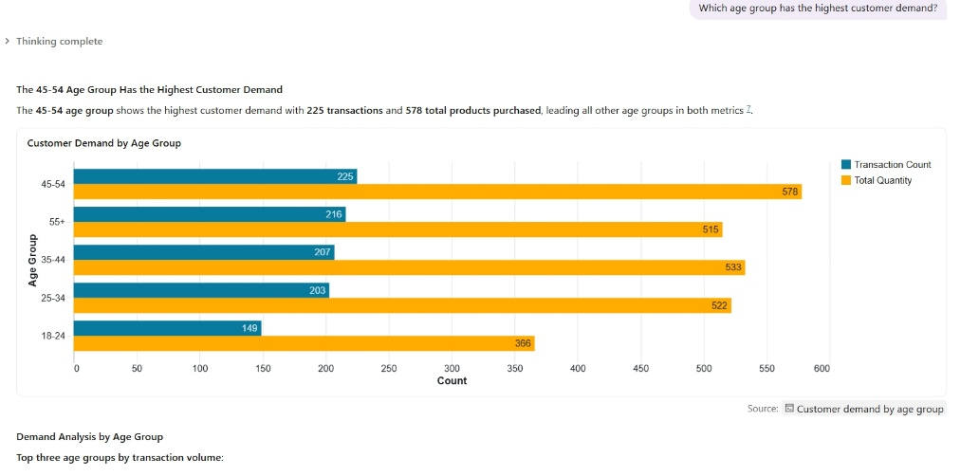
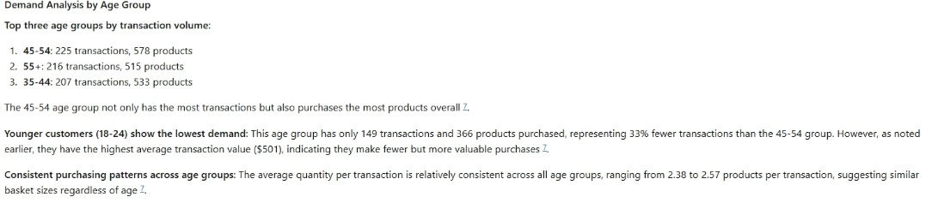
Question 9
Which product category is most popular among customers under 30?
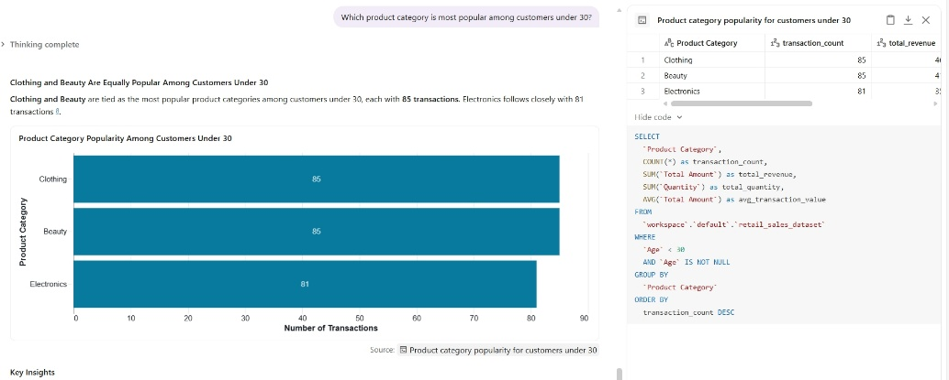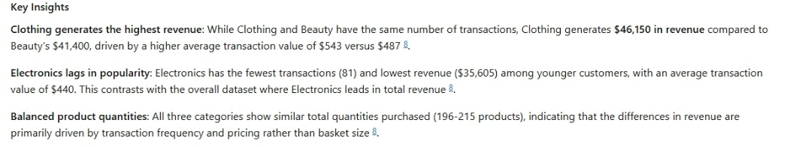

Question 10
Who are the most valuable customers?
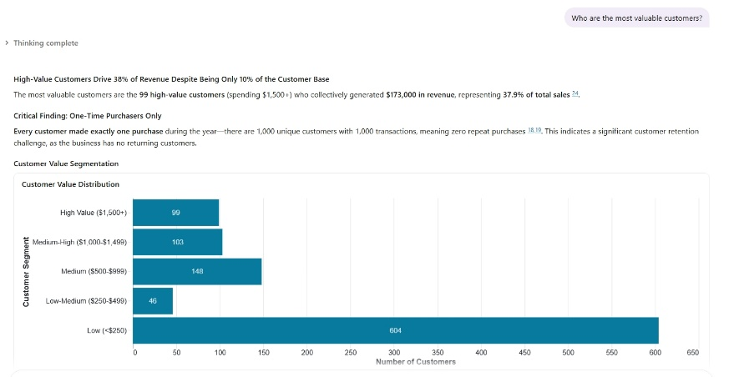
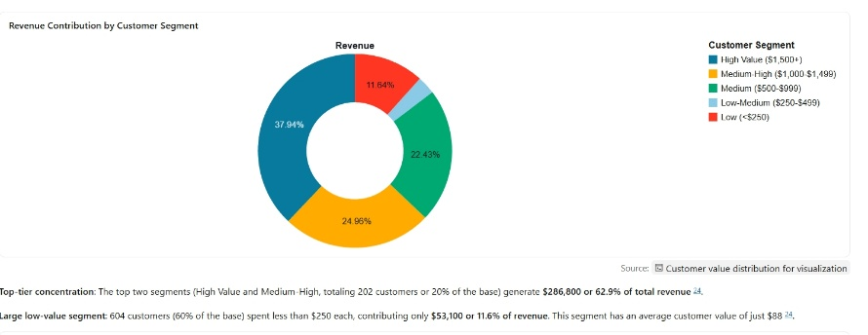
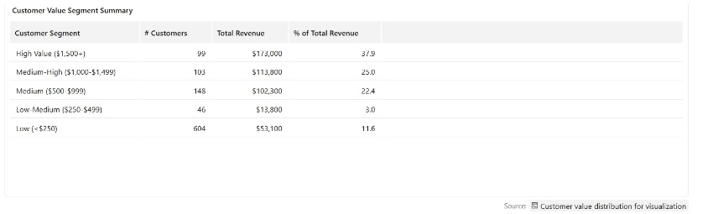
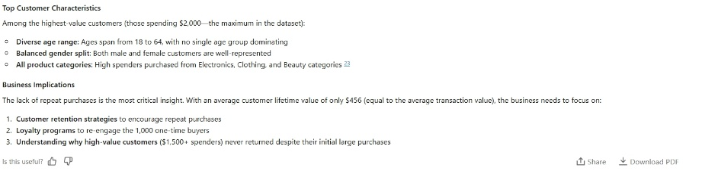

9. Validation of 3 Answers
1. Agent Answer: Question 1
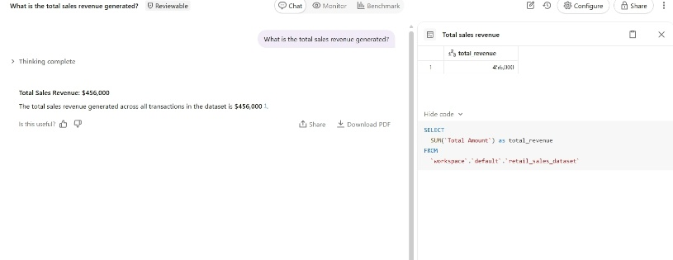
The answer was validated using a SQL aggregation query.
Validated Answer
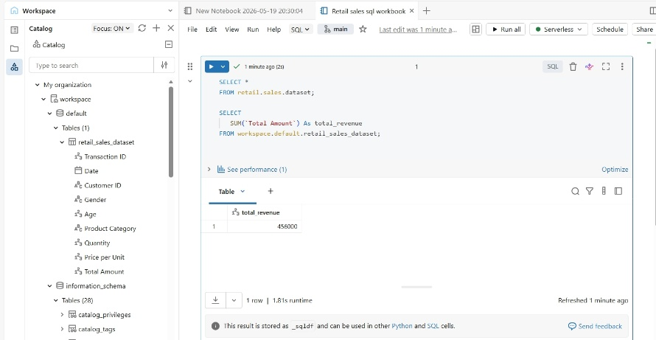
The answer was correct because the calculated totals matched the agent’s response.
2. Agent Response: Question 5
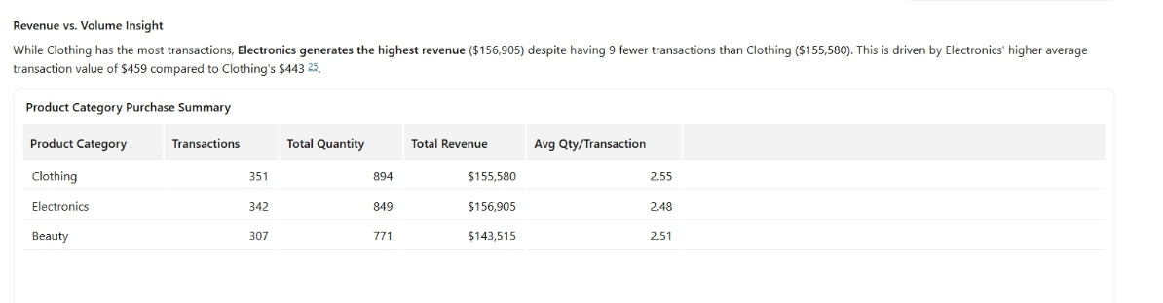
The answer was validated using a SQL aggregation query from the agent, I took the code from the agent and wrote it on notebook and run code.
Validated Answer
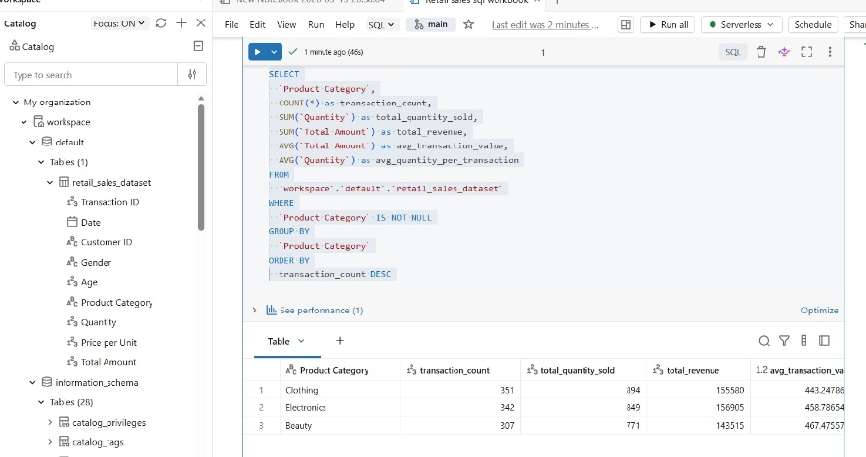
The answer was correct because the calculated totals matched the agent’s response.

3. Agent Answer: Question 6
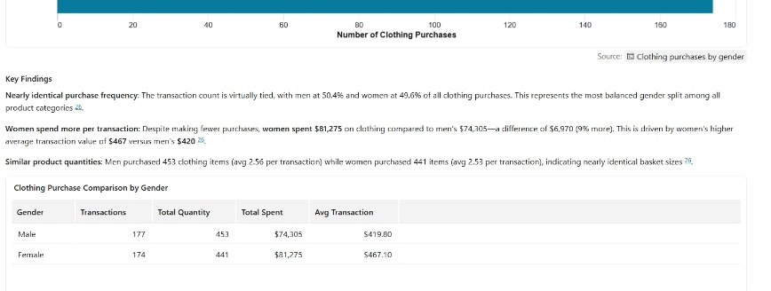

The answer was validated using a SQL aggregation query from the agent, I took the code from the agent and wrote it on notebook and run code.
Validated Answer
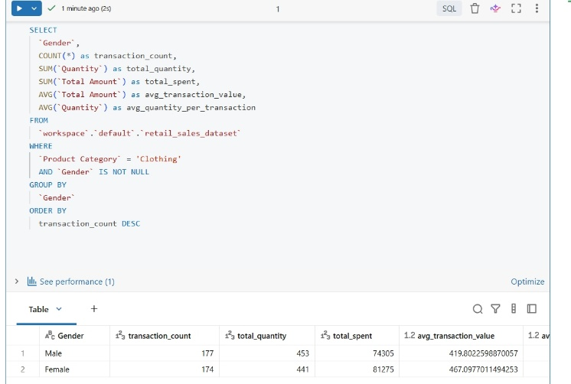
The answer was correct because the calculated totals matched the agent’s response.

10. Key Insights
The analysis showed that Electronics generated the highest sales revenue. Customers between the ages of 25 and 35 contributed the largest percentage of purchases. Monthly sales trends showed increased sales during the final quarter of the year.

11. Business Recommendations
Based on the analysis, the business should focus more on products with the highest sales because they bring in more revenue. The business can also target the age groups that buy the most products through promotions and advertising.

12. Challenges Experienced
One challenge experienced during the project was understanding how to configure the Data Agent correctly in Databricks. Another difficulty was validating the agent’s responses using SQL queries hence I queried using the code show on the data agent response.

13. Conclusion
This project demonstrated how AI and data analytics can be combined to support business decision-making. The Data Agent successfully answered questions related to retail sales and customer behaviour. In future, more advanced datasets and visualisations could improve the quality of insights.

