California State University, Sacramento
The College of Engineering and Computer Science

CPE 166 Advanced Logic Design

Midterm

Fall 2020

Student Name: Shammah Thao

- [23 points]. (1). Write the Verilog program for the following combinational circuit.
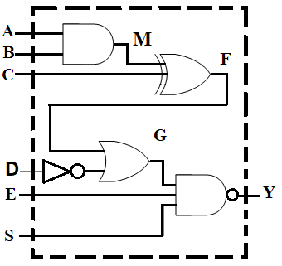

module cir1 (A, B, C, D, E, S, Y );

input ______A,B,C,D,E,S__________________________;

output _______Y_________________________;

wire ________M,F,G_________________________;

assign M = _______A & B_____________________ ;

assign F = ______M ^ C______________________;

assign G = ________F | ~D_____________________;

assign Y = ________~ (G & E & S)_____________________;

endmodule

(2). Complete the testbench for the above circuit to generate testing cases for all possible values of A, B, C, D, E, and S.

module tb;

__reg_______ A, B, C, D, E, S;
_wire________ Y;
__integer_______ i;

_ex1 uut( .A(A), .B(B), .C(C), .E(E), .S(S)) ______________;

initial
begin
{ A, B, C, D, E, S } = __0__________________ ;
for ( i=0; i < ___64________; i=i+1)
begin
#5 _______A,B,C,D,E,S_________________;
end
#5 $stop;
end
endmodule

2.[27 points] Use Verilog hierarchical design method to design the following circuit.
1). Design clock rising edge triggered 1-bit D FlipFlop with asynchronous reset.
module dff (D, clk, reset, Q);
input ______D,clk,reset_________________;
output ________Q_______________;
reg ________Q_______________;

always@( __posedge_____clk________ or _________posedge reset___________ )
begin
if (reset)
___Q <= 1’b0 ______________;
else
___Q <= D;______________;
end
endmodule

2). Use dff above to implement the following circuit and complete the Verilog design.
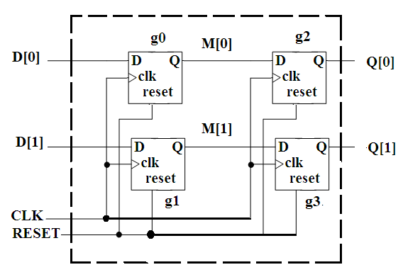
module cir2 (D, CLK, RESET, Q);
input ___[1:0]D_______________;
input ___CLK, RESET_______________;
output ____[1:0]Q_______________;
wire _____[1:0]M______________ ;

dff g0(.D(D[0]), .clk(CLK), .reset(RESET), .Q(M[0]));

dff g1(.D(D[1]), .clk(CLK), .reset(RESET), .Q(M[1]));

dff g2(.D(M[0]), .clk(CLK), .reset(RESET), .Q(Q[0]));

dff g3(.D(M[1]), .clk(CLK), .reset(RESET), .Q(Q[1]));

endmodule

3. [30 points] A finite state machine is described using a state diagram shown below.
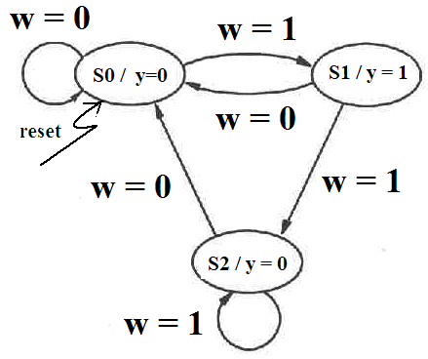

Write the complete Verilog code for the above finite state machine.

module fsm(reset, clk, w, y);  input reset, clk, w;  output y;  reg y;  reg [1:0] cs, ns;  parameter S0=2b'00, S1=2'b01, S2=2'b10;  always@(cs)  begin  case(cs)  S0: y=0;  S1: y=1;  S2: y=0;  default y=0;  endcase  end  always@(cs or w)  begin  case(cs)  S0: if(w) ns=S1;  else ns=S0;  S1: if(w) ns=S2;  else ns=S0;  S2: if(w) ns=S2;  else ns=S0;  default: ns=S0;  endcase  end  always@(posedge clk or posedge reset)  begin  if(reset) cs <= S0;  else cs <=ns;  end  end module | // continue your code here.

4. [20 points] Complete the following circuit design in VHDL.

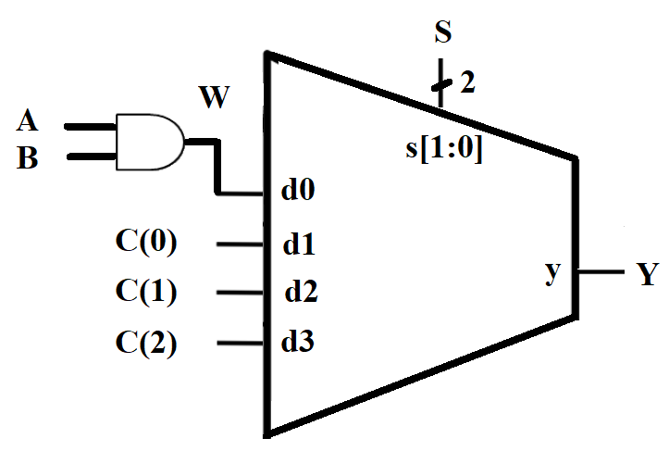

Library __IEEE_____________________________;
Use ____IEE.STD_LOGIC_1164.ALL___________________________;

_entity________ cir4 is
Port ( A, B: _in std_logic__________________________;
C: _in std_logic_vector [2 downto 0]__________________________;
S: _in std_logic_vector[1 downto 0]__________________________;
Y: _ out std_logic__________________________ );
End cir4;

_ architecture__________ design of ____cir4______ is

_signal________ W: ___std_logic___________________________;

Begin

W <= _______A and B________________________;

Y <= ____W____________ when ____S=’00’_________ else

________C(0)________ when ______S=’01’_______ else

_______C(1)_________ when _____S=’10’________ else

_____C(2)___________ ;

end design;

