Shammah Thao

8/4/20

CPE 185

Homework 8

1.

(a) PROGSl.ASM(17): warning A4012: line number information for segment without class

'CODE' : cseg. CodeView cannot process modules with code in segments with class names

that do not end with "CODE."

(b) LlNK : warning L4055: start address not equal to 0x100 for /TINY. COM programs (/TINY

memory model) must start at 0100H.

(c) PROG51 .ASM(23): error ,42006: undefined symbol :eOOh. Assembler "thinks" this number

is a label.

(d) Program assembles without error. However, when run, the output screen is blank. The

wrong interrupt (number 10 instead of 16) is being called.

(e) PROG51 .ASM(27): error A2006: undefined symbol : IIIA. This symbol is not defined

anywhere in the program

(f) PROG51 .ASM(31): fatal error A101 0: unmatched block nesting : cseg. Assembler cannot

find the end of the segment.

(g) LlNK :warning L4055: start address not equal to 0x100 for /TINY. Linker cannot find a

starting address.

(h) 102 errors! PROG51 .ASM(30): error A2046: missing single or double quotation mark in

string. PROG51 .ASM(30): error A2039: line too long.

2.

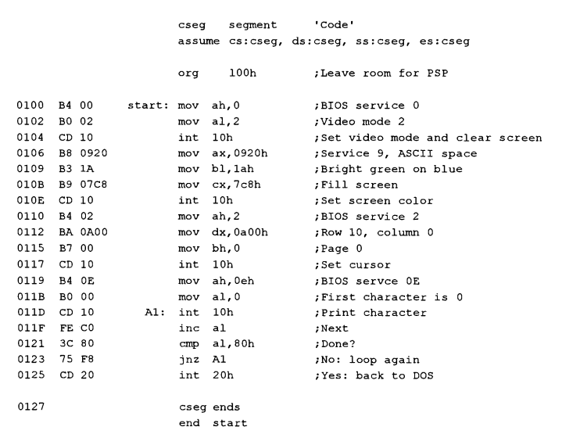service 0 ;Video mode 2 ;Set video mode and clear screen ;Service 9, ASCII space ;Bright green on blue ;Fill screen ;Set screen color ;BIOS service 2 ;Row 10, column 0 ;Page 0 ;Set cursor ;BIOS servce OE ;First character is 0 ;Print character ;Next ;Done? ;No: loop again ;Yes: back to DOS