Shammah Thao

3/14/2020

Cpe 138

Socket Programming #1

Server Python File:

from socket import *

serverPort = 12000

serverSocket = socket(AF_INET, SOCK_DGRAM)

serverSocket.bind(('', serverPort))

print("The server is ready to receive")

while True:

message, clientAddress = serverSocket.recvfrom(2048)

modifiedMessage = message.decode().upper()

serverSocket.sendto(modifiedMessage.encode(), clientAddress)

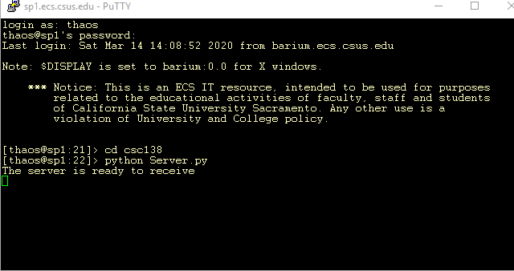

Client Python File:

from socket import *

serverName = 'sp1.ecs.csus.edu'

serverPort = 12000

clientSocket = socket(AF_INET, SOCK_DGRAM)

message = raw_input('Input lowercase sentence:')

clientSocket.sendto(message.encode(), (serverName, serverPort))

modifiedMessage, serverAddress = clientSocket.recvfrom(2048)

print modifiedMessage.decode()

clientSocket.close()

