Shammah Thao

EEE 117L Network Analysis Lab

Lab 6: Sallen-Key Band Pass Filter

12/7/20

Introduction:

The Sallen-Key Band Pass Filter, we first had to create the given sallen key bandpass filter into the PSpice and then ran the simulation. We then proceed to build the sk bandpass filter onto a protoboard which is than linked with the analogy discovery 2 to show the waveform of the result. The lab is an extension of lab #5 where we used the opamp to find different frequency.

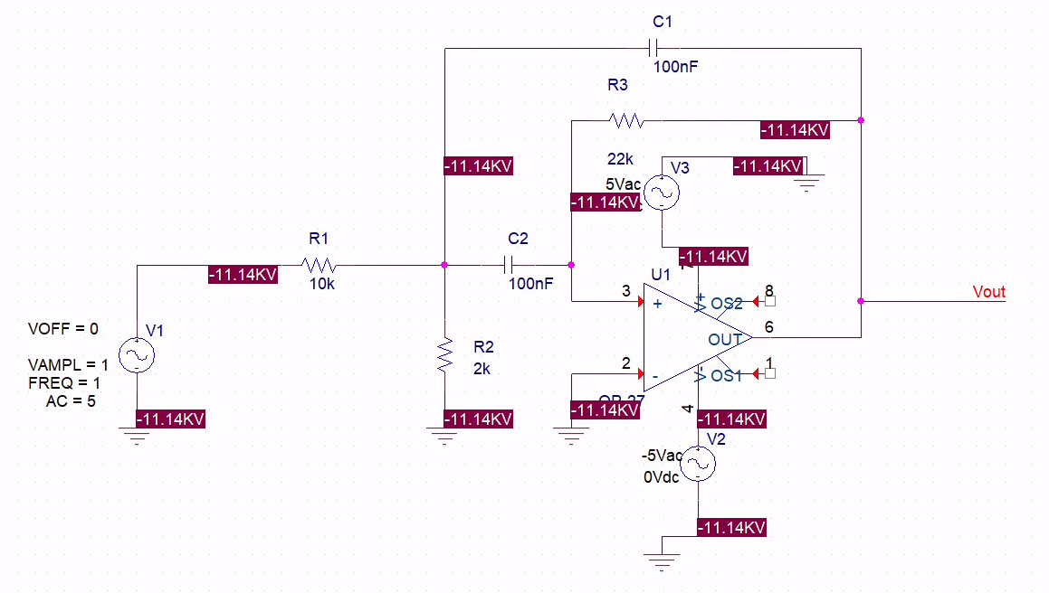

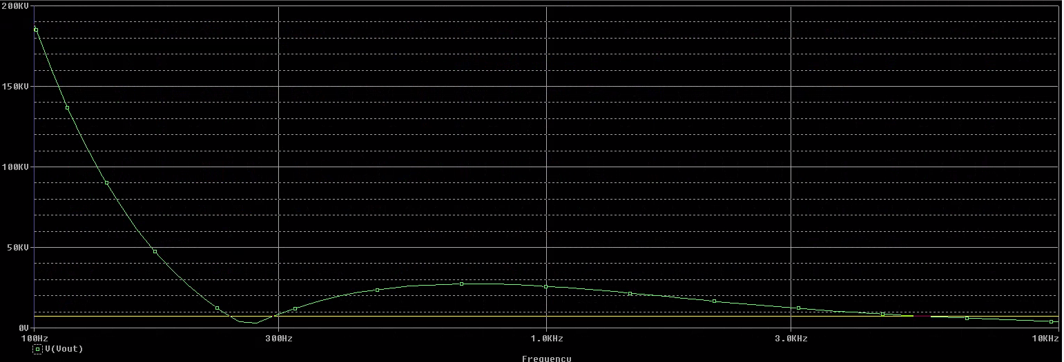

The frequency started around 175kV and went down base on the time.

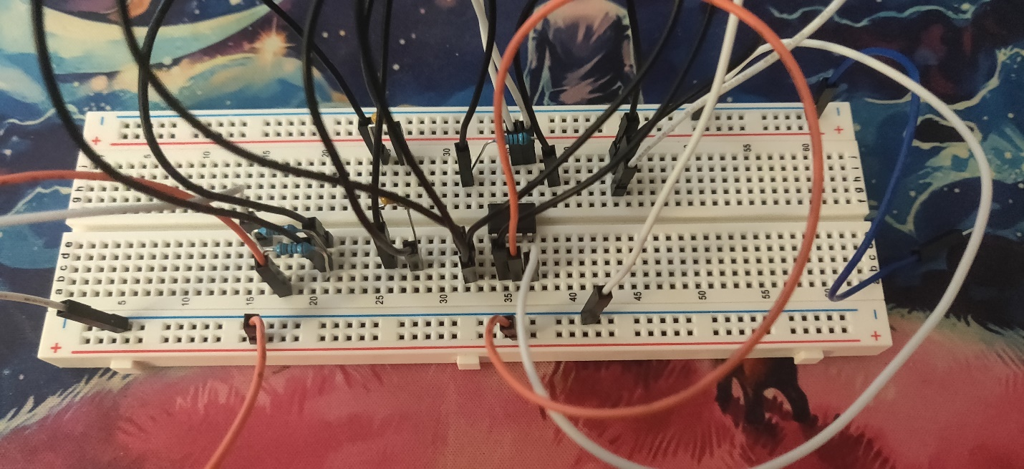

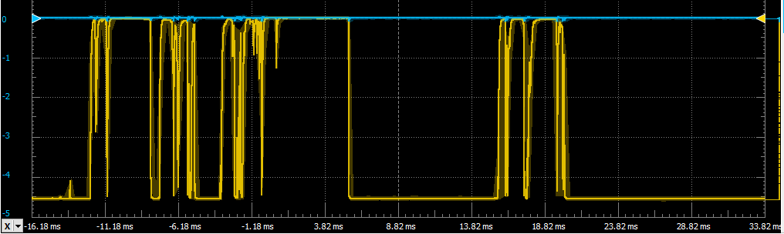

The result fluctuate when it was plugged in into waveform. It went from -4.5 to 0V then it went back to being a solid -4.5V line.

Conclusion:

The lab itself didn’t seem as difficult, but the only issue really was trying to understand what the output should be and how to build the protoboard. After some tweaking on the protoboard I was about to make it run but the result turns out to be different from what the Pspice simulation was showing.