Shammah Thao

EEE 117L Network Analysis Lab

Lab 5: Low Pass Filters

11/22/20

Introduction:

In this lab we became familiarized with low pass filters and how to implement them into circuits. This lab took three weeks and consisted of two main parts. The first part was to simply construct each of the four circuits. The circuits were the passive and active low pass filters, and another set of the same circuits but with a 1k ohm load resistor from Vin to Vout. We had to make four sets of measurements. We measured the Vin, Vout, and Phaseshift. We also calculated the theoretical gain, the measured gain and recorded the frequency at which the cut off was for the low pass filter. In the second part of the lab we used PSPICE to create the circuits that we created to see the graphs of certain variables. Then we compared the PSPICE values to the values we obtained experimentally, as well as the values we calculated for.

Part 1: Sinusoidal Steady State Frequency Response

Passive Simulation

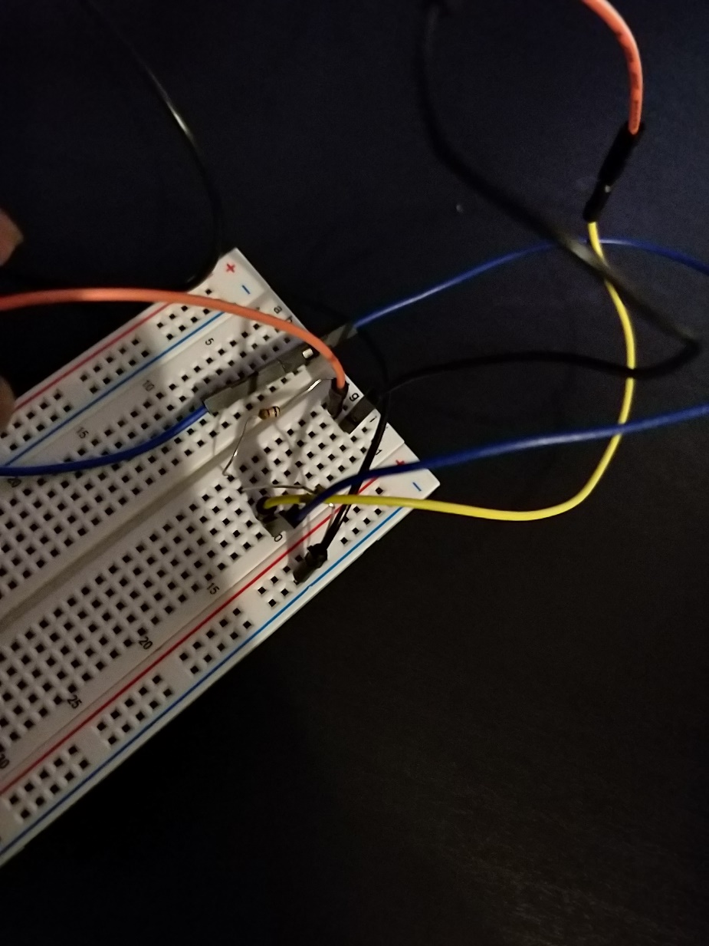

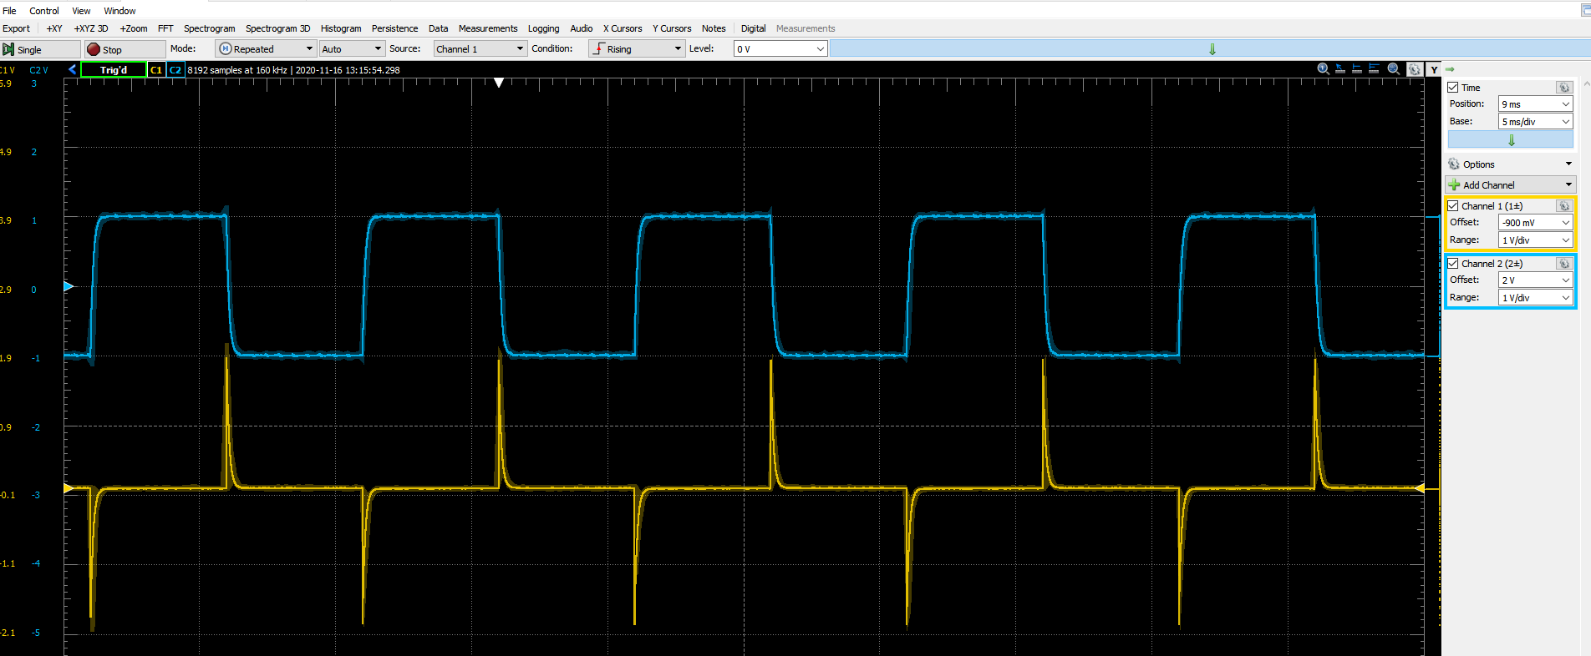

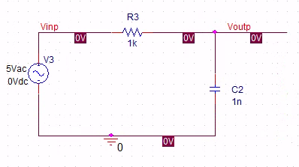

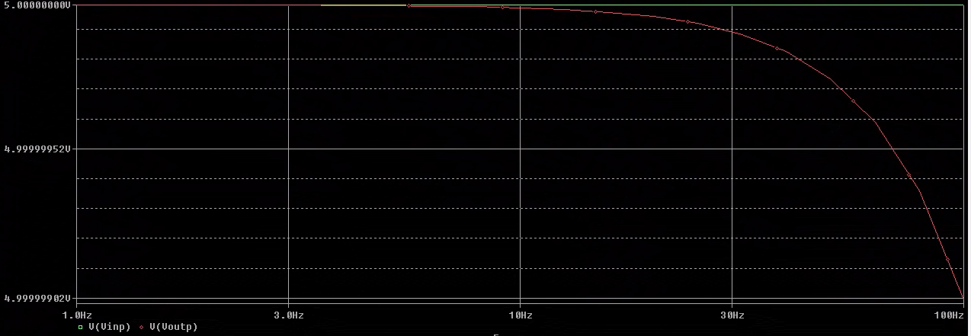

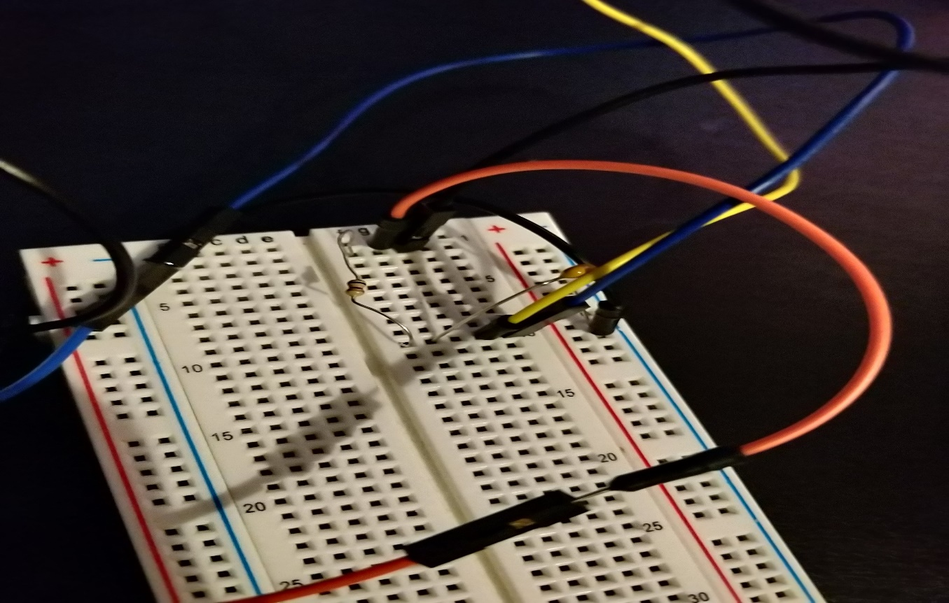

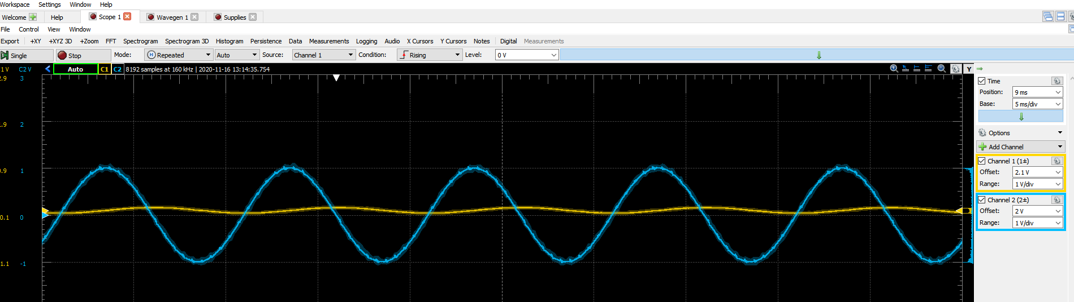

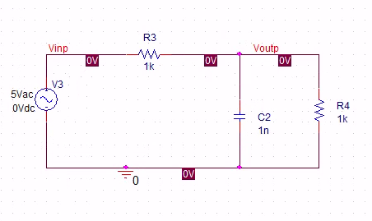

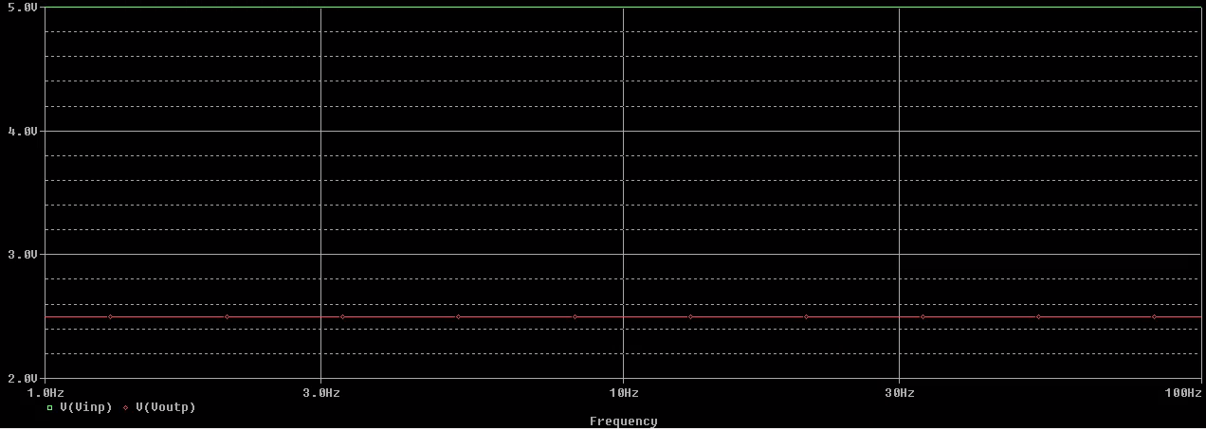

Active Simulation

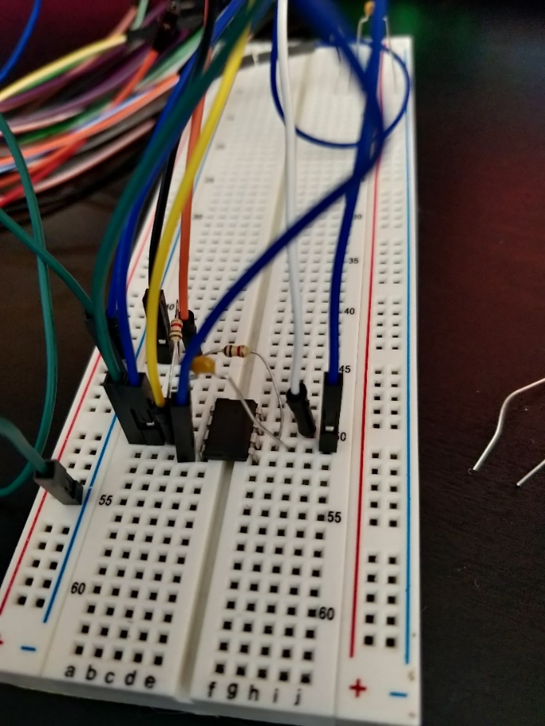

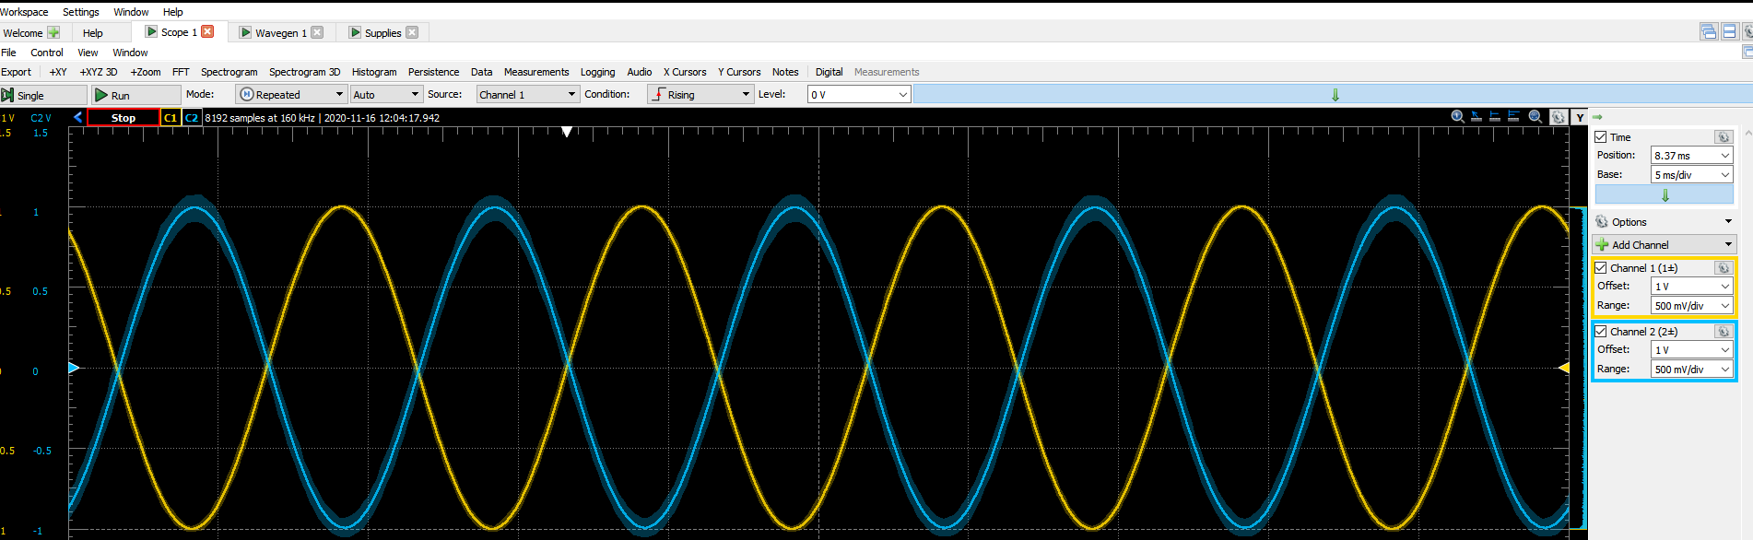

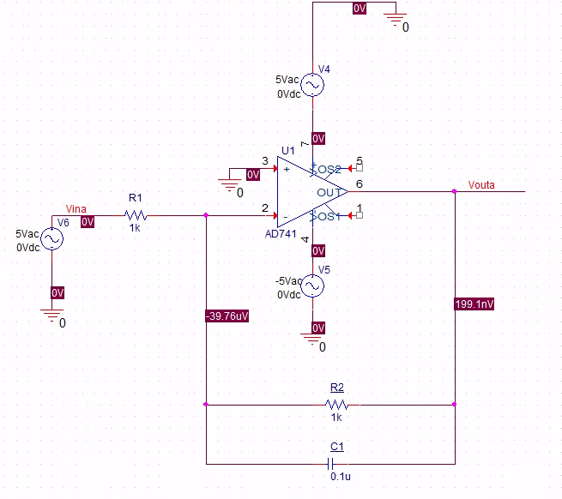

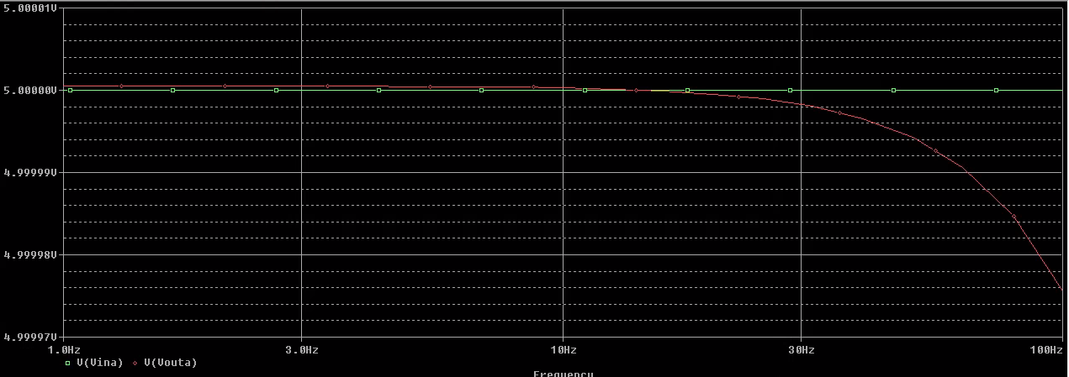

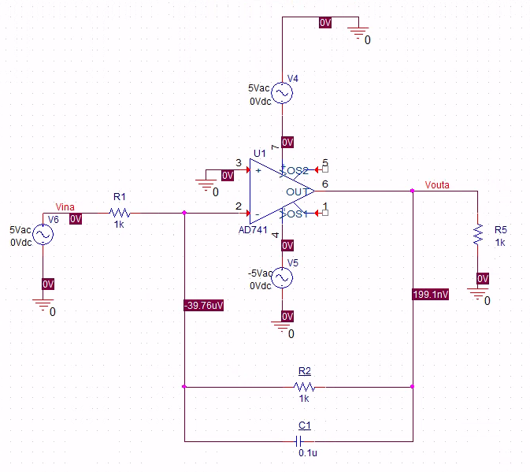

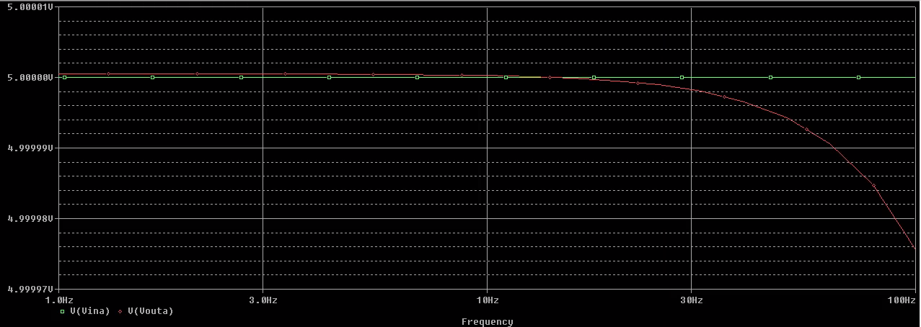

|  |  |  |  |  |  |  |  |  |
| --- | --- | --- | --- | --- | --- | --- | --- | --- |
|  |  | Vin | Vout | Theoretical Gain | Measured Gain | Phaseshift | Frequency |  |
| Passive Circuit |  | 356 mv | 354.2 mv | 1 | 0.995 | -3.5 | 100 Hz |  |
|  |  | 348.5 | 251.9 | 0.707 | 0.723 | -42 | 1.5KHz | (Cutoff Freq) |
| With 1k Resistor |  | 347.1 | 173.5 | 0.5 | 0.4998559493 | -0.5 | 100Hz |  |
|  |  | 344.3 | 123.5 | 0.3535 | 0.3586988092 | -41.2 | 3Khz | (Cutoff Freq) |
| Active Circuit |  | 246.5 | 246.5 | 0 | 0 | 0 | 100 |  |
| With 1k Resistor |  | 246.5 | 174.5 | 0.707 | 0.7079107505 | 0 | 1.6Khz |  |

Part 2: Square Wave Input/Fourier Series Analysis

Calculation:

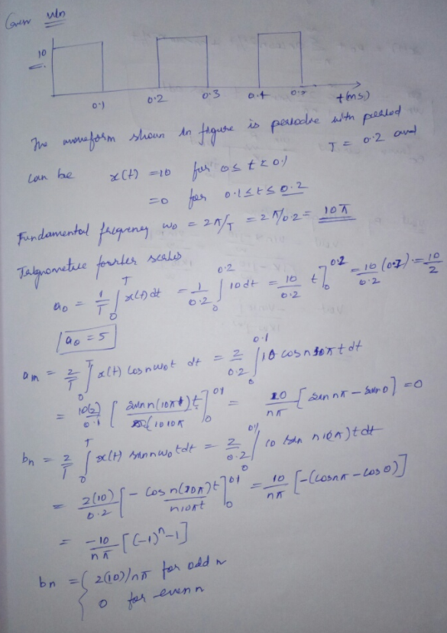

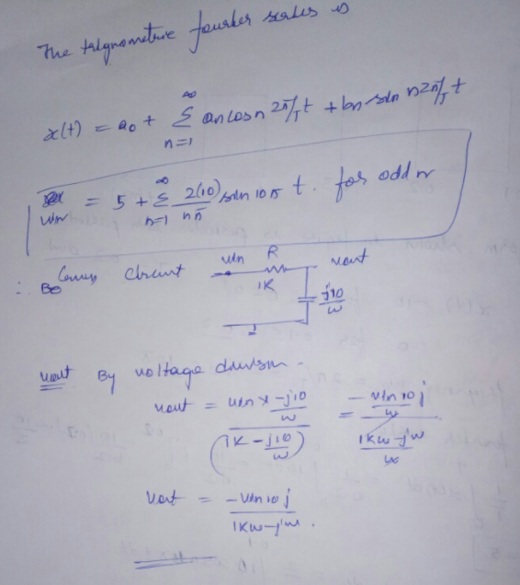

Passive:

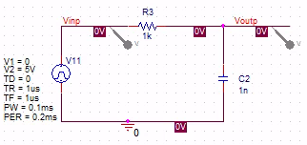

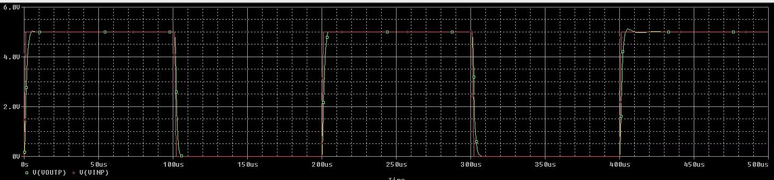

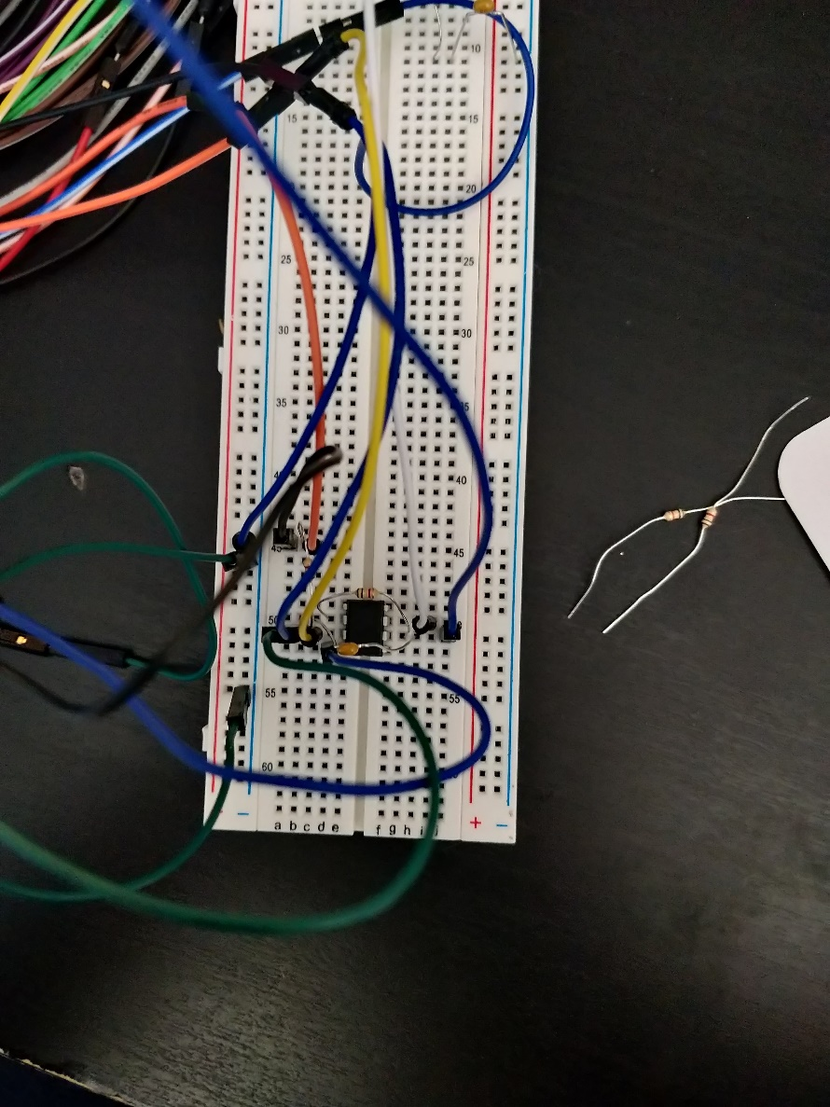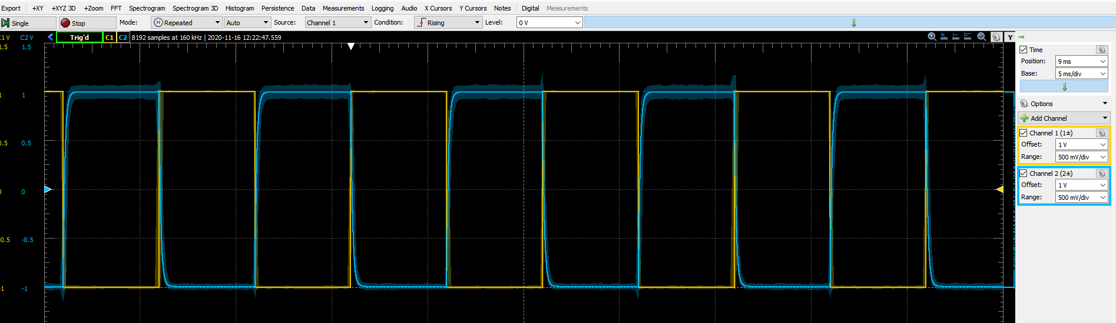

Active:

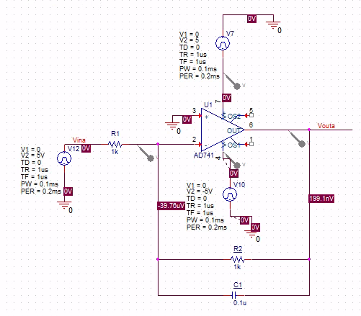

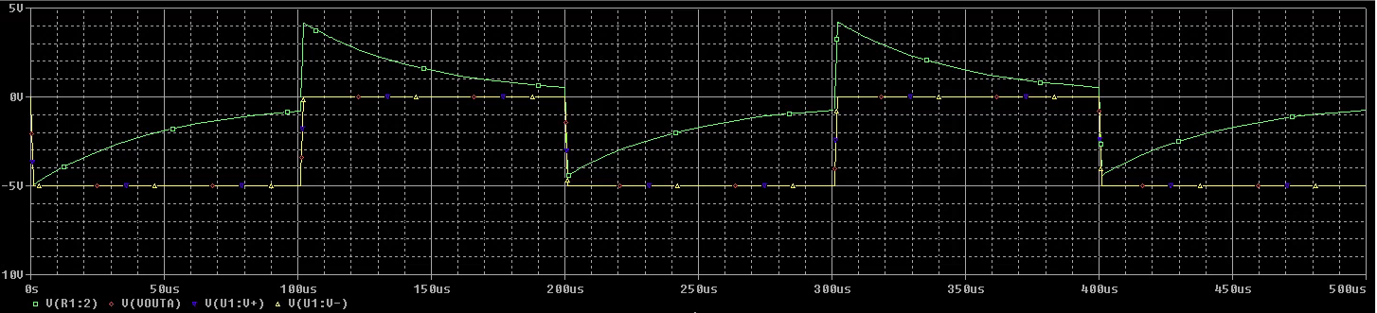

Discussion:

1. Compare the various gains and phase shifts found in Part I.

For the passive circuit, the gain without changing the frequency from the initial of 100Hz was .995. After modifying it to reach the theoretical gain of .707 (.707 point), the frequency was at 1.5Khz but the measured gain was .723 before we reached the cut off frequency. The phase shift initially was -3.5 and then it went to -42 after reaching the cut off frequency of 1.5Khz With the loaded passive circuit, the gain was .4998 while the theoretical was .5. The phase shift was about -0.5 degrees at the initial frequency of 100 Hz. After increasing the frequency to reach the cut off at 3 Khz, the theoretical gain was .3535 and the measured was .3589. The phase shift at that point was -41.2 degrees.

2. Compare the steady state response of the active circuit to the response of the passive circuit when a load is added.

Both the active and passive circuit both simulated the same result, they both started around the started voltages then it steady incline down to 0 voltages. When the load was the active stayed the same while the passive change to be two straight horizontal lines, one being on 5v and the other on 0 voltages both of which are not changing.

3. Compare the calculated Fourier series coefficients with the PSPICE generated coefficients.

The PSPICE simulation and the Fourier series coefficient was different from each other by a little bit. The PSPICE simulations shows the voltage going from a 5V start and decline to meet up with the other voltages. The simulation that was done on waveform doesn’t overlap like the simulation that was done in PSICE but the result would be similar if the result overlap.

4. Compare the experimental output to the PSPICE simulated output for the square wave input of Part II.

The PSPICE simulated output for the square wave input was not the same for us as the one in our experiment. We could not pinpoint the issue with our waveform but it was curving in straight lines at what seemed like 45 degree angles. As such, it was not the same as the PSPICE simulated output. According to the lab instructor, the issue could possibly have been with the oscilloscope or with the way we set up our circuit. We believe that the issue was with the way the settings on the oscilloscope were set up because we had correct readings for our other circuits on a separate oscilloscope.

Conclusion:

In this lab we compared the different methods of implementing low pass filters, both active and passive. We tested these out using the 1k ohm resistor. We then performed the experiment to determine the cut off frequency for each low pass filter. In the second part of the lab, we constructed the Fourier series for the input and attempted to construct the Fourier series for the output. We made the circuit on PSPICE so that we could simulate the circuit and obtain the waveform we were looking for. Using the Fourier Analysis tool, we were able to determine the coefficients for the Fourier series up till the eighth harmonic.