Shammah Thao

EEE 117L Network Analysis Lab

Lab 4: Introduction to Operational Amplifier

10/29/20

Introduction:

For this lab, we are building the non-inverting amplifier on SPICE which is all connected to a 5 V power supplies. To start off the lab we did some preliminary calculations which resistor values are chosen by us. We than transition into the SPICE schematic and simulation of the waveform. Finally, we built the schematic onto a breadboard and simulated it onto Waveform with the Analog discovery 2.

Preliminary Calculation:

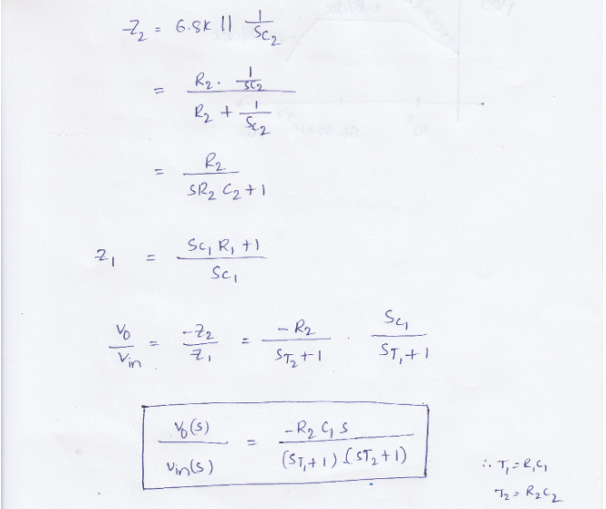

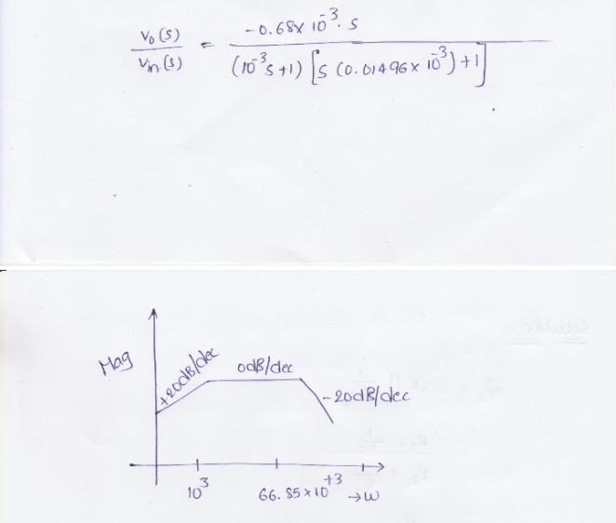

Spice Simulations: Non-inverting

The schematic was a replication of the schematic shown to us in the instruction. It is being powered by a voltage of 5V which goes into the amplifier which is connected to some resistor connected to ground.

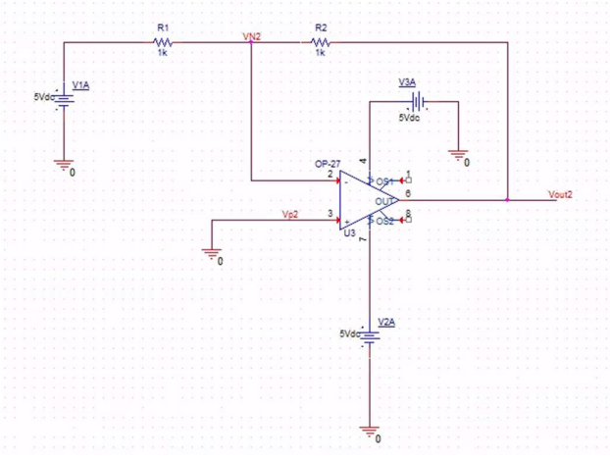

The waves that I generated from this was a straight line from both the Vn1 and Vout1. Both are receiving different voltages, Vn1 is getting about 2.5V and Vout1 received 5V.

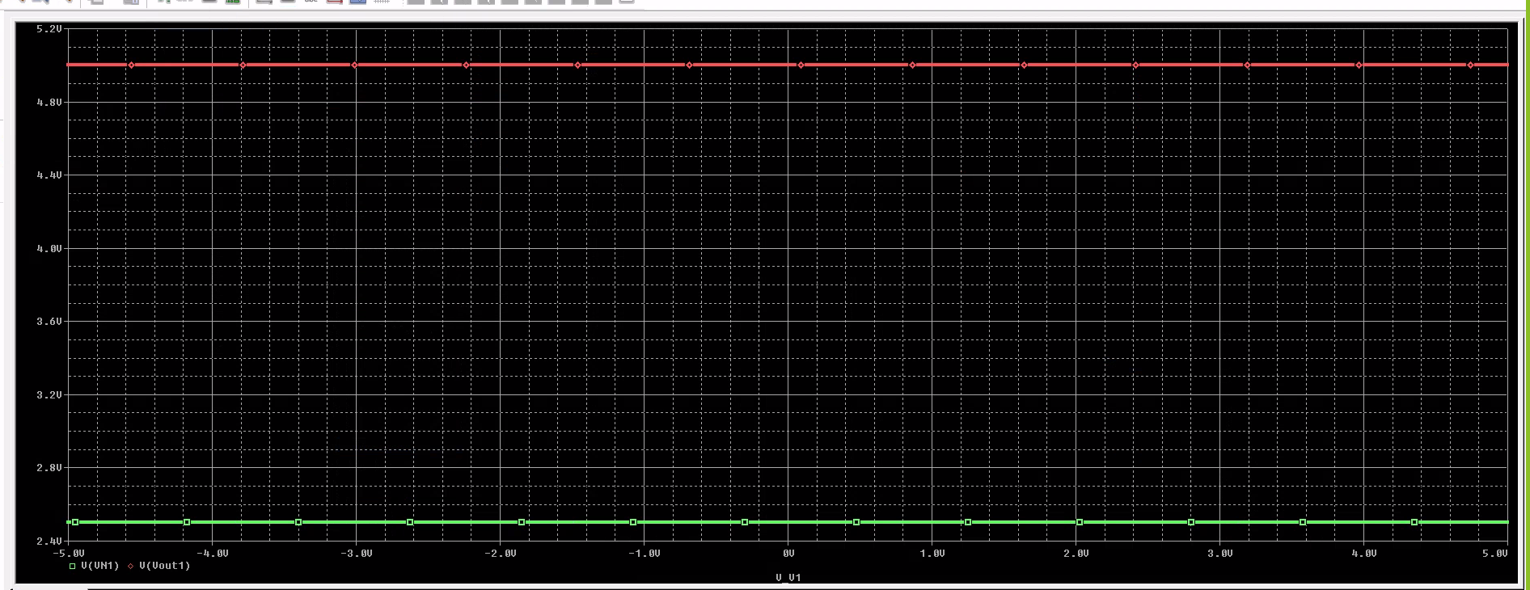

The Figure below shows the division between Vout2 and Vn2 which gave me a straight line at 1V.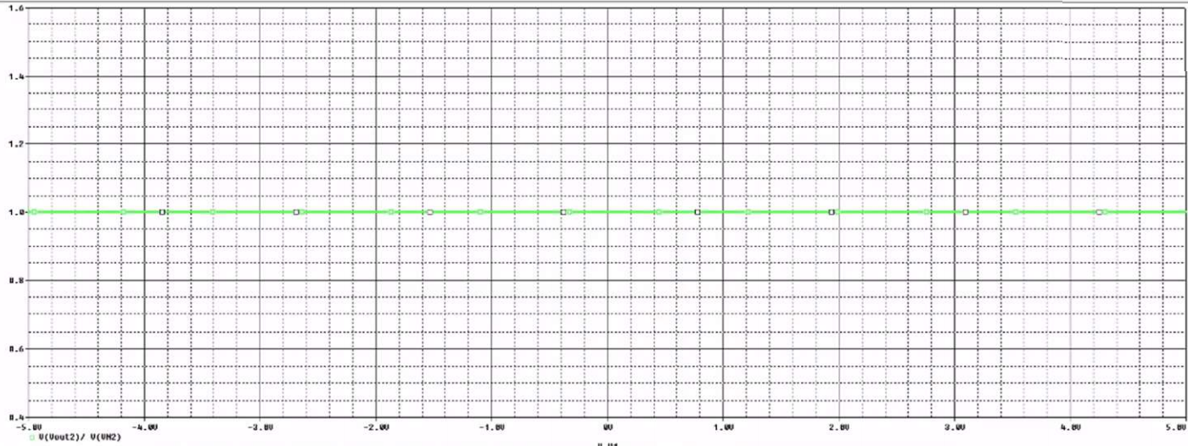

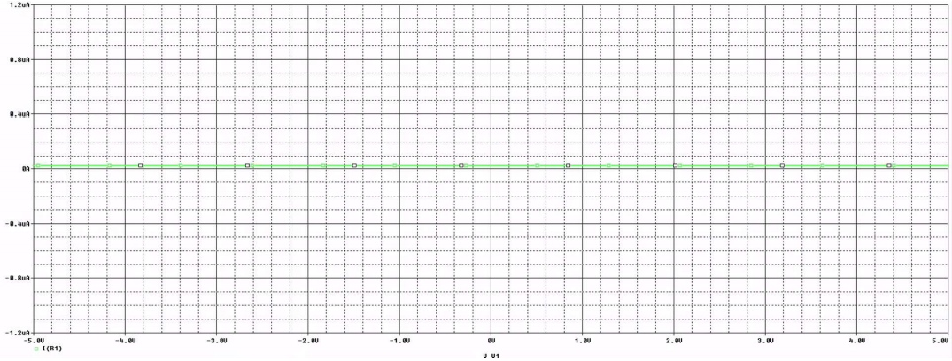

The figure above shows the R1 which is constantly 0 at all the voltage points.

Laboratory Experiment

For this experiment, we built the breadboard matching the schematic and then implementing the AD2 on to it.

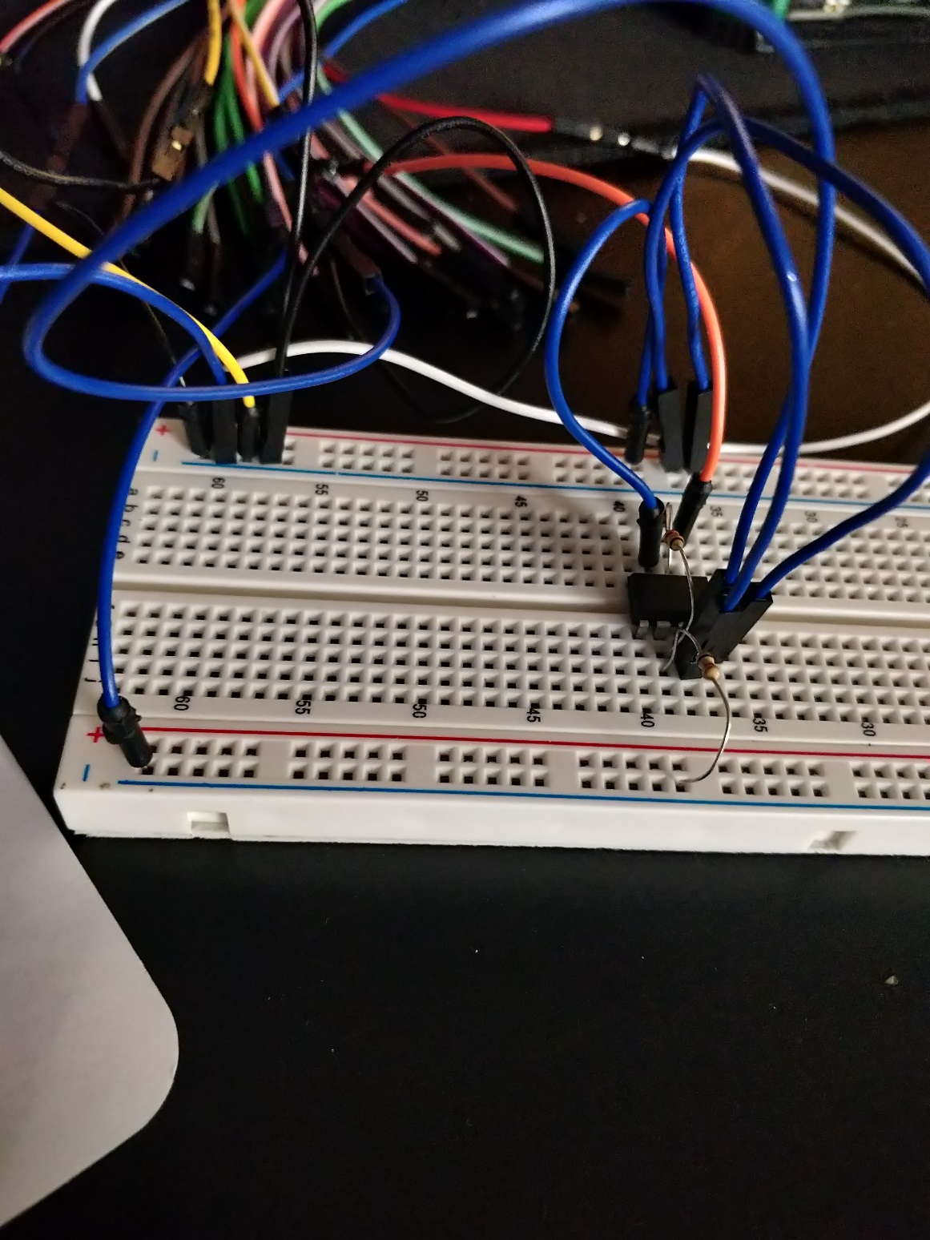

Our waveform that was generated from this was different from the one on SPICE, but it was able to generate a working wave

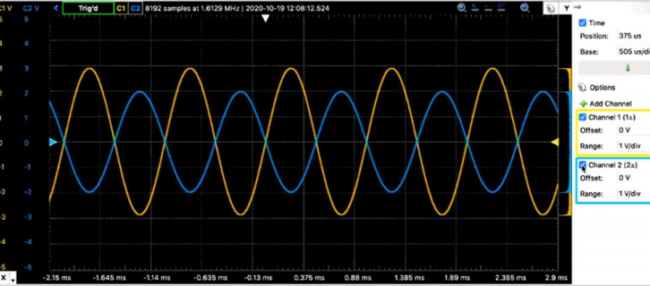

Conclusion:

We learned about the characteristic of the non-inverting amplifier along with how its built-on SPICE and how it functions on the breadboard with its components. The most difficult part of this lab was just building it and getting it to work, as we must find the correct component and then putting it all together with the AD2. Other than that, working with SPICE has gotten easier. The lab helped me further my knowledge of constructing different amplifier physically and digitally. It was helpful and I hope it will stick with me on the long run.