Lab 2: Introduction to SPICE Analysis Techniques

EEE117 Lab Section # 2

10/18/20

Shammah Thao

Step 1. Preliminary Calculations:

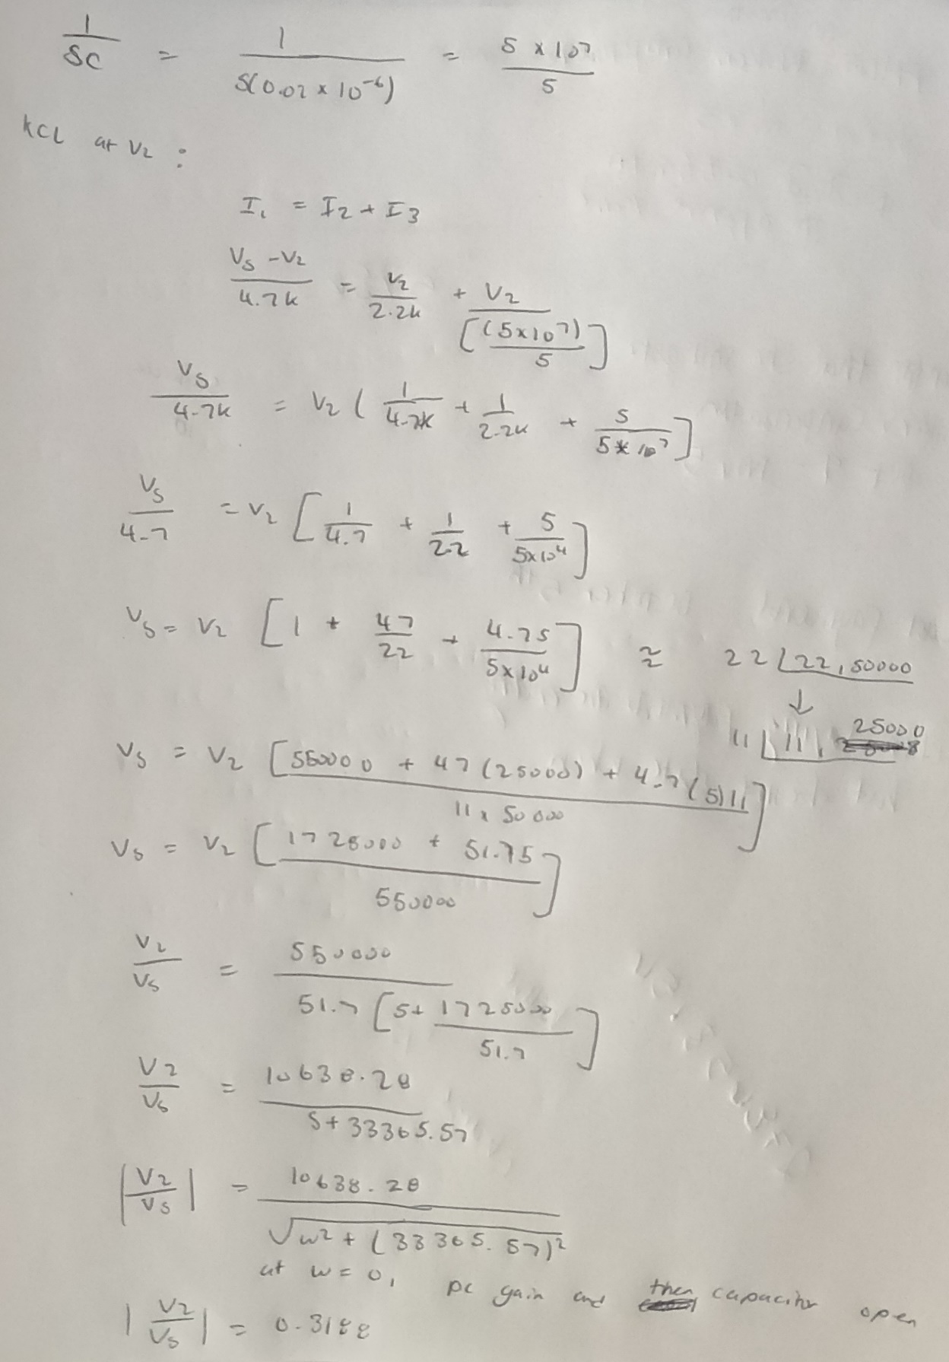

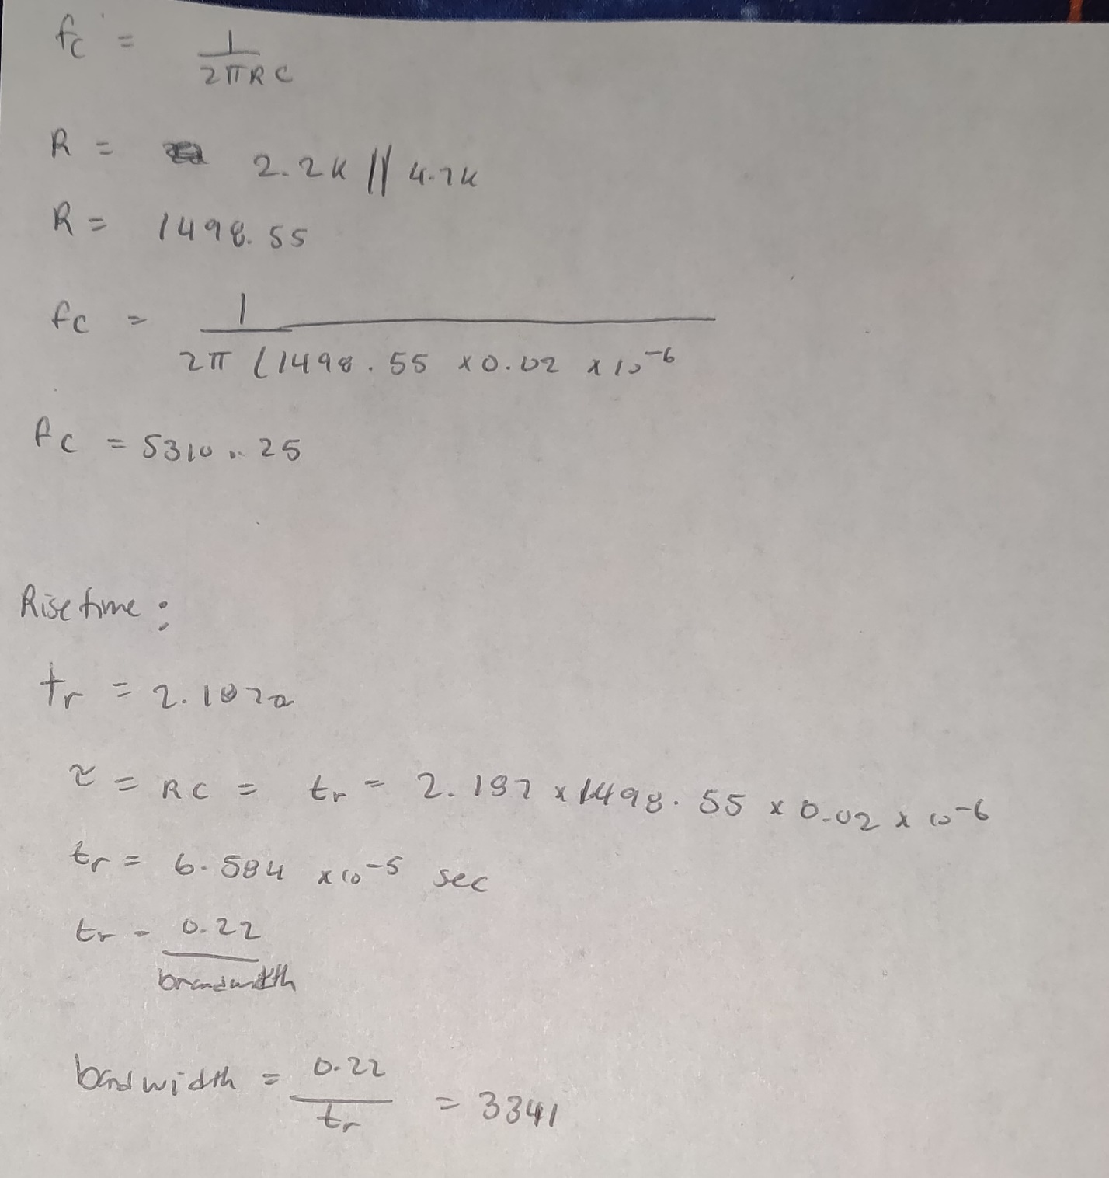

Part 1.

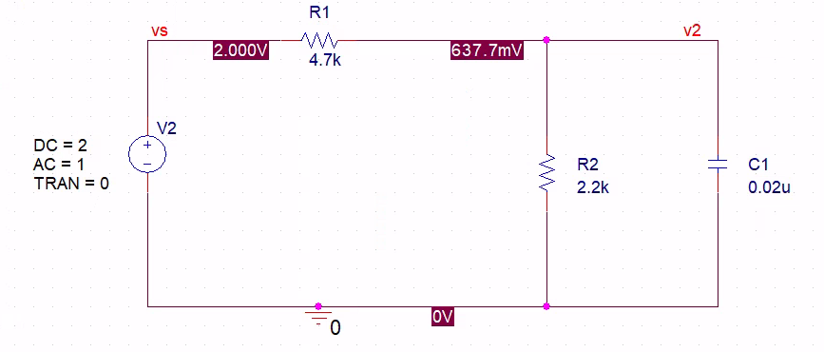

For this part, we had to first set up the schematic from the given figure. We used a Vsrc voltage source, along with some resistor and one C. The resistor and C were set to given values, we just had to set net alias and set up the connection between the parts

Part 2: Dc sweep

For part 2, we were to find the DC sweep from the circuit. We set the Sweep Variable to the voltage source, and for Sweep type we did a linear from -2 to +2 volts. Incrementing at 10mV.

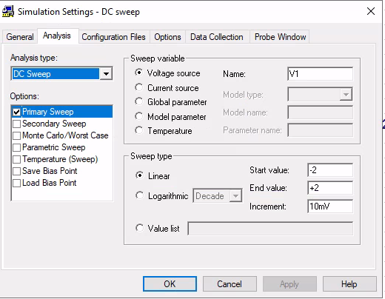

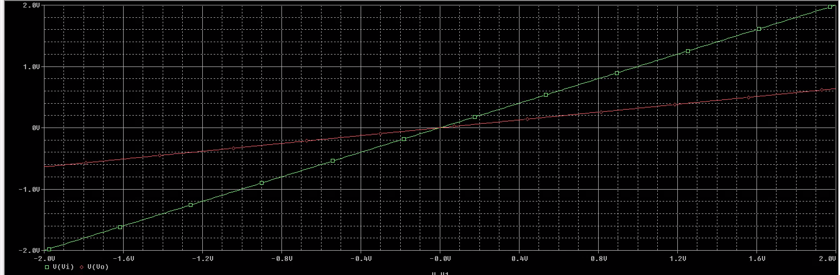

We first found the analog and voltages for the two-net alias: vs and v2. Running the simulation gave us the graph above with vs being green and starting at -2 while v2 being red and started around -0.5v.

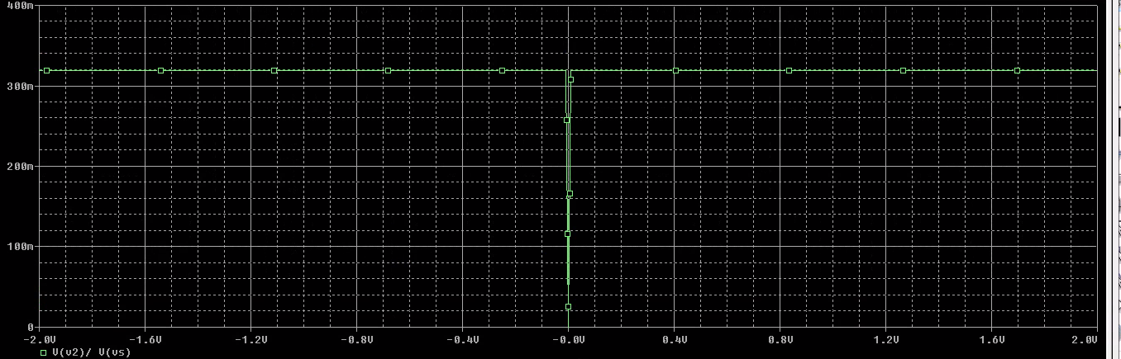

Above, we found v2/vs by clearing the previous chart and setting in new traces. It was constantly around 320n until it reaches 0v where it dips.

Part 3: Ac sweep

For part 3, we examine the frequency response of a circuit. We used the same schematic from Part 1. We just had to make a new simulation in AC sweep. It was set to logarithmic, starting at 100Hz frequency until 100kHz.

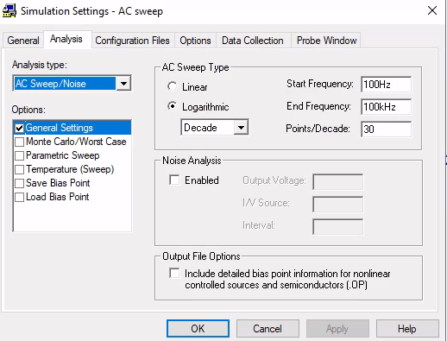

Running the simulation with just plotting the two net alias is only giving a changing value for v2 while bs is always at 1v.

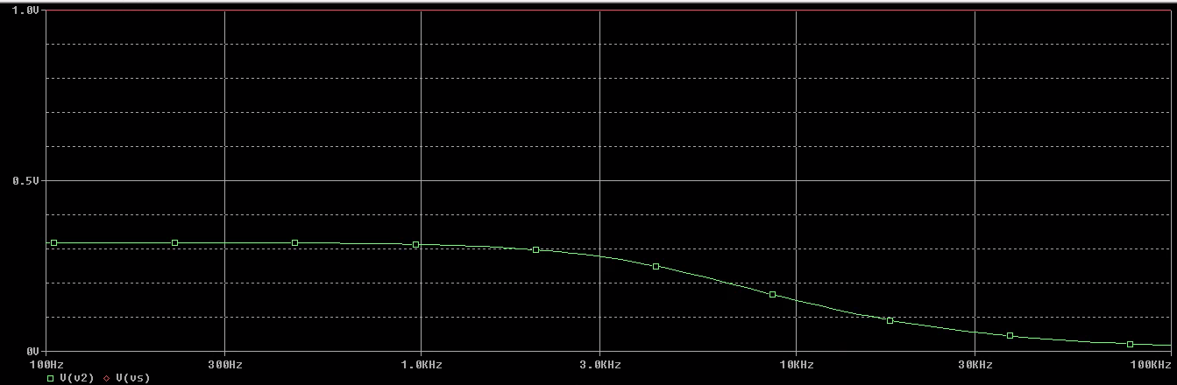

With D(V2), the voltage started at 6, and headed for a incline of 0 over the 100khz

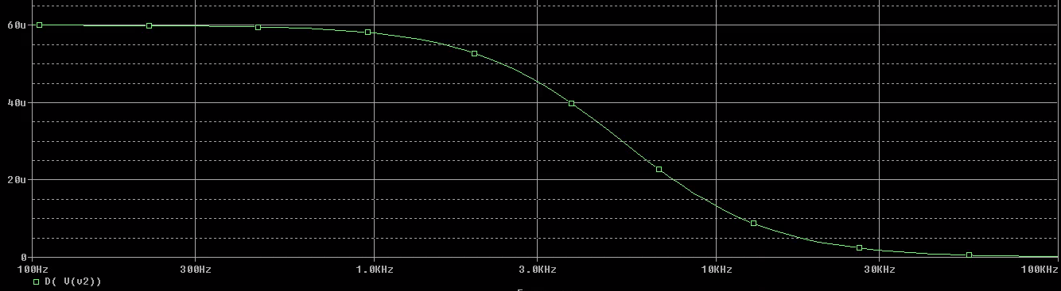

Vdb(v2) and Vp(v2), both are showing difference in changes to itself over time. Vp(v2) incline slower compared to db(v2). Both of them started at different voltages, but still going to zero at the end.

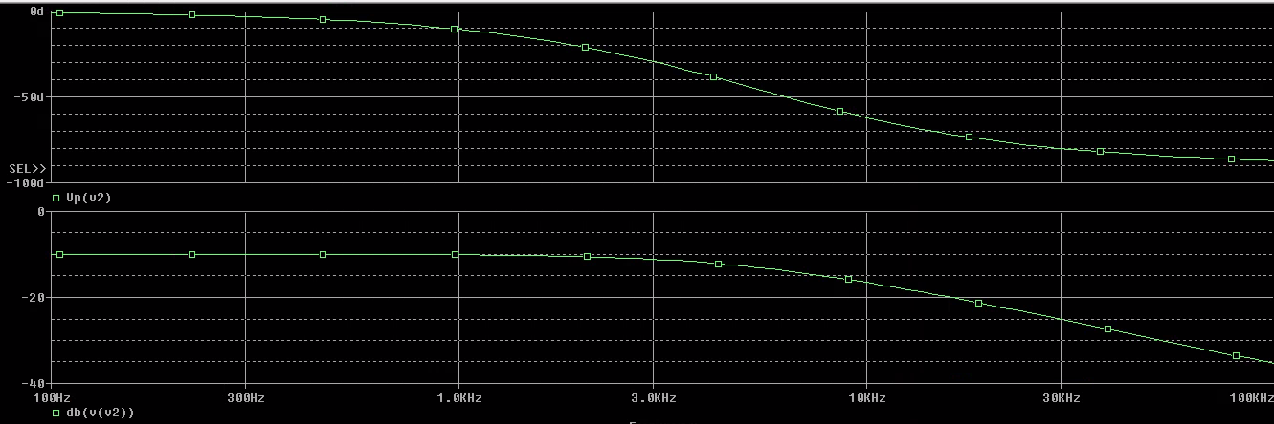

Part 4: Transient simulation

For this part of the lab, we were learning how transient works. Transient is used to obtain circuit voltages and currents as functions of times. We made the same circuit with just different power supply of Vpulse.

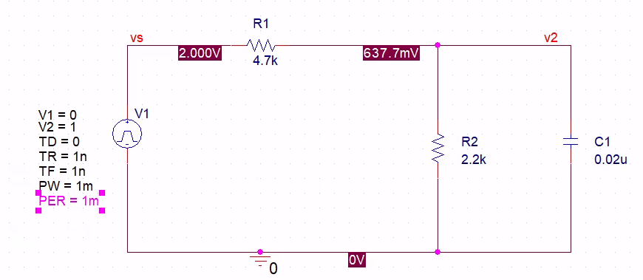

We made a new simulation for transients, running it at 1m per second.

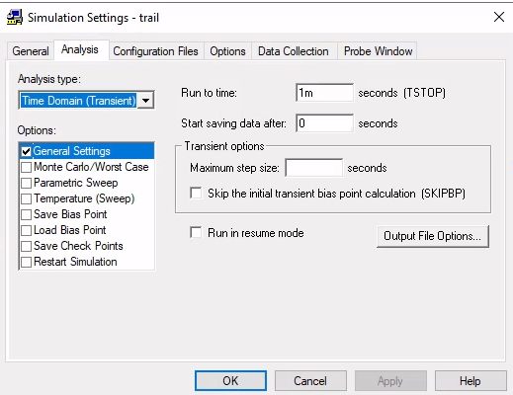

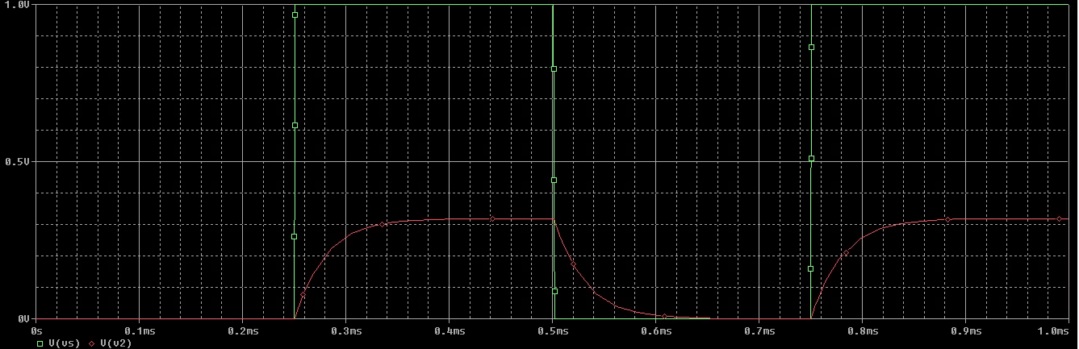

The above simulation shows vs and v2 as its being plotted into the chart. While the bottom chart shows the difference between the two.

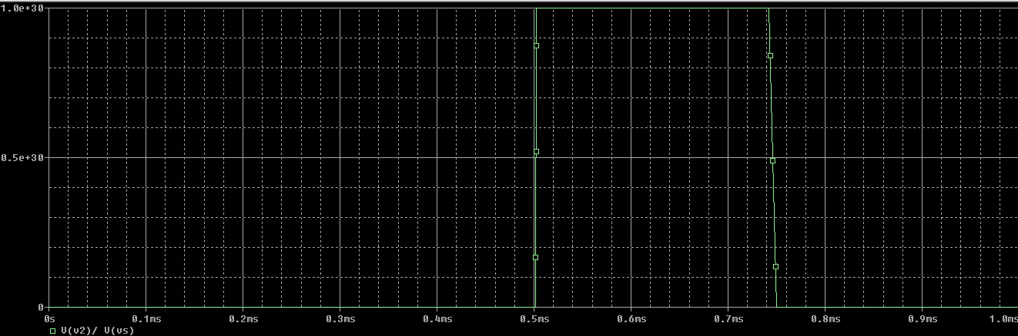

Conclusion:

In conclusion, there was man thing to learn about the SPICE, some are a bit more complicated then same but overall, it is not that bad. There only thing that could be troubling is sometime the net alias or the parts aren’t actually connected even though they look like that are, with a quick fix of just redoing it again it was more do able. Learning how to do the transient simulation was quite more interesting as there was more going on in the graphs. With the simulation being able to show you data that might be harder to find otherwise.