A Comparative Study of Project Management Web Application Built on
ASP.NET Core and Laravel MVC Frameworks

By
Alon Poudel

A Starred Paper
Submitted to the Graduate faculty of
St. Cloud State University
In Partial Fulfillment of the Requirements
For the Degree of Master of Science
In Computer Science

October 2018
Starred Paper Committee:
Dr. Bryant A. Julstrom
Dr. Jie H. Meichsner
Mr. Channa J. Kumarage

Abstract
With rapid advancement in the field of computer science, the way we use and interact with web applications have changed immensely. Developers must create web applications for browsers, cell phones, and search engines. That is accessible and easy to use in various devices. Therefore, the efficiency of software development is very important. Software design pattern plays a significant role to give that advantage to the developers. Software Design Pattern is an essential part of software development which is intended to solve real-world problems by creating templates of best practices. Design patterns bring in clarity, cost effectiveness and better communication in the software development cycle. It also helps with the development speed, support features, usage, and expenses. Documentation and maintenance aspect of an established web application frameworks are other attractions for developers.
The research is in Model-View-Controller (MVC) software design pattern to understand the technology, architecture, behavior, and environment. The study is a detailed analysis and comparison between ASP.NET Core and Laravel PHP web application development frameworks. MVC facilitates reuse of codes and separation of application layers. The Developer explains the development experience of Project Management Web application on .NET Core and Laravel. The web applications include a document library, a note page, and a discussion forum. It uses compatible programming languages such as HTML, JavaScript, and CSS to fulfill the web application requirements. Comparative analysis has been done based on the Developer’s experience and performance monitoring tools.

1. Introduction
(Include summary of Developer’s experience from the proposal, summary from the discussion)
Software design patterns are reusable solutions to software design problems that are recurrent in the application development world [1]. They are templates of formalized best practices in designing a real-world application or system.
Developing software applications is complex and costly. Programmers need to focus on the behavior and environment of each platform, technology, and architecture. Software Design Patterns brings that into the software development cycle. It helps identify potential problems before the implementation stage and reduces code complexity and code clutter.
There are various web application frameworks following numerous software design patterns. Among them, the Developer surveys the Model-View-Controller (MVC) pattern. The Developer presents analysis, design, and implementation of software applications based on MVC. A major focus is on the proper use of MVC software architectural pattern in ASP.NET Core and Laravel web development frameworks. MVC offers the possibility of code reuse and provides strict separation of concerns between the application layers. MVC is divided into three border sections: Model, View, and Controller. MVC gives more control to the developers and helps to build lightweight web applications.
1.1 ASP.NET Core Framework
ASP.NET is a scripting tool developed by Microsoft for developing web applications and web pages. Moreover, ASP.NET Core MVC is a web application development framework that integrates MVC architecture and .NET platform. The framework provides the users with a clean client-side code that downloads and renders quickly in the browser. It gives stability and flexibility of rapid application development [4]. .NET Core is better for a new application that could be part of a cloud workload.
1.2. Laravel Framework
PHP is a scripting tool that stands for Hypertext Preprocessor. PHP is free and strives to simplify web development. Laravel is a clear, simple, elegant and well-documented framework [13]. Laravel relies on industry standard conventions to reduce code. PHP framework is useful when there is an issue of time limitation, security and the complexity of the web application envisioned. Laravel has front-end, business logic, Eloquent and a database. Front page uses Blade template, jQuery, and Bootstrap for an interactive and dynamic page.
  - Problem Statement
There are many web application frameworks in the market. It is essential for developers to know about the most suitable framework for the development speed, support features, usage, and expenses. Therefore, a good understanding of the framework is vital for web developers. The focus of the research is to understand the MVC software design pattern and compare web application framework based on ASP.NET Core and Laravel.
  - Proposed Solution
ASP.NET Core and Laravel frameworks are open source and have a vast community. These are among the most popular framework. Laravel and .NET Core web applications are great for project management site consisting of a document library, a note, and a discussion forum. From this study, we will determine the advantages and challenges of using each framework.

2. Literature Review
(Write the requirements at the end)
Design patterns are reusable solutions to software design problems that are recurrent in the application development world [1]. Design pattern reuses successful software architectures and provides design alternatives to make a system reusable. Moreover, it helps with the documentation and maintenance of existing systems [9].
Developing generic software applications built on the dynamic web is complex and costly because programmers need to understand specific platforms, technologies, and architecture. MVC offers the possibility of code reuse and provides a strict separation between the application layers. Platforms, technologies, and dynamic web architecture produce significant cost on a technical level. Programmers are required to produce high-quality dynamic web applications within a short period [5].
2.1 ASP.NET Core Framework
.NET Core is better for a new application that could be part of cloud workload. It is not recommended to use it for existing workloads as it lacks some common .NET features [1]. ASP.NET Core MVC is a web application development framework from Microsoft that integrates MVC architecture. MVC is divided into three border sections: Model, View, and Controller. The View is used for the user interface and user experience. The model delivers data to the View. The Controller takes the user's request and loads the appropriate Model and View. First, the controller gets the input, and then it goes to the View. There could be many views but only one controller. This single controller selects views to be rendered. The View is unaware of the controller or a reference to the controller. However, View and Model are aware of each other as the controller passes back to the Model and not the controller serving it up. As a result, it helps manage the difficulty of large-scale projects by working on individual components [4].
2.2 Laravel Framework
Laravel has expressive and elegant syntax that provides a solution for development by facilitating general task in big web projects [7]. Laravel is a clear, simple, elegant and well-documented framework that focuses on equipping and enabling developers. It helps developers learn, start and develop quickly [13]. Laravel relies on industry standard conventions to reduce code. The documentation gets updated before the release of a new version to provide the latest information to the users.
2.3 System Requirements
Basis of Comparison | ASP.NET MVC .NET Core 2 (Dev) | Laravel 5.5 (Dev) | Laravel 5.5 (Deploy)
Environment | Windows 10 | Windows 10 | Ubuntu 1700
Object Relational Mapper (ORM) | Entity Framework | Eloquent | Eloquent
Template Engine | Razor | Blade | Blade
License | MIT License | MIT License | MIT License
Support and Security | Developed and maintained by Microsoft and the .NET community on Github | Developed and maintained by Taylor Otwell and the Laravel community on Github | Developed and maintained by Taylor Otwell and the Laravel community on Github
User Interface / User Experience Design | AdminLTE 2 – Open source admin dashboard & control panel theme | AdminLTE 2 – Open source admin dashboard & control panel theme | AdminLTE 2 – Open source admin dashboard & control panel theme
Programming Language | C# | PHP | PHP
Integrated Development Environment (IDE) | Visual Studio 2017 Community | Sublime Text 3 | Sublime Text 3
Database Server | Microsoft SQL Server 2014 | MySQL | MySQL
Community | Great Community | Growing Community | Growing Community

3. Design
(Include Analysis and MVC diagram and the diagram of the project management web application)
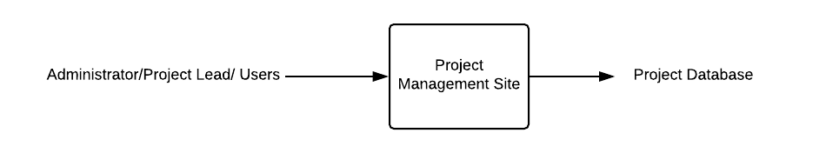
Figure 1: Project Management Site
Figure 1 shows the implementation of Project Management web application based on .Net Core and Laravel frameworks. Administrator/Project Lead/Users logs into the system to use various features in the Project Management Site according to their permission level.
HOW IS THIS WORKING?

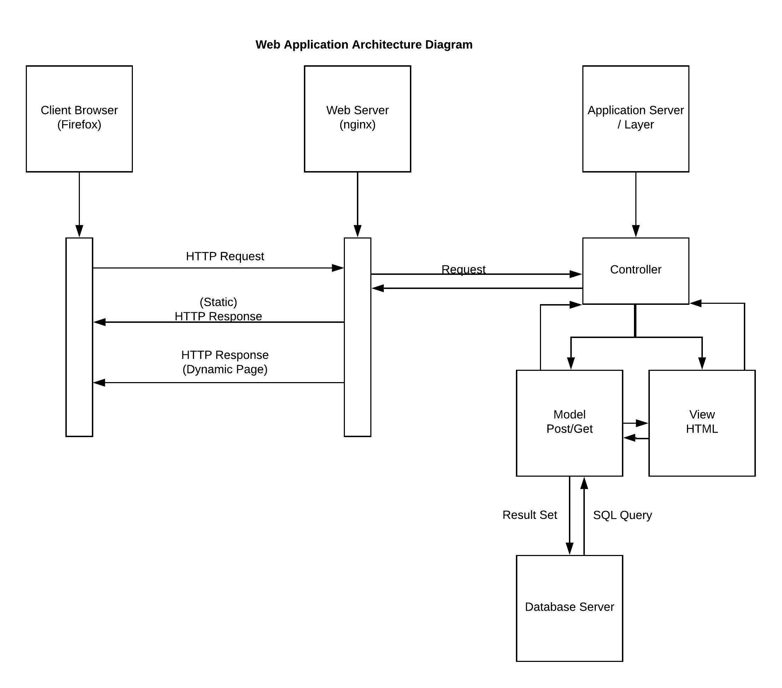
The client browser sends an HTTP (GET/POST) request to the web server. The web server accepts the HTTP request and forwards the request to the controller of the application. The controller determines whether it needs to interact with the model or not. If interaction with model or database is not needed, it returns a view, composed of HTML markup code as HTTP response, known as static page. If the controller determines that the interaction with model is needed, it interacts with the model, which interacts with the database server using the SQL queries generated under the controller. The result set is generated by the database server which is interpreted by the controller and the controller responds with a dynamic page.

3.1 Design of Project Management web application in Laravel and .NET Core Framework
The Developer has developed a web application based on ASP.NET Core 2 and Laravel 5.5. The web application with the Insert, Update and Delete functionalities. The performance evaluation of web applications will include Page Load Time and the evaluation is performed using various benchmark and system performance tools.
Microsoft Windows 10 operating system is required to develop web application based on ASP.NET Core 2.0. The Relational Database Management System (RDBMS) for the web application will be Microsoft SQL Server 2014. The web server is inbuilt for ASP.NET Core 2.0. Visual Studio Community 2017 will be the Integrated Desktop Environment (IDE) or development tool to build this web application.
Laravel 5, based on PHP programming language, is hosted on Ubuntu 17.10. PHP is the programming language for the development of web application on Laravel. Moreover, MySQL is the database system. The web server is Nginx, and Sublime Text 3 is the IDE used for the development.
4. Implementation
(What I implemented, include picture of the dashboard)

4.1 Implementation of .NET Core
Before starting the development of Project Management System in ASP.NET Core 2.0 MVC web development framework, the developer had to setup the development environment as well as plan the development of the application.
The setup for the development involved installation of Visual Studio 2017 Community which included required packages to develop the web application, installation of Microsoft SQL Server 2014 and installation of .NET core 2.0 in the development machine.
After thoroughly planning out all the features before starting the coding, a new .NET Core ASP.NET MVC web application project was created using the Visual Studio 2017 Community edition IDE (Integrated Development Environment).
The project was created utilizing the in-built authentication feature called ASP.NET Single Identity at first but due to its lack of flexibility in the development process, the developer had to remove the feature and build own custom authentication module in the application. The custom authentication module involved creating of login controller where the user logins were validated, login sessions were created in the web browser if found valid, and logging out of sessions to logout from the application.
The user interface framework “AdminLTE 2”, as used in the Laravel application, was used to look both the applications as identical as possible. After the user interface was integrated into the application, required changes were made to the application. The required changes, such as changes in the login page, the dashboard, removal of unwanted files, integration of different JavaScript and CSS plugins like DataTables, and Jquery-Comments.
The developer went on to further develop the application but encountered various problems while working on different modules in the application. The design of the application showed few problems such as several plugins were not functioning properly, Jquery functions were not working properly, the user interface had design flaws, so the developer had to make debug and troubleshoot these problems to make it work as expected.
To avoid the repetition of code, a generic repo and methods were added by the developer to the application.
To help the code to be more organized and manageable certain standard had to be followed, so a standard was setup to be used all over the available modules. The standard involved creating four different projects under the same solution in Visual Studio. The four projects were the main project, interfaces, models and repositories separated based on their functionalities. The main project included the main web application contents and integrated the other three projects together. The interfaces project is a class library which consists of all the interfaces needed by controllers to interact with the repositories. As the name suggests, the interfaces project includes all the interfaces which are implemented in the repositories project. The repositories project is a class library which consists of implementations of the interfaces in the interfaces class library project. The models project consists of all the models required for the project. The separation of the entire application on the basis of their functionalities helps to debug and troubleshoot the application.
4.2 Implementation of Laravel Framework
After setting up the development environment, Laravel 5.5 was downloaded, installed and configured on the development machine.
Before starting the development of Project Management System in Laravel 5.5 PHP web development framework, the developer had to setup the development environment as well as plan the development of the application.
The setup for the development involved installation of XAMPP 7.0.27 which included PHP 7.0.27, Apache HTTP server 2.4 and MySQL database server, installation of composer and Node.js in the development machine.
After thoroughly planning out all the features before starting the coding, Laravel 5.5 was downloaded and installed on the development machine using Composer.
The installation involved configuring the application by adding a .env file which consisted the basic configuration options for the application.
Since Laravel is installed with Composer, a package dependency resolver for Laravel, it is easy to add few features needed for the rapid application development.
Composer was used to add authentication service to the application which allowed the developer to add basic authentication and a head start to build the application.
Migration service is inbuilt in Laravel, so it was enabled in the application to make it easy to migrate the application from development machine to the production machine.
An HTACCESS file along with the routing rules was added to take care of routing problem that occurred during the first phase of development of the application.
After all these, coding of the application started which involved adding new controllers, models, views, resources to the Laravel framework as per the prior planning of the application.
A third-party debugger called “Debugbar” was added to make it easy for the developer to debug the application and speed the development process of the application.
An open-source user interface template called “AdminLTE alpha” was added using npm, a default package manager for the JavaScript runtime environment Node.js.
The developer went on further to develop the application but encountered various problems working with the newly integrated interface, so the developer had to remove the npm dependency on the AdminLTE alpha user interface framework. A stable version of AdminLTE was added by the developer without the npm dependency.
The developer made changes in the composer.json file to resolve the required dependencies before issuing the Composer update command to resolve the dependencies.
The developer encountered several other issues while working on the project such as redirection problem while logging out of the application, error in the sidebar of the interface, problem in the migration of permission module, problem in using Spatie as an authentication provider, etc.
The developer had to rollback major changes to troubleshoot some of the problems and finally got the application to be stable and run smoothly. WHAT ABOUT THE LARAVEL DEPLOYMENT?
For Laravel Deployment on Ubuntu:
The IP address of the Linux server on Virtual Box may vary depending on the network the computer is connected to. Use the Wireless Network Watcher to scan the available machines in the connected network. Look for device name "alon-VirtualBox" in the list of available machines, note the IP address of the server. The URL for the Laravel application should be
http://IP_ADDRESS:8080
4.3 Project Management web applications in .NET Core on Windows, Laravel on Windows, and Laravel on Ubuntu
Dashboard
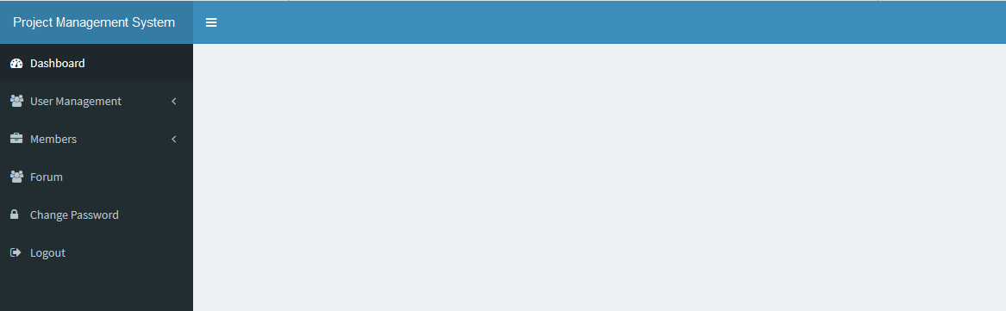
Figure 9: Dashboard page of the Project Management System
Sign Up Page
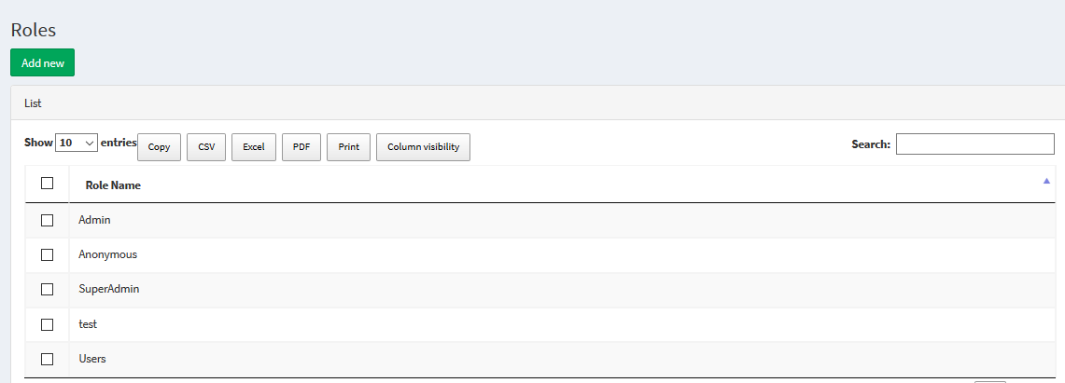
Figure 10: Sign Up page of the Project Management System
Login Page
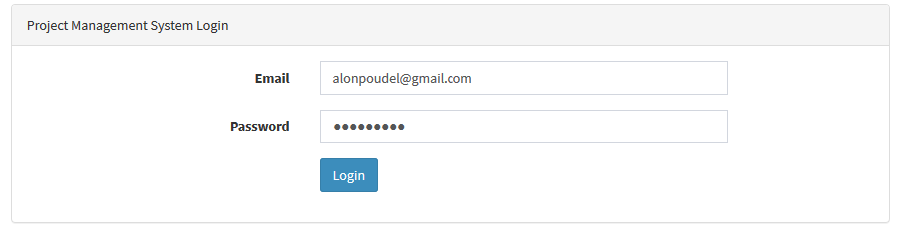
Figure 11: Login page of the Project Management System

Roles
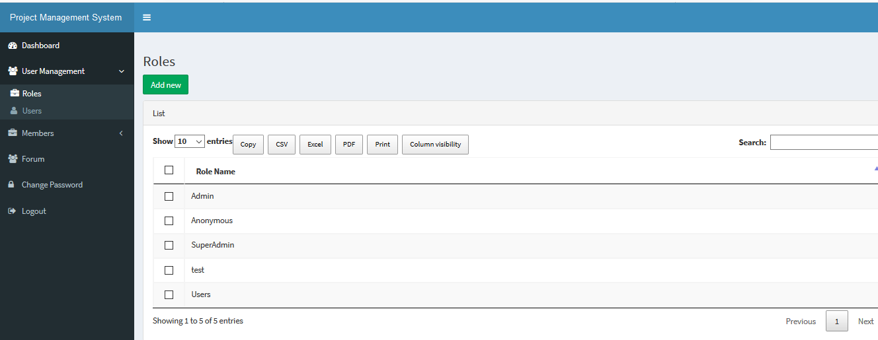
Figure 12: Role management page of the Project Management System
Document Library Page
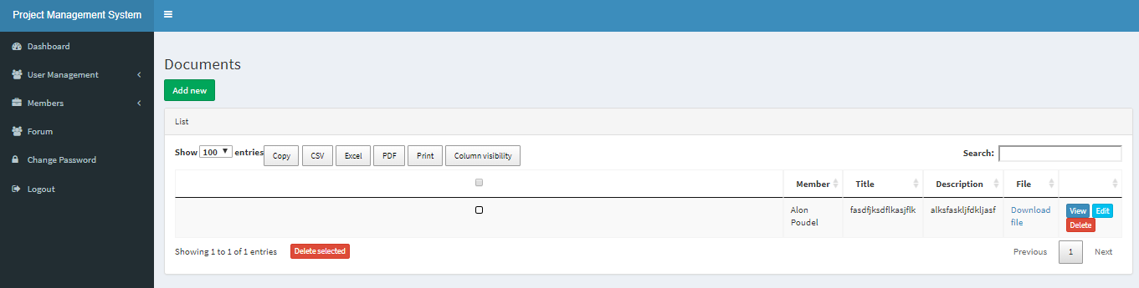
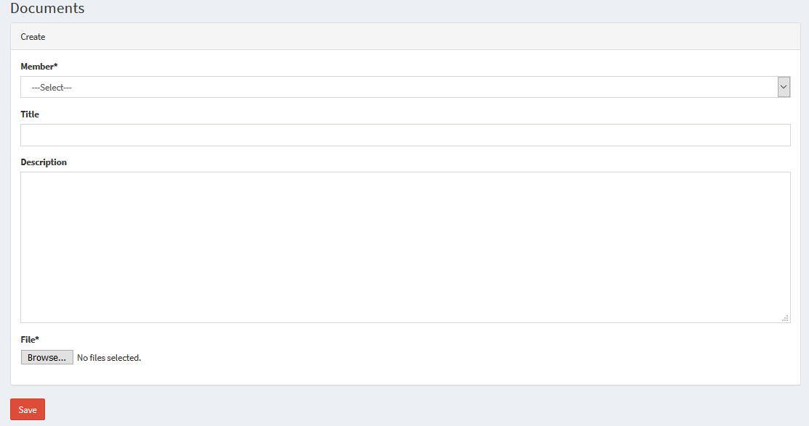

Figure 13: Document Library page of the Project Management System
Discussion Forum Page
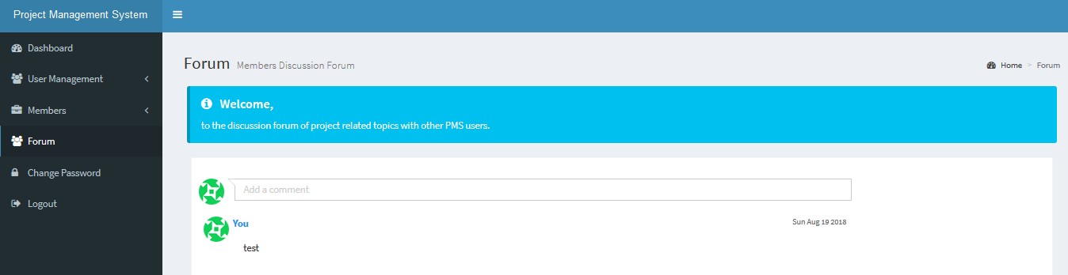
Figure 14: Discussion forum page of the Project Management System

5. Results and Discussions
Results (no opinion) and Discussion (evaluation and user experience). Include Before and After as a developer and how it benefits me as a developer from SDLC perspective. Comparative analysis between Laravel in Ubuntu, Laravel in Windows and .NET Core in Windows.

5.1 Results
Sample size of 400 was taken to show the comparative graphs below. There are 4 pages considered for the test, with each page tested 100 times.
Figure : Page Latency of Project Management Web Applications (.NET Core on Windows, and Laravel on Windows and Ubuntu)
Latency is the minimum delay required for the data browsing the network between the web server and the web user’s browser and vice versa.
The figure above presents the page latency experienced by the 4 pages, 100 times on each page, in each Project Management web application developed in Laravel and .NET core on Windows and Ubuntu. Red graph is the latency in Laravel on Windows, Black graph is the latency in Laravel on Ubuntu and the Blue graph is the latency in Windows.
Figure : Average Latency of Project Management Web Applications (.NET Core on Windows, and Laravel on Windows and Ubuntu)
The picture above represents the average page latency for each page on dot Net Core, Laravel on Ubuntu and Laravel on Windows respectively.
Figure : Average bytes received from the server of Project Management Web Applications (.NET Core on Windows, and Laravel on Windows and Ubuntu)
Bytes represents the quantity of data in the sample response returned from the server. The picture above represents the average bytes received from the server for each page on dot Net Core, Laravel on Ubuntu and Laravel on Windows respectively.

Figure : Average bytes sent to the server of Project Management Web Applications (.NET Core on Windows, and Laravel on Windows and Ubuntu)
Sent bytes represents the quantity of data in the sample sent the server. The picture above represents the average bytes sent to the server for each page on dot Net Core, Laravel on Ubuntu and Laravel on Windows respectively.
  - Discussion
Evaluation of Developer’s Pre and Post Proposal knowledge and experience:
Developer’s Proposal Experience on .NET Core Framework: The Developer downloaded and installed the 64-bit version of .NET Core Software Development Kit (SDK) required to start the development of the application, on a Microsoft Windows operating system. The web application built on .NET is a self-hosted application, so any other web server application like Internet Core Information Services (IIS) is not required. NuGet Packet manager is used in .NET to manage dependencies. For an Integrated Development Environment (IDE), the Developer chose Microsoft Visual Studio 2017 Community which is free and user-friendly. The web application is database driven, so it needed a Relational Database Management System (RDBMS) to store and manipulate the data required for the application. Therefore, it was decided to use Microsoft SQL server 2014 Express edition as the RDBMS.
Developer’s Proposal Experience on Laravel Framework: The Laravel 5.5 requires PHP version higher than 7.0.0. To set up the development environment for the web application, the Developer downloaded and installed XAMPP for Windows 7.0.27 on the development machine since it comes bundled up with Apache 2 (web servers), MySQL (an RDBMS software), and PHP. Before installation and configuration of Laravel 5.5, Composer was installed, which is a dependency manager for PHP. The installation of XAMPP on the development machine meets almost all the development requirements, so the Developer decided to choose XAMPP as one of the development environments for the application. The Developer installed Sublime Text 3 as it needed a good, lightweight and easy to use IDE to develop the application.
Developer’s post implementation experience of User Interface and Experience: Command Line Interface (CLI) was the most effective way to control computers in the past. With the rapid development in the field of Computer Science, interaction with the applications has changed immensely. Graphical User Interface (GUI) has made it much easier for users to control the applications. In the context of web applications, scripting and markup languages like Hypertext Markup Language (HTML), Cascading Style Sheets (CSS), JavaScript has been used excessively making it easier to build a robust user interface and experience. UI refers to the way the user interacts with a device using a series of input controls and navigational components like buttons, text fields, icons, checkboxes, etc. and UX refers to the internal experience the user has while interacting with the various aspects of the web application. In a web application, UI elements such as input controls, navigational components, and informational components play a vital role to provide easy access and proper understanding of the application. It also facilitates the user to get what they expect from the application. The user might use the web application from a browser, cell phone, search engines, etc. It should be readily accessible and easy to use. However, it is essential to know about the limitations. In a nutshell, UI and UX play a vital role in the success or failure of the web application. User Interface / User Experience Design: The developer has used Admin LTE 2, an open source admin dashboard & control panel theme, as the user interface for both the applications developed in ASP.NET Core MVC and Laravel 5.5. Template Engine: Razor is a view or template engine for ASP.NET Core MVC. The developer found Razor view engine as a user friendly and easy to learn view engine, which nicely integrates C# with HTML. The code looks much cleaner using this view engine. Blade is a simple, yet powerful view or template engine for Laravel web development framework. The developer found it to be a handy tool to integrate PHP code into the views of the application. It has its own markup code and easy to learn. But, in comparison to Razor, the developer found Blade to be less user friendly, more difficult to learn and less clean. The Razor is well integrated into the Visual Studio and maintaining a clean look of the Razor markup code is very easy. The Visual Studio auto indent the code to make it look clean and tidy. The Visual Studio also allows auto completion of the code which is not possible in Sublime Text 3. Blade is not integrated into Sublime Text 3. The developer has to indent the markup code by himself to make it look clean.
Developer’s post implementation experience of Security: Security of web applications has become an essential requirement for the development of these web applications. With the rapid increase in the development of various software and applications, security is becoming a subject of grave concern. For instance, let’s assume that the data travel from a point to another point on the Internet. The data may need to move through various points in between, from the source to destination. It makes the data vulnerable to data breach and interception or data alteration by unauthorized or malicious users. These vulnerabilities can create a severe threat to the information security. Therefore, the framework should enforce various security measures to ensure that the web application is secure. There should also be a limitation on the features of the web application for better security. Going beyond its capability will bring in various problems like hacking, network congestion, attacks, etc. Support and Security: Since the .NET Core is developed and maintained by Microsoft Inc. and the .NET community on Github, the support and security vulnerabilities are addressed by Microsoft and .NET community on Github. If the .NET Core has any security vulnerabilities or any software related issues, it is more likely to get them fixed immediately, since it has been supported by Microsoft and the .NET community on Github. Unlike .NET Core, if any security vulnerabilities are discovered in Laravel, the issues are addressed by its developer Taylor Otwell. Large organizations are more likely to choose .NET Core over Laravel as their web application development framework, since Microsoft is a trusted name and can provide enterprise level support to the .NET Core framework.
Developer’s post implementation experience of Application Performance: Web application performance is the measurement of quality and efficiency at which the web application performs. The application performance indicator can help the developers to make the web application more robust and minimize the response time of the web application. The performance of the web application depends on various aspects such as bandwidth capacity, the number of user requests on the network, different application protocols, the application hosting environment and the programming tools and languages used to develop the application. For proper application performance, the pages should render efficiently with less browser connection and content. The web application and portals need to be fast and flexible. A webpage taking a lot of load time will not be useful. Users will move on to the next website if it takes a long time and shows problems in rendering content smoothly. Moreover, it should focus on easily scalable web application framework.
Developer’s post implementation experience of Technology: Web application development comprises of two categories: client-side programming and server-side programming. Client-side programming, also known as front-end programming, includes everything that a user sees on a web browser. Whereas server-side programming, also known as back-end programming, deals with the logic and functioning of web applications. Before choosing a technology to develop a web application, a developer needs to have proper insight into the process of web application development. As there are plenty of tools and technology to choose from, the developer must take different aspects such as performance, user interface, scalability, software design pattern, web frameworks, application protocols, servers, database, and storage into account before opting for the right technology for the development of web application. Hence, choosing the right technology to address these aspects is very essential. The developer needs to understand different types of protocols, mark up and scripting languages such as HTTP, JavaScript, cascading style sheets, and other resources used by the application, their impact on performance concerning a specific web application framework. Also, it is only logical to avoid creating something that is already there and improved upon rigorously. Choosing a framework that a development team is comfortable with is a significant advantage. Object Relational Mapper (ORM): The Object Relational Mapper (ORM) is a tool or technique that allows conversion of data between incompatible type systems using an object-oriented paradigm. The .NET Core uses Entity Framework as an ORM. The Entity Framework (Core) is not available in ASP.NET MVC project (if a blank project is selected) but can be installed through the nuget package manager. Laravel 5.5 uses Eloquent as an ORM and can be found in-built within the framework. Although .NET framework supports Entity Framework integrated with EDMX database model, which allows to import database and its components directly from the database server with a nice interface, it is yet to be found in .NET core. The developer had to write the code for the database context, database set, transient service, and models, which would have been easier and faster if the EDMX database model was available for .NET Core. In the context of Laravel, Eloquent handles most of the database connection and database components easily that the developer only had to write the model for the database to interact the application with the database server. Programming Language: The web application developed using ASP.NET Core MVC utilizes C# as the programming language. The web application developed using Laravel 5.5 utilizes PHP as the programming language. Both programming languages are general-purpose programming languages and have their own advantages and disadvantages. However, the developer has found PHP to be easier to learn and get mastery over than C#. On the contrary, C# is more preferred to develop enterprise applications than PHP. Database Server: The ASP.NET Core MVC based web application uses Microsoft SQL Server 2014 as the database management system (DBMS) server and the Laravel based web application uses MySQL as the DBMS server. The MSSQL Server has SQL Management Studio as the graphical interface to manage the database whereas PHPMyAdmin has been used as the graphical interface for MySQL database server. The developer preferred MSSQL over MySQL based on their functionalities, performance, features and integration
Developer’s post implementation experience of License: Open source software can be used, modified or shared for free. However, the developer needs to learn about the terms and conditions of respective open source licenses before making use of these free application frameworks to avoid any legal consequences. Quality, security, flexibility, customizability, support options, interoperability, and security open-source software, is attractive compared to propriety software solutions. Moreover, open source software can be used, modified or shared for free. There are plenty of open-source web application development frameworks available. ASP.NET Core 2.0 and Laravel MVC frameworks are a couple of examples for such open-source web application development frameworks. Even though these application frameworks are free to use, the developer needs to learn about the terms and conditions of respective open source licenses before making use of these free application frameworks to avoid any legal consequences. Hence, it is significant to research on licenses of the web application frameworks and its add-ons, plug-ins, and extensions. License: .NET Core is the open-source version of popular .NET framework developed by Microsoft from scratch. Both .NET Core and Laravel are licensed under the MIT License. The license allows any developer to use the frameworks for commercial purpose, modify them as per their need, distribute them, or any private usage.
Developer’s post implementation experience of Unit Testing: The unit testing is done to increase the quality, reusability, efficiency, and software bug fixes in the code. The term unit testing refers to a practice in software development cycle where each component of the software is tested for any bugs or defects. The primary purpose of unit testing is to ensure that each unit or function or area of the software performs as expected. The unit testing is done to increase the quality, reusability, efficiency, and software bug fixes in the code. A well-tested web application that behaves and performs as expected will only enhance overall user satisfaction as well as it will increase the chance of new features working correctly without any unexpected output. There are more benefits to unit testing than these. It is a great help to have the capacity of unit testing of the application.
Developer’s post implementation experience of Developer’s Learning Curve and Experience: It is essential to choose the smallest learning curve. This saves time and focuses on productivity. Therefore, the Developer will share his experience and effort in the completion of this project. Integrated Development Environment (IDE): The developer has used Visual Studio 2017 Community as an IDE for the development of web application using ASP.NET Core MVC. The developer has used Sublime Text 3 for the development of web application using Laravel 5.5. The developer has found Visual Studio 2017 Community to be more advanced, more useful, helpful and user-friendly tool when it comes to developing .NET core applications. However, it takes more time to install and takes more disk space on the development machine unlike Sublime Text 3, the IDE used for development of Laravel based web application, which is light weight, fast and takes less disk space on the development machine.
Developer’s post implementation experience of The Community: Active community support is the lifeline of any design pattern. Diverse and highly motivated members are the signs of a great community. Therefore, choosing a framework with a friendly community ensures the web application’s longevity. Proper documentation on the web application framework is essential for the web application’s growth and stability. The web application framework backed by the active community will ensure regular updates, application robustness, and high performance. Community: Both .NET Core and Laravel have good community presence, however, .NET Core has greater community in comparison to Laravel. The developer has found that .NET Core has greater community on Github than Laravel, but Laravel’s community is also growing faster.

APPENDIX

Appendix 1:
Steps on creating Project Management web application in Laravel: Following is the step that the developer followed to create the Project Management web application in Laravel.
Create a new project
composer create-project --prefer-dist laravel/laravel {project name}
Configuration
A random key need to be generated before using the newly created project on Laravel. Check if the key is set in the .env file. If not, the key can be generated and installed into the application by issuing the following command:
php artisan key:generate
.env file is configured, including the database configuration.
App.php file is configured to include project name, application environment, debugging mode.
Create a new controller
We create a new controller by issuing the following command:
php artisan make:controller {controller name}
Or we can use the following command to generate code for CRUD(Create-Read-Update-Delete) functionalities:
php artisan make:controller {controller name} -r
Creating a Route
We need to create a route rule to access the controller. The following lines of code will route the request to the controller.
Route:get(‘pathName’, ‘controllerName@methodName’);
Creating a View
We create a view page ‘viewName.blade.php’ under views in resources/views folder in Laravel. The view page consists of HTML codes along with blade view engine syntax.
Database and Migrations
Since our application is database driven, we need database to store and interact with the database. Since we’re using mysql as our database system, we need to configure Laravel to use mysql. We can setup and configure Laravel by making changes to .env file as follows:
DB_CONNECTION=mysql
DB_HOST=127.0.0.1
DB_PORT=3306
DB_DATABASE={database name}
DB_USERNAME={database username}
DB_PASSWORD={database password}
After configuring the database, we can create a new migration table using the following command:
php artisan make:migration migrationName –table={table name}
We can execute the newly created migration tables using the following command:
php artisan migrate
Install Authentication
Laravel comes with basic user authentication and we can enable that authentication by issuing the following command:
php artisan make:auth
For Debugging Purpose
Using debugbar, a third-party plugin for debugging purpose, in Laravel. To install debug-bar, we used the following command:
composer require barryvdh/laravel-debugbar –dev
To reload the composer settings after the installation, we used the following command:
composer dump-autoload
npm install
npm run dev
npm install admin-lte --save
npm run watch
npm install font-awesome
php artisan make:model modelName -m
php artisan route:list
composer require barryvdh/laravel-debugbar --dev
php artisan db:seed
php artisan serve --port 9000
composer update
composer install
composer dump-autoload
php artisan migrate:fresh –seed

Appendix 2:

Project Management File structure in Laravel
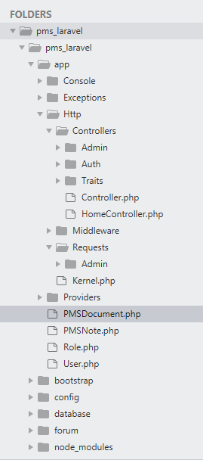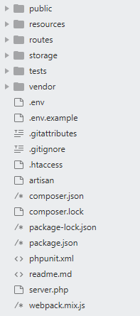
Figure 8: File structure of the Project Management System in Sublime text editor
Page Description of Project Management application in Laravel Framework
Description of important pages in the Project Management System web application in Laravel framework are listed below:
PMSDocumentController.php: The PMSDocumentController is responsible for adding the document to the Project Management System (PMS) by the user where the document is shared with other users to view and download. The document may be a PDF, or Text file and it can be only edited and deleted by the user or owner of the document.
PMSForumController.php: The PMSForumController is responsible for providing common platform for all the users or members in the PMS to discuss on a common topic.
PMSNoteController.php: The PMSNote is responsible for adding notes so that the user can add his/her note and share the note among all the members in the PMS.
RolesController.php: The role controller is responsible to manage roles in the PMS. The role can be either a super user (administrator) or a normal user where the super user has full privileges to add, delete, edit and read unlike the normal user who has limited privileges throughout the PMS.
UsersController.php: The UsersController is responsible for managing the users in the PMS. It can be accessed only with administrator/super user privileges. It can be used to create new user, delete the existing user, update the information of the existing user or list out the available users in the PMS.
UploadFileTrait.php: This is a helper file in Laravel to help the application to upload the file into the application server. This is responsible to create a new folder if it doesn’t exist and upload the user uploaded file based on the file type. For instance, if the user uploaded file is an image file, it resizes the file size and uploads into the server. It is also responsible for managing the file permission so that it is accessible to the application users.
Controller.php: Controller is the base controller class which provides few convenience methods such as the middleware methods, which may be used to attach middleware to controller actions. Simply put, it is a basis for providing good functionalities to newly created controllers.
StorePMSDocumentsRequest.php (This applies to all the files under Requests/Admin folder)
StorePMSDocumentsRequest validates the form data obtained from the form submitted by the user. It validates the data based on the rules written in the file. It successfully executes the database operation if the validation is successful but denies the database operation if the given rules are not validated. For instance, if a form field requires numeric data to be filled but the user supplies special character then the application will issue a warning that the input data is not valid.
PMSDocument.php (Same for all the models): This file consists of PMSDocument class which inherits its functionalities from the Model class. PMSDocument consists of field names such as name, description, file, user_id which are used to interact with the corresponding field names in the database using the Eloquent ORM in Laravel. These field names are bound in the forms which in turn carry the data from the user and interact with the database.
App.php: This file is responsible for the basic configuration of the application. The properties of the application such as the application name, application environment, debugging settings, application URL, application providers, aliases, etc. reside here.
Database.php: It consists of database connection settings for the application. Such as name and type of the database to connect, user credentials of the database to connect, etc.
PMSDocumentFactory.php (Applies to all files under Factories): It is a feature that comes with Laravel which allows to create fake data for models. It is very useful to test the application and seed the database with the fake data in order to test the application in action before it is made available for real-time users to use.
Migration: Migration is a feature in Laravel that allows creation of tables in the database. For instance, during the deployment of the application, it won’t be necessary to create tables manually in the database, migration in Laravel will take care of creating those required tables into the database.
Seed: Seed allows to insert default data into the tables in the database. It populates tables with default data in the database after the tables are migrated.
Public folder: The public folder consists of web resources such as css, images, javascript files of the application.
Resources/Views: The views folder consists of files which handle the user interface or presentation part of the application. The controller calls the view method and renders the layout in these files.
.env: .env is the configuration file for Laravel which consists of important variable names and their corresponding values which are used by the application.
Appendix 3:
Sequence Diagram in Laravel

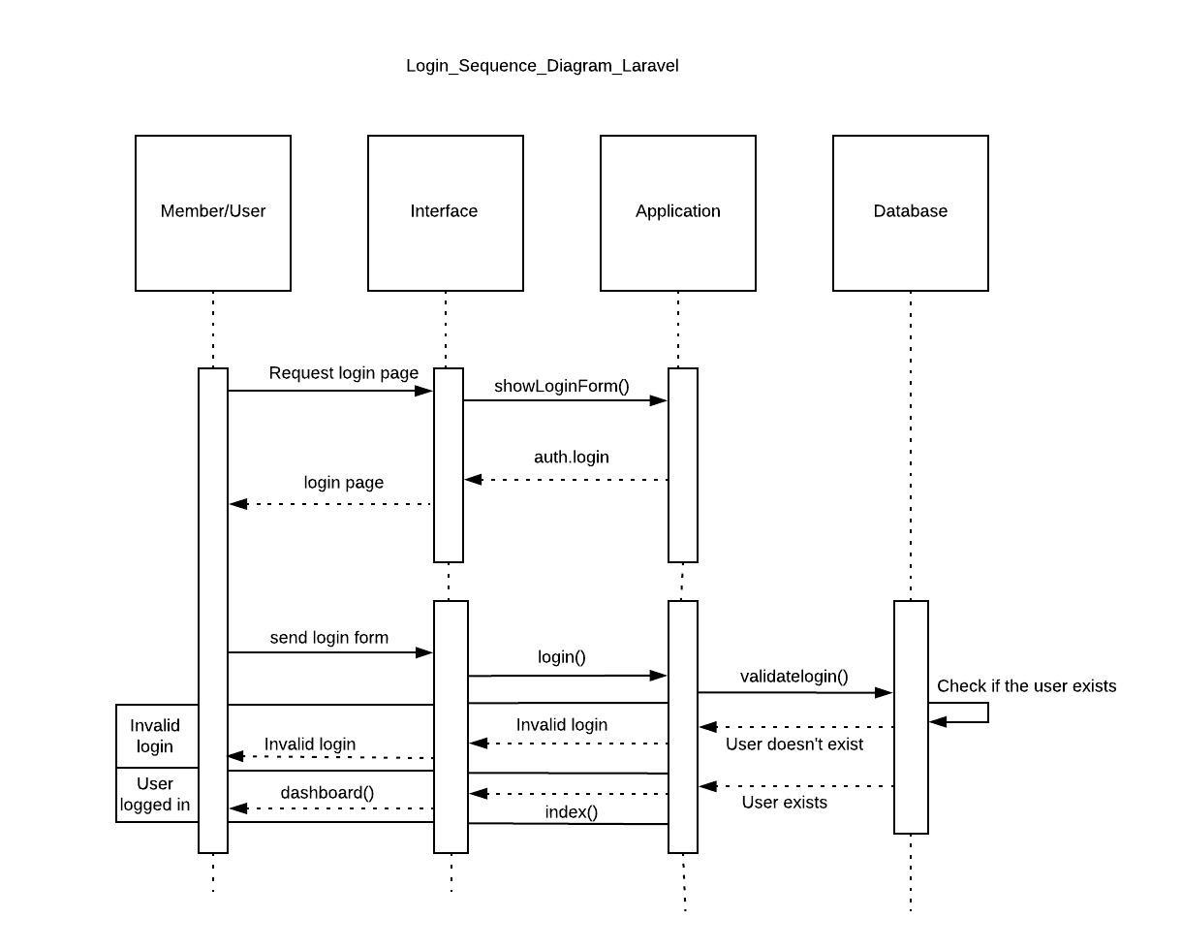
Figure : User login sequence diagram of the Project Management Web Applications in Laravel on Windows and Ubuntu.
The user sends a request to show a form to application via interface and the application accepts the request and responds with the login form. The user fills up the login details in the login form and submits the form. The application validates the user details, if the validation is successful, then the application redirects to the dashboard page. If the validation is unsuccessful, the application returns the login page with validation errors.

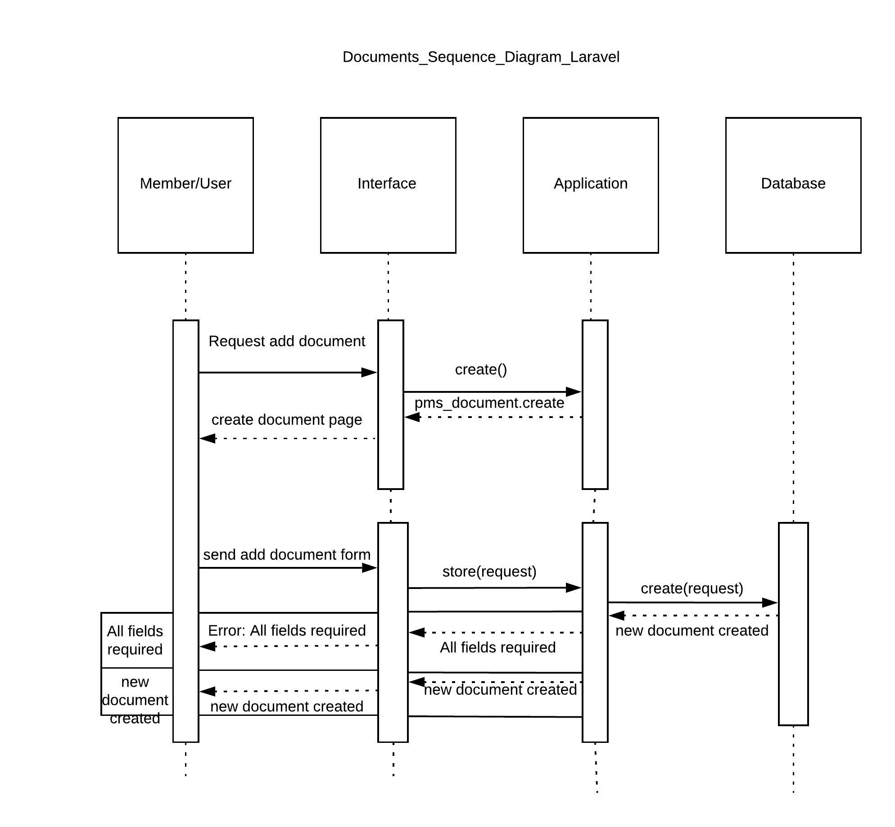
Figure : Add/update documents sequence diagram of the Project Management Web Applications in Laravel on Windows and Ubuntu.
When the user clicks on the 'Add Document' button on the web application, the web browser (interface) sends an HTTP GET request to the web server (application). The web server accepts the HTTP GET request and the create() function is triggered in the document controller. Then it returns a view page which consists of a new document form markup code. It sends a response to the web browser containing the view and the web browser displays the new document form. The user fills up the fields in the new document form and submits the form to create a new document. The web browser sends an HTTP POST request to the web server (Application), the web server accepts the request and the store() function validates the required fields received from the posted data. If the validation is successful, the request is forwarded to create() function where the database query is generated based on the create request to the database server. The data is inserted into the database and notification of successful creation of a new document is sent to the web browser as response. If the validation is unsuccessful, the function returns the view page with the message that the required fields are not filled.
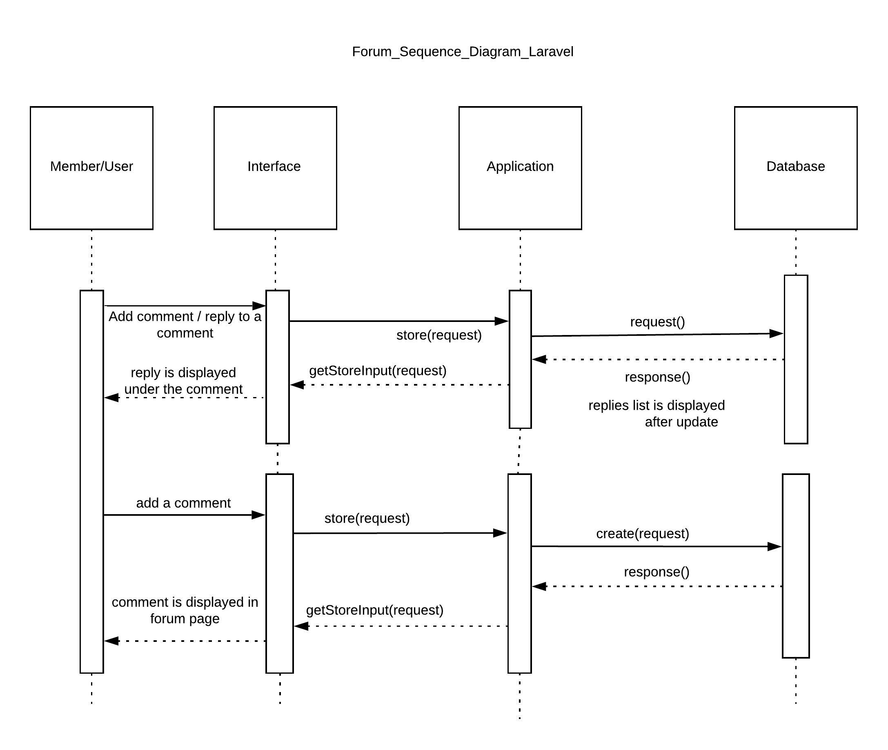
Figure : Discussion forum sequence diagram of the Project Management Web Applications in Laravel on Windows and Ubuntu.
The user sends a request to application to show a forum page via the interface and the forum page is displayed. The user adds a new comment on the comment form and submits the form, which is then sent to the application and the application send the request to the database where the new comment gets inserted. The forum page is displayed with the list of the available comments. The user can reply to the comment posted, which is sent to the application and finally inserted into the database. The new replies list is displayed after the update.
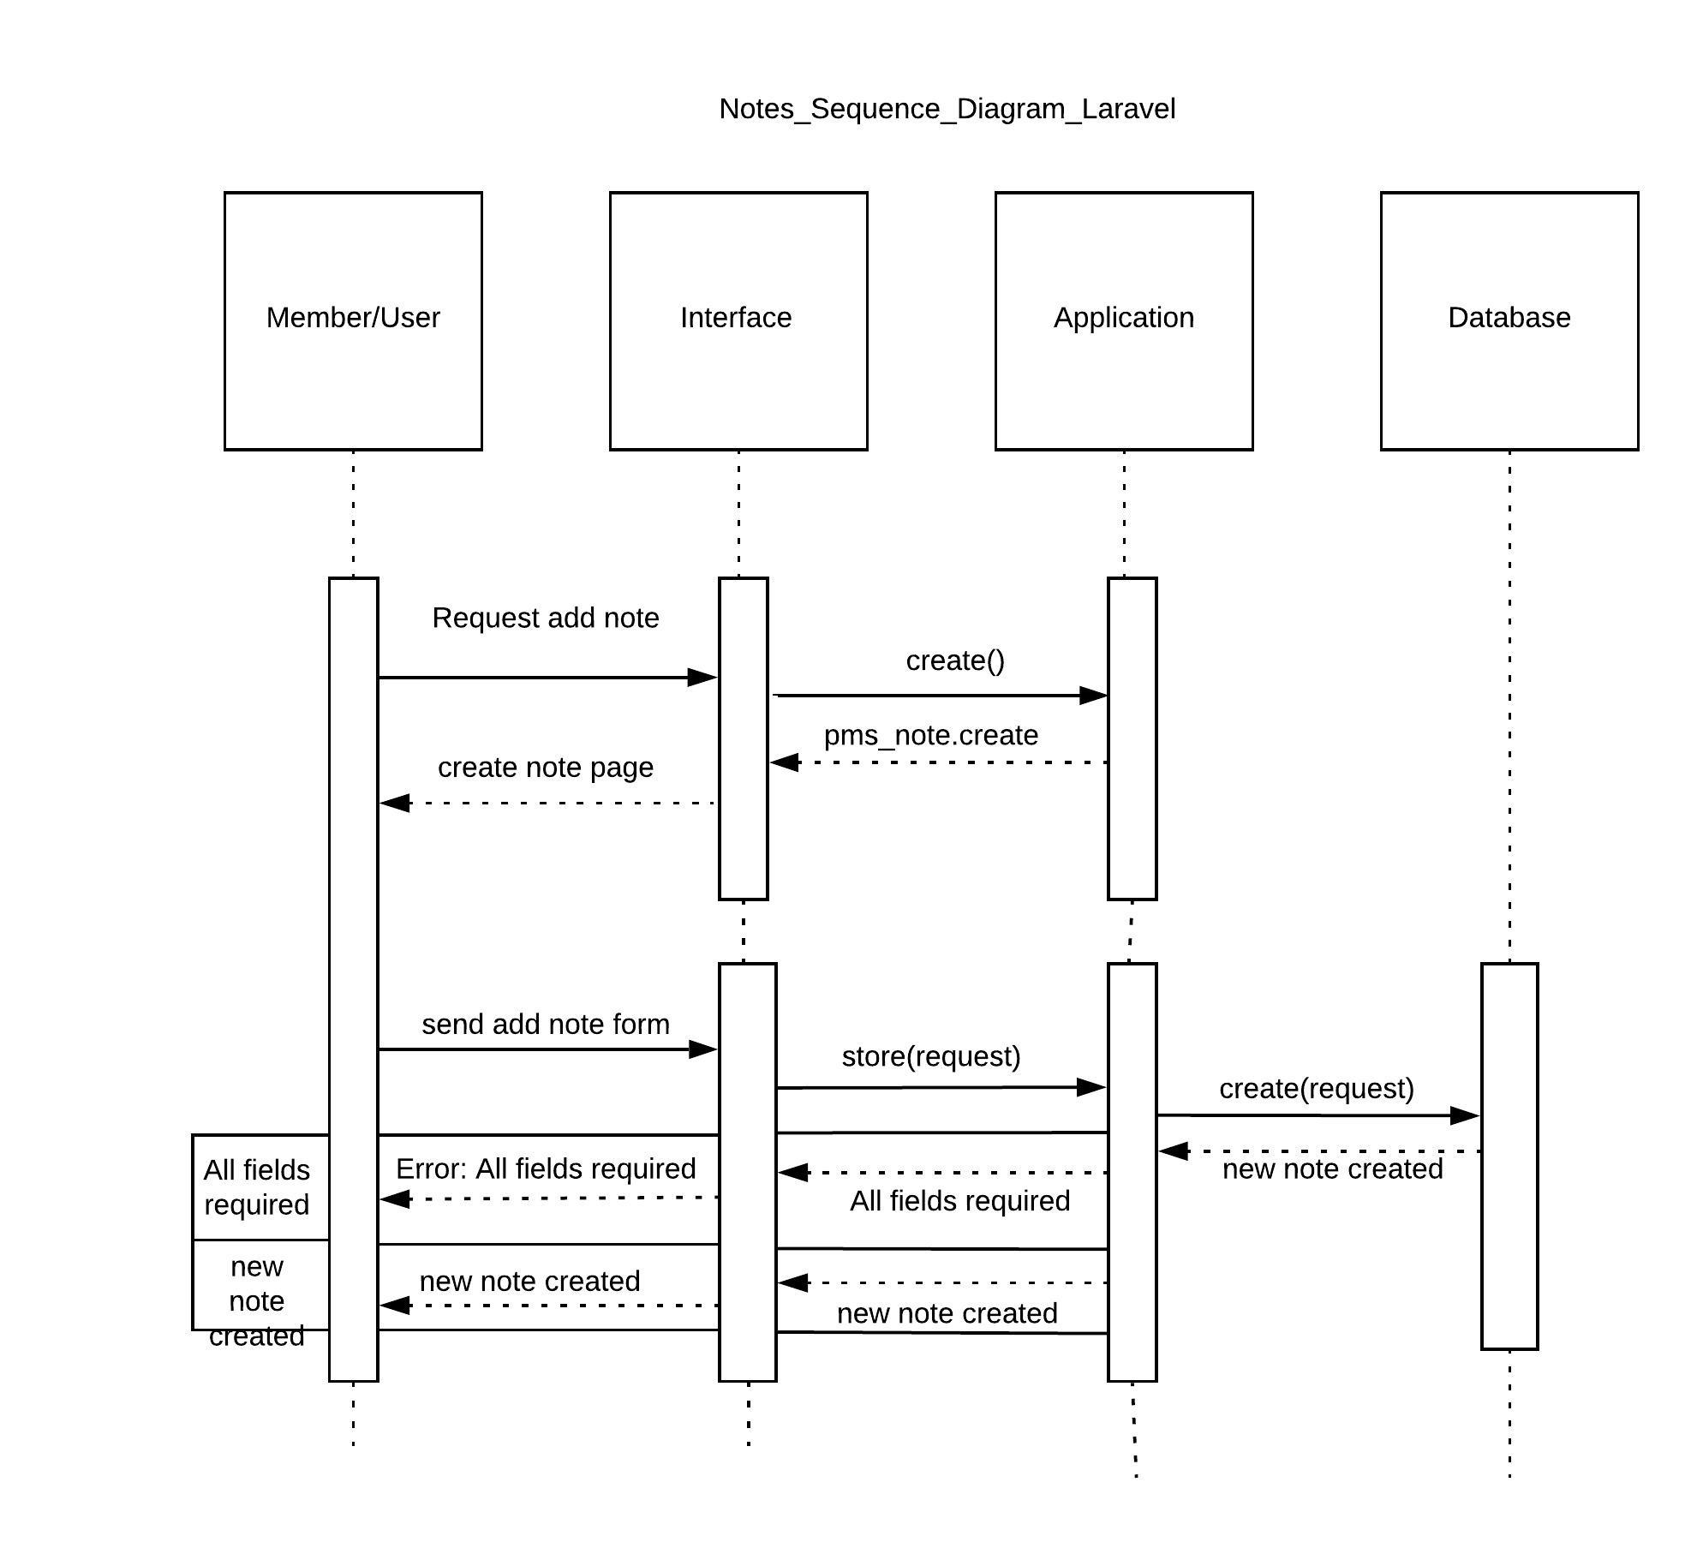
Figure : Add/update notes sequence diagram of the Project Management Web Applications in Laravel on Windows and Ubuntu.
The user sends a request to application to show a Notes page via the interface and the Notes page is displayed. The user adds a new Note and submits the note, which is then sent to the application and the application send the request to the database where the new note gets inserted along with the member’s name. The Note page is displayed with the list of the available notes. Also, the user can update the notes posted, which is sent to the application and finally inserted into the database.
Appendix 4
Project Management File structure in .NET Core Framework
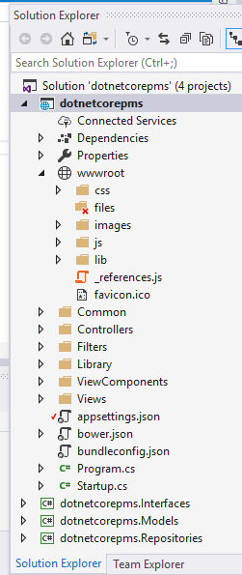
Figure: File Structure of the Project Management System in .NET Core in Visual Studio
Page Description of Project Management application in Laravel Framework
Description of important pages that are added or modified for the building of the Project Management System web application in .NET Core Framework.
Common/ModuleHelper.cs
The ModuleHelper class is responsible for listing out the available menu items and helping the side bar navigation view to display the menu items as per the given order. It also helps to setup main menu items and their sub-menu items (if any) in the navigation sidebar.
AdminController.cs
The AdminController is responsible for displaying the dashboard of the application after the user is successfully logged in.
BaseController.cs
The BaseController, as the name suggests, is the base controller for all the controllers used in the application. The BaseController provides the basic and common functionalities to all the other controllers.
DocumentsController.cs
The DocumentsController is responsible to allow users to upload their document into the server and view the documents uploaded by other users in the application. The user can upload word document, text files via this feature.
ErrorController.cs
The ErrorController is responsible to redirect the application to an error page if any error occurs in the application.
ForumController.cs
The ForumController is responsible for providing a common platform for the users in the application to communicate with each other. It is a discussion forum where the users provide their comment on a particular topic and discuss on the topic with each other.
NotesController.cs
The NotesController is responsible for allowing the users to write their notes and share the notes among all the users in the PMS.
RolesController.cs
The RolesController is responsible for managing roles in the application. The roles such as administrator, normal user, etc. are created, deleted, viewed and updated under this feature in the PMS.
UsersController.cs
The UsersController is responsible for managing users in the application. The UsersController can be used to create, delete, view and update the users in the PMS.
EncryptionLibrary.cs
The EncryptionLibrary is responsible to encrypt and decrypt the password for authentication purposes
Appendix 5
.NET Core Sequential Diagram
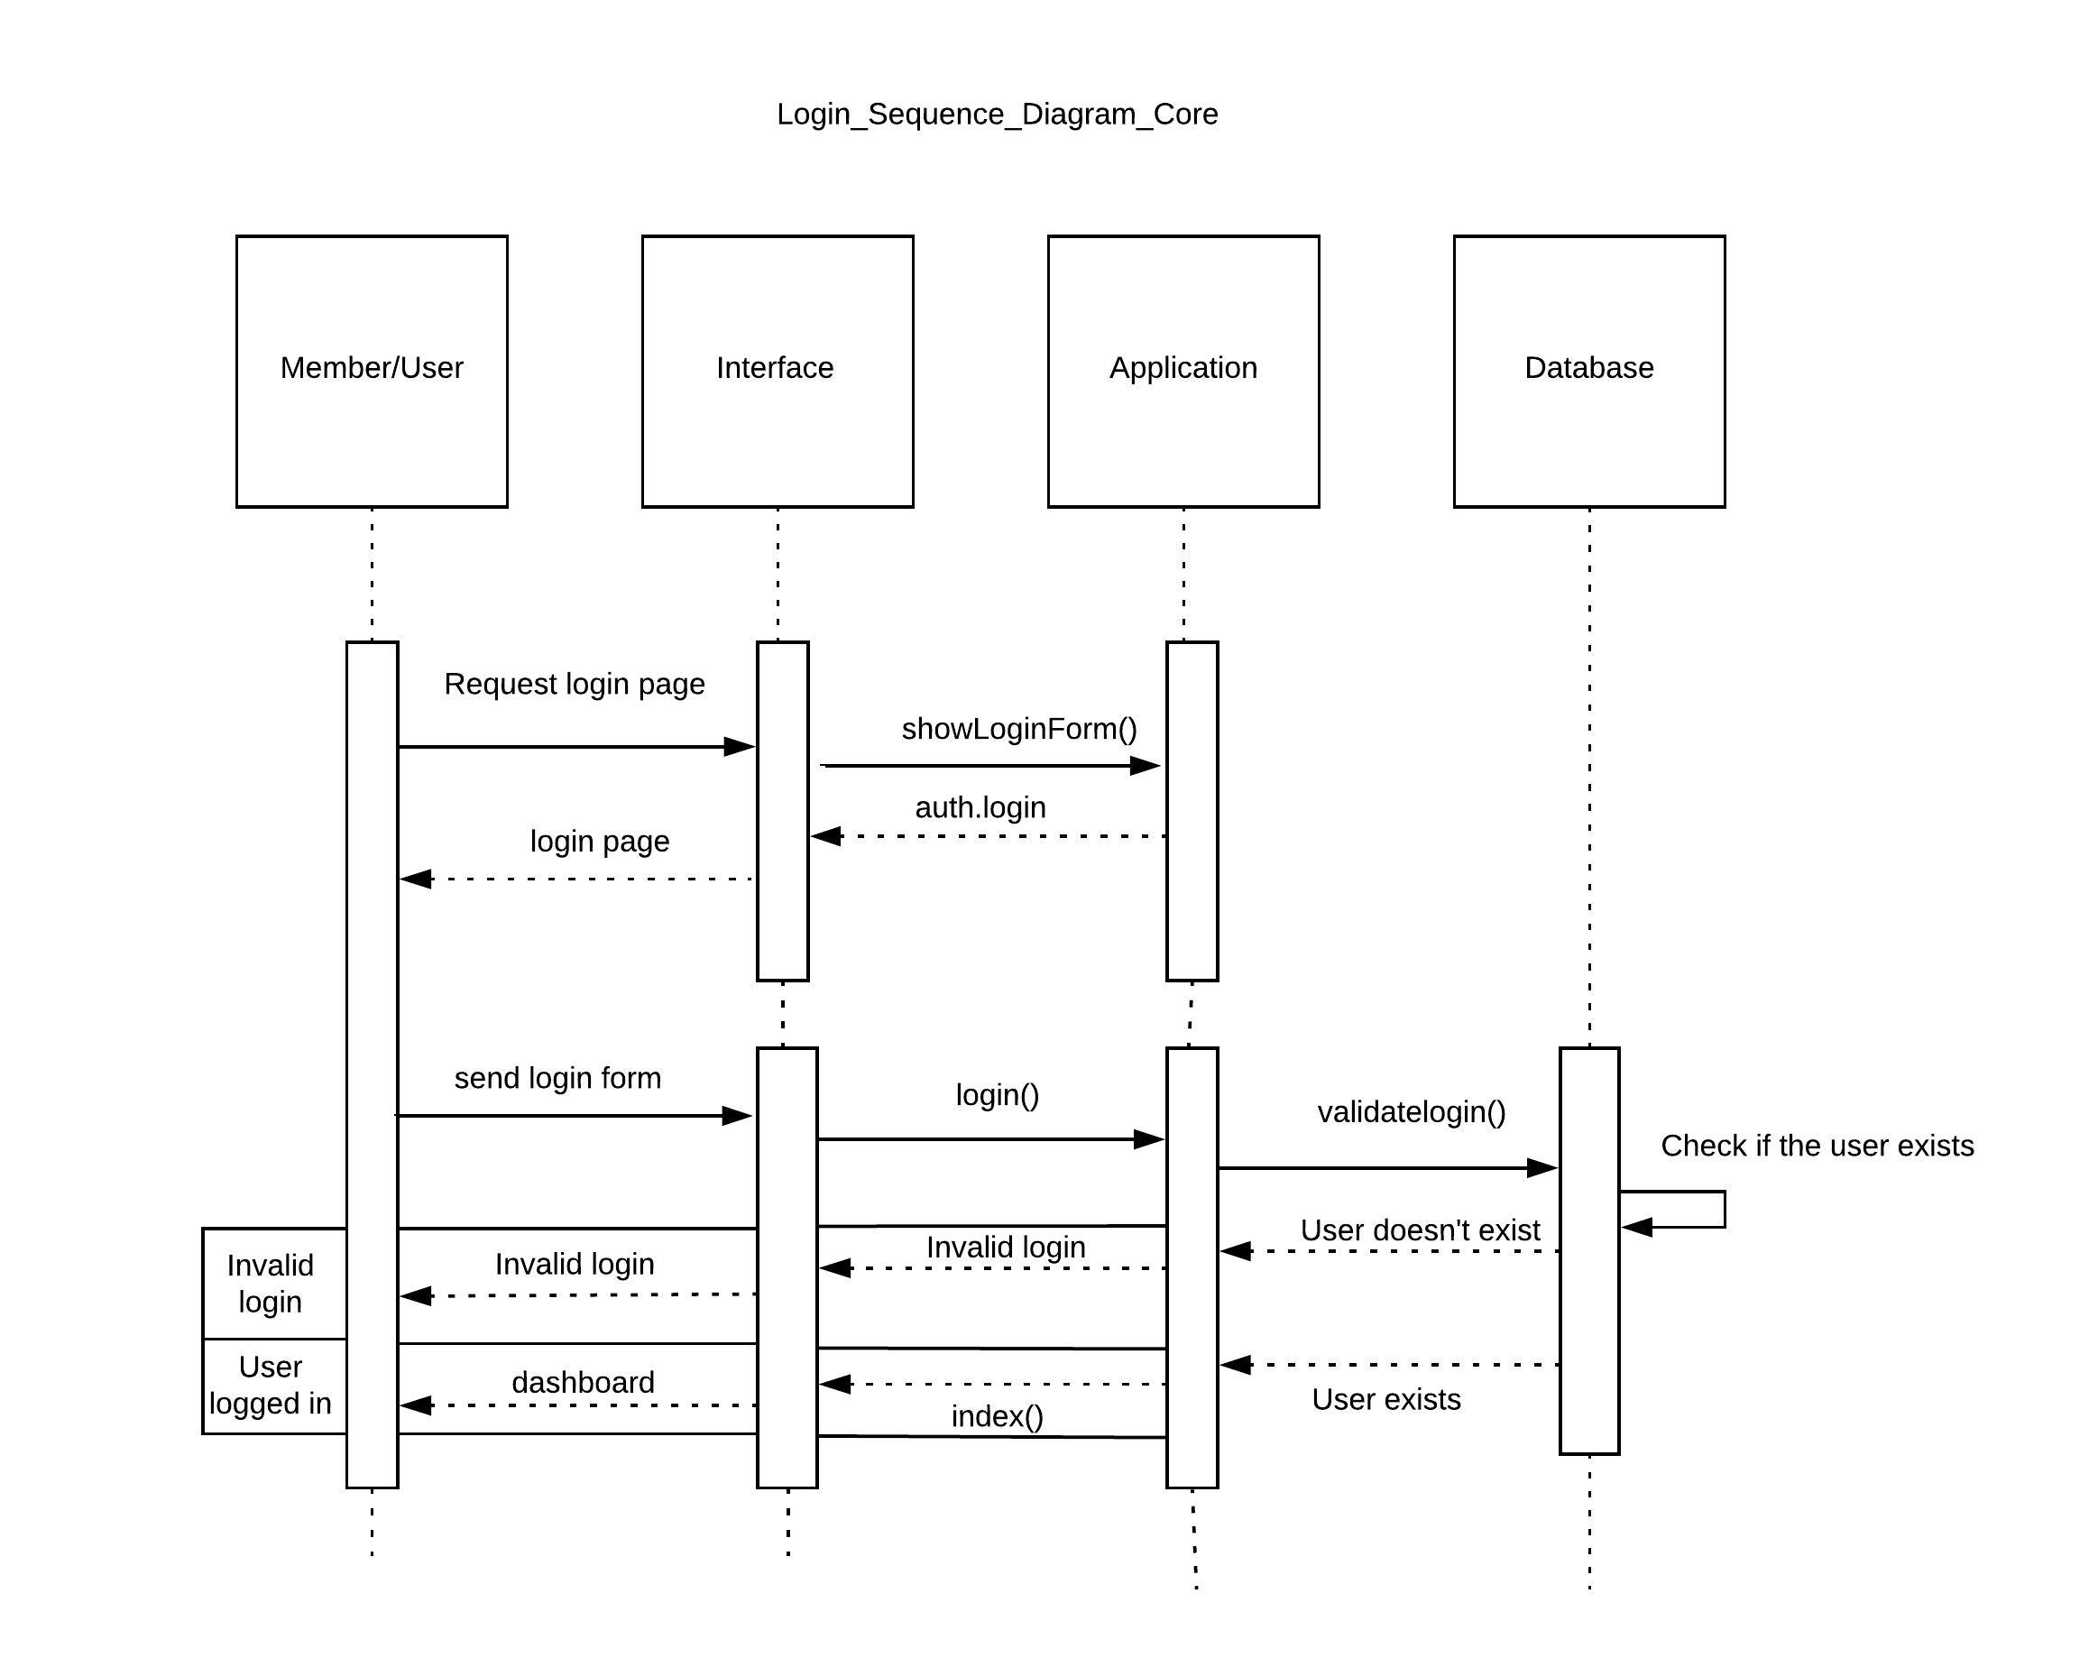
Figure : User login sequence diagram of the Project Management Web Applications in Dot Net Core on Windows.
The user sends a request to show a form to application via interface and the application accepts the request and responds with the login form. The user fills up the login details in the login form and submits the form. The application validates the user details, if the validation is successful, then the application redirects to the dashboard page. If the validation is unsuccessful, the application returns the login page with validation errors.

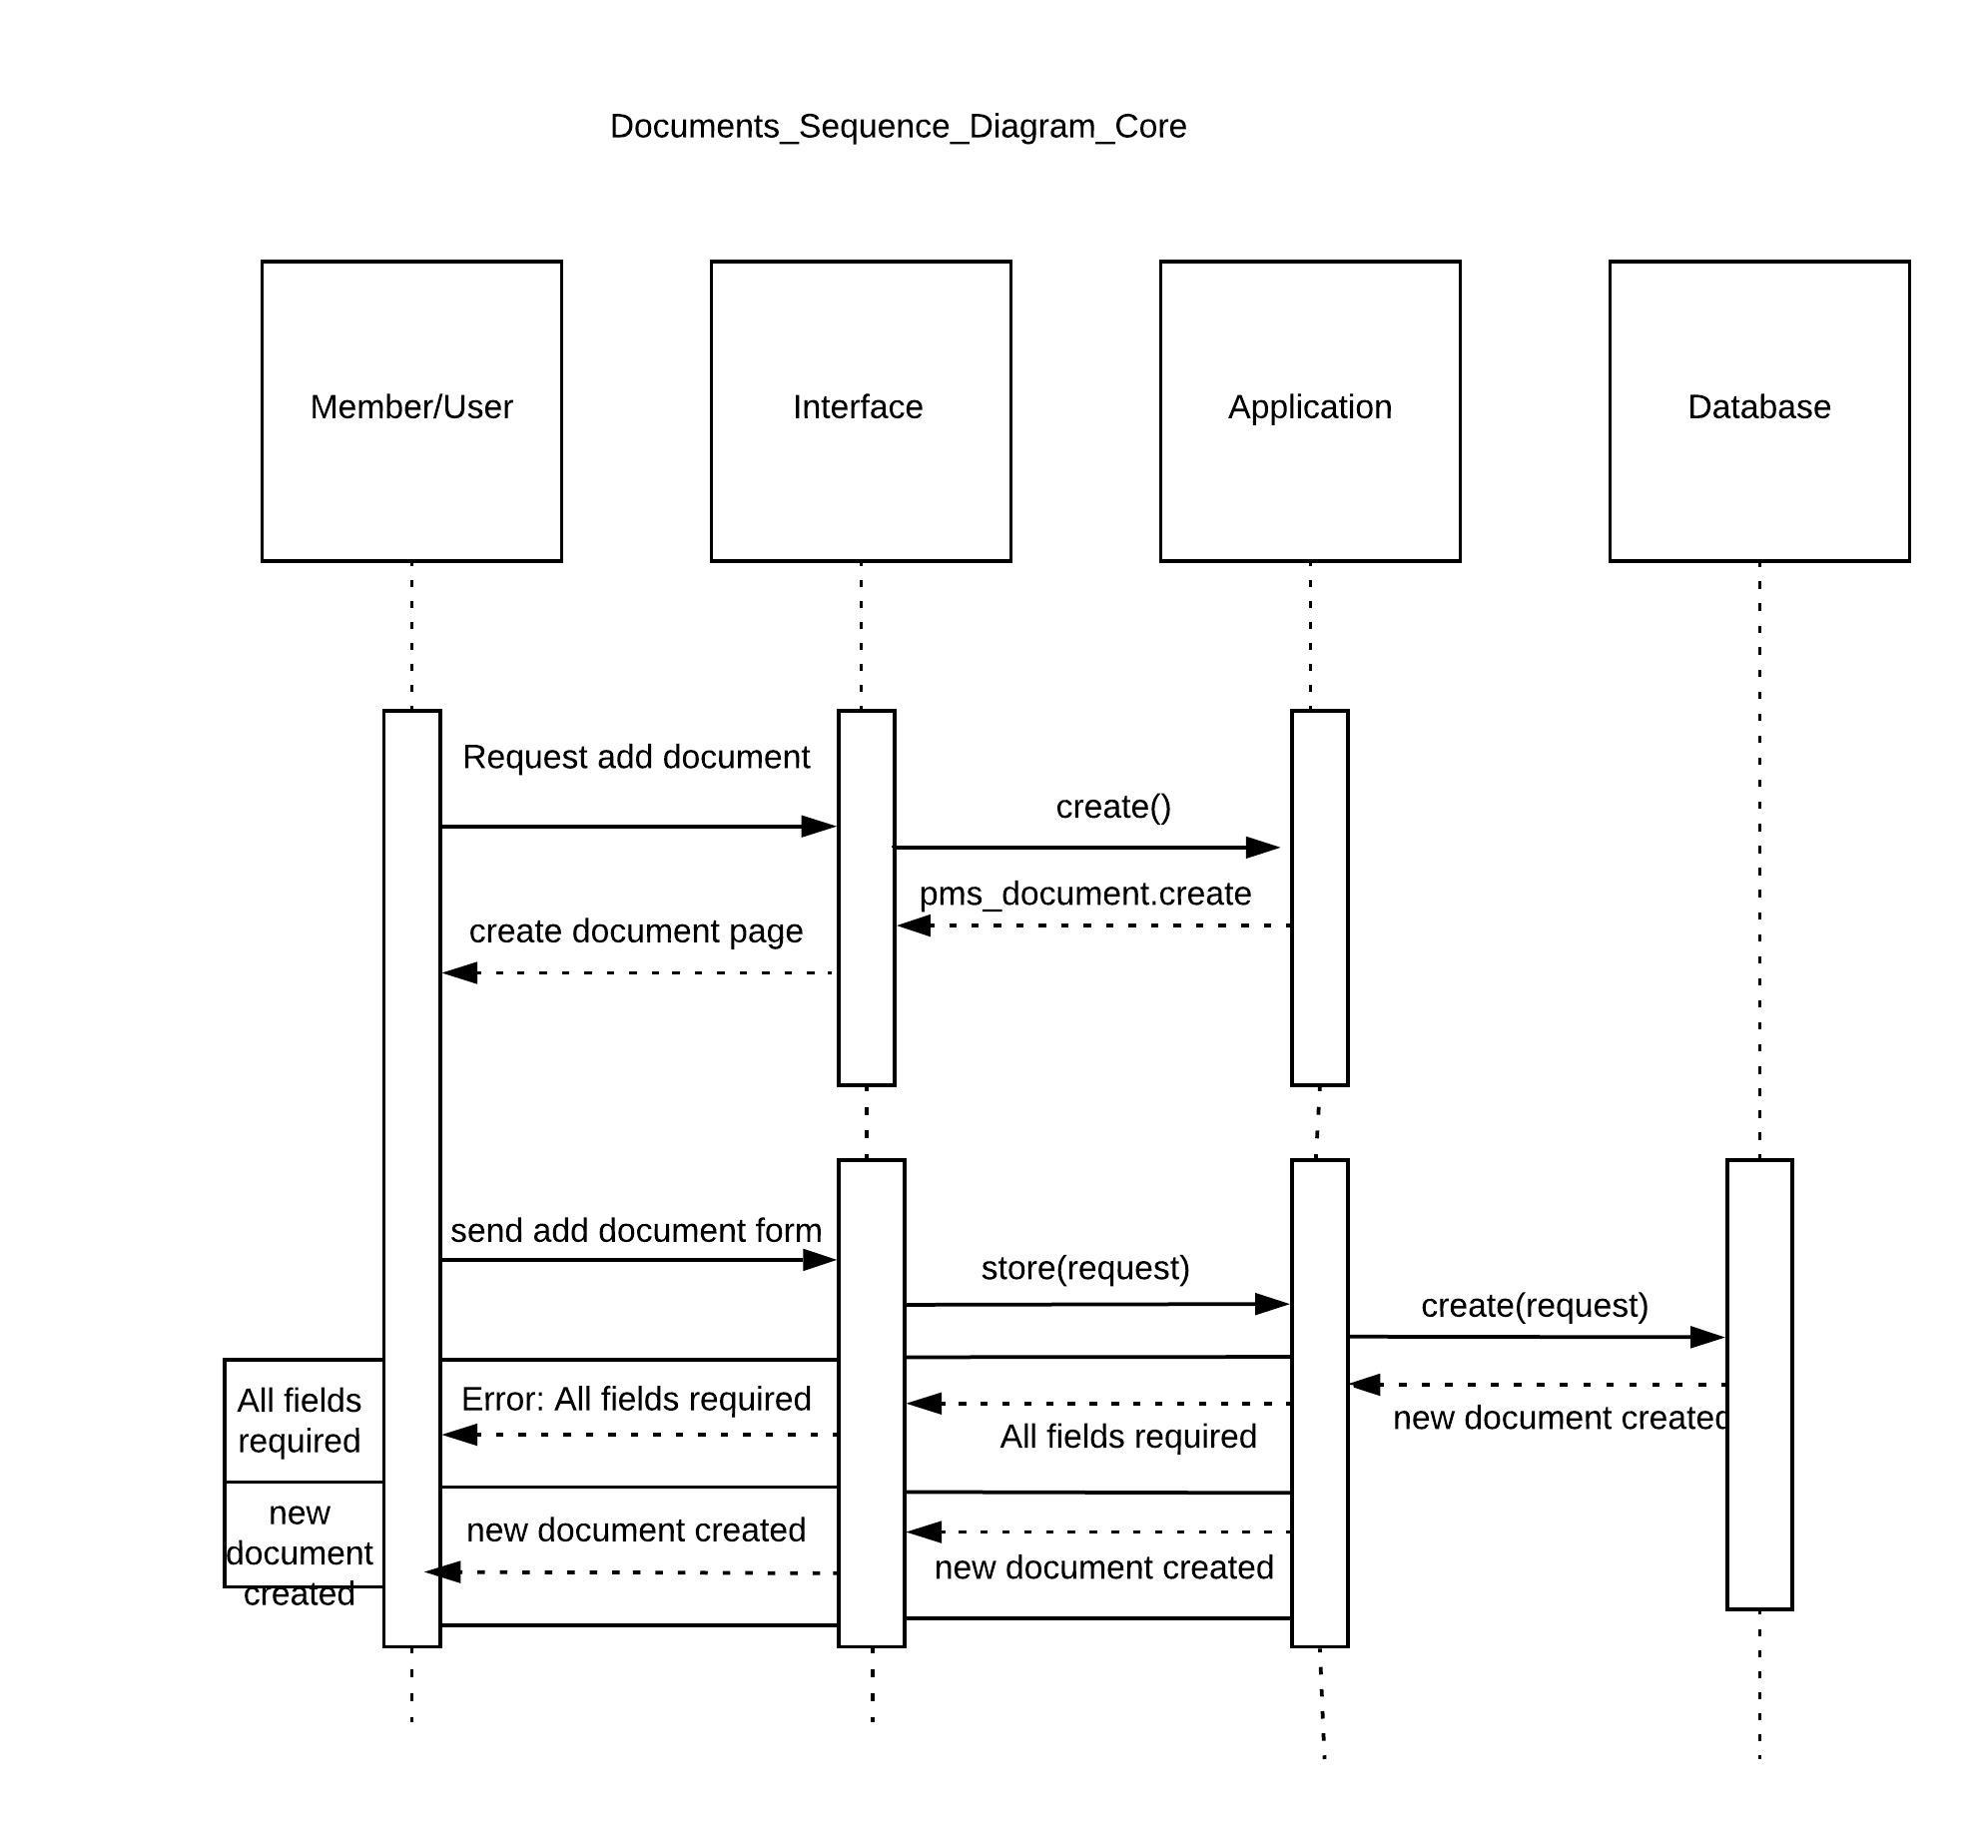
Figure : Add/update documents sequence diagram of the Project Management Web Applications in Dot Net Core on Windows.
When the user clicks on the 'Add Document' button on the web application, the web browser (interface) sends an HTTP GET request to the web server (application). The web server accepts the HTTP GET request and the create() function is triggered in the document controller. Then it returns a view page which consists of a new document form markup code. It sends a response to the web browser containing the view and the web browser displays the new document form. The user fills up the fields in the new document form and submits the form to create a new document. The web browser sends an HTTP POST request to the web server (Application), the web server accepts the request and the store() function validates the required fields received from the posted data. If the validation is successful, the request is forwarded to create() function where the database query is generated based on the create request to the database server. The data is inserted into the database and notification of successful creation of a new document is sent to the web browser as response. If the validation is unsuccessful, the function returns the view page with the message that the required fields are not filled.
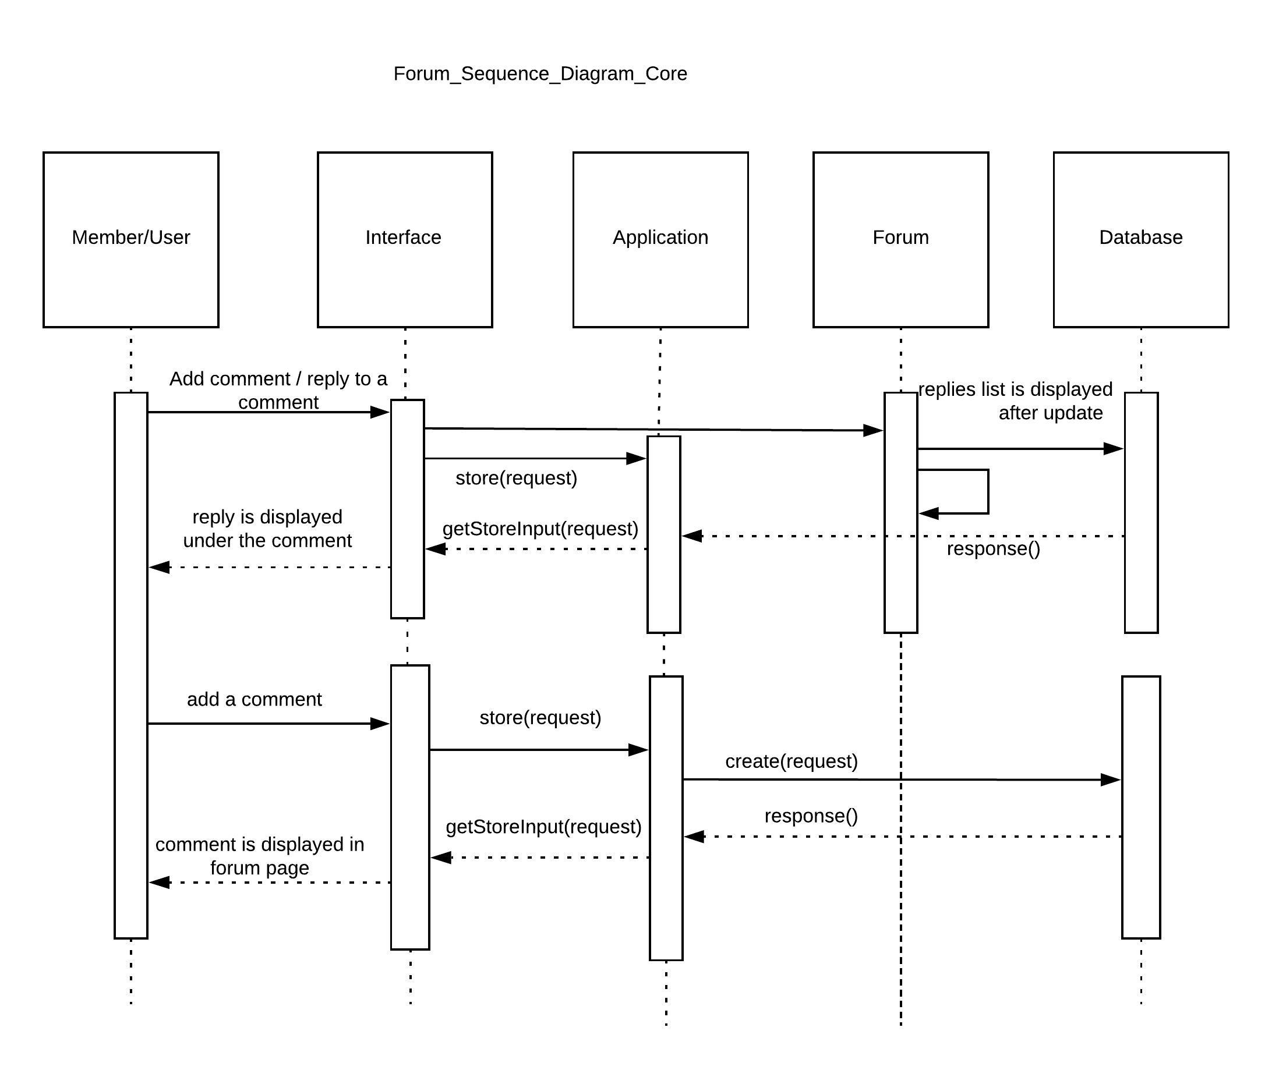
Figure : Discussion Forum sequence diagram of the Project Management Web Applications in Dot Net Core on Windows.
The user sends a request to application to show a forum page via the interface and the forum page is displayed. The user adds a new comment on the comment form and submits the form, which is then sent to the application and the application send the request to the database where the new comment gets inserted. The forum page is displayed with the list of the available comments. The user can reply to the comment posted, which is sent to the application and finally inserted into the database. The new replies list is displayed after the update.
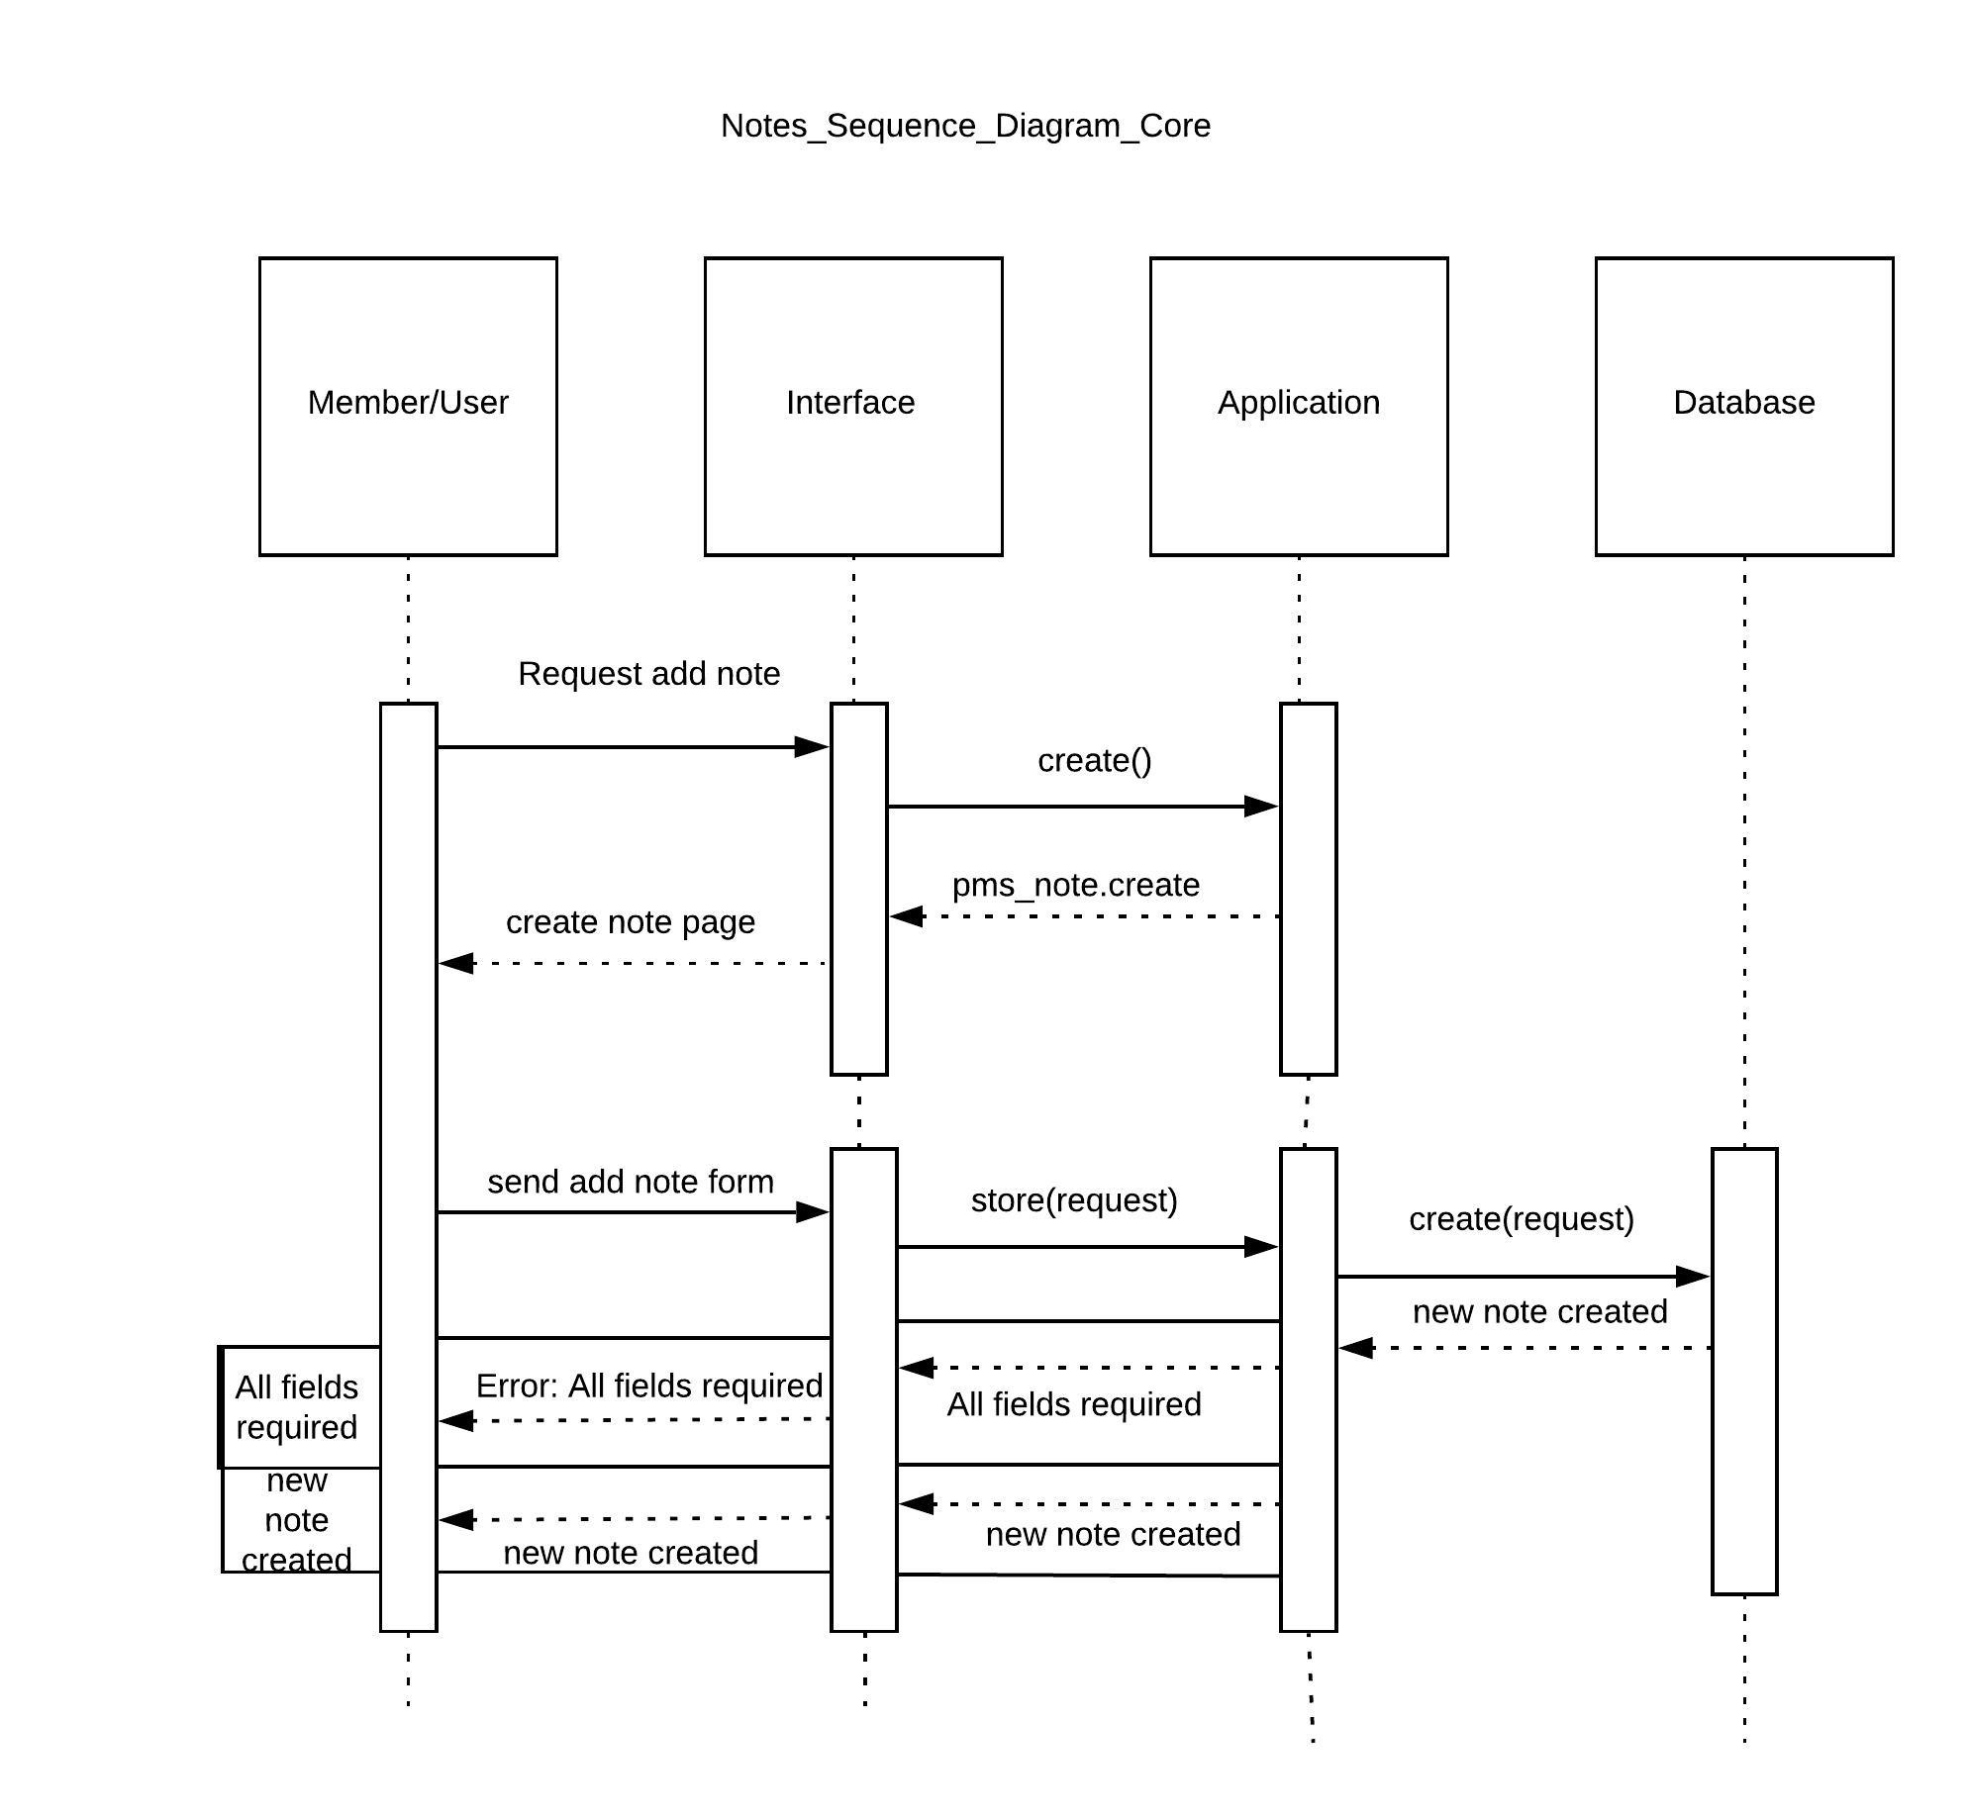
Figure : Add/Update Notes sequence diagram of the Project Management Web Applications in Dot Net Core on Windows.
The user sends a request to application to show a Notes page via the interface and the Notes page is displayed. The user adds a new Note and submits the note, which is then sent to the application and the application send the request to the database where the new note gets inserted along with the member’s name. The Note page is displayed with the list of the available notes. Also, the user can update the notes posted, which is sent to the application and finally inserted into the database.
Appendix 6
Public | + | Anywhere in the program and may be called by any object within the system
Private | - | The class that defines it
Protected | # | - The class that defines it or  - A subclass of that class
Table: Class Diagram of the Project Management Web Application on Dot NET Core
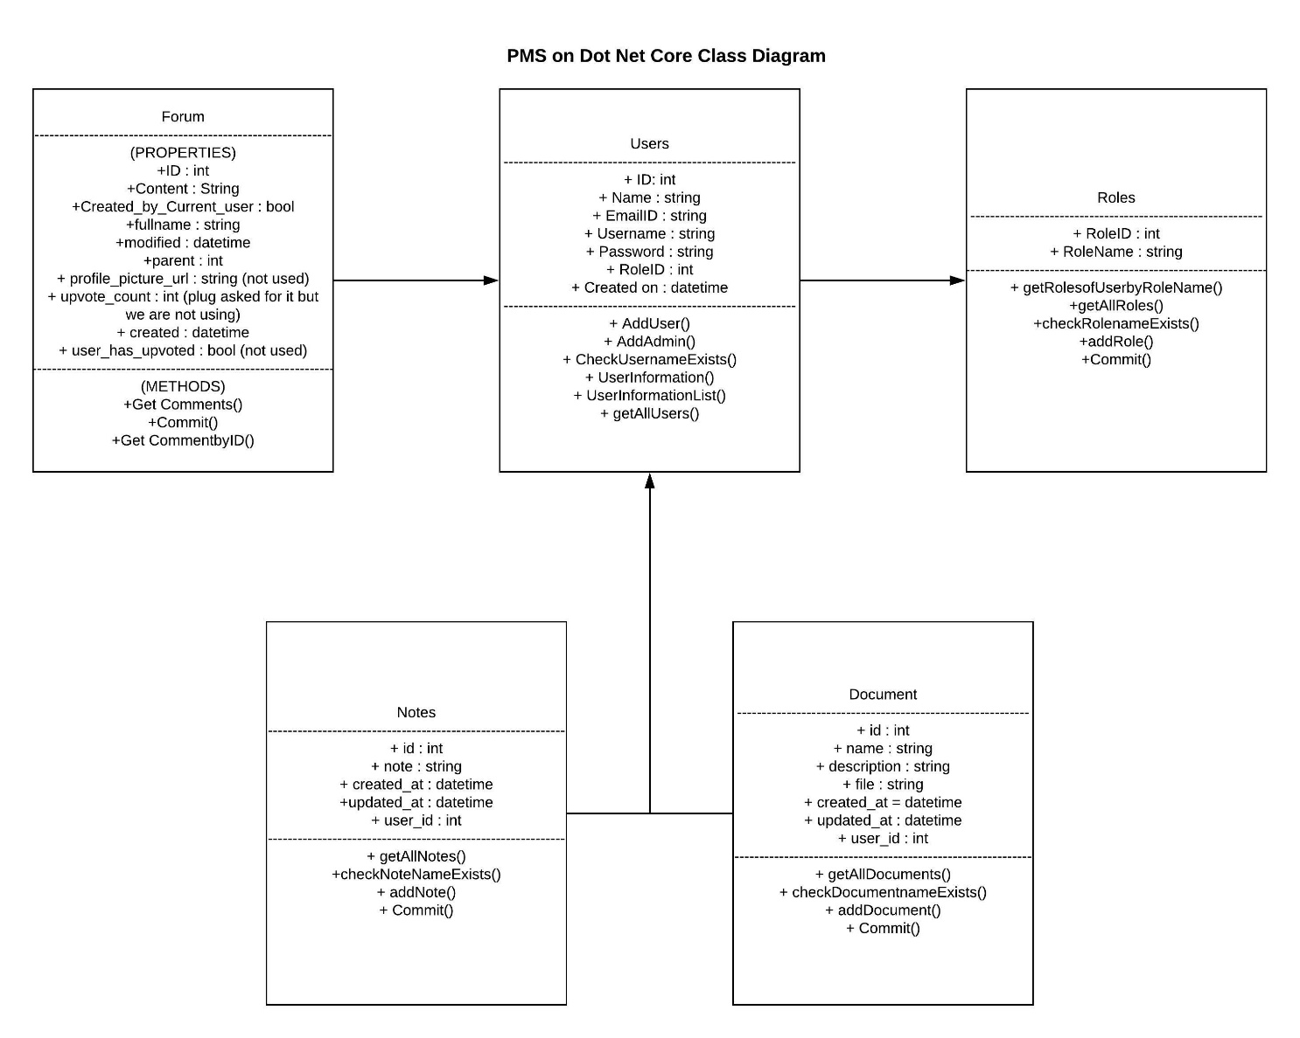
Figure: Class Diagram of the Project Management Web Application in Dot Net Core on Windows
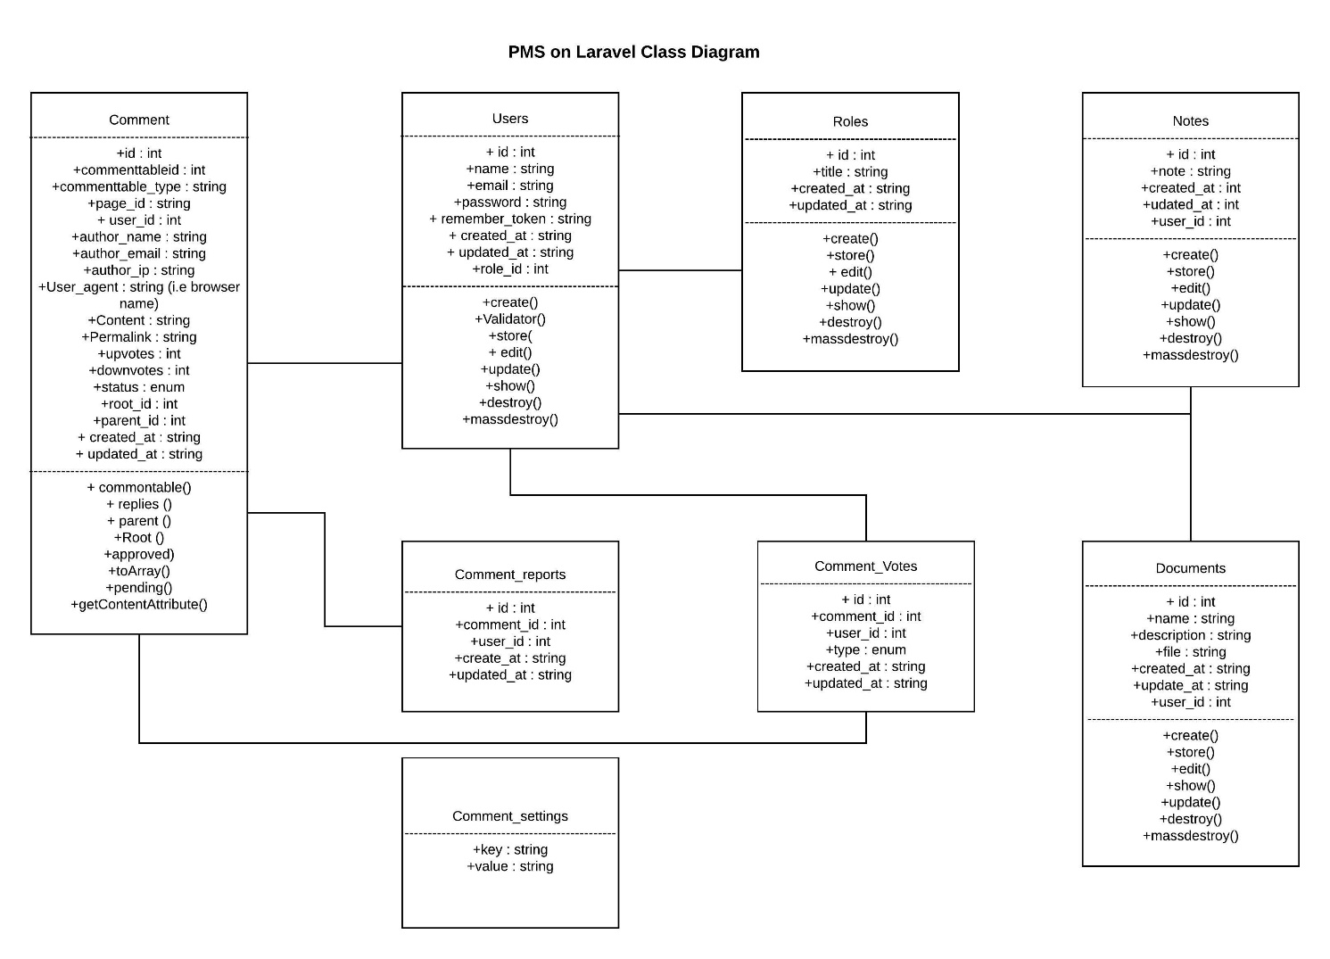
Figure: Class Diagram of the Project Management Web Application in Laravel on Windows and Ubuntu
Appendix 7
Testing
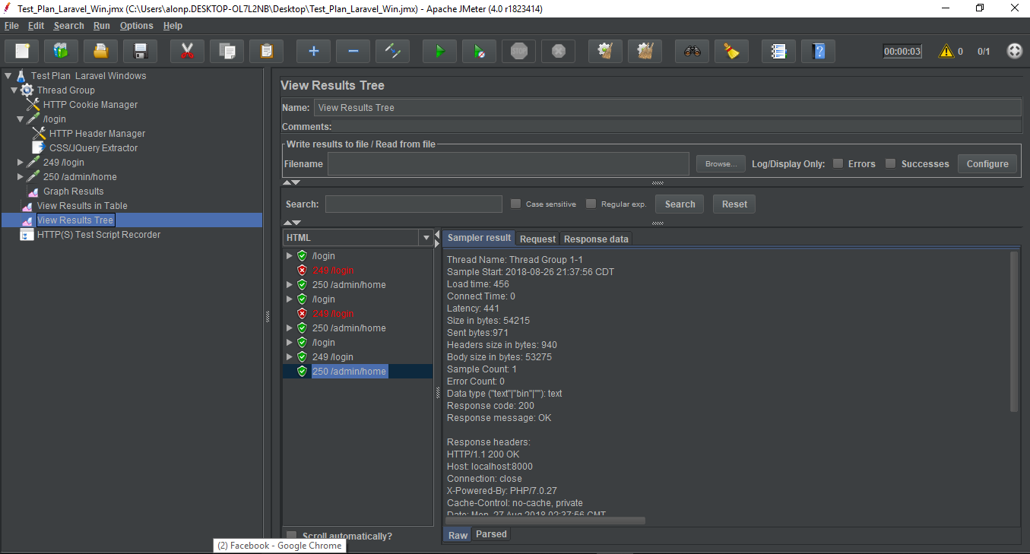
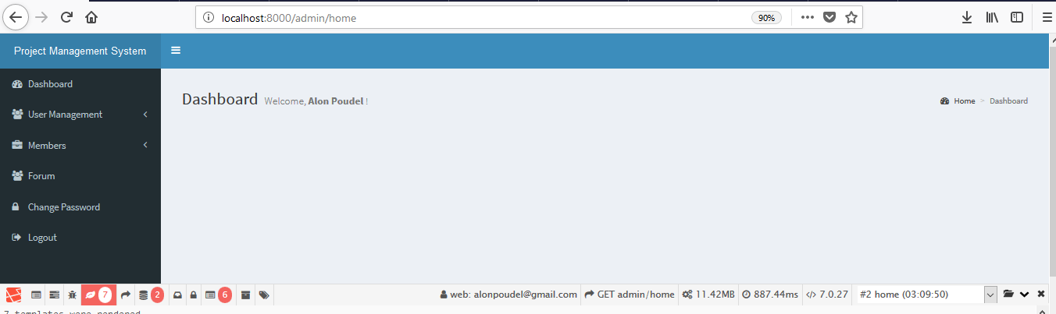
HTTP(S) Test Script Recorder
Since the Laravel application uses (Cross-site Reference Forgery) CSRF protection, it requires special and unique token to be validated every time. The JMeter cannot retrieve the pages which require authentication. The HTTP(S) Test Script Recorder creates a proxy server that acts as an intermediary between the browser and the application, retrieves the pages along the authentication page being accessed via the browser. Using CSS/JQuery Extractor, the retrieved authentication page is modified to mimic actual authentication to access the pages that require authentication. HTTP Cookie Manager is also added, since the authentication page requires cookie to store authentication details as session.
References
- Bisson, S. (2017, March 15). .Net Framework or .Net Core? When to use which. Retrieved January 28, 2018, from https://www.infoworld.com/article/3180478/development-tools/net-framework-or-net-core-when-to-use-which.html
- Building Web Applications From Scratch With Laravel. Retrieved September 15, 2017, from https://code.tutsplus.com/tutorials/building-web-applications-from-scratch-with-laravel--net-25517
- Freeman, A. (2016). Pro ASP.NET Core MVC. Berkeley, CA: Apress.
- Helm, R., Johnson, R. E., Gamma, E., & Vlissides, J. (2000). Design patterns elements of reusable object-oriented software. Charlesbourg, Québec: Braille Jymico Inc.
- H. Komara, B. Hendradjay, and G. A. P. Saptawati, "Dynamic generic web pattern for multi-platform," 2016 International Conference on Data and Software Engineering (ICoDSE), Denpasar, 2016, pp. 1-5.
URL: http://ieeexplore.ieee.org/stamp/stamp.jsp?tp=&arnumber=7936130&isnumber=7936094
- 1. L. (2017, November 21). Laravel/laravel. Retrieved November 21, 2017, from https://github.com/laravel/larave
- L. Alfat, A. Triwiyatno and R. R. Isnanto, "Sentinel web: Implementation of Laravel framework in web based temperature and humidity monitoring system," 2015 2nd International Conference on Information Technology, Computer, and Electrical Engineering (ICITACEE), Semarang, 2015, pp. 46-51.
URL: http://ieeexplore.ieee.org/stamp/stamp.jsp?tp=&arnumber=7437768&isnumber=7437747
- L. Chen, W. Huang, A. Sui, D. Chen and C. Sun, "The online education platform using Proxmox and noVNC technology based on Laravel framework," 2017 IEEE/ACIS 16th International Conference on Computer and Information Science (ICIS), Wuhan, 2017, pp. 487-491.
URL: http://ieeexplore.ieee.org/stamp/stamp.jsp?tp=&arnumber=7960041&isnumber=7959951
- M. Jailia, A. Kumar, M. Agarwal and I. Sinha, "Behavior of MVC (Model View Controller) based Web Application developed in PHP and .NET framework," 2016 International Conference on ICT in Business Industry & Government (ICTBIG), Indore, 2016, pp. 1-5.
URL: http://ieeexplore.ieee.org/stamp/stamp.jsp?tp=&arnumber=7892651&isnumber=7892628
- .NET Design Patterns. Retrieved May 21, 2017, from http://www.dofactory.com/net/design-patterns
- Palleboina, S., & Eltaeib, T. (2015). A Study of MVC – A Software Design Pattern for Web: Application Development on J2ee Architecture. Journal of Multidisciplinary Engineering Science and Technology (JMEST), 2(4). Retrieved January 17, 2017
- Should I learn and start doing ASP.NET Core? Retrieved January 28, 2018, from https://codingblast.com/learn-asp-net-core/
- Stauffer, M. (2016). Laravel: up and running. S.l.: OReilly Media.
- Understanding ASP.NET MVC. ASP.NET MVC 4 Recipes, 15-57.
- X. Chi, B. Liu, Q. Niu and Q. Wu, "Web Load Balance and Cache Optimization Design Based Nginx under High-Concurrency Environment," 2012 Third International Conference on Digital Manufacturing & Automation, GuiLin, 2012, pp. 1029-1032.
URL: http://ieeexplore.ieee.org/stamp/stamp.jsp?tp=&arnumber=6298691&isnumber=6298247

