NATURAL LANGUAGE PROCESSING
Detecting AI-Generated Text
A comparison of TF-IDF Logistic Regression and fine-tuned DistilBERT
SEA 820 | Final-Year Undergraduate NLP
Sthapanavichet Long and Amir Abdalla
8/10/2026

Abstract
This project investigates binary classification of human-written and AI-generated text. A classic baseline represents documents with unigram and bigram TF-IDF features and trains a class-balanced Logistic Regression classifier. The advanced model fine-tunes DistilBERT on the same stratified training split. Both systems are evaluated on an untouched test set using accuracy, precision, recall, and F1-score.
The TF-IDF Logistic Regression baseline achieved an F1-score of 0.9765, outperforming DistilBERT’s F1-score of 0.9705. Although DistilBERT detected a greater proportion of AI-generated texts, the baseline produced fewer false accusations and achieved stronger overall test performance.
Error analysis separates false positives from false negatives and considers document length, topic, style, and dataset artifacts. The project concludes that an AI-text detector should be treated as uncertain decision support rather than proof of authorship.

1. Introduction
Large language models can generate fluent text at low cost, creating challenges for academic integrity, content moderation, and misinformation response. Detecting AI-generated writing is difficult because model outputs overlap with human writing and can be revised, paraphrased, or combined with human contributions. This project asks whether a fine-tuned Transformer provides a meaningful improvement over a transparent classic baseline on the AI vs. Human Text dataset.
The main contribution is a reproducible, apples-to-apples comparison. Both models use the same training and held-out test partitions, and the analysis goes beyond accuracy by examining class-1 precision, recall, F1, confusion patterns, and individual errors.

2. Dataset and Exploratory Analysis
The project uses the AI vs Human Text dataset published on Kaggle by Shane Gerami. Each record contains a text sample and a binary label: 0 for human-written and 1 for AI-generated. The notebook removes missing values, empty text, duplicate texts, and invalid labels before sampling.
After removing missing, empty, duplicate, and invalid records and applying stratified sampling, the experiment used 12,000 text samples. The sample contained 7,531 human-written texts (62.76%) and 4,469 AI-generated texts (37.24%). Although the classes were not perfectly balanced, stratified splitting preserved this distribution across the training, validation, and test sets.
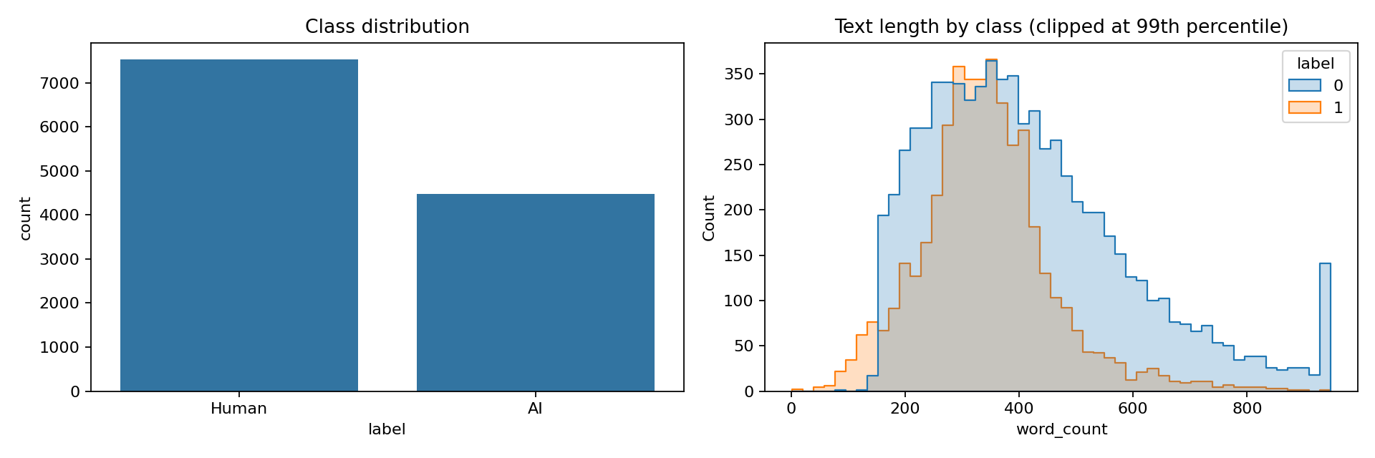
To fit a free Colab GPU session, the default final experiment uses a reproducible stratified sample of 12,000 records. Data are split into 70% training, 15% validation, and 15% testing. Stratification preserves class proportions, while random seed 42 supports reproducibility.

3. Methods

3.1 TF-IDF baseline
The baseline lowercases text, applies Unicode accent normalization, and constructs unigram and bigram TF-IDF features. Features occurring in fewer than two documents or more than 98% of documents are excluded, and the vocabulary is capped at 100,000 features. A Logistic Regression classifier uses balanced class weights, C=2.0, and a maximum of 1,000 iterations.

3.2 Transformer model
The advanced model is DistilBERT-base-uncased with a two-label classification head. Text is truncated to 256 tokens and dynamically padded per batch. The default configuration uses batch size 16, learning rate 2e-5, two epochs, 0.01 weight decay, a 0.1 warm-up ratio, and mixed-precision training when a GPU is available. The checkpoint with the highest validation F1 is restored for final testing.

3.3 Evaluation protocol
The untouched test set is used once for final comparison. Precision, recall, and F1 treat AI-generated text as the positive class. Accuracy measures overall correctness; precision measures how often an AI flag is correct; recall measures how many AI examples are detected; F1 balances precision and recall.

4. Results
Model | Accuracy | Precision | Recall | F1
TF-IDF + Logistic Regression | 0.9828 | 0.9908 | 0.9627 | 0.9765
DistilBERT | 0.9778 | 0.9578 | 0.9836 | 0.9705
The TF-IDF Logistic Regression baseline achieved an accuracy of 0.9828, precision of 0.9908, recall of 0.9627, and F1-score of 0.9765. DistilBERT achieved an accuracy of 0.9778, precision of 0.9578, recall of 0.9836, and F1-score of 0.9705. The baseline’s F1-score was 0.0060 higher, equivalent to an improvement of 0.60 percentage points. DistilBERT achieved higher recall, meaning that it detected more AI-generated samples, but its lower precision caused more human-written texts to be incorrectly flagged. Therefore, the classic baseline provided the strongest balance between precision and recall on this test set.
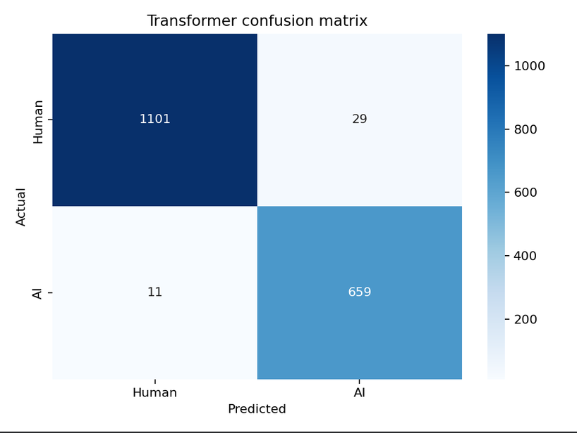
On the 1,800-sample test set, DistilBERT correctly classified approximately 1,101 of the 1,130 human-written texts and 659 of the 670 AI-generated texts. It produced 29 false positives, in which human-written texts were incorrectly classified as AI-generated, and 11 false negatives, in which AI-generated texts were classified as human-written. This pattern explains the model’s high AI recall of 0.9836 and its lower precision of 0.9578. The model rarely missed AI-generated text, but this came at the cost of falsely flagging more human writing.

5. Error Analysis
The notebook exports every misclassified test example with its true label, predicted label, error type, text, and word count. False positives are human texts incorrectly flagged as AI; these are the most consequential errors in disciplinary settings. False negatives are AI texts classified as human and reduce the detector's coverage.
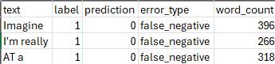
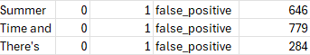
Three false positives and three false negatives were examined. The false-negative AI texts began with “Imagine,” “I’m really,” and “AT a” and contained 396, 266, and 318 words, respectively. Their average length was approximately 326.7 words. The false-positive human texts began with “Summer,” “Time and,” and “There’s” and contained 646, 779, and 284 words, respectively, averaging approximately 569.7 words.
In this small error sample, the false-positive human texts were considerably longer than the false-negative AI texts. This suggests that document length alone did not provide a reliable indication of authorship. Some longer human texts were incorrectly classified as AI-generated, while several shorter AI-generated texts were classified as human-written. The examples demonstrate that the model may rely on combinations of vocabulary, sentence structure, tone, and topic rather than a single feature such as length. Because only six errors were examined, this pattern should be treated as an observation from the test sample rather than a universal rule.

The Transformer produced 29 false positives and 11 false negatives. False positives were more common, showing that the model’s high recall was achieved partly by classifying more texts as AI-generated. This is especially important in academic settings because a false positive could result in an unsupported accusation against a human writer. Six individual errors were examined to determine whether text length, tone, sentence structure, topic, or stylistic variation contributed to the incorrect predictions.
These hypotheses must be described as observations from this test sample rather than universal rules. A classifier can also exploit unintended dataset signals, including topic, source, prompt style, and differences between the AI systems represented in training and those encountered later.

6. Ethical Considerations
AI-text detection may help instructors prioritize review and help platforms study content provenance, but false accusations can harm students, writers, and non-native English speakers. Prior work has shown that some detectors disproportionately classify non-native English writing as AI-generated. A score therefore cannot establish misconduct, intent, or authorship.
- Human review: never use the classifier as the sole basis for punishment or content removal.
- Transparency: disclose uncertainty, evaluation population, threshold, known failure modes, and appeal procedures.
- Fairness: evaluate performance across language background, text length, genre, topic, and disability-related writing tools before deployment.
- Privacy: avoid retaining student writing longer than necessary and restrict access to submitted text and model outputs.
- Robustness: expect performance to decay on unseen model families, paraphrased outputs, human-AI collaboration, and future generators.
The appropriate use is limited, reversible decision support combined with contextual evidence and an appeal process. The model developed here is an educational research prototype and is not validated for high-stakes deployment.

7. Limitations
The experiment uses one dataset and a resource-constrained sample, so measured performance may not generalize to other genres, domains, languages, or newer language models. Truncation can remove useful evidence from long texts. Labels simplify mixed-authorship documents into two classes. Hyperparameter search is limited by Colab compute, and GPU nondeterminism may cause small run-to-run changes.

8. Conclusion
This project establishes a reproducible comparison between a strong classic text-classification baseline and a fine-tuned Transformer.
The TF-IDF Logistic Regression baseline was the strongest overall model, achieving a test F1-score of 0.9765 compared with 0.9705 for DistilBERT. This represents an F1 improvement of 0.0060, or 0.60 percentage points. The baseline also achieved higher accuracy and precision, while DistilBERT achieved higher recall. These results demonstrate that the added complexity of Transformer fine-tuning did not improve overall classification performance on this dataset. The baseline may also be preferable in higher-risk settings because it produced substantially fewer false positives. However, neither model should be treated as proof of authorship nor used as the sole basis for disciplinary action.
Regardless of aggregate performance, the error analysis and ethical review show that AI-text detection is probabilistic and context-dependent. Future work should test cross-dataset generalization, calibrated confidence, subgroup performance, unseen generators, and mixed human-AI writing.

References
Devlin, J., Chang, M.-W., Lee, K., & Toutanova, K. (2019). BERT: Pre-training of Deep Bidirectional Transformers for Language Understanding. NAACL-HLT.
Gerami, S. AI vs Human Text. Kaggle dataset. https://www.kaggle.com/datasets/shanegerami/ai-vs-human-text
Liang, W., et al. (2023). GPT detectors are biased against non-native English writers. Patterns, 4(7), 100779.
Mitchell, E., et al. (2023). DetectGPT: Zero-Shot Machine-Generated Text Detection using Probability Curvature. ICML.
Sanh, V., Debut, L., Chaumond, J., & Wolf, T. (2019). DistilBERT, a distilled version of BERT. arXiv:1910.01108.

