MongoDB Practical Assignment - Set 2
Database: companyDB (collections: employees, courses) | Shell: mongosh
Name: ____________________________ Register No.: ____________________

Question 1
Create companyDB and an employees collection. Insert at least 8 employees with name, department, salary, experience and city.

Queries
use companyDB
db.createCollection("employees")
db.employees.insertMany([
{ name: "Arun Kumar", department: "IT", salary: 65000, experience: 4, city: "Chennai", phone: "9876543210" },
{ name: "Priya Sharma", department: "HR", salary: 48000, experience: 3, city: "Salem" },
{ name: "Karthik Raj", department: "IT", salary: 85000, experience: 6, city: "Bengaluru", phone: "9845012345" },
{ name: "Divya Nair", department: "Finance", salary: 55000, experience: 2, city: "Coimbatore" },
{ name: "Suresh Babu", department: "Marketing", salary: 42000, experience: 1, city: "Madurai" },
{ name: "Meena Iyer", department: "Finance", salary: 72000, experience: 5, city: "Chennai", phone: "9791122334" },
{ name: "Rahul Verma", department: "IT", salary: 50000, experience: 2, city: "Hyderabad" },
{ name: "Anitha Devi", department: "HR", salary: 38000, experience: 1, city: "Salem" },
{ name: "Vignesh M", department: "Sales", salary: 60000, experience: 3, city: "Trichy" },
{ name: "Lakshmi Priya", department: "IT", salary: 78000, experience: 4, city: "Coimbatore", phone: "9884455667" }
])
db.employees.countDocuments()
db.employees.find().limit(3)

Output
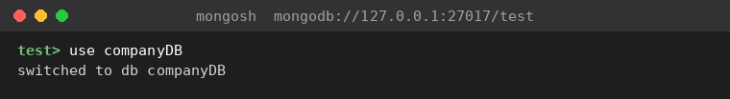
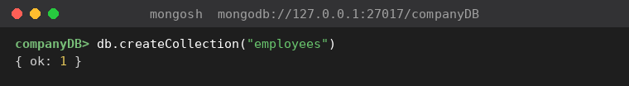
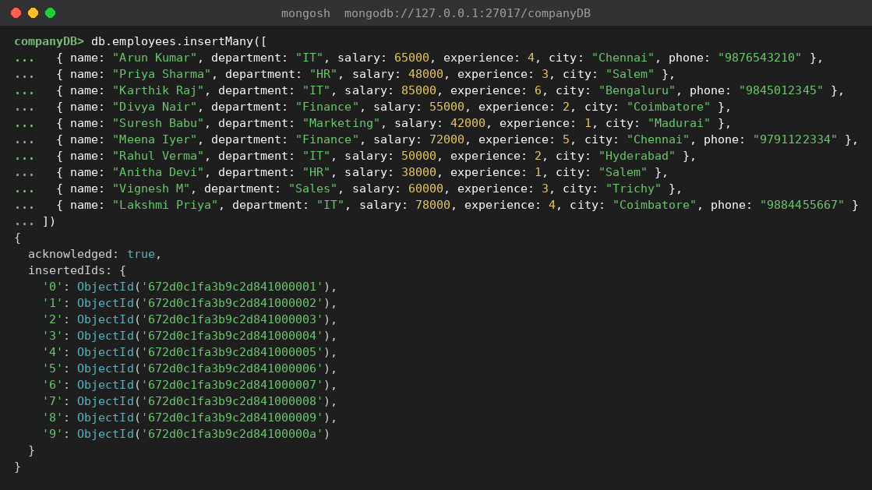

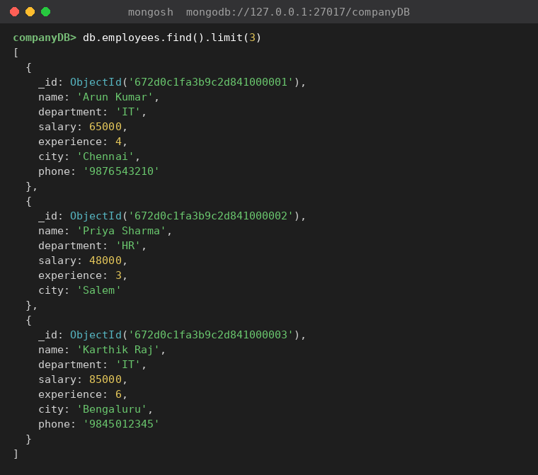

Explanation
Switching to a database that does not exist yet creates it on the first write. The employees collection holds 10 documents; the phone field is given to only four of them on purpose, so it can be used for the $exists query in Question 8.

Question 2
Find all employees in the IT department. Then find employees whose salary is greater than 50000.

Queries
db.employees.find({ department: "IT" })
db.employees.find({ salary: { $gt: 50000 } })

Output
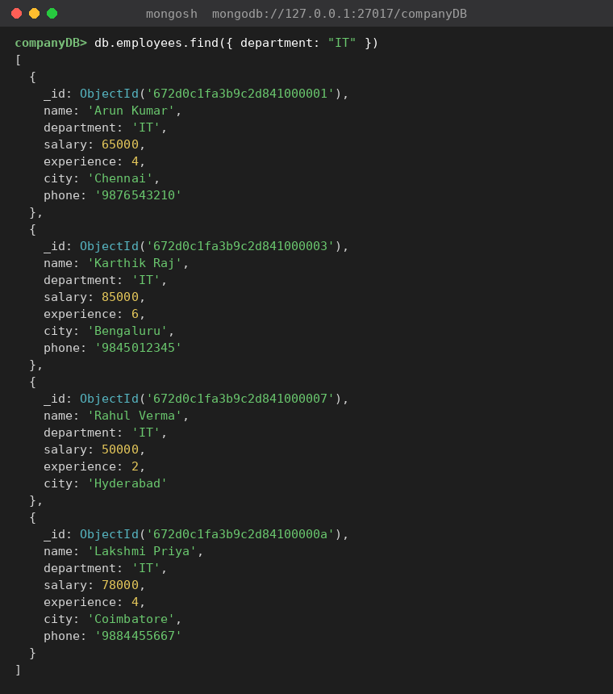
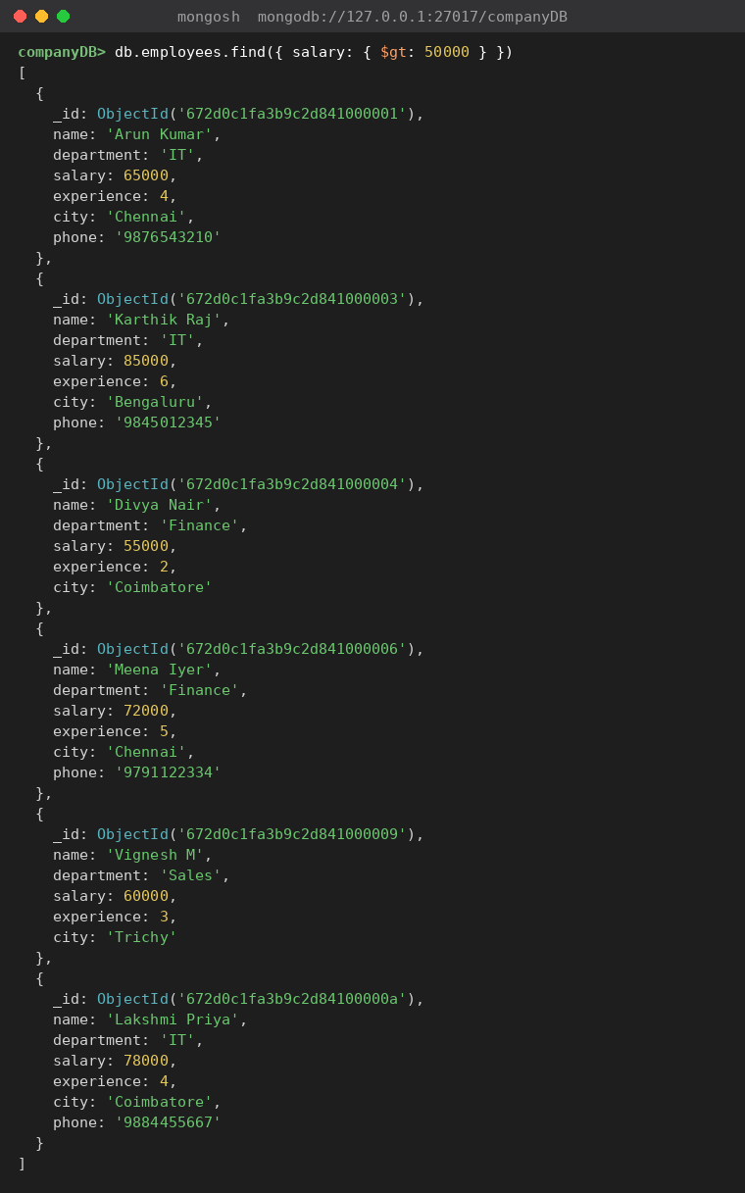

Explanation
Equality match on department returns the 4 IT employees. $gt is strict, so Rahul Verma (salary exactly 50000) is excluded from the second query.

Question 3
Find employees whose experience is greater than 2 years and salary is less than 80000. Use $and.

Queries
db.employees.find({
$and: [
{ experience: { $gt: 2 } },
{ salary: { $lt: 80000 } }
]
})

Output
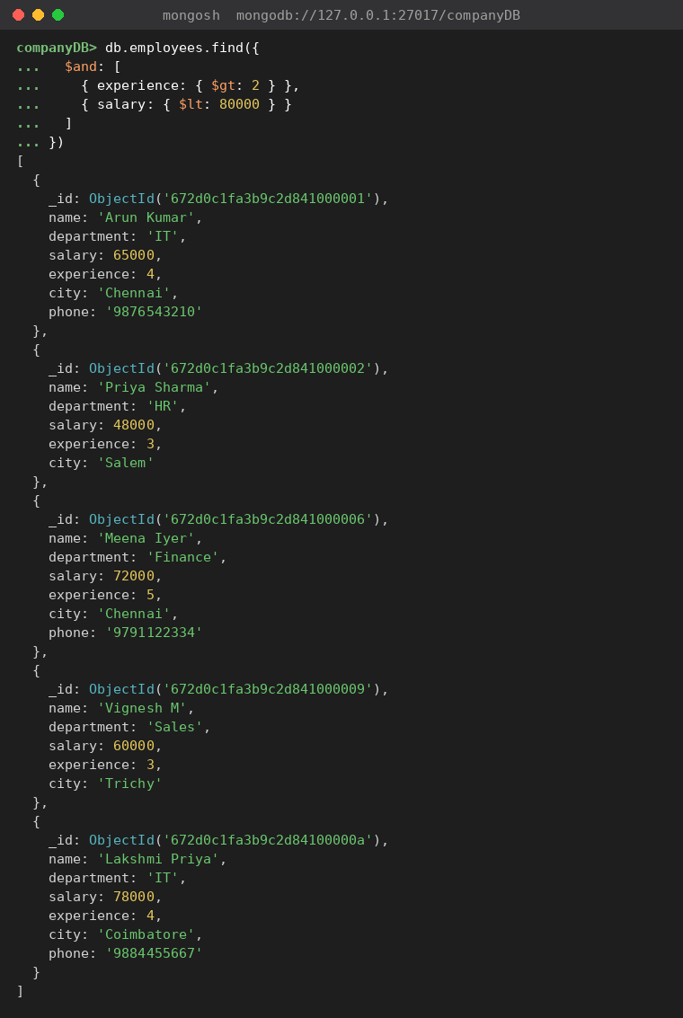

Explanation
$and requires every condition to be true. Five employees satisfy both experience > 2 and salary < 80000. Karthik Raj is excluded by salary and Divya Nair by experience.

Question 4
Find employees belonging to either HR or Finance using $in. Also demonstrate $nin.

Queries
db.employees.find({ department: { $in: ["HR", "Finance"] } })
db.employees.find({ department: { $nin: ["IT", "HR", "Finance"] } })

Output
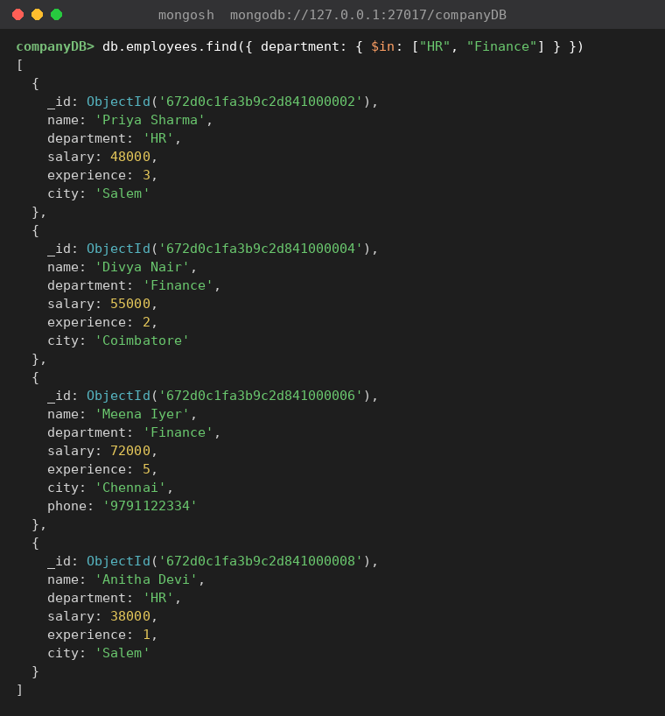
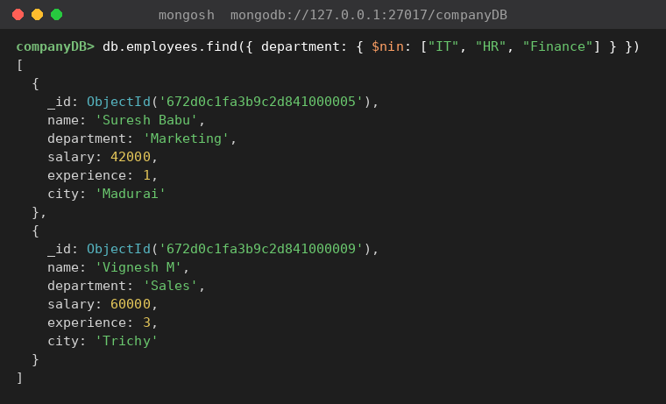

Explanation
$in matches any value in the list (HR or Finance: 4 employees). $nin is the opposite and returns documents whose department is not in the list (here Marketing and Sales).

Question 5
Update one employee's salary using updateOne(). Then increase the salary of all IT employees using $inc and updateMany().

Queries
db.employees.updateOne(
{ name: "Priya Sharma" },
{ $set: { salary: 52000 } }
)
db.employees.find({ name: "Priya Sharma" }, { _id: 0, name: 1, salary: 1 })
db.employees.updateMany(
{ department: "IT" },
{ $inc: { salary: 5000 } }
)
db.employees.find({ department: "IT" }, { _id: 0, name: 1, department: 1, salary: 1 })

Output
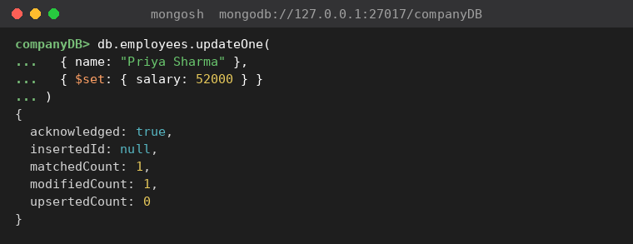
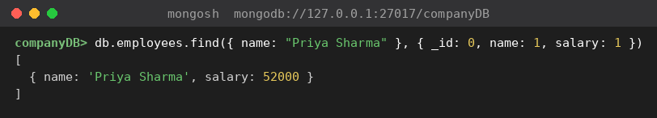
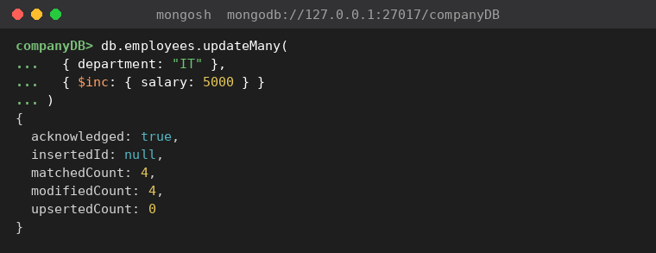
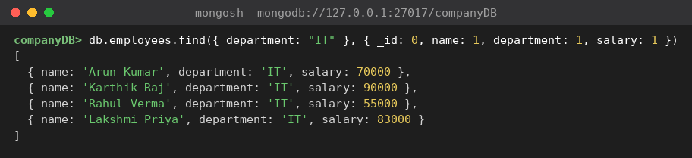

Explanation
updateOne() changes the first matching document only (Priya Sharma: 48000 to 52000). updateMany() with $inc adds 5000 to every IT employee (4 documents modified).

Question 6
Add a status field to selected employees using $set and set it to active.

Queries
db.employees.updateMany(
{ experience: { $gte: 3 } },
{ $set: { status: "active" } }
)
db.employees.find({ status: "active" }, { _id: 0, name: 1, experience: 1, status: 1 })

Output
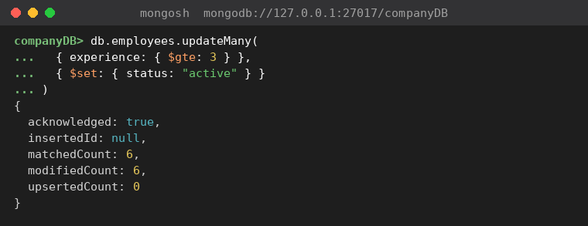
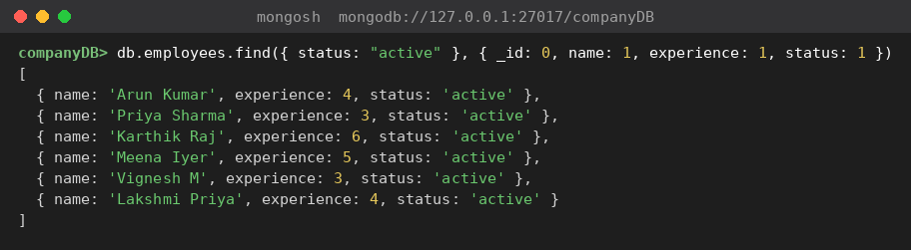

Explanation
$set adds the status field when it does not exist. It was applied to employees with experience of 3 years or more (6 documents).

Question 7
Create a courses collection with at least 6 documents containing courseName, duration, fee and mode. Find courses offered online.

Queries
db.courses.insertMany([
{ courseName: "MongoDB Fundamentals", duration: "4 weeks", fee: 8000, mode: "Online" },
{ courseName: "Python for Data Science", duration: "8 weeks", fee: 15000, mode: "Online" },
{ courseName: "Big Data with Hadoop", duration: "10 weeks", fee: 18000, mode: "Offline" },
{ courseName: "Machine Learning Basics", duration: "12 weeks", fee: 25000, mode: "Offline" },
{ courseName: "Data Visualization with Tableau", duration: "6 weeks", fee: 12000, mode: "Online" },
{ courseName: "Full Stack Web Development", duration: "12 weeks", fee: 20000, mode: "Offline" }
])
db.courses.find({ mode: "Online" })

Output
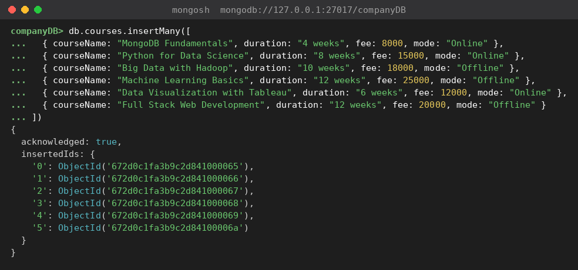
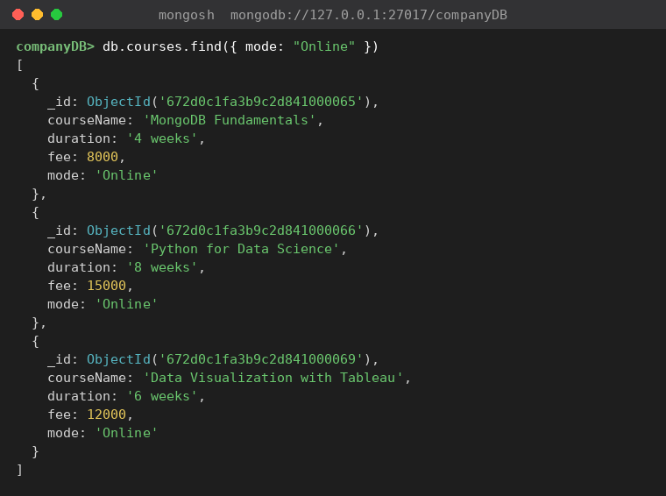

Explanation
The courses collection is created by the first insertMany(). Three of the six courses have mode "Online".

Question 8
Find documents where a particular field exists using $exists. For example, find employees who have a phone field.

Queries
db.employees.find({ phone: { $exists: true } }, { _id: 0, name: 1, phone: 1 })
db.employees.find({ phone: { $exists: false } }, { _id: 0, name: 1 })

Output
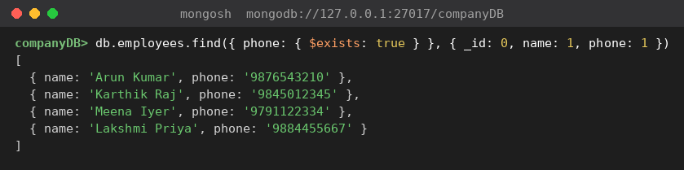
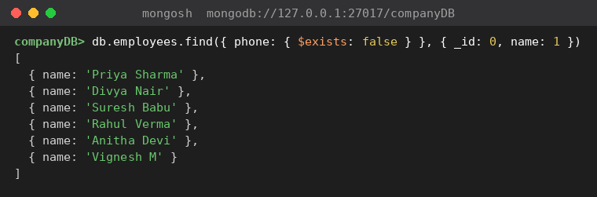

Explanation
{ $exists: true } returns documents that contain the field, even if its value is empty. { $exists: false } returns those without it.

Question 9
Use projection to display only name, department and salary from employees while hiding the MongoDB _id field.

Queries
db.employees.find({}, { _id: 0, name: 1, department: 1, salary: 1 })

Output
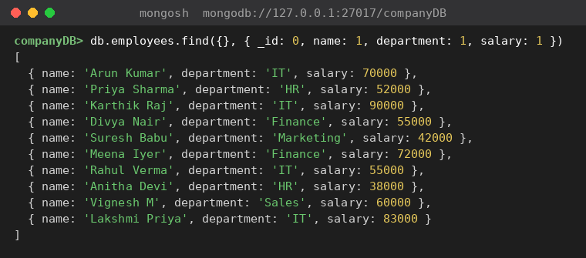

Explanation
In a projection, 1 includes a field and 0 excludes it. _id is included by default, so it has to be hidden explicitly with _id: 0. Salaries reflect the updates made in Question 5.

Question 10
Explain and demonstrate $gt, $gte, $lt, $lte, $eq, and $ne using examples from your collection.

Queries
db.employees.find({ salary: { $gt: 60000 } }, { _id: 0, name: 1, department: 1, salary: 1 })
db.employees.find({ salary: { $gte: 60000 } }, { _id: 0, name: 1, department: 1, salary: 1 })
db.employees.find({ salary: { $lt: 50000 } }, { _id: 0, name: 1, department: 1, salary: 1 })
db.employees.find({ salary: { $lte: 52000 } }, { _id: 0, name: 1, department: 1, salary: 1 })
db.employees.find({ department: { $eq: "HR" } }, { _id: 0, name: 1, department: 1, salary: 1 })
db.employees.find({ department: { $ne: "IT" } }, { _id: 0, name: 1, department: 1, salary: 1 })

Output
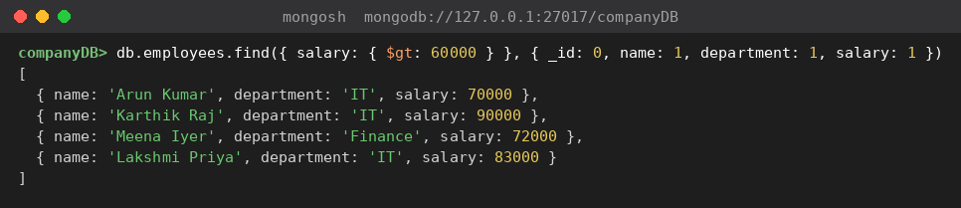
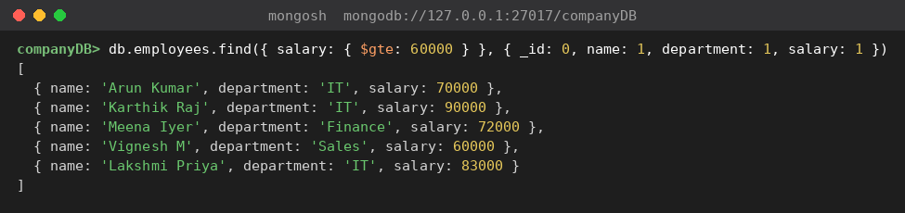
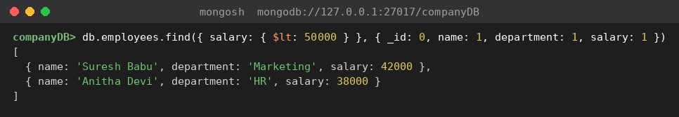
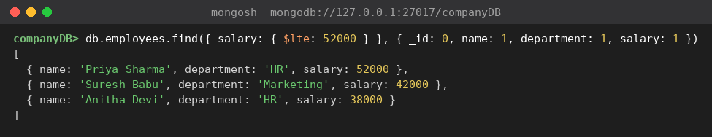
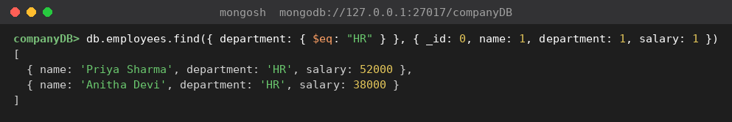
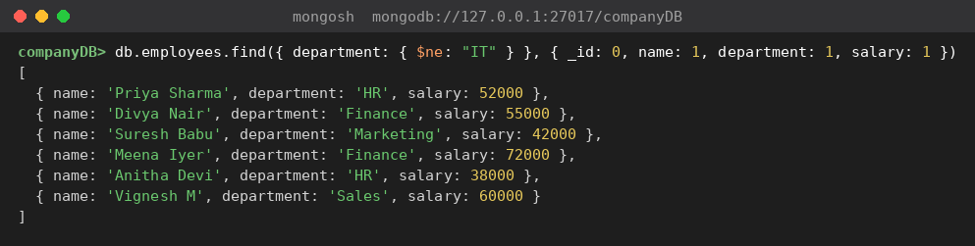

Explanation of each operator
Operator | Meaning | Example used | Result
$gt | Greater than (strict) | salary > 60000 | Arun Kumar, Karthik Raj, Meena Iyer, Lakshmi Priya
$gte | Greater than or equal to | salary >= 60000 | Same four plus Vignesh M (60000)
$lt | Less than (strict) | salary < 50000 | Suresh Babu, Anitha Devi
$lte | Less than or equal to | salary <= 52000 | Priya Sharma (52000), Suresh Babu, Anitha Devi
$eq | Equal to a value | department = HR | Priya Sharma, Anitha Devi
$ne | Not equal to a value | department != IT | All 6 non-IT employees
Note: $gt/$gte and $lt/$lte differ only at the boundary value, which is why Vignesh M (exactly 60000) and Priya Sharma (exactly 52000) appear in the inclusive queries.

