CivilQntify User Manual
Complete Guide to Using the CivilQntify Desktop Application Version 1.0.10
Concrete Mix Design, Particle Size Distribution, Material Quantification, Cost Estimation, and History

Table of Contents
1 Introduction
2 Getting Started
2.1 System Requirements and Installation
2.2 Main Window Overview
2.3 Toolbar Settings and Weather
3 Concrete Mix Design Tab
3.1 Step 1 Design Parameters
3.2 Step 2 Material Properties
3.3 Step 3 Admixtures and Supplementary Cementitious Materials
3.4 Optional Trial and Self-Compacting Checks
3.5 Results and Exports
4 Particle Size Distribution PSD Tab
4.2 Passing Test Results
4.3 Failing Test Results and What They Mean
5 Material Quantification Tab
5.1 Design Mix Proportions Mode
5.2 Mix Ratios and Volume Mode
6 Cost Estimation Tab
7 History Tab
8 Reports and Data Exchange
9 Command Line Workflow
10 Design Standards Referenced
11 Troubleshooting

1 Introduction
Back to TOC
This manual explains how to use every feature of the CivilQntify desktop application through its graphical user interface. It is written for civil engineers, concrete technologists, quantity surveyors, and students who proportion concrete mixes, check aggregate grading, quantify structural materials, estimate project cost, and review saved work.
CivilQntify automates mix proportioning to three design codes, ACI 211.1-22, IS 10262:2019, and BRE 331:1997 DOE method, analyses aggregate particle size distribution against IS 383:2016 or ASTM C33/C33M grading bands, computes material bills for structural elements or work volumes, estimates cost in Ghana cedis (GHc), and keeps a searchable history of every calculation with PDF, CSV, JSON, and text exports.
The fastest way to work is Mix Design to Material Quantification to Cost Estimation, using the Send buttons that carry results forward. Each tab also works standalone when quantities or prices are entered manually. Figures in this manual are screenshots of the running application.

2 Getting Started
Back to TOC

2.1 System Requirements and Installation
Back to TOC
- Operating system: Windows 10 or later, Ubuntu 22.04 or later, or macOS 13 or later.
- Python 3.10 or later with the project requirements installed, or the packaged CivilQntify installer.
- Launch the graphical interface with python main.py from the project folder, or use python main_cli.py for the interactive command line workflow.

2.2 Main Window Overview
Back to TOC
The main window has a top toolbar, a tab bar with four tabs, and a status bar. The toolbar holds the Weather button and the settings gear. The tabs are Mix Design, Material Quantification, Cost Estimation, and History. The status bar at the bottom confirms actions such as transfers and exports.
- Mix Design: proportion concrete mixes and analyse aggregate grading on two inner tabs, PSD and Concrete Mix Design.
- Material Quantification: convert a mix into material bills by volume, elements, or nominal mix ratios.
- Cost Estimation: price the bill with manual material rates and overheads.
- History: find, reload, and export any past calculation.
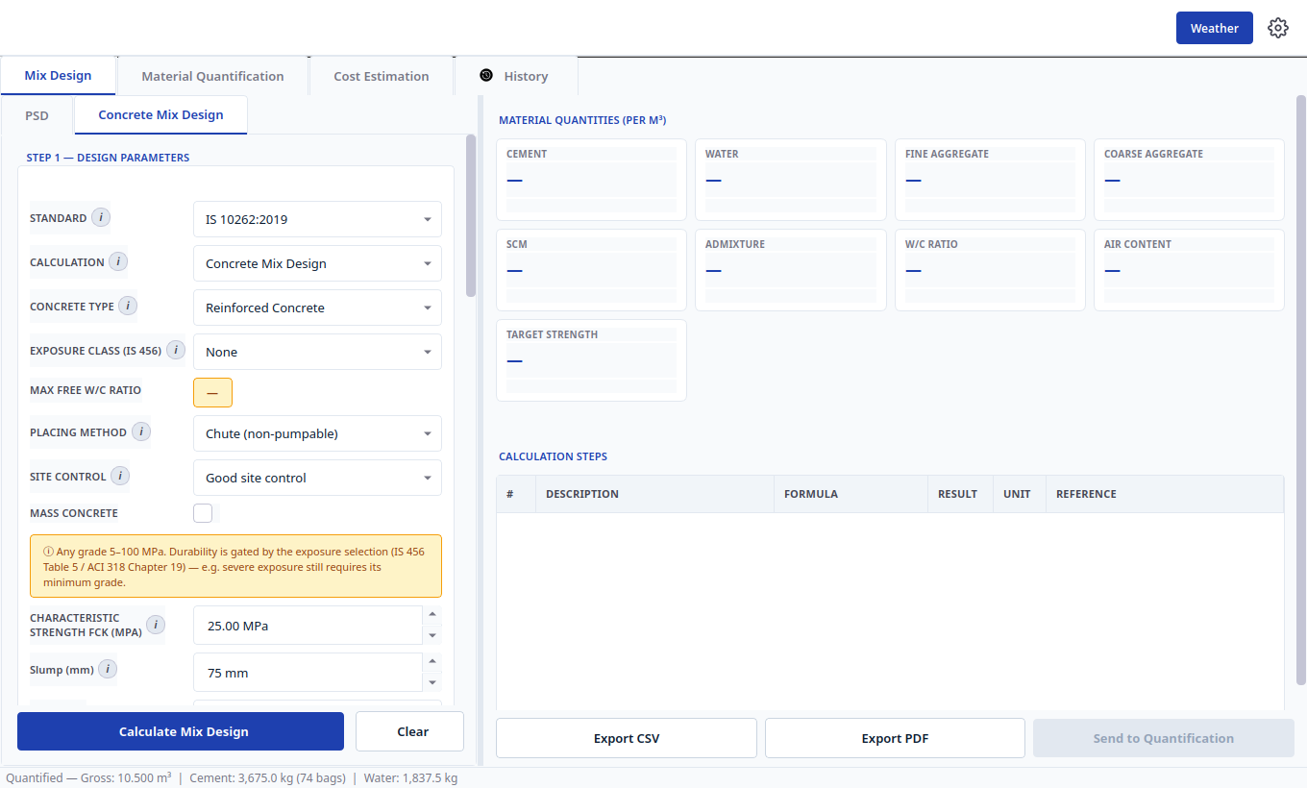
Figure 1. Main window on the Mix Design tab with the Concrete Mix Design inner tab open.

2.3 Toolbar Settings and Weather
Back to TOC
Select the gear icon at the top right to open Settings. The dialog controls the unit system, Metric or Imperial, and the visibility of the Weather button. Unit choices relabel every quantity spin box across the application. Select the Weather button to open the weather panel, which shows current temperature and humidity for the selected Ghana city with concreting advice for hot or cold weather placing.
- Open Settings with the gear icon, change units or weather visibility, then select Apply.
- Open weather with the Weather button, pick a city, and read the placing advice before scheduling a pour.

3 Concrete Mix Design Tab
Back to TOC
Open the Mix Design tab and choose the Concrete Mix Design inner tab. The left panel is a scrollable form in three steps plus optional checks. The right panel shows material quantity cards, the target strength card, the step by step calculation table with formula, result, unit, and standard reference columns, and the action buttons Export CSV, Export PDF, and Send to Quantification.

3.1 Step 1 Design Parameters
Back to TOC
1. Standard: select IS 10262:2019, ACI 211.1-22, or DOE BRE 331:1997. Exposure, water content, and aggregate tables follow the selected code.
2. Calculation: select Concrete Mix Design for normal proportioning or Strength Prediction to reverse calculate 28 day strength from a water cement ratio.
3. Concrete Type: select Plain, Reinforced, or Prestressed. Durability limits follow the choice.
4. Exposure Class (IS 456): select the exposure condition, for example Mild, Moderate, Severe, or None. Minimum grade and maximum free water cement ratio are gated by this selection.
5. Max Free W/C Ratio: read only display of the durability cap for the chosen exposure.
6. Placing Method: select Chute non-pumpable or Pumpable, which adjusts water and aggregate inputs.
7. Site Control: select Good or Poor site control, which sets the assumed standard deviation used in target strength.
8. Mass Concrete: tick for mass pours, which applies Annex F adjustments.
9. Characteristic Strength fck (MPa): enter the specified 28 day strength, 5 to 100 MPa.
10. Slump (mm): enter the required workability.
11. Select Calculate Mix Design to run the design, or Clear to reset the form.

3.2 Step 2 Material Properties
Back to TOC
Enter cement type and grade, specific gravities of cement, fine aggregate, and coarse aggregate, water absorption and free moisture of each aggregate, nominal maximum size of coarse aggregate, fineness modulus or zone, and air content where applicable. Moisture entries correct batch water automatically. Select an information icon beside any field for the standard clause behind it.

3.3 Step 3 Admixtures and Supplementary Cementitious Materials
Back to TOC
Enter superplasticizer dosage with its water reduction percentage (IS 10262 Annex G), and fly ash or GGBS replacement percentage with its efficiency factor. The engine recomputes cementitious content, water content, and paste volume, and the calculation steps table cites each adjustment.

3.4 Optional Trial and Self-Compacting Checks
Back to TOC
The Trial Check group (ACI Section 5.3.10) accepts a trial water cement ratio to compare against the design value. The SCC fresh property group (IS) checks slump flow, V-funnel, and L-box criteria. Trial mix workbooks for DOE Section 6 and ACI Appendix A.5 open from the result panel after a design, with batch schedule, feedback inputs, density correction, and the verdict of minor adjustment or second trial.

3.5 Results and Exports
Back to TOC
- Material cards: read cement, water, fine aggregate, coarse aggregate, SCM, admixture, water cement ratio, air content, and target strength per cubic metre.
- Calculation Steps table: audit every step with its formula and standard reference.
- Export CSV: save the quantities and steps for site logs. Export PDF: preview the formatted report, then save it with embedded inputs, steps, and charts.
- Send to Quantification: transfer the per cubic metre mix into the Material Quantification tab and continue to Section 5.

4 Particle Size Distribution PSD Tab
Back to TOC
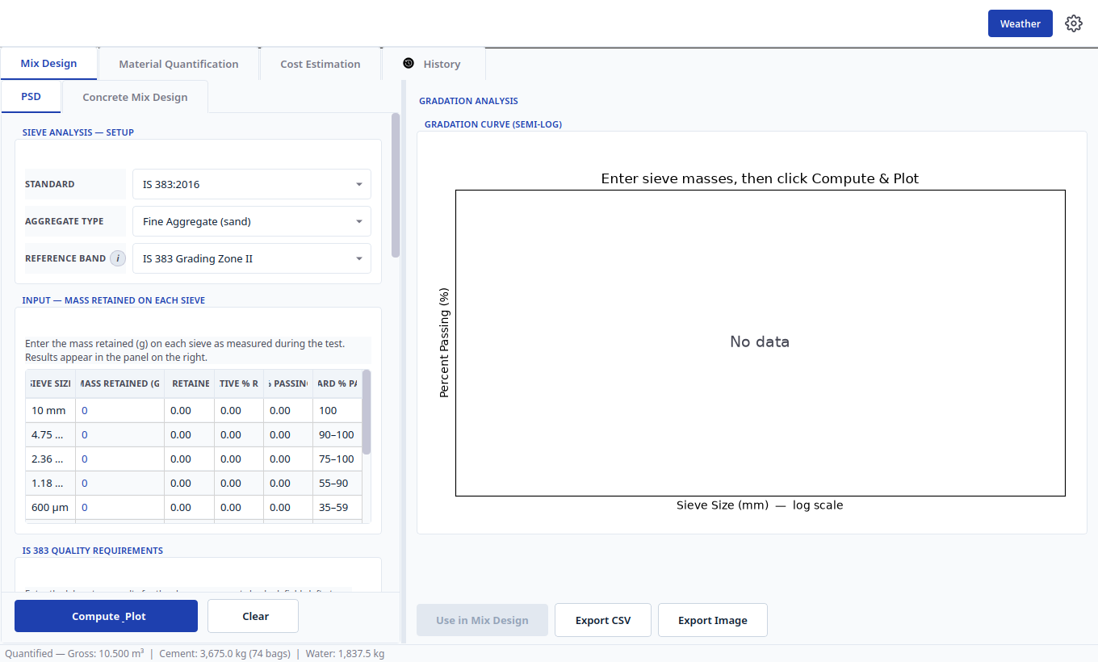
Figure 2. PSD inner tab with sieve setup on the left and the semi-log gradation curve on the right.
Open the PSD inner tab inside Mix Design before designing a mix when sieve data is available, because derived values can feed the mix form. The left panel holds Sieve Analysis Setup, the retained mass input table, and quality requirements. The right panel shows the gradation curve, the results summary, and the action buttons Use in Mix Design, Export CSV, and Export Image.
1. Standard: select IS 383:2016 or ASTM C33/C33M. Never mix sieve series and limits across standards; rows and bands always follow this selector.
2. Aggregate Type: select Fine Aggregate (sand) or Coarse Aggregate.
3. Reference Band: select the grading reference, for example IS 383 Grading Zone II for sand, or the 10 mm, 20 mm, or 40 mm coarse bands which map to ASTM Sizes 8, 67, and 467.
4. Input table: enter the mass retained in grams on each sieve exactly as weighed. IS fine work uses a 10 mm top sieve with Zones I to IV; ASTM fine work uses a 9.5 mm top sieve with the Table 1 envelope; coarse tables list the full Table 7 or Table 2 sieve series.
5. Select Compute and Plot. The app computes percent retained, cumulative passing, fineness modulus, D10, D30, D60, and the zone or envelope verdict, then draws the measured curve over the smoothed standard band on a semi-log plot.
6. Read compliance in the results summary. For ASTM work, select the compliance control to open the full requirement dialog covering grading, deleterious substances, and soundness with exact clause citations.
7. Select Use in Mix Design to lock derived fineness modulus, zone, 600 micron passing, or nominal size into the mix form. Select Clear on the PSD tab to release the lock and restore previous values.
8. Export CSV saves the sieve table and results; Export Image saves the gradation chart.

4.2 Passing Test Results
Back to TOC
The four worked examples below were entered into the running application as laboratory style retained masses, one for fine and one for coarse aggregate under each standard. Every one conforms to its selected band: the results summary shows a green Conforms to selected band banner, the measured curve stays inside the shaded standard band, D10, D30, and D60 markers are drawn on the curve, and the status bar confirms that all applicable requirements were checked with no non-conformance found.
Case | Standard and Reference Band | Sample Mass | Application Result
Fine sand, IS 383 Zone II | IS 383:2016, Grading Zone II | 1000 g total | Fineness modulus 2.74, Zone II, conforms
Fine sand, ASTM Table 1 | ASTM C33/C33M, Fine Table 1 | 1000 g total | Fineness modulus 2.80, conforms
Crushed stone, IS graded 20 mm | IS 383:2016 Table 7, graded 20 mm | 5000 g total | D60 12.5 mm, conforms
Crushed stone, ASTM Size 67 | ASTM C33/C33M Table 2, Size 67 (20 mm) | 5000 g total | D60 11.5 mm, conforms

Retained masses used, coarsest sieve first with the pan catch last. IS 383 fine Zone II (10, 4.75, 2.36, 1.18, 600 micron, 300 micron, 150 micron): 0, 50, 70, 160, 250, 280, 140 g with a 50 g pan. ASTM C33 fine Table 1 (9.5, 4.75, 2.36, 1.18, 600 micron, 300 micron, 150 micron): 0, 20, 80, 220, 260, 250, 120 g with a 50 g pan. IS 383 coarse graded 20 mm (80 down to 2.36 mm): 0, 0, 0, 250, 750, 1000, 1000, 1750, 200 g with a 50 g pan. ASTM C33 coarse Size 67 (100 mm down to 300 micron): 0, 0, 0, 0, 0, 0, 0, 250, 1250, 1600, 1650, 150, 50, 0 g with a 50 g pan.
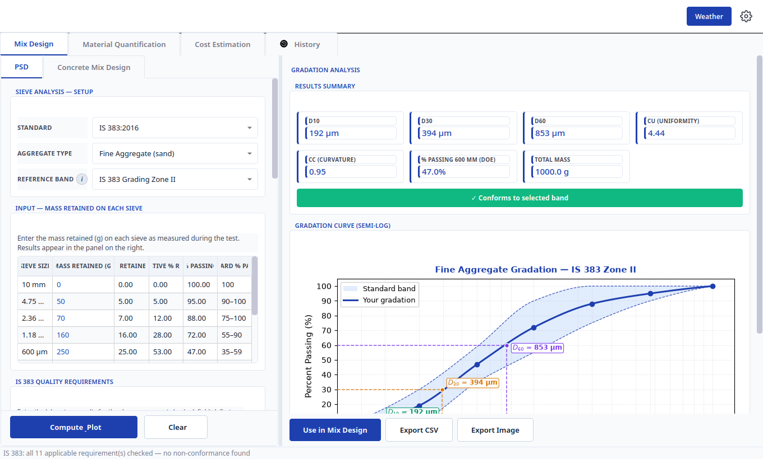
Figure 3. Passing result for IS 383 fine aggregate, Zone II. Green banner, curve inside the band, and D10, D30, D60 markers.
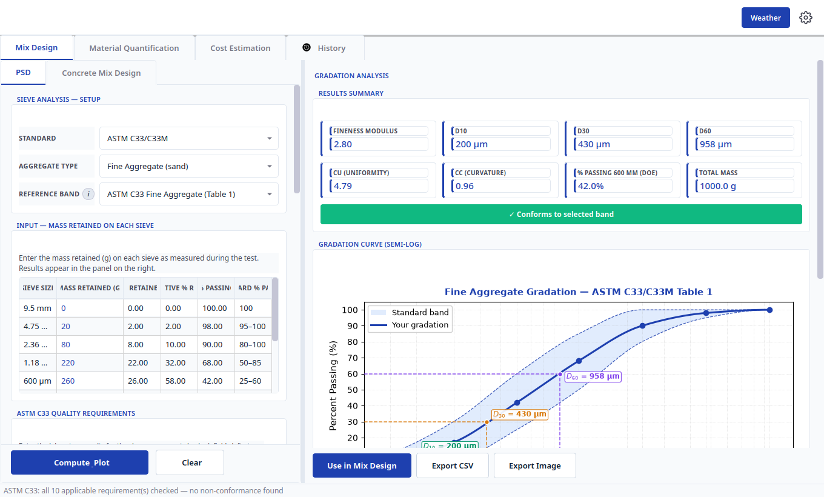
Figure 4. Passing result for ASTM C33 fine aggregate, Table 1, with fineness modulus 2.80.
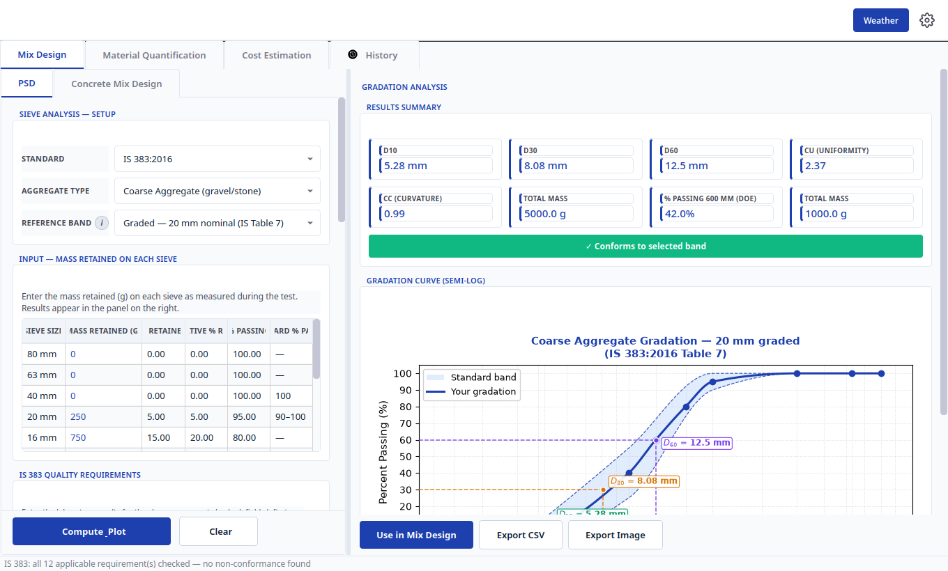
Figure 5. Passing result for IS 383 coarse aggregate, graded 20 mm nominal, Table 7.
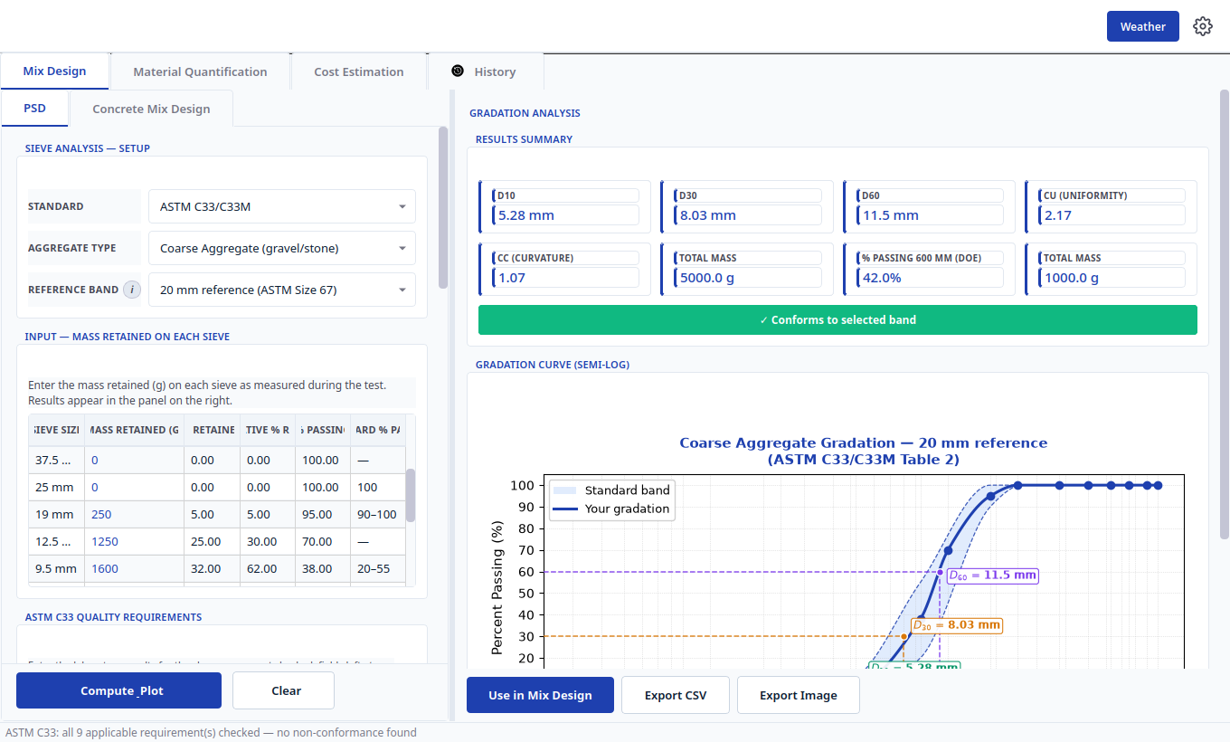
Figure 6. Passing result for ASTM C33 coarse aggregate, 20 mm reference Size 67, Table 2.
To repeat any passing test, select the standard, aggregate type, and reference band exactly as shown in the figure, type the retained masses into the input table, and select Compute and Plot. Select Use in Mix Design to lock the derived values into the mix form, Export CSV for the sieve record, or Export Image for the chart.

4.3 Failing Test Results and What They Mean
Back to TOC
A non-conforming sample is unmistakable. The results summary shows a red banner counting the sieves out of band, the offending points on the curve are marked with red crosses outside the shaded band, and a compliance dialog opens automatically, citing the exact clause and the measured value against the limit. Two failing examples, one per standard, are shown below.

IS 383 Fine Aggregate Failure, Too Coarse
Retained masses 0, 150, 250, 300, 200, 80, 15 g with a 5 g pan (1000 g total) give passing values of 85, 60, 30, 10, 2.0, and 0.5 percent against Zone II minima of 90, 75, 55, 35, 8, and 0 percent. Five sieves fall out of band, the fineness modulus rises to 4.12, and the dialog reports that Clause 6.3 Table 9 is not met, naming each sieve with its measured passing value.
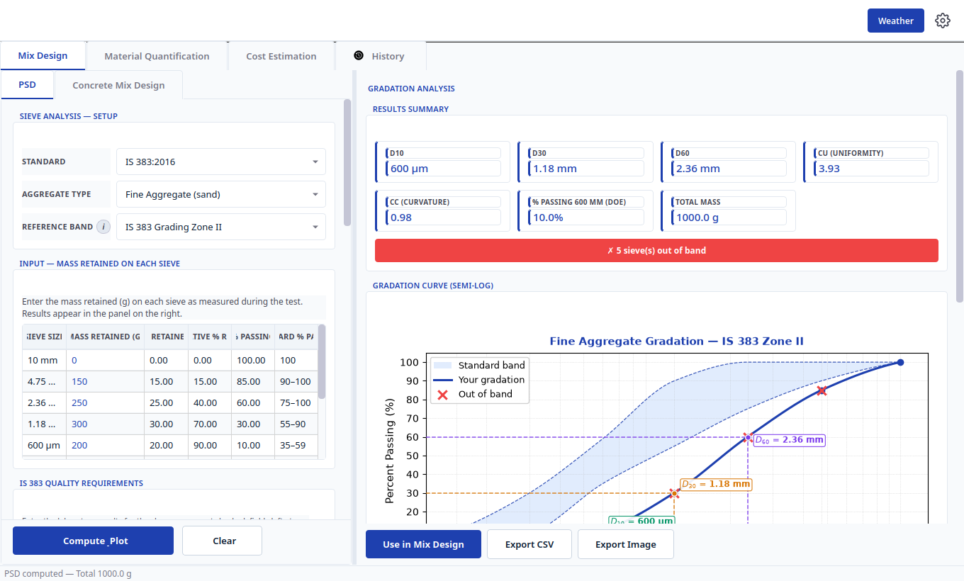
Figure 7. Failing IS 383 Zone II sand. Red banner counts five sieves out of band and red crosses mark the breaches.
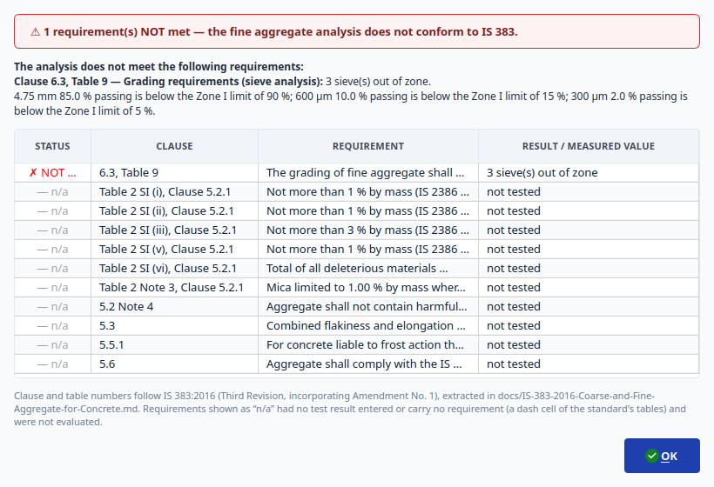
Figure 8. IS 383 compliance dialog. Clause 6.3 Table 9 is cited with measured passing values per sieve.

ASTM C33 Coarse Aggregate Failure, Too Fine
Retained masses of 100 g on 19 mm, 300 g on 12.5 mm, 900 g on 9.5 mm, 1500 g on 4.75 mm, 1200 g on 2.36 mm, 600 g on 1.18 mm, and 200 g on 300 micron with a 200 g pan (5000 g total) give 74 percent passing 9.5 mm against a 20 to 55 percent limit, 44 percent passing 4.75 mm against a 0 to 10 percent limit, and 20 percent passing 2.36 mm against a 0 to 5 percent limit. Three sieves fall out of band and the dialog cites Clause 10.1 Table 2 with the measured values.
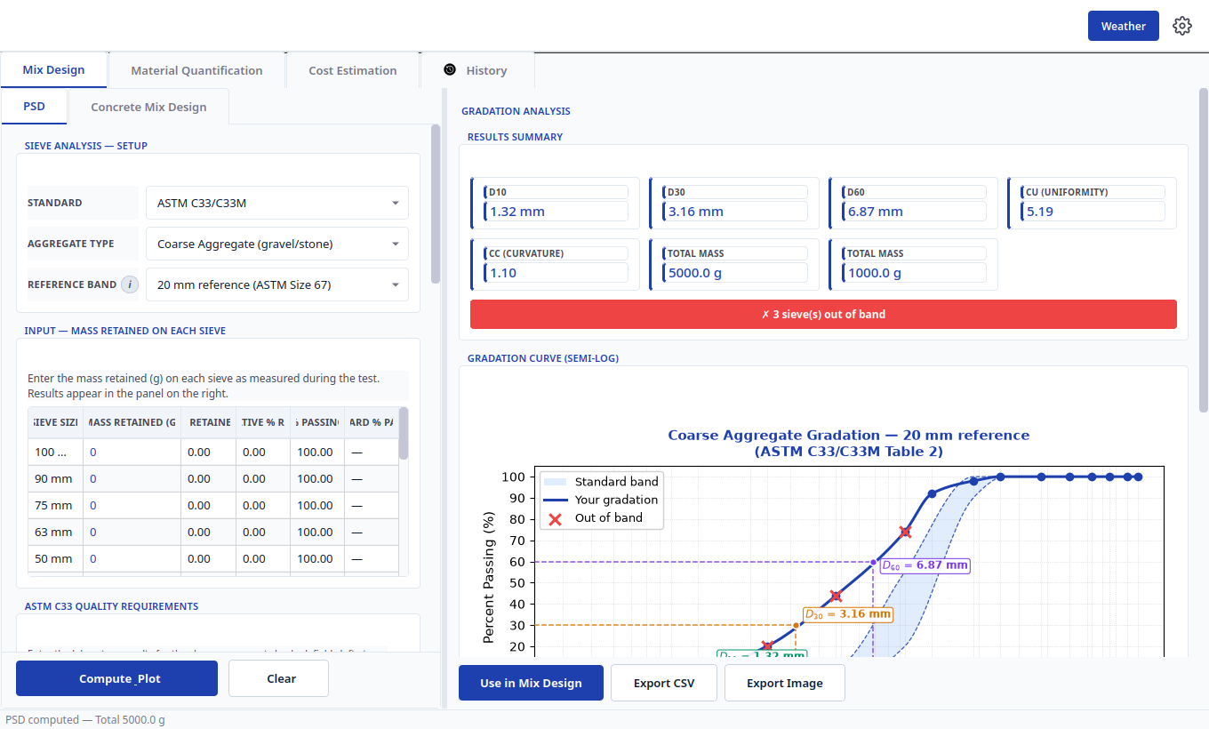
Figure 9. Failing ASTM Size 67 stone. The excess fines pull the curve left of the band with three sieves out.
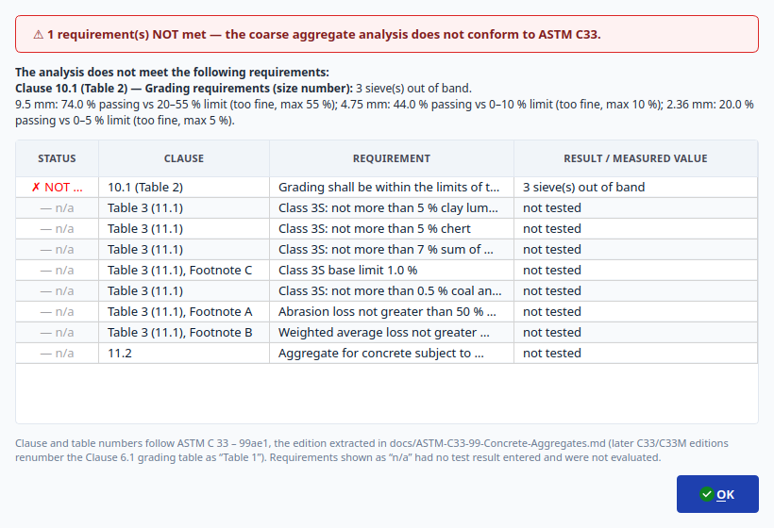
Figure 10. ASTM C33 compliance dialog. Clause 10.1 Table 2 is cited with measured values and the too fine verdict.
When a result fails, select OK to close the dialog and read the red banner and curve markers. Do not transfer failing values with Use in Mix Design until the material position is resolved. The standard site responses are to retest a fresh sample, blend with a complementary stockpile and re-run the analysis, or reject the delivery. Rows marked n/a in the dialog had no test result entered and were not evaluated.

5 Material Quantification Tab
Back to TOC
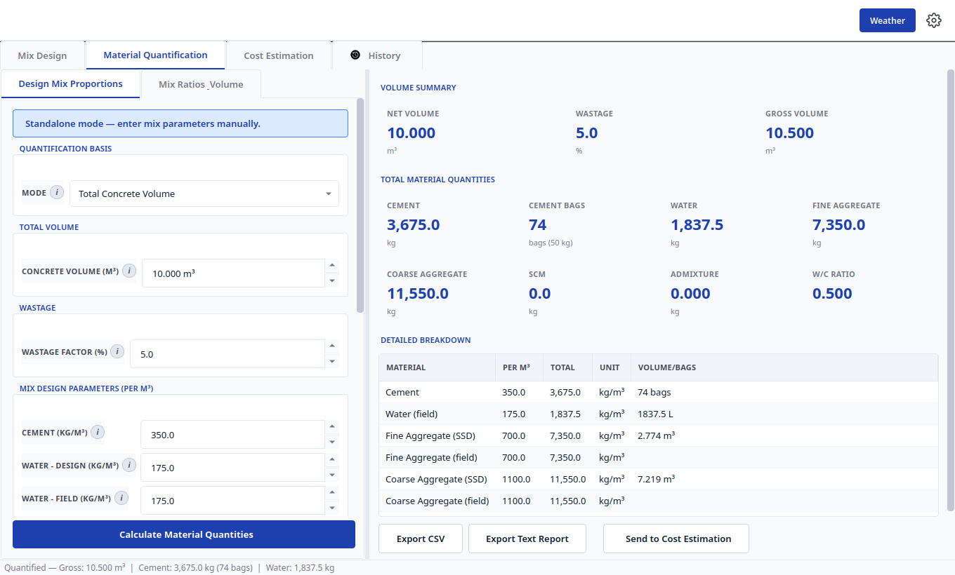
Figure 11. Material Quantification on Design Mix Proportions with volume summary and detailed breakdown.
Open the Material Quantification tab to turn a mix into a site bill. It has two inner tabs. Design Mix Proportions uses an engineered per cubic metre mix, either transferred from Mix Design or typed manually. Mix Ratios and Volume uses a nominal Cement to Sand to Coarse Aggregate ratio with a work volume.

5.1 Design Mix Proportions Mode
Back to TOC
1. Quantification Basis, Mode: select Total Concrete Volume or Structural Elements. In Elements mode, add slabs, beams, columns, footings, walls, retaining walls, and staircases with dimensions; the app totals the net volume.
2. Total Volume: enter the concrete volume in cubic metres.
3. Wastage: enter the wastage factor percent, typically 5 percent; gross volume equals net volume plus wastage.
4. Mix Design Parameters (per cubic metre): confirm or type cement, design water, field water, fine and coarse aggregate, SCM, and admixture. Transferred mixes arrive filled; standalone work starts from the defaults.
5. Select Calculate Material Quantities. Read Net Volume, Wastage, and Gross Volume, then the total cards for cement, cement bags, water, fine and coarse aggregate, SCM, admixture, and water cement ratio, then the Detailed Breakdown table with per cubic metre, total, unit, and volume or bag columns.
6. Export CSV or Export Text Report for the site, or select Send to Cost Estimation to carry the bill forward.

5.2 Mix Ratios and Volume Mode
Back to TOC
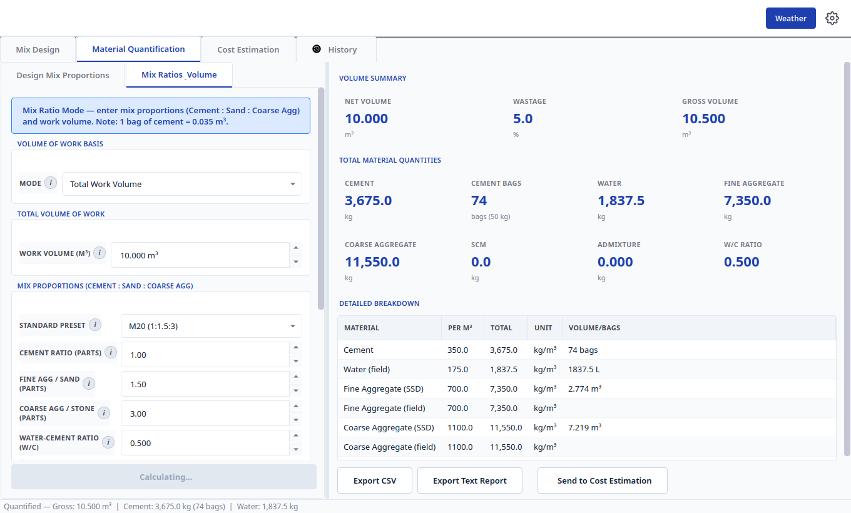
Figure 12. Mix Ratios and Volume mode with a nominal 1 to 1.5 to 3 preset and work volume basis.
Select the Mix Ratios and Volume inner tab, choose Total Work Volume or Elements for the volume basis, enter the work volume, then set Cement to Sand to Coarse Aggregate parts directly or from a standard preset such as M20 (1:1:1.5:3). Enter the water cement ratio and factors such as dry volume factor and bag volume (1 bag equals 0.035 cubic metres). Select Calculate, then export or send to Cost Estimation exactly as in Section 5.1.

6 Cost Estimation Tab
Back to TOC
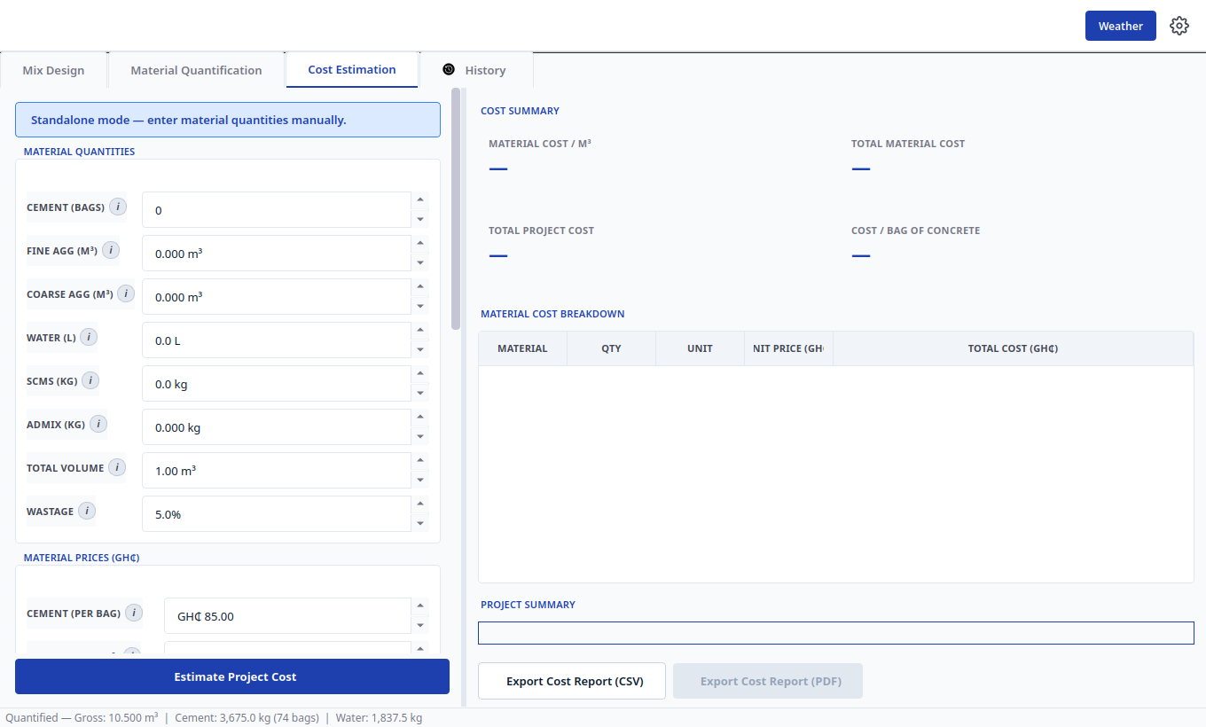
Figure 13. Cost Estimation with material quantities, prices in Ghana cedis, and summary cards.
Open the Cost Estimation tab to price the bill. A banner states whether quantities arrived from Quantification or are being entered manually in standalone mode. The left panel holds Material Quantities, Material Prices (GHc), Additional Costs, and Project Information. The right panel shows the Cost Summary cards, the Material Cost Breakdown table, the Project Summary, and the export buttons.
1. Material Quantities: confirm transferred cement bags, fine and coarse aggregate volumes, water, SCMs, admixture, total volume, and wastage, or type them manually in standalone mode.
2. Material Prices (GHc): enter cement per bag, sand and gravel per cubic metre, water, and admixture rates.
3. Additional Costs: enter labour, transport, overheads, profit, and contingency as amounts or percentages.
4. Project Information: enter project name, client, location, and notes for the report header.
5. Select Estimate Project Cost. Read Material Cost per cubic metre, Total Material Cost, Total Project Cost, and Cost per Bag of Concrete, with the line by line breakdown table beneath.
6. Select Export Cost Report (CSV) or Export Cost Report (PDF) to save the priced bill.

7 History Tab
Back to TOC
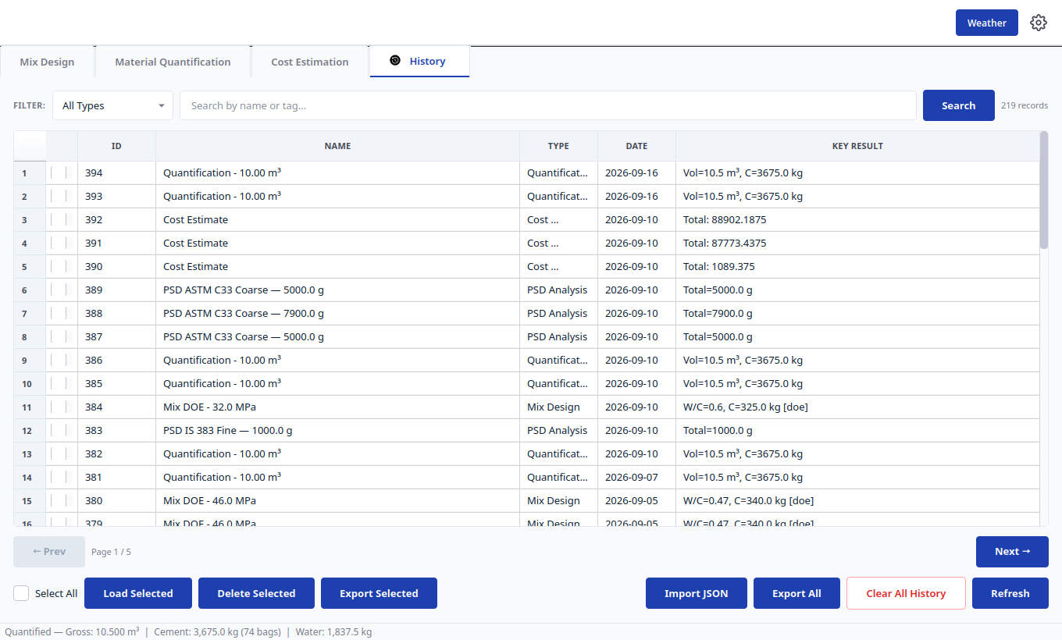
Figure 14. History tab with type filter, search, records table, pagination, and batch actions.
Open the History tab to audit and reuse past work. Every Mix Design, PSD Analysis, Quantification, Cost Estimate, and DOE or ACI trial mix is stored in the local SQLite database with its inputs and key result.
- Filter: restrict the table by record type with the drop down, then type a name or tag and select Search.
- Records table: read ID, name, type, date, and key result columns. Page with Prev and Next; 50 records show per page.
- Select All and row checkboxes: tick records, then Load Selected to reopen one record back in its tab, Delete Selected to remove them, or Export Selected to save them.
- Import JSON and Export All: move records between machines or archive the full log.
- Clear All History: remove every record after confirmation. Refresh: reload after external changes.
- Double select any row to open the detail dialog with full inputs, results, and parent links for trial mixes chained to their design record.

8 Reports and Data Exchange
Back to TOC
Format | Where It Is Created | What It Contains
PDF report | Mix Design Export PDF, Cost Export Cost Report (PDF) | Formatted inputs, step by step calculations, quantity and cost tables, and charts.
CSV | Every tab Export CSV | Machine readable quantities, steps, sieve tables, or cost lines for spreadsheets and site logs.
JSON | History Export and Import | Full record payloads for backup, transfer, and audit.
Text report | Quantification Export Text Report | Plain text bill of materials for printing and messaging.
Image | PSD Export Image | Gradation curve chart for reports and presentations.

Always preview a PDF before saving. File dialogs default to descriptive names such as mix_design_report.pdf; rename per project before saving.

9 Command Line Workflow
Back to TOC
Run python main_cli.py for an interactive terminal workflow that mirrors the GUI: design a mix to ACI 211.1 or IS 10262, answer the handoff prompt, then quantify materials with editable overrides. The CLI is suited to remote servers and batch checks, while the GUI remains the primary route for charts, PSD curves, and formatted PDF reports.

10 Design Standards Referenced
Back to TOC
Calculations cite their clauses on screen and in reports. The three proportioning codes are ACI PRC-211.1-22 for normal and high density concrete, IS 10262:2019 with IS 456 exposure limits for Indian practice, and BRE 331:1997 DOE method for British practice. Aggregate grading follows IS 383:2016 Table 7 and Table 9 or ASTM C33/C33M Tables 1 and 2. Target strength rounds up to the whole megapascal as a conservative application policy.
Task | Reference
Target strength | IS 10262 Clause 7.1 Tables 1 and 2; BRE Section 5.1 Figure 3
Water cement ratio | ACI Sections 5 and 9; IS Table 8 Figure 1; BRE Figure 4 Section 9.3
Water content | ACI Table 5.3.3; IS Tables 7 and 12; BRE Tables 3 and 9
Aggregate proportions | ACI Tables 5.3.3 to 5.3.6; IS Tables 10 and 13; BRE Figure 6
Admixtures and SCMs | IS Annex G and Annex E; ACI Section 6.3
Moisture correction | ACI Section 9.3.8; IS Annex D-9.1
Trial batches | ACI Section 9.3.9 Appendix A.5; IS Sections 9 Annexes D E F; BRE Sections 5.6 and 7

11 Troubleshooting
Back to TOC
Symptom | What To Do
Calculate stays disabled | Complete all required fields; check that exposure grade and water cement ratio are consistent.
No PSD fineness modulus | The current standard and aggregate do not consume fineness modulus, or a standard sieve is missing; check the derivation note.
Transfer button greyed out | Run a successful calculation first; Send buttons activate only with a valid result.
Units look wrong | Open the gear Settings dialog and confirm Metric or Imperial before entering values.
History record will not load | Confirm the record type matches the tab; trial mixes chain to a parent design record.
PDF export fails | Choose a writable folder and a simple file name, then retry; confirm ReportLab is installed.

CivilQntify version 1.0.10. For defects or feature requests, attach the exported CSV or JSON record and the PDF report so the calculation can be reproduced.

