CivilQntify User Manual
Concrete Mix Design, Aggregate Grading, Quantification and Costing • Labeled Screenshot Edition
Standards: IS 10262:2019 • ACI PRC-211.1-22 • BRE 331:1997 (DOE) • IS 383:2016 / ASTM C33

How to read this manual
Every screenshot in this manual carries blue numbered badges (1, 2, 3, ...) placed next to the control or section they describe. Directly below each screenshot is a legend table with the same numbers: column 1 repeats the badge number, column 2 names the element, and column 3 explains exactly what that field or section does, which options it offers, and how it affects the calculation. Work through the badges in numerical order and you will have touched every feature of that screen.
Screen layout. The application has four main tabs:
Mix Design (with PSD and Concrete Mix Design sub-tabs), Material Quantification, Cost Estimation, and History. A Weather button and a Settings (unit system) button sit in the top-right toolbar on every screen, and a status bar at the bottom always shows the last action and key results.

1 Mix Design, Step 1: Design Parameters
Open the Mix Design tab, then the Concrete Mix Design sub-tab. Step 1 collects the structural and durability inputs that select the design route through the chosen standard.
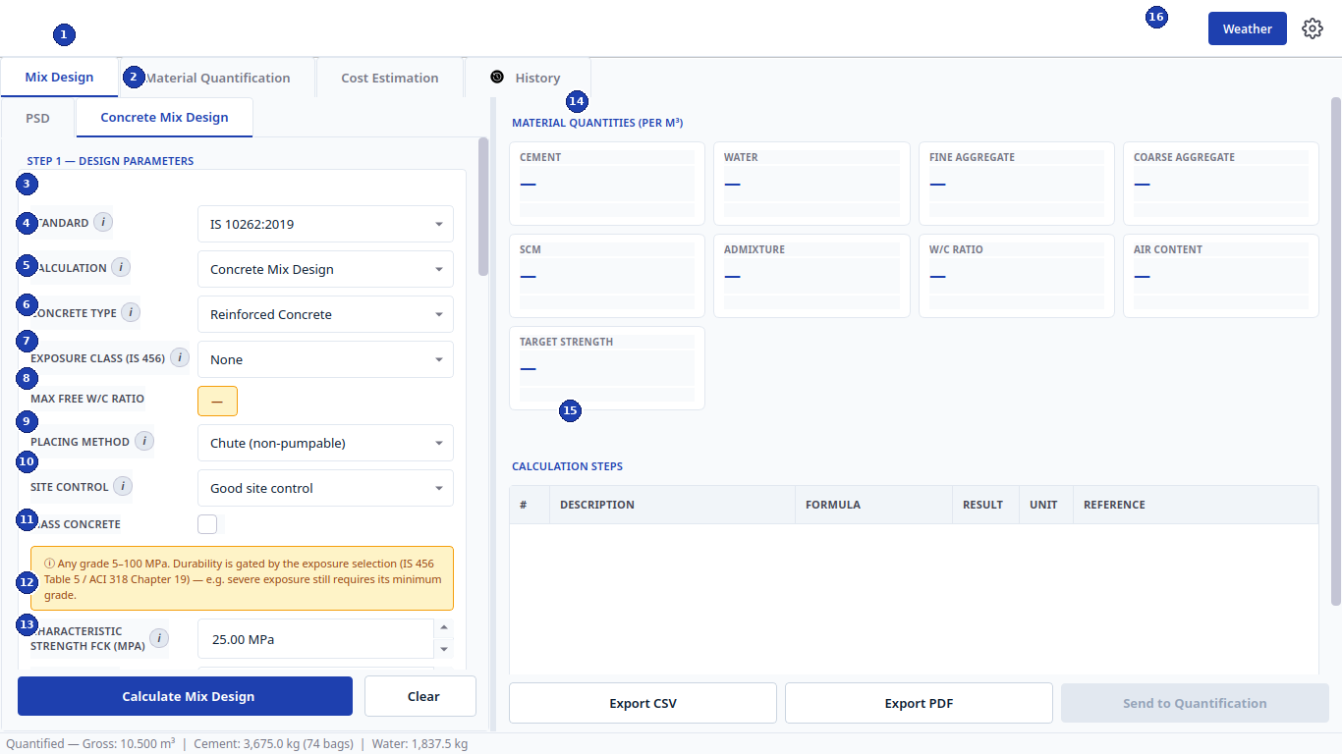
Figure 1 - Mix Design, Step 1 design parameters (left) with empty results panel (right).
Label | Element | Function and how to use it
1 | Main navigation tabs | Switch modules: Mix Design, Material Quantification, Cost Estimation, History. Results flow left to right: a finished mix can be sent to Quantification, and quantified work to Costing.
2 | Sub-tabs: PSD / Concrete Mix Design | PSD runs sieve (gradation) analysis; Concrete Mix Design runs the proportioning calculation. Both live inside the Mix Design tab.
3 | STANDARD | Selects the design code: IS 10262:2019, ACI PRC-211.1-22, or BRE 331:1997 (DOE). Switching standards changes the visible fields, tables, and formulas used downstream.
4 | CALCULATION | Calculation mode, e.g. Concrete Mix Design. Other modes expose target-strength checks. Keep the default unless you are verifying an existing mix.
5 | CONCRETE TYPE | Plain, Reinforced, or Prestressed concrete. The choice gates durability rules (minimum cement, maximum w/c) in IS 456 Table 5 / ACI 318 Chapter 19.
6 | EXPOSURE CLASS (IS 456) | Durability exposure: None, Mild, Moderate, Severe, Very Severe, Extreme. This single choice drives the maximum free water-cement ratio and minimum cement content.
7 | MAX FREE W/C RATIO (auto) | Amber display field, not typed input. Shows the governing durability limit derived from the exposure class. The design w/c can never exceed it.
8 | PLACING METHOD | Chute (non-pumpable) or Pumpable. Pumped mixes need higher fines and adjusted water. DOE Table 3 and IS placing guidance apply.
9 | SITE CONTROL | Good or Fair site control. Sets the assumed standard deviation used for target mean strength (IS 10262 Table 1 / Clause 7.1). Better control lowers the required over-design margin.
10 | MASS CONCRETE checkbox | Tick for dams, rafts, and large pours. Follows the IS 10262 Annex F low-heat route (blended cements, lower cement content).
11 | Durability note banner | Reminder that any grade from 5 to 100 MPa is allowed but durability still gates the minimum grade (IS 456 Table 5 / ACI 318 Chapter 19). Read it before overriding exposure.
12 | CHARACTERISTIC STRENGTH FCK (MPa) | Specified 28-day strength, default 25.00 MPa. The engine computes target mean strength f'ck = fck + 1.65 x S (rounded up to whole MPa per app policy).
13 | Slump row with Calculate / Clear | Slump (mm) sets workability and water demand (default 75 mm). Below it, Calculate Mix Design runs the engine; Clear resets the form. Buttons for Step 2/3 sit further down the scroll.
14 | MATERIAL QUANTITIES result cards | After calculation each card shows one quantity per cubic metre: cement, water, fine and coarse aggregate, SCM, admixture, w/c ratio, air content, target strength. Dashes mean no calculation yet.
15 | CALCULATION STEPS table | Step-by-step audit trail with columns #, Description, Formula, Result, Unit, Reference. Below the table, Export CSV and Export PDF save the design; Send to Quantification pushes the mix into the next tab.
16 | Weather and Settings toolbar | Weather opens live site-weather and concreting advice; the gear opens Unit Settings (Metric vs American Imperial, WeatherAPI key, build info).

2 Mix Design, Step 2: Material Properties
Scroll the left panel down to Step 2. These are the laboratory properties of your actual materials. Defaults suit typical Ghanaian/Indian materials; overwrite them with test values for a job mix.
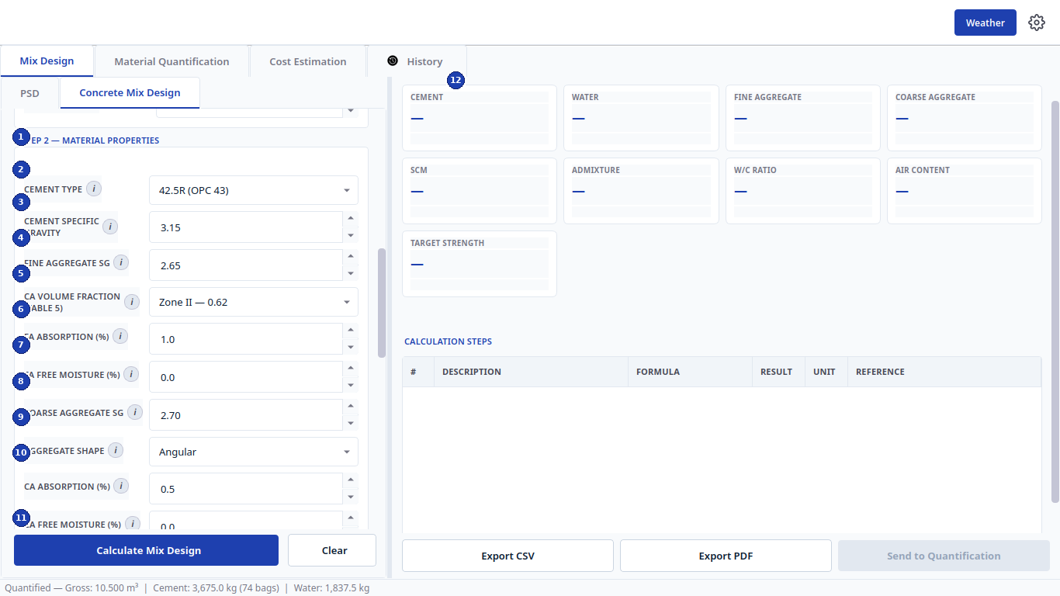
Figure 2 - Mix Design, Step 2 material properties.
Label | Element | Function and how to use it
1 | STEP 2 header | Marks the start of material-property inputs. Everything below feeds the absolute-volume equation.
2 | CEMENT TYPE | Cement grade/brand, e.g. 42.5R (OPC 43). Selects default specific gravity and strength curves.
3 | CEMENT SPECIFIC GRAVITY | Default 3.15 for OPC. Change only from a lab test (Le Chatelier flask). Directly scales cement volume.
4 | FINE AGGREGATE SG | Specific gravity of sand, default 2.65. Used in the absolute-volume split between paste and aggregates.
5 | CA VOLUME FRACTION (TABLE 5) | Dry-rodded coarse aggregate volume per IS 10262 Table 5 for the selected Zone and NMSA, e.g. Zone II - 0.62. Higher values mean more stone, less sand.
6 | FA ABSORPTION (%) | Water absorbed into sand pores (SSD basis), default 1.0%. Used for field-moisture correction.
7 | FA FREE MOISTURE (%) | Surface water carried on site sand, default 0.0%. Positive values reduce added mixing water and increase field sand weight.
8 | COARSE AGGREGATE SG | Specific gravity of stone, default 2.70. Same volumetric role as fine SG.
9 | AGGREGATE SHAPE | Angular, Sub-angular, Rounded, Flaky. Adjusts water demand and packing (DOE aggregate classification, BRE 331 Tables 2-3).
10 | CA ABSORPTION (%) | Stone absorption, default 0.5%. Same correction role as fine absorption.
11 | CA FREE MOISTURE with action buttons | Surface water on stone. Below it: Calculate Mix Design runs the full design; Clear resets all three steps.
12 | Results panel | Right side shows quantity cards, the calculation-steps audit table, and Export CSV / Export PDF / Send to Quantification (enabled after a successful run).

3 Mix Design, Step 3: Admixtures, Trial Check and SCC
Keep scrolling to Step 3. Superplasticizer and supplementary cementitious materials are optional; the trial and SCC check groups are verification aids, not replacements for laboratory trials.
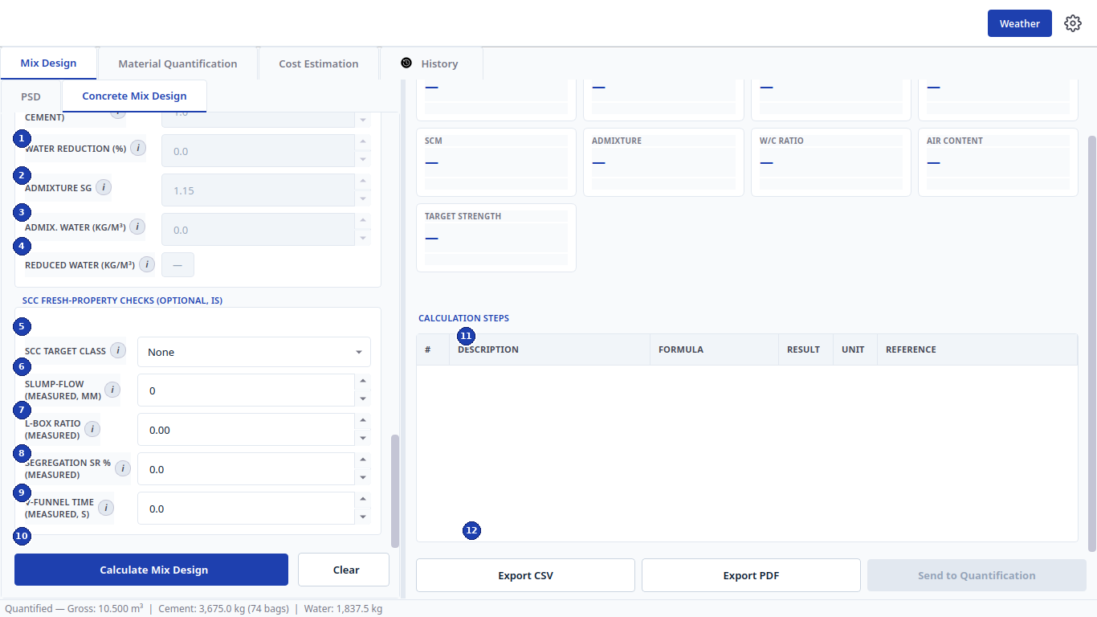
Figure 3 - Step 3 admixtures (top) and optional SCC fresh-property checks (bottom).
Label | Element | Function and how to use it
1 | WATER REDUCTION (%) | Percentage of mixing water saved by the superplasticizer, e.g. 0.0 with no admixture. Reduces water while holding workability.
2 | ADMIXTURE SG | Specific gravity of the admixture liquid, default 1.15. Converts admixture mass to volume in the absolute-volume balance.
3 | ADMIX. WATER (KG/M3) | Water contributed by the liquid admixture itself. Subtracted from added water so w/c stays exact.
4 | REDUCED WATER (KG/M3, auto) | Display of final mixing water after reduction. Amber/grey display, not typed.
5 | SCC TARGET CLASS | Self-compacting concrete class per IS 10262 Annex E (None/SF1/SF2/SF3). None disables the checks below.
6 | SLUMP-FLOW (MEASURED, MM) | SCC spread diameter from the Abram's cone flow test. Compared against the target class envelope.
7 | L-BOX RATIO (MEASURED) | Passing-ability ratio h2/h1. Values near 1.0 pass congested reinforcement easily.
8 | SEGREGATION SR % (MEASURED) | Sieve-segregation resistance. High values warn of separation risk.
9 | V-FUNNEL TIME (MEASURED, S) | Flow time through the V-funnel; a viscosity indicator for SCC stability.
10 | Calculate / Clear | Runs or resets the whole three-step design including admixture and SCC inputs.
11 | CALCULATION STEPS | Audit table of every intermediate value with formula and code reference. Scroll it to verify each step.
12 | Export / handoff row | Export CSV, Export PDF, and Send to Quantification. Handoff stays disabled until a valid design exists.

4 Mix Design Results: Warnings, Trial Protocol and Quantities
This is the same screen after pressing Calculate with the defaults (IS 10262, fck 25 MPa, 75 mm slump). The example yields cement 398.0 kg, water 192.0 kg, fine aggregate 670.0 kg, coarse aggregate 1133.0 kg at w/c 0.480 and target strength 32.0 MPa.
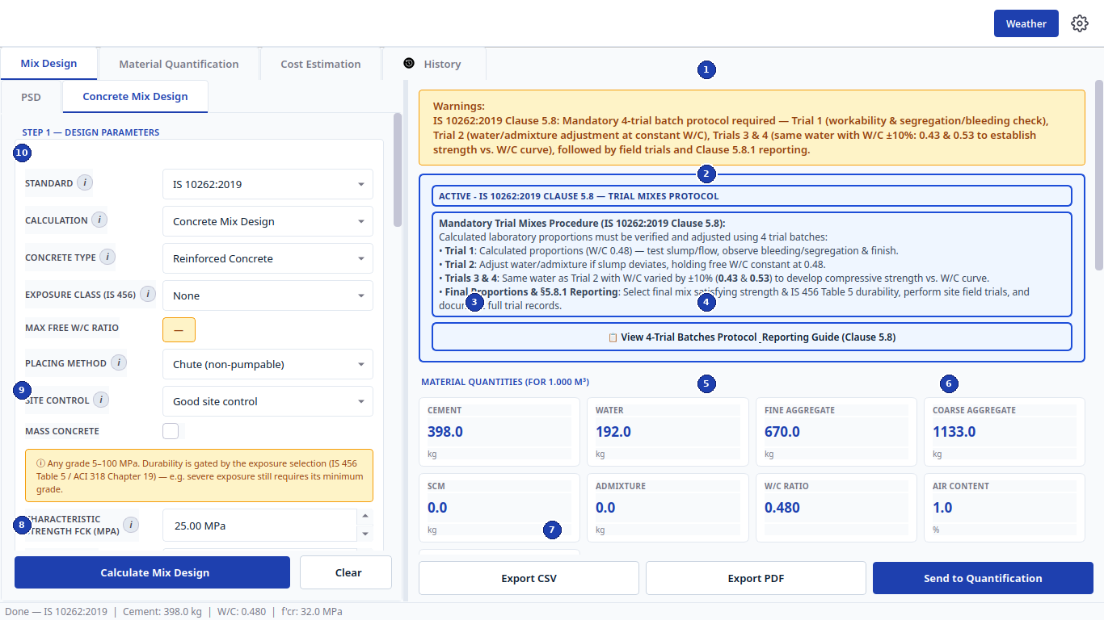
Figure 4 - Completed IS 10262 design with trial-mix protocol, quantity cards, and export row.
Label | Element | Function and how to use it
1 | Warnings banner | Compliance notice: IS 10262 Clause 5.8 requires a mandatory 4-trial batch protocol (Trials 1-2 for workability, Trials 3-4 at W/C +/-10%, i.e. 0.43 and 0.53) plus field trials and Clause 5.8.1 reporting. Always read warnings first.
2 | Trial mixes protocol panel | Blue panel restating the 4-trial procedure and final-proportion reporting duty. The View 4-Trial Batches Protocol button opens the full per-trial guide with the reporting checklist.
3 | MATERIAL QUANTITIES header | Confirms the basis, here FOR 1.000 M3. Change the design volume (Step 1) to rescale every card.
4 | Top quantity cards | Cement 398.0 kg, Water 192.0 kg, Fine aggregate 670.0 kg, Coarse aggregate 1133.0 kg. These are the batch weights per cubic metre (SSD basis unless noted).
5 | Bottom cards, left | SCM 0.0 kg and Admixture 0.0 kg because none were entered. They populate automatically when SCM/admixture inputs are used.
6 | Bottom cards, right | W/C ratio 0.480 and Air content 1.0%. W/C is the single most important strength/durability number: verify it against the badge-7 limit of Figure 1.
7 | Export CSV / Export PDF / Send to Quantification | CSV saves machine-readable results; PDF builds the signed calculation report; Send pushes cement, water, aggregates, w/c and admixture into the Quantification tab and switches to it.
8 | Calculate Mix Design | Re-run after any input change. The status bar confirms, e.g. Done - IS 10262:2019 | Cement: 398.0 kg | W/C: 0.480 | f'cr: 32.0 MPa.
9 | MASS CONCRETE + note | Reminder row: the durability exposure choice, not the grade alone, governs minimum cement and maximum w/c.
10 | STANDARD selector | Confirms which code produced these numbers. Change it and recalculate to compare IS vs ACI vs DOE for the same inputs.

5 PSD Tab: Sieve Analysis Setup, Input and Gradation Curve
The PSD sub-tab checks whether your sand or stone grading complies with IS 383:2016 or ASTM C33/C33M. Never mix one standard's sieves with the other's limits: pick the standard first, then the matching reference band (AGENTS.md PSD rules).
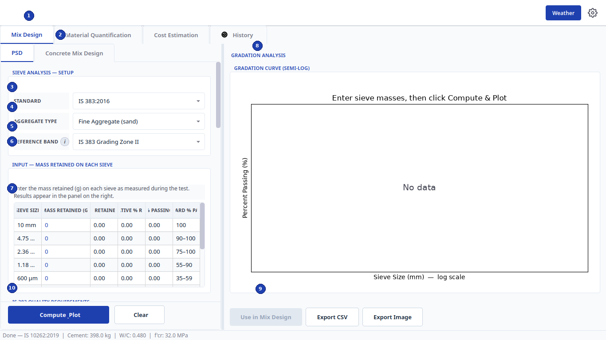
Figure 5 - PSD sieve analysis: setup, mass-retained input table, and semi-log gradation curve.
Label | Element | Function and how to use it
1 | Main tabs | You are inside Mix Design. PSD results can feed the mix via Use in Mix Design (badge 9).
2 | PSD sub-tab | Select PSD (not Concrete Mix Design) to reach this screen.
3 | STANDARD | IS 383:2016 or ASTM C33/C33M. This locks the sieve series and the pass/fail envelope: IS fine uses a 10 mm top sieve with Zones I-IV; ASTM fine uses a 9.5 mm top sieve with Table 1 limits; coarse project bands are exactly 10 mm (Size 8), 20 mm (Size 67), 40 mm (Size 467).
4 | AGGREGATE TYPE | Fine Aggregate (sand) or Coarse Aggregate (stone). Changes the available reference bands and sieve columns.
5 | REFERENCE BAND | Grading envelope to test against, e.g. IS 383 Grading Zone II. A dash/blank cell in the standard means no requirement on that sieve: it stays available for input but is excluded from conformance.
6 | INPUT section header | Instruction block: enter the mass retained (g) on each sieve exactly as weighed. Results compute to the right.
7 | Sieve input table | Columns: sieve size, mass retained (g, the only editable column), % retained, cumulative % retained, % passing, standard band. Type each weighed mass and the row statistics update. The table includes every Table 2 laboratory sieve for ASTM (100 mm down to 300 um).
8 | GRADATION CURVE (SEMI-LOG) | Semi-log plot of % passing vs sieve size with the reference band drawn through every stated limit (smoothed only between control points, never overshooting). Shows No data until masses are entered; after Compute it shows Pass/Fail per sieve.
9 | Use in Mix Design / Export CSV / Export Image | Use in Mix Design copies the measured zone/fineness into the mix form. Export CSV saves the table; Export Image saves the curve for reports.
10 | Compute_Plot / Clear | Compute_Plot runs grading, fineness modulus, and conformance, then draws the curve. Clear empties the table. On failure the app opens the compliance dialog (IS 383 or ASTM C33) naming each offending sieve.

6 Material Quantification Tab
Quantification converts a per-cubic-metre design into total site quantities. It works standalone (type the mix manually) or receives the mix automatically from Send to Quantification.
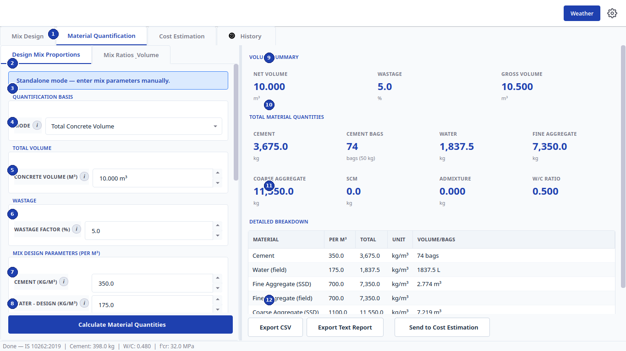
Figure 6 - Quantification in Design Mix Proportions mode with volume summary and totals.
Label | Element | Function and how to use it
1 | Mode sub-tabs | Design Mix Proportions (paste/type a known per-m3 design) vs Mix Ratios_Volume (classic 1:1.5:3 nominal ballet). This figure shows Design Mix Proportions.
2 | Standalone banner | Blue banner confirms Standalone mode - enter mix parameters manually. After a handoff it names the source design instead.
3 | QUANTIFICATION BASIS header | Groups the mode switch below it.
4 | MODE | Total Concrete Volume (this figure) vs Structural Elements (slabs, beams, columns, footings, walls, stairs with openings deduction). Elements mode totals volumes for you.
5 | CONCRETE VOLUME (M3) | Net design volume, here 10.000 m3. All totals scale from this value.
6 | WASTAGE FACTOR (%) | Site allowance, here 5.0%. Gross volume = net x (1 + wastage/100); every material is ordered on the gross figure.
7 | MIX DESIGN PARAMETERS cement row | Per-m3 cement content, here 350.0 kg/m3. Further rows below (scroll) carry water, fine and coarse aggregate, SCM and admixture.
8 | Water row with Calculate button | Per-m3 design water, here 175.0 kg/m3. Below it, Calculate Material Quantities produces the right-hand panel.
9 | VOLUME SUMMARY | Net 10.000 m3, wastage 5.0%, gross 10.500 m3. Check gross before ordering.
10 | TOTAL MATERIAL QUANTITIES cards | Headline totals: cement 3,675.0 kg (74 bags of 50 kg), water 1,837.5 kg, fine aggregate 7,350.0 kg, coarse 11,550.0 kg, plus SCM, admixture and w/c.
11 | DETAILED BREAKDOWN table | Per-material rows with PER M3, TOTAL, UNIT and VOLUME/BAGS columns (cement 350.0 -> 3,675.0 kg/m3 -> 74 bags; water in litres; aggregates in m3). Scroll for the coarse-aggregate and drum-mix rows.
12 | Export / handoff row | Export CSV for spreadsheets, Export Text Report for site records, Send to Cost Estimation to carry quantities and volumes into costing.

7 Cost Estimation Tab: Quantities and Prices
Costing is manual price entry in GHc. Quantities arrive from Quantification or are typed directly; prices, labour, transport, overheads, profit and contingency are always typed.
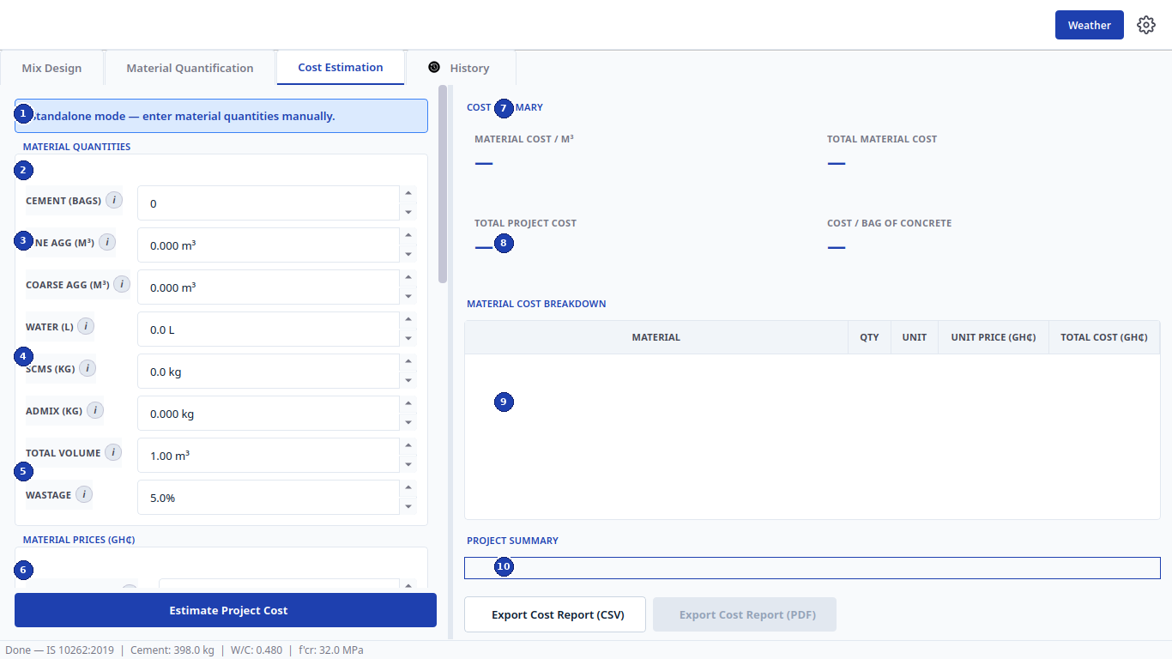
Figure 7 - Cost Estimation quantities (left) with empty cost summary awaiting calculation (right).
Label | Element | Function and how to use it
1 | Standalone banner | Standalone mode - enter material quantities manually. After Send to Cost Estimation it shows the linked quantification instead.
2 | CEMENT (BAGS) row | Cement quantity in 50 kg bags. First and most expensive line: verify against the quantification bags figure.
3 | Fine / coarse aggregate rows | FINE AGG (M3) and COARSE AGG (M3) in cubic metres, the commercial unit for aggregates. The engine converts from kg using bulk densities.
4 | Water / SCM / admixture rows | WATER (L) in litres, SCMS (KG) and ADMIX (KG) in kilograms. Zero means the material is not costed.
5 | TOTAL VOLUME + WASTAGE | cord: TOTAL VOLUME 1.00 m3 is the costing basis; WASTAGE 5.0% uplifts quantities exactly as in Quantification.
6 | MATERIAL PRICES (GHc) with Estimate button | Unit prices per bag/m3/litre/kg (scroll for all rows). Below, Estimate Project Cost runs the costing and fills the right panel.
7 | COST SUMMARY header | Section title for the four headline numbers below it.
8 | Headline cost cards | MATERIAL COST / M3, TOTAL MATERIAL COST, TOTAL PROJECT COST, COST / BAG OF CONCRETE. Dashes clear to values after estimating.
9 | MATERIAL COST BREAKDOWN table | Per-material rows: MATERIAL, QTY, UNIT, UNIT PRICE (GHc), TOTAL COST (GHc). The audit trail of the estimate.
10 | PROJECT SUMMARY with exports | Free-text summary box plus Export Cost Report (CSV) and Export Cost Report (PDF). PDF enables after a successful estimate.

7.1 Cost Estimation: Labour, Overheads and Project Data
Scroll the left panel down for site costs and the right panel for the finished breakdown. Labour and plant are entered here, never in the materials section.
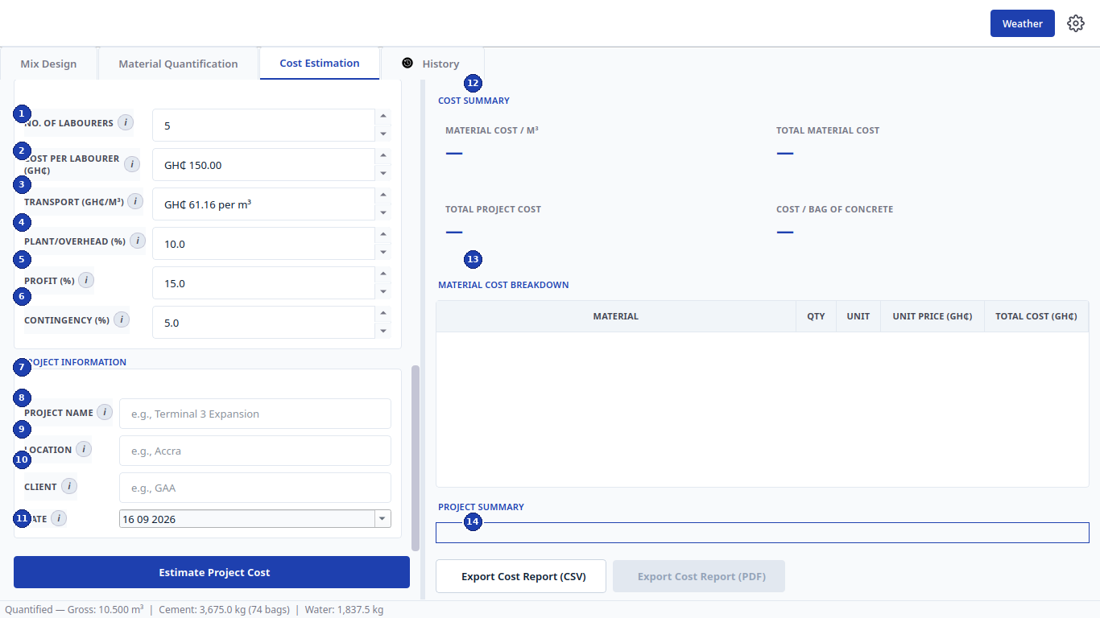
Figure 8 - Labour, additional costs, project information, and the cost breakdown tables.
Label | Element | Function and how to use it
1 | NO. OF LABOURERS | Headcount deployed, here 5. Multiplied by rate and duration in the labour build-up.
2 | COST PER LABOURER (GHc) | Daily/contract rate per head, here GHc 150.00. Keep the rate basis (day vs lot) consistent with headcount.
3 | TRANSPORT (GHc/M3) | Haulage rate per cubic metre, here GHc 61.16 per m3. Covers batching-plant-to-site movement.
4 | PLANT/OVERHEAD (%) | Site plant, supervision and office overhead as a percentage, here 10.0%. Applied on the direct cost subtotal.
5 | PROFIT (%) | Contractor margin, here 15.0%. Applied after overheads.
6 | CONTINGENCY (%) | Risk allowance, here 5.0%. Applied last so it covers the full marked-up cost.
7 | PROJECT NAME row | Free text, e.g. Terminal 3 Expansion. Prints on the PDF cover and history record.
8 | LOCATION row | Site town/city, e.g. Accra. Used in weather advice and report headers.
9 | CLIENT row | Client name, e.g. GAA. Stored with history for retrieval.
10 | DATE row | Report date, defaulting to today (16 09 2026). Click the calendar picker to change.
11 | Estimate Project Cost | Runs the full build-up: materials + labour + transport, then overheads, profit and contingency. Right panel populates on success.
12 | COST SUMMARY values | The four headline cards with computed GHc figures after estimating.
13 | MATERIAL COST BREAKDOWN | Populated per-material cost table with quantities, units, unit prices and line totals.
14 | Export row | Export Cost Report (CSV) always; Export Cost Report (PDF) once project info is valid. Both files are recorded in History.

8 History Tab: Records, Search and Reuse
Every calculation, quantification, costing, and PSD analysis is stored in a local SQLite database (234 records in this example). History is the audit trail: reload any past job into its tab, export selections, or wipe the log.
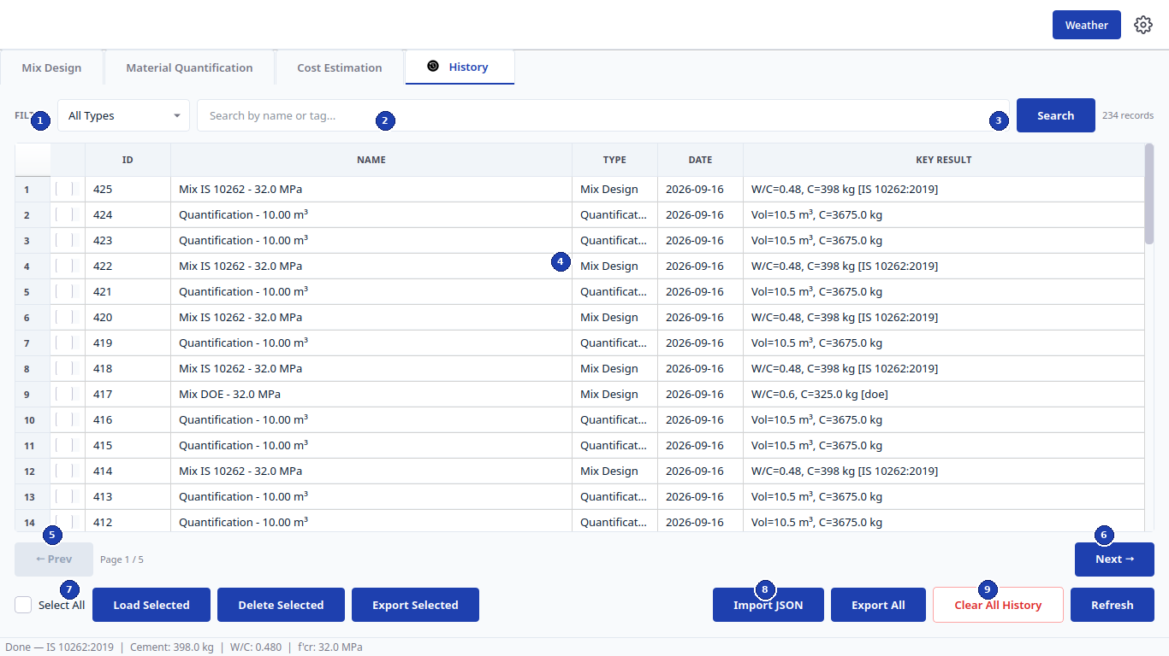
Figure 9 - History table with filter, search, pagination, and batch actions.
Label | Element | Function and how to use it
1 | FILTER dropdown | All Types, Mix Design, Quantification, Cost Estimation, PSD. Narrows the table before searching.
2 | Search box | Free text matched against name or tag, e.g. a project or client. Combine with the filter, then press Search.
3 | Search with count | Blue Search button runs the query; the count at right (here 234 records) confirms the result size.
4 | Records table | Columns: row number, checkbox, ID, NAME (e.g. Mix IS 10262 - 32.0 MPa), TYPE, DATE, KEY RESULT (e.g. W/C=0.48, C=398 kg). Tick rows for batch actions. Double-click or Load Selected reopens the full record in its home tab.
5 | Pagination Prev | Steps back one page through large histories.
6 | Pagination Next | Steps forward; the Page 1 / 5 indicator between the buttons shows position.
7 | Select All with Load/Delete/Export | Select All ticks the page; Load Selected restores the mix/quant/cost/PSD into its tab; Delete Selected removes them; Export Selected writes the chosen rows to JSON/CSV.
8 | Import JSON | Restores records exported from another machine. Used for site-to-office transfer.
9 | Export All / Clear All / Refresh | Export All backs up the whole log; Clear All History wipes it (with confirmation, red to signal danger); Refresh re-reads the database after external changes.

9 Settings, Units and Weather
The gear opens Unit Settings; the Weather button opens live site weather with concreting advice. The backend always stores metric internally and converts on display, so switching units never corrupts saved records.
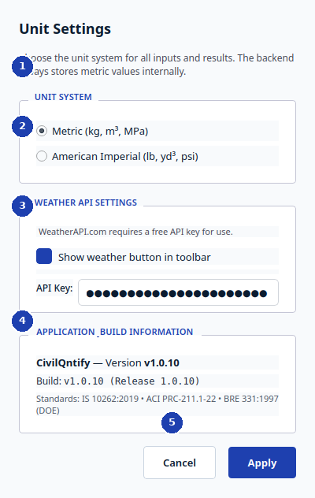
Figure 10 - Unit Settings dialog.
Label | Element | Function and how to use it
1 | UNIT SYSTEM radios | Metric (kg, m3, MPa) or American Imperial (lb, yd3, psi). Applies instantly to every input and result across all tabs.
2 | WEATHER API SETTINGS | WeatherAPI.com key status. Without a key the Weather button shows guidance only; with a key it fetches live temperature and humidity.
3 | Show weather button in toolbar | Blue toggle controlling whether the Weather button appears in the main toolbar. Unticked hides site-weather access for offline machines.
4 | APPLICATION_BUILD INFORMATION | App name, version (here v1.0.10), and the three design standards compiled into this build. Quote it in support requests.
5 | Cancel / Apply | Cancel discards changes; Apply saves units and key, then refreshes all open tabs in the new system.

Weather use. Weather dialog (toolbar button): enter the site city to fetch temperature and relative humidity, then read the concreting advice. Hot weather (high temperature, low humidity) warns about rapid slump loss and plastic-shrinkage cracking and advises shading, cooled mixing water, and prompt curing; cold weather warns about retarded setting and recommends heated enclosures and extended curing. Advice is guidance only: the mix design itself does not change.

10 End-to-End Workflow and Standards Map
Recommended order: (1) run PSD on your sand and stone and confirm the zone/band; (2) design the mix with those materials and the correct exposure class; (3) run the mandatory 4-trial laboratory protocol and adjust; (4) quantify the structure with wastage; (5) cost with current GHc prices; (6) export PDF/CSV and file the history record. Each handoff button (Send to Quantification, Send to Cost Estimation, Use in Mix Design) carries data forward so nothing is retyped.
Standard trace. Water-cement ratio: ACI 211.1-22 Sections 5 and 9; IS 10262 Table 8 and Figure 1; BRE 331 Figure 4 and Section 9.3. Target strength: IS 10262 Clause 7.1 with Tables 1-2 and BRE 331 Section 5.1 with Figure 3; the app rounds every target up to whole MPa. Aggregates and water content: ACI Tables 5.3.3-5.3.6, IS Tables 7/10/12-13, BRE Tables 3/9 with Figure 6. Admixtures: IS Annex G and ACI Section 6.3. Moisture correction: ACI Section 9.3.8 and IS D-9.1. Durability: IS 456 Tables 3/5 and ACI 318 Chapter 19 / ACI 211 Tables 4.7.3a-d. Trial batches: ACI Section 9.3.9 with Appendix A.5, IS Section 9 with Annexes D-F, BRE Sections 5.6-7. SCC: IS Annex E. Mass concrete: IS Annex F. High-density concrete: ACI Appendix B.

