CivilQntify
User Manual
A picture-led guide to using the app — what to click, what to type, and how to check your results.
20 September 2026 • Desktop app (Windows / Linux / macOS) • Prices in GH₵
Start at Chapter 2 and follow the pictures. Chapter 9 lets you verify each design method against its published textbook example.
Who this is for: site engineers, concrete technicians, quantity surveyors, students, and anyone who designs concrete, checks aggregates, lists materials, or prices a job.
How to use this manual: work left to right across the tabs — design the mix, list the materials, then price the job. Every chapter ends with what you should see on screen.

Contents — click to jump
The list below is the table of contents. Click any line to jump there. Page numbers fill in automatically — if they show 1, press Ctrl+A then F9, or view Print Preview.
Contents — click a line to jump (page numbers update on print preview).
1. Welcome to CivilQntify 1
2. Getting Started 1
2.1 Opening the app and the main screen 1
2.2 Toolbar, units and display 1
3. Designing a Concrete Mix (in detail) 1
3.1 Choosing the design method and calculation type 1
3.2 Step 1 — Describe what you need 1
3.3 Extra boxes for the Indian method (IS 10262) 1
3.4 Extra boxes for the American method (ACI) 1
3.5 Extra boxes for the British method (DOE / BRE 331) 1
3.6 Step 2 — Describe your materials 1
3.7 Step 3 — Cement replacements and chemical admixtures (optional) 1
3.8 Press Calculate and read your results 1
3.9 Trial batches — check before you pour 1
3.10 Sending your mix onward, or printing it 1
4. Checking Your Aggregates (Sieve Analysis) 1
4.1 When to do this 1
4.2 Entering your sieve results step by step 1
4.3 Reading the curve and using it in your mix 1
5. Calculating How Much Material You Need 1
5.1 Option A — From a designed mix 1
5.2 Option B — From a simple ratio (no designed mix) 1
5.3 Reading your materials list 1
6. Estimating Project Cost 1
6.1 Entering quantities and prices 1
6.2 Labour, transport and margins 1
6.3 Reading the cost breakdown 1
7. Reusing Past Work (History) 1
8. Settings and Weather 1
9. Worked Examples for Each Standard (with comparisons) 1
9.1 Example 1 — Indian method (IS 10262:2019, M40) 1
9.2 Example 2 — American method (ACI PRC-211.1, 2500 psi) 1
9.3 Example 3 — British method (DOE / BRE 331, 30 MPa) 1
10. Printing, Saving and Sharing 1
11. Troubleshooting — If Something Does Not Work 1
You can also press Ctrl and click any entry to jump there. The Navigation Pane in Word shows the same headings.
Chapters: 1 Welcome • 2 Getting Started • 3 Designing a Concrete Mix (in detail) • 4 Checking Your Aggregates • 5 Calculating Materials • 6 Estimating Cost • 7 Reusing Past Work • 8 Settings and Weather • 9 Worked Examples for Each Standard (with comparisons) • 10 Printing and Sharing • 11 Troubleshooting

1. Welcome to CivilQntify
CivilQntify answers four everyday questions:
- What should my concrete contain? — Mix Design.
- Are my sand and stone well graded? — Sieve Analysis inside Mix Design.
- How much cement, sand, stone and water must I order? — Material Quantification.
- What will it cost? — Cost Estimation.
Everything you calculate is saved in History, so you can reload, print, or reuse it later.
If you want to… | Go to…
Design a new concrete mix | Mix Design → Concrete Mix Design
Check sand or stone grading | Mix Design → Sieve Analysis
Work out quantities for a slab, beam or whole job | Material Quantification
Price the job in GH₵ | Cost Estimation
Find, reload or print an old calculation | History

Tip: Work left to right: design, then quantities, then cost. The app carries numbers forward so you do not retype them.

2. Getting Started

2.1 Opening the app and the main screen
Open CivilQntify. Across the top are four tabs. On the left is your input form; on the right are your results. Along the bottom, a short message confirms what just happened (for example, that your mix was sent to the next screen).
- Mix Design — design concrete and check aggregates.
- Material Quantification — turn a mix or a ratio into a shopping list.
- Cost Estimation — add prices and get a project cost.
- History — every past calculation, searchable and reloadable.
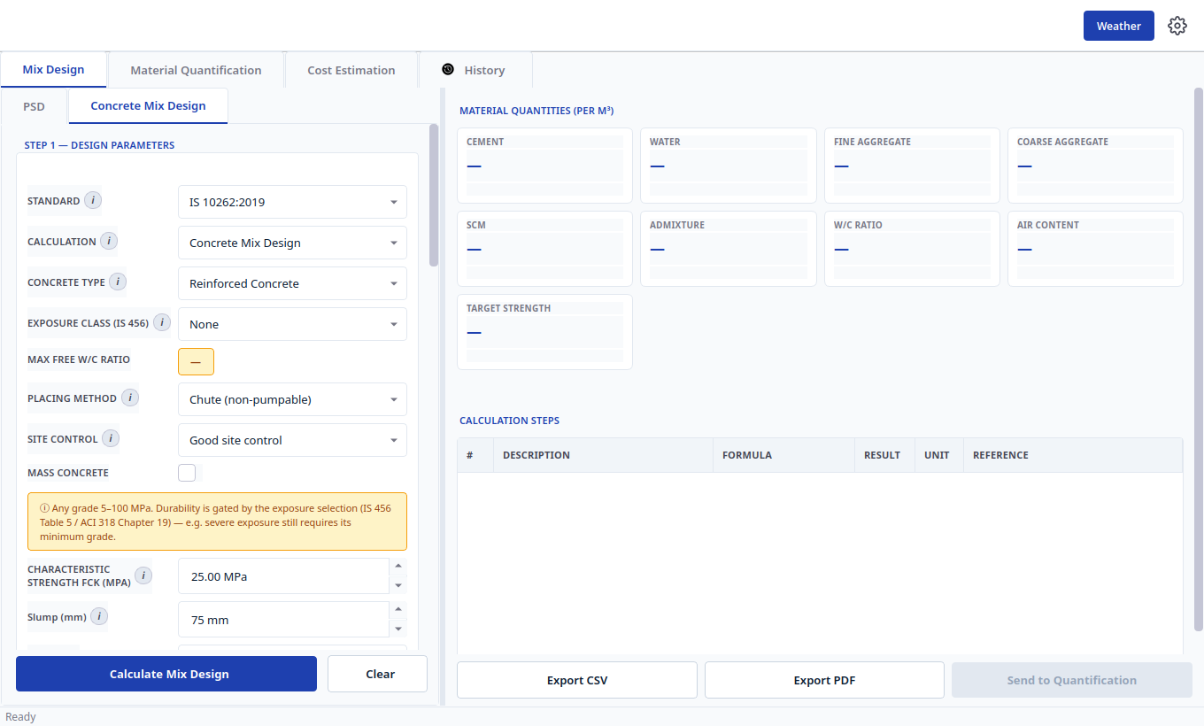
Figure 1 — The main screen. Tabs across the top, form on the left, results on the right.

2.2 Toolbar, units and display
Top-right has two controls: Weather (weather information for planning pours) and the gear icon (Settings).
Units: open Settings and choose Metric (kg, cubic metres, MPa) or American Imperial (lb, cubic yards, psi). This only changes how numbers look — saved work stays correct. Prices are always in GH₵.
If a small “i” appears beside a box, click it for a one-sentence explanation of that box.
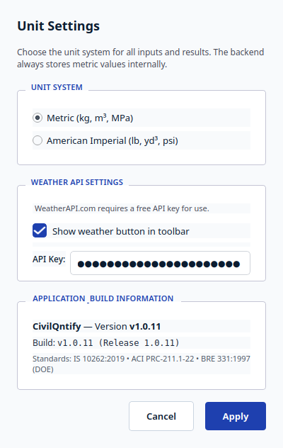
Figure 2 — Settings. Change units here; show or hide the Weather button.
Tip: If numbers suddenly look too big or too small, check Settings first — you may be viewing metric values in imperial units or the reverse.

3. Designing a Concrete Mix (in detail)
Go to Mix Design → Concrete Mix Design (the second small tab on the left). Fill the form top to bottom in three steps, then press the blue Calculate button. The form reshapes itself for the standard you pick, so you only see boxes that matter.

3.1 Choosing the design method and calculation type
Box at the top | What to pick and why
Design standard | IS 10262 (Indian), ACI (American), or DOE / BRE (British). Pick the one your project specification names. Tables, limits and result cards follow that method.
Type of calculation | Leave as Concrete Mix Design for a full recipe (strength + water + cement + sand + stone). Choose Target Strength only if you want the required average strength number without quantities. The blue button name changes to match.

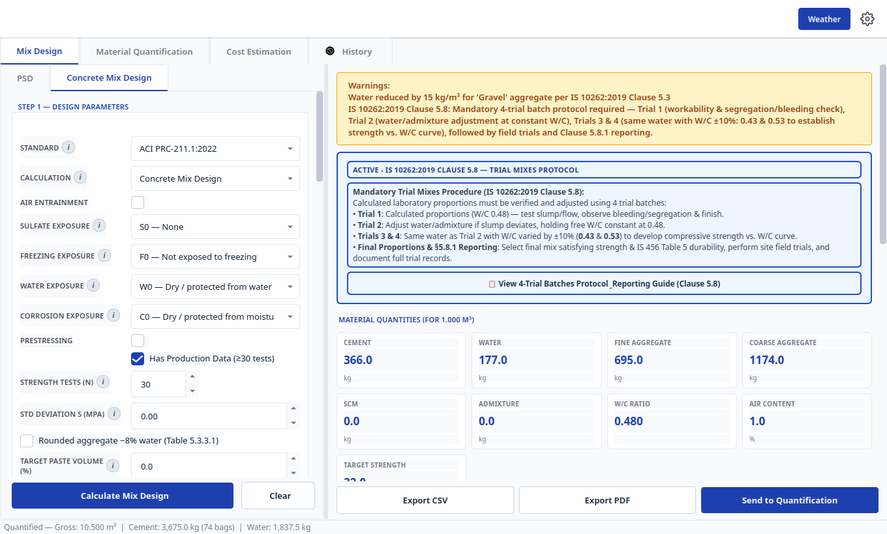
Figure 3 — Picking a different standard reshapes the form. Only the boxes you need are shown (shown here: American method).

3.2 Step 1 — Describe what you need
This is the job requirement. Work slowly here — everything below depends on it.
Box | What to enter (with everyday examples)
Concrete type | Plain or Reinforced Concrete. Reinforced is stricter on durability.
Exposure | Where the concrete will live: dry indoors, wet soil, rain, chemicals, frost, or sea spray. When in doubt choose the harsher option — the app adds protection automatically.
Strength (fck) | The strength on your drawings, e.g. 25 MPa or 40 MPa.
Slump / workability | How fluid the fresh concrete must be, e.g. 75 mm for normal slabs. Low slump = stiff; high slump = flowing. For the British method you may use Vebe time instead.
Largest stone size | The biggest aggregate you will use, e.g. 20 mm. Must suit your formwork and bar spacing.
Placing method | Chute (normal) or pump (needs more workable, cohesive mix).
Site control | How well your site batches and supervises. Better control needs less extra safety margin.
Min / max cement, max water-cement ratio | Limits from your specification. Leave at 0 (no limit) unless the drawings state a limit.

Note: Durability can control the design. Even if strength alone needs less cement, exposure rules may demand more cement or less water. A yellow warning on the results screen tells you when this happens — keep the app's safer values.

3.3 Extra boxes for the Indian method (IS 10262)
When IS 10262 is selected you will also see:
- Grading Zone (I–IV) for your sand — pick from your sieve test, or use Zone II as a start. Finer zones shift sand content.
- Aggregate shape (rounded, angular, flaky) — angular needs slightly more water.
- Chemical admixture water — only if your liquid admixture adds water; otherwise leave at 0.

3.4 Extra boxes for the American method (ACI)
When ACI is selected you will also see exposure choices (sulfate, freezing, water, corrosion) plus:
- Fineness modulus of sand (around 2.4–3.0) — copy it from the sieve screen after Compute & Plot.
- Packed weight of stone (dry-rodded density) — from your lab test; the default suits many crushed stones.
- Air entrainment tick — only for concrete that will freeze and thaw.
- Production history — tick if you have 30+ past strength tests; the safety margin drops.

3.5 Extra boxes for the British method (DOE / BRE 331)
When DOE is selected you will also see:
- Defective rate and number of test cubes — how certain you want to be. Fewer past tests means a bigger safety margin.
- Margin known tick — if your site already knows its margin from records, tick it and type the margin.
- Cement strength class and aggregate type (crushed or natural) — sets the strength curves.
- Sand passing 600 micron (%) — from your sieve test; drives the sand share.
- Stone split — leave as Single stock unless you blend two or three single sizes.
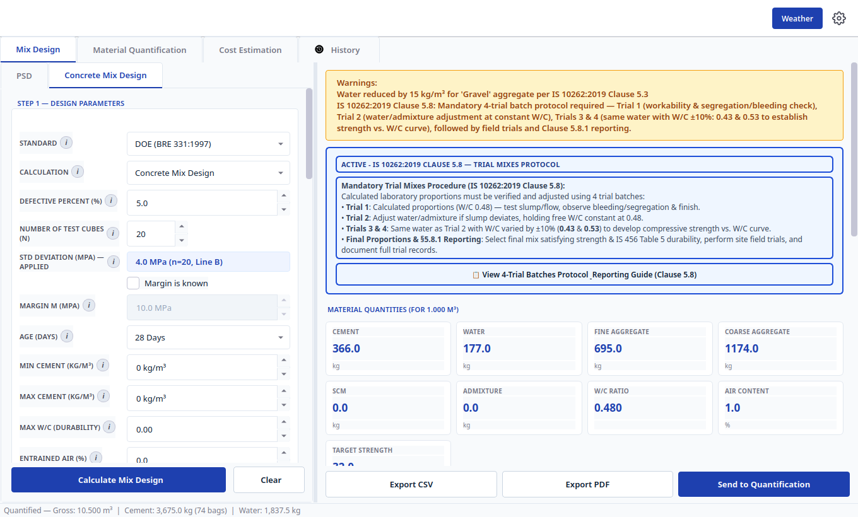
Figure 4 — The British (DOE) form. Margin, age, and sand-grading boxes appear only here.

3.6 Step 2 — Describe your materials
Scroll to Step 2. These are simple lab values. Start with defaults and update them when test results arrive:
Box | Plain meaning and safe start
Cement type and weight | Cement grade and its specific gravity. 3.15 suits ordinary cement.
Sand: weight, absorption, wetness | Specific gravity (often 2.60–2.70), how much water it soaks up inside, and how wet it is on the surface. Wet sand means you add less mixing water.
Stone: weight, absorption, wetness | Same idea as sand. Clean, dry stone is the baseline.
American method extras | Sand fineness, manufactured-sand tick, and packed weight of stone (see 3.4).

Tip: Leave anything you have not tested at its default. The app uses safe, typical values so you can still get a draft mix.

3.7 Step 3 — Cement replacements and chemical admixtures (optional)
If you use fly ash, slag, silica fume, plasticiser or superplasticiser, add it here. Choose the type, the percentage of cement it replaces, and the dosage. Set the expected water reduction (superplasticiser often 15–30%). If you use none, leave this section as None.
The Reduced Water display shows the water left after the reduction — this is what the app uses for cement content.

3.8 Press Calculate and read your results
- Press the blue Calculate Mix Design button at the bottom.
- Read the cards on the right: Cement, Water, Sand, Stone, plus water-cement ratio, air content and target strength. Each card shows the amount for one cubic metre.
- Open Calculation Steps below the cards to see how each number was found, step by step.
- Check for a yellow Warnings box — it means a durability rule controlled your mix. Keep those values.
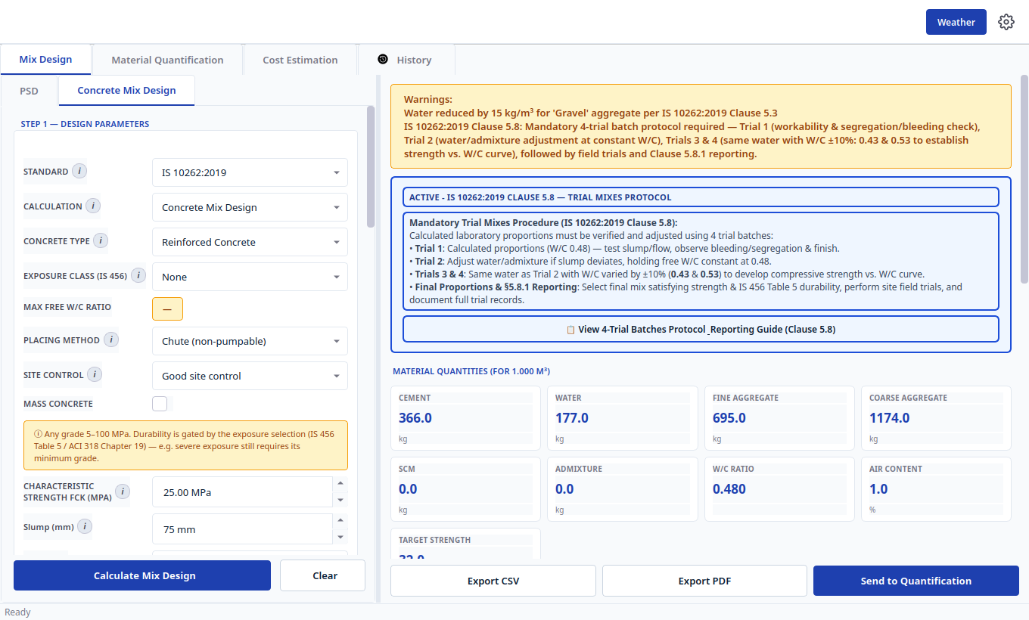
Figure 5 — A finished mix. Cards show what to batch per cubic metre; buttons below export or forward the mix.
At the bottom of the cards you will see the mix ratio (for example 1.0 : 1.6 : 3.0 at water-cement ratio 0.36). This is the shorthand site teams use.
Tip: Always glance at the water-cement ratio and the warnings box before printing. They tell you at a glance whether the mix is safe.

3.9 Trial batches — check before you pour
Above your results is a trial-mix card. Open it to see small laboratory batches to try first (usually several mixes around your design). Cast, cure and test them, adjust water or admixture, then lock the final production mix. This one check prevents costly failures on site.

3.10 Sending your mix onward, or printing it
Press Send to Quantification. The app opens Material Quantification with your mix already filled in. Use Export PDF for a paper report or Export CSV for a spreadsheet — both include your inputs and step-by-step workings for approval.

4. Checking Your Aggregates (Sieve Analysis)

4.1 When to do this
Do this before designing your mix if you have laboratory sieve weights. Two minutes here makes the mix more accurate and fills sand grading into the design automatically.
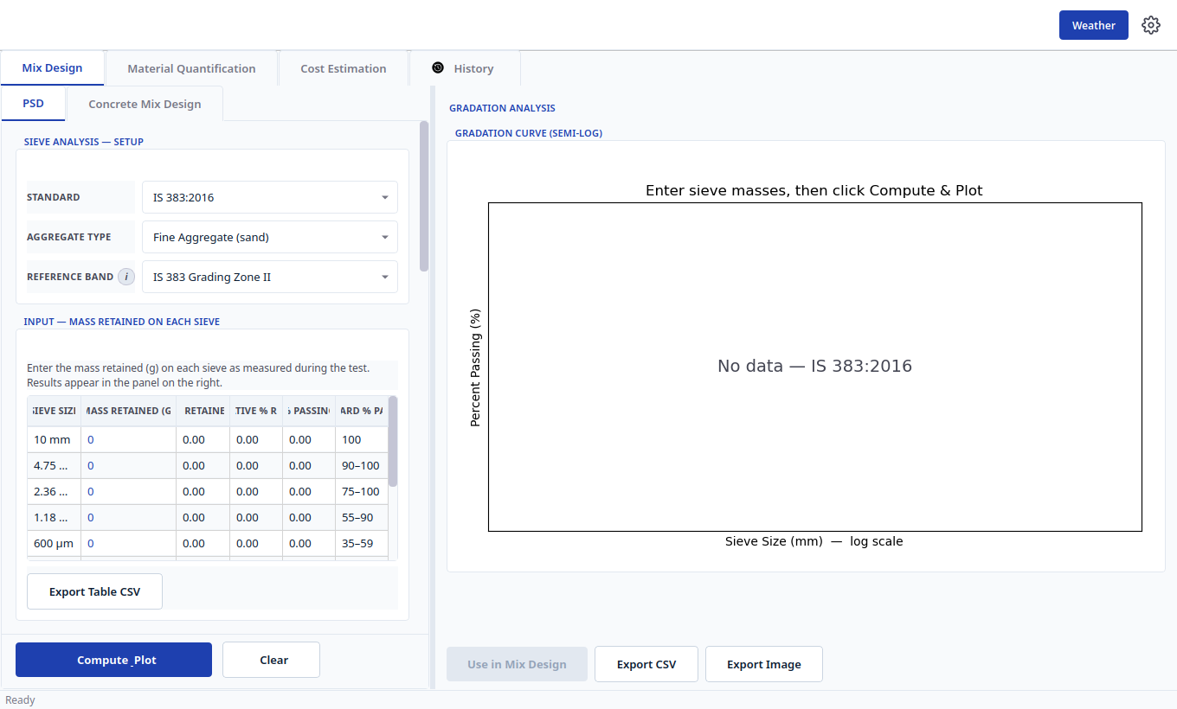
Figure 6 — Sieve analysis. Choose the standard, type each weight, then Compute & Plot.

4.2 Entering your sieve results step by step
- Go to Mix Design → the first small tab (Sieve Analysis).
- Choose the Standard you will claim (IS 383, ASTM C33 or BS 882), whether it is Sand or Stone, and the grading band to check (for example Zone II, or 20 mm graded). Never mix one standard's sieves with another's limits.
- Type the weight left on each sieve (in grams) into the Mass column. Put material passing the finest sieve in the Pan row.
- If you did extra lab tests (clay, soundness, organics), enter them in Quality Requirements. Leave anything you did not test as “not tested” — the app skips it instead of failing you.
- Press Compute & Plot.

4.3 Reading the curve and using it in your mix
On the right you will see a green Conforms badge (or a red message listing which sieves failed), the grading curve, and key numbers such as fineness modulus and the sand passing 600 micron. If it fails, a table names the exact sieve and how far it missed.
- If it passes, press Use in Mix Design. The app copies the grading into your mix form and returns you to the design screen.
- If it fails, adjust blending or source, then re-enter and compute again. Save the table or curve picture with Export if you need evidence.
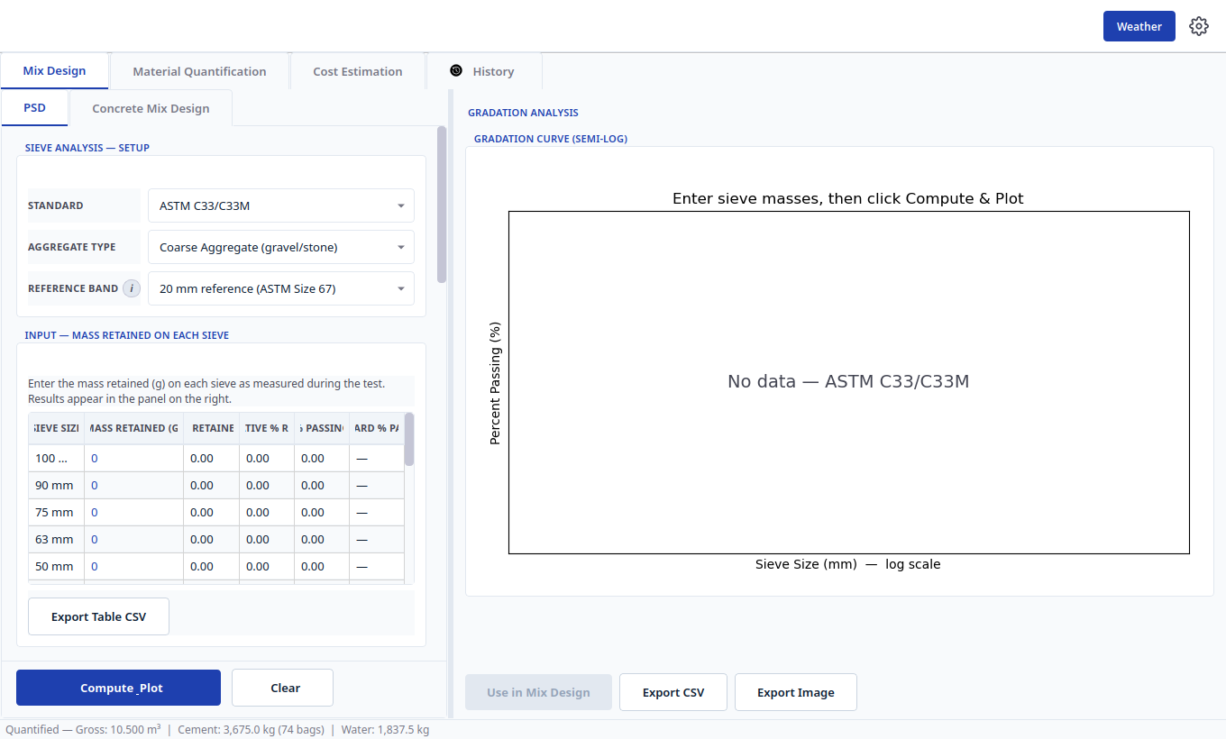
Figure 7 — The same screen for coarse stone (shown here: American band). Sieve rows and limits switch automatically.
Tip: Check the Pan row: a missing pan weight is the most common reason the total looks wrong.

5. Calculating How Much Material You Need
Open Material Quantification. Pick the route that matches what you have — a designed mix, or a simple site ratio.
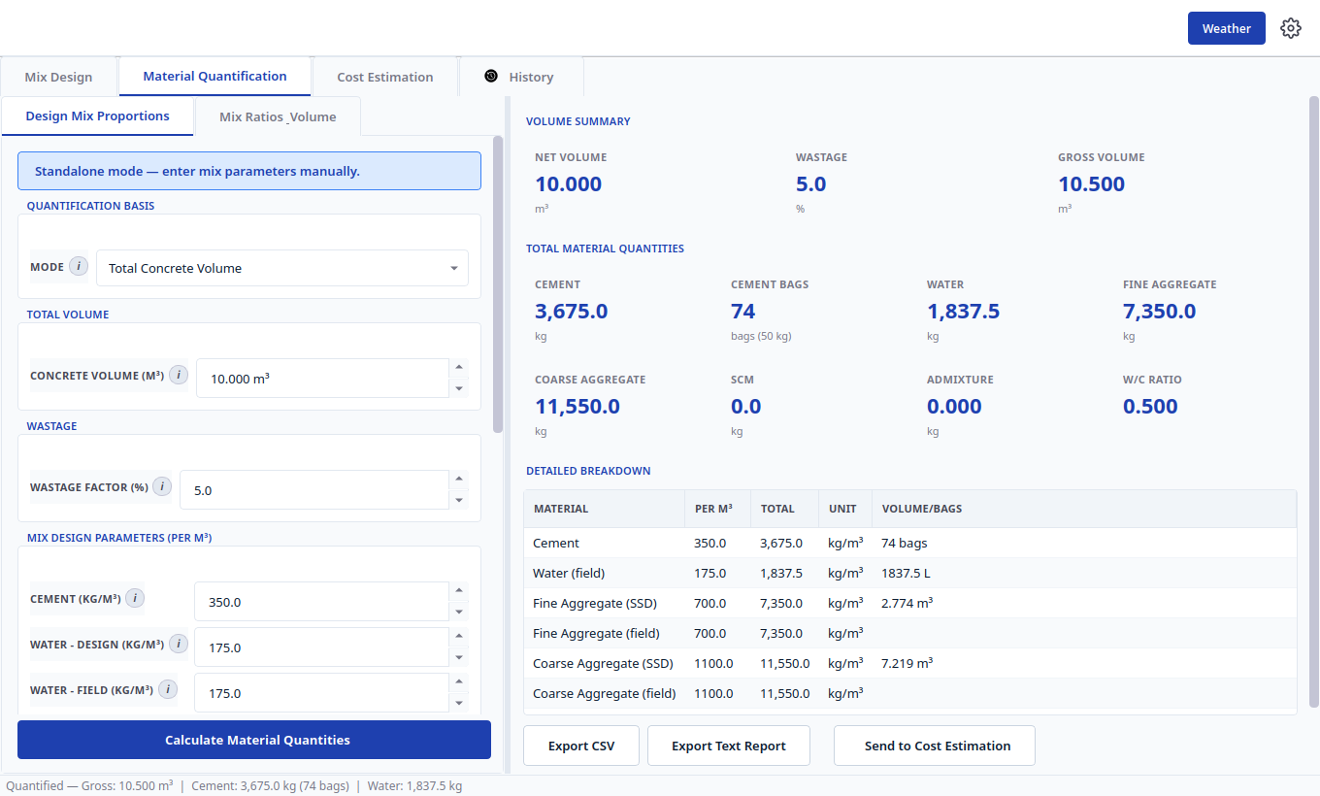
Figure 8 — Quantities from a designed mix. Enter volume, add wastage, press Calculate.

5.1 Option A — From a designed mix
Use this after Chapter 3 (or press Send to Quantification to arrive with numbers already filled).
- Choose how to give the volume: type the total volume directly, or switch to Structural Elements and list each footing, column, beam or slab with length, width, depth and quantity. The app totals it for you.
- Set Wastage (5% is a safe start; 3–5% for ready-mix, 5–10% for site mixing).
- Check the per-cubic-metre numbers (they came from your mix) and press Calculate Material Quantities.

5.2 Option B — From a simple ratio (no designed mix)
Use the second small tab, Mix Ratios & Volume, when you only have a nominal ratio such as 1:1.5:3 (M20) or 1:4 mortar.
- Pick a preset (M25, M20, M15, mortar) or choose Custom and type your own cement : sand : stone parts. Set stone to 0 for mortar.
- Enter the volume and keep the dry-volume factor (1.54) and wastage (5%) unless your supervisor says otherwise.
- Press Calculate Material Quantities.
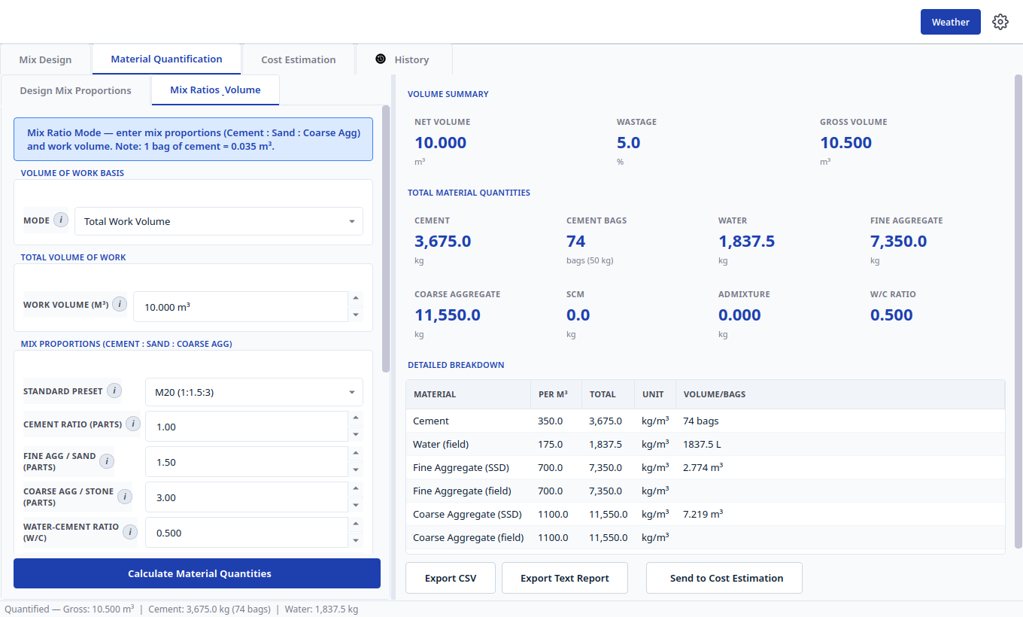
Figure 9 — Quantities from a ratio. Pick a preset or type a custom ratio.

5.3 Reading your materials list
On the right: Net Volume, Wastage and Gross Volume cards, then total Cement (and bags), Water, Sand and Stone. The detailed table shows both per-cubic-metre and total amounts. Press Send to Cost Estimation to price this list without retyping, or export it for the storekeeper.

6. Estimating Project Cost
Open Cost Estimation. If you arrived via Send to Cost Estimation your quantities are already filled — just add prices. Otherwise type them by hand.
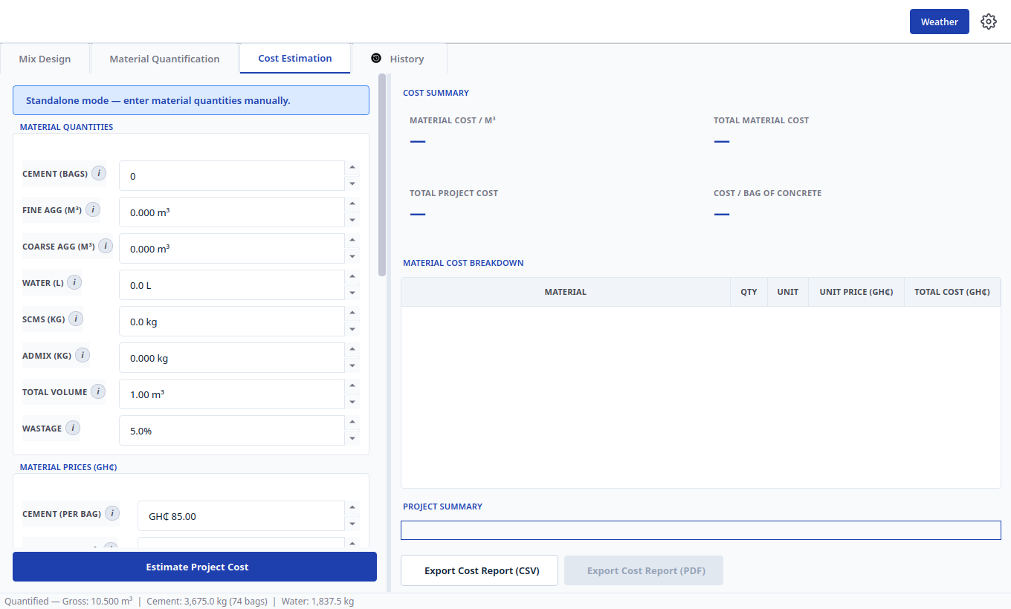
Figure 10 — Cost estimation. Quantities at the top, prices in the middle, labour and margins below.

6.1 Entering quantities and prices
Top: confirm Cement (bags), Sand, Stone, Water, and Total Volume. Middle: type what you actually pay — cement per bag, sand and stone per cubic metre, water per 1,000 litres, admixture per kg. Press Reset to Default Prices any time to restore typical Ghana figures and adjust from there.

6.2 Labour, transport and margins
Lower section: number of labourers and daily rate, transport per cubic metre, then plant/overhead, profit and contingency percentages. Fill Project Information (name, location, client, date) so it prints on your report.

6.3 Reading the cost breakdown
- Press Estimate Project Cost.
- Read the summary cards: material cost per cubic metre, total material cost, total project cost, and cost per bag of concrete.
- The table shows every material with quantity, unit price and total. Export as PDF for the client or CSV for your records.
Tip: Change one price and press Estimate again to compare suppliers instantly.

7. Reusing Past Work (History)
Every calculation — mix, sieve check, quantities, cost — is saved in History with its date and headline result.
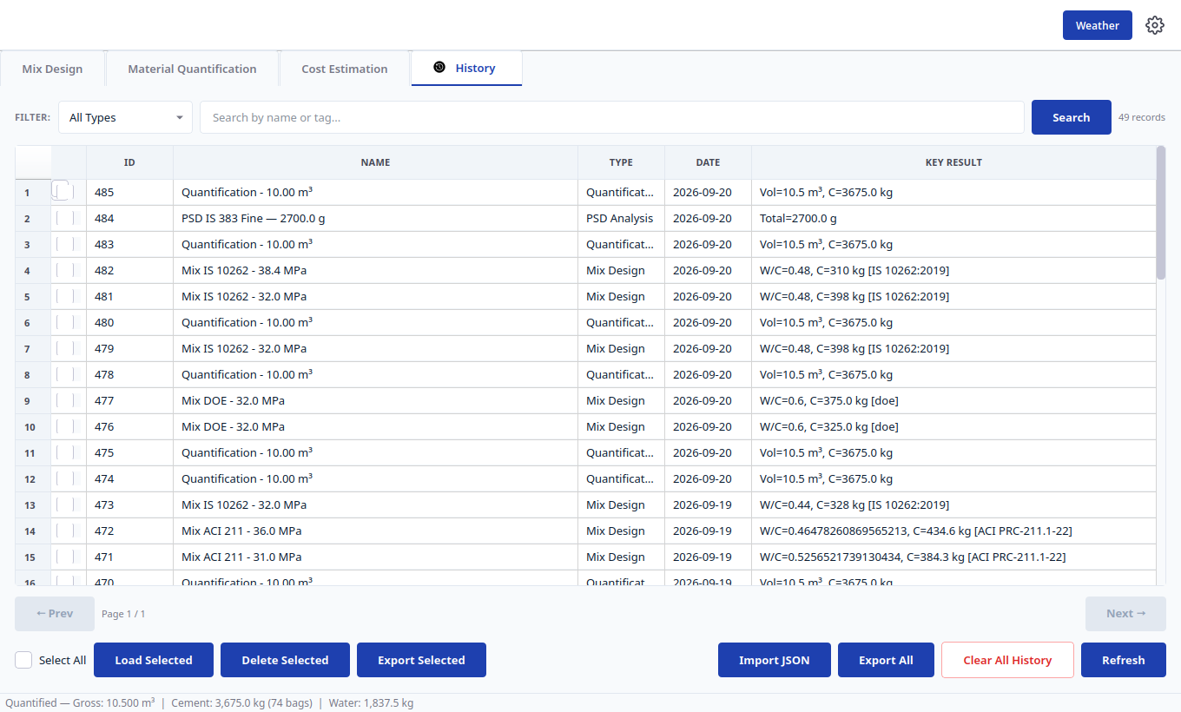
Figure 11 — History. Filter, search, reload, pin, or export any past calculation.
- Find it: pick a type in the Filter box or type a project name in Search.
- Reuse it: tick a row and press Load Selected — it reopens in the correct screen.
- Keep it handy: right-click to pin it to the top or rename it (for example “Block B – M25 – approved”).
- Share or tidy up: Export Selected / Export All saves a backup file; Import restores one; Delete or Clear All tidies up.

8. Settings and Weather
Settings (gear icon, top-right): choose Metric or American Imperial display, and show or hide the Weather button. Press Apply.
Weather (Weather button): pick your city and press Refresh. You see current conditions, a 5-day outlook and an hourly forecast. Hot, dry, windy weather means cracking risk — cure early. Cold weather means slower setting. Weather never changes your mix; it only helps you plan pouring and curing.
One weather source needs a free key (the screen tells you where to get it and where to paste it in Settings). The other works without a key.

9. Worked Examples for Each Standard (with comparisons)
This chapter proves the app against one published example per method. Follow each example click-by-click in the app — you should get the same numbers shown here. Small, explained differences come from two deliberate safety rules used everywhere in the app: the target strength is always rounded UP to a whole MPa, and cement from the Indian method is rounded UP to the next 5 kg. Both choices are conservative — they never under-design.
Tip: Recreate each example exactly as listed, press Calculate, then compare your result cards with the tables below.

9.1 Example 1 — Indian method (IS 10262:2019, M40)
Textbook source: IS 10262:2019, Annex A — M40 reinforced concrete, 20 mm stone, Severe exposure, 75 mm slump, PPC cement treated on the 43-grade curve, superplasticiser at 1% with 23% water reduction. Target in the book: 48.25 MPa (40 + 1.65 × 5), water 148 kg, cement 412 kg, sand 648 kg, stone 1234 kg, water-cement ratio 0.36.
What to enter in the app:
Section | Enter this
Design standard | IS 10262:2019
Concrete type / Exposure / Placing | Reinforced Concrete / Severe / Chute (non-pumpable)
Strength / Slump / Stone size | 40 MPa / 75 mm / 20 mm
Cement | 43-grade type; specific gravity 2.88
Sand | Zone II; specific gravity 2.65; absorption 1.0%; moisture 0%
Stone | Angular; specific gravity 2.74; absorption 0.5%; moisture 0%
Admixture | Superplasticiser, 1.0% dose, 23% water reduction

Press Calculate Mix Design. You should see the screen below.
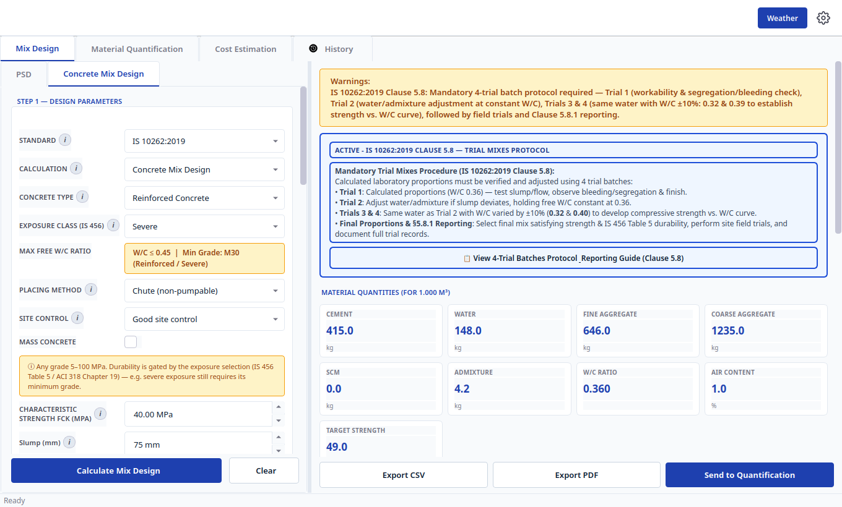
Figure 12 — Indian M40 result in the app: 415 / 148 / 646 / 1235 kg, ratio 0.360, target 49 MPa.
Compare your cards with the book:
Quantity | Book (Annex A) | App | Why any difference?
Target strength | 48.25 MPa | 49.0 MPa | App rounds the target UP to a whole MPa (safety rule).
Water-cement ratio | 0.36 | 0.360 | Exact match.
Water | 148 kg | 148.0 kg | Exact match.
Cement | 412 kg | 415.0 kg | Book gives 411.1 kg; book prints 412, app rounds UP to next 5 kg = 415 (safety rule).
Sand | 648 kg | 646.0 kg | 2 kg shift after cement rounding (volumes must still fill 1 m³).
Stone | 1234 kg | 1235.0 kg | 1 kg shift for the same reason.
Admixture (1%) | 4.12 kg | 4.2 kg | Scales with the rounded cement.
Mix ratio | — | 1.0 : 1.6 : 3.0 (0.360) | App shorthand for the site.

Note: Verdict: exact on water and ratio; cement +3 kg is the deliberate round-up. The yellow Clause 5.8 card reminds you to run the four trial batches before production.
Tip: If your cement card reads 412 instead of 415, check you selected the IS 10262 standard and entered 23% water reduction — otherwise the water and cement both shift.

9.2 Example 2 — American method (ACI PRC-211.1, 2500 psi)
Textbook source: ACI PRC-211.1-22, Section 9.2 Example 1 — 2500 psi (≈ 17.24 MPa) below-ground concrete, rounded 1½ in. (≈ 40 mm) stone, 3–4 in. slump, no air, no sulfate/frost risk. Book design (per cubic yard, dry): water 300 lb, cement 484 lb, stone 1927 lb, sand 1308 lb at ratio 0.62 (equals per cubic metre: 178.0 / 287.1 / 1143.2 / 776.0 kg). Required average strength is 3500 psi (2500 + 1000, because no test history and strength below 3000 psi).
What to enter in the app:
Section | Enter this
Design standard | ACI PRC-211.1:2022
Strength / Slump / Stone size | 17.24 MPa (2500 psi) / 100 mm (≈ 4 in.) / 40 mm (≈ 1½ in.)
Cement type | General-purpose (Type I / 42.5N equivalent)
Sand | Fineness modulus 2.80; specific gravity 2.64; absorption 0.7%; moisture 0%
Stone | Specific gravity 2.68; absorption 0.5%; moisture 0%; packed weight 1602 kg/m³ (100 lb/ft³)
Exposure | Air entrainment off; sulfate / freezing / water / corrosion all at None/Dry
Production history | No history (unticked) — the app applies the +1000 psi margin for you

Press Calculate Mix Design. You should see the screen below.
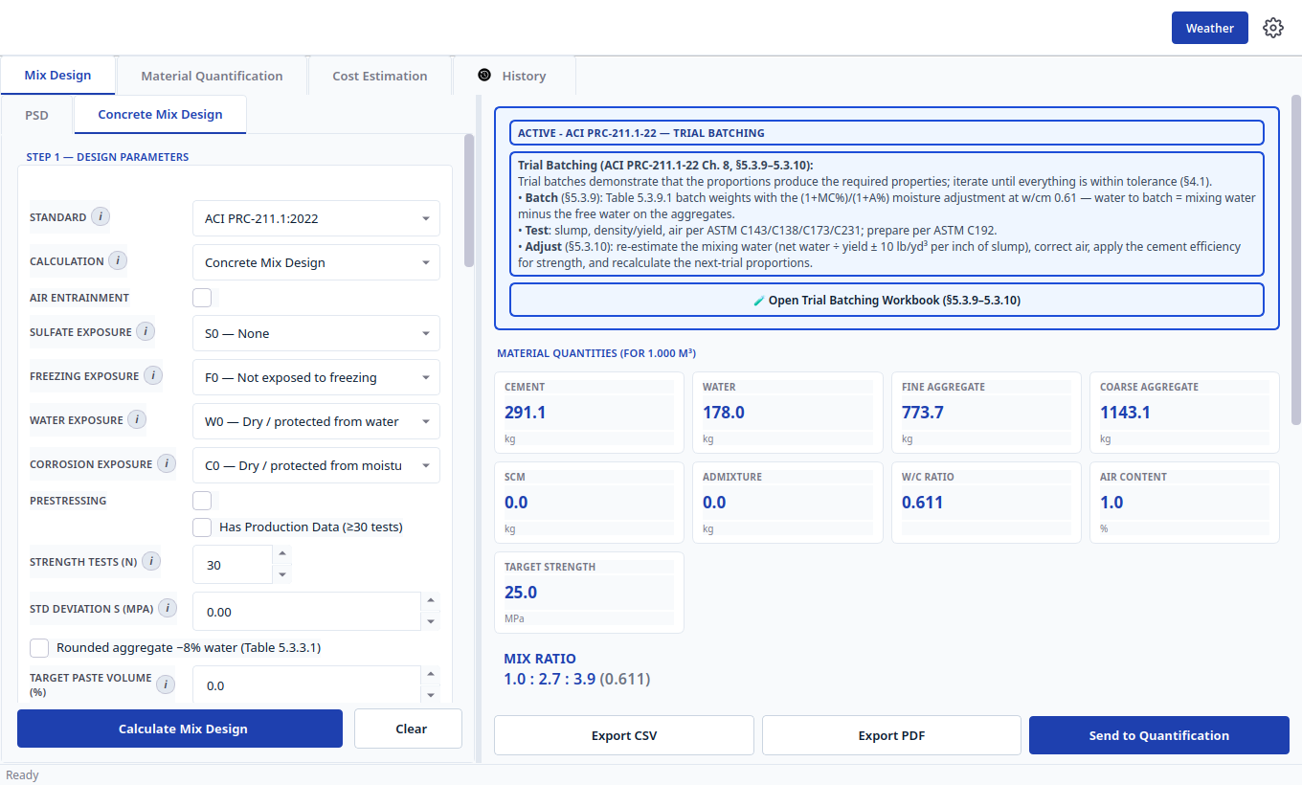
Figure 13 — American example result in the app: 291.1 / 178.0 / 773.7 / 1143.1 kg, ratio 0.611, target 25 MPa.
Compare your cards with the book (converted to kg per cubic metre):
Quantity | Book (Table 9.2.7.2) | App | Why any difference?
Target strength | 3500 psi = 24.13 MPa | 25.0 MPa | App rounds the target UP to a whole MPa.
Water-cement ratio | 0.62 | 0.611 | Book reads the ratio at exactly 3500 psi; app interpolates the same table at the rounded 25 MPa.
Water | 300 lb = 178.0 kg | 178.0 kg | Exact match.
Cement | 484 lb = 287.1 kg | 291.1 kg | +4 kg because 178 ÷ 0.611 (rounded-target ratio).
Sand | 1308 lb = 776.0 kg | 773.7 kg | −2.3 kg to close the 1 m³ volume.
Stone | 1927 lb = 1143.2 kg | 1143.1 kg | Effectively exact (−0.1 kg).
Mix ratio | — | 1.0 : 2.7 : 3.9 (0.611) | App shorthand for the site.

Note: Verdict: water and stone exact; cement and ratio shift only because the target was rounded up first. Re-enter with surface moisture on the aggregates and the app reproduces the book's batch-weight table too (water to batch drops by the free surface water).

9.3 Example 3 — British method (DOE / BRE 331, 30 MPa)
Textbook source: BRE 331:1997 (DOE method), Section 7.1 Example 1 — 30 MPa at 28 days, 2.5% defective rate, cement class 42.5, slump 10–30 mm, 20 mm natural (uncrushed) stone and sand, 70% of sand passing 600 micron, density 2.6, durability limits max ratio 0.55 and min cement 290 kg. Book answers: target 46 MPa, ratio 0.47, water 160 kg, cement 340 kg, sand 515 kg, stone 1385 kg (split 460 kg of 10 mm + 925 kg of 20 mm at 1:2).
What to enter in the app:
Section | Enter this
Design standard | DOE (BRE 331:1997)
Strength / Slump / Stone size | 30 MPa / 20 mm (inside the 10–30 mm class) / 20 mm
Statistics | Defective rate 2.5%; number of test cubes 5 (fewer than 20, so the book's Line A applies: deviation 8 MPa)
Cement / Age / Limits | Class 42.5; 28 days; min cement 290; max ratio 0.55
Aggregates | Both Uncrushed; density 2.6; sand passing 600 micron 70%
Stone split | Single stock (20 mm auto-splits 10 + 20 mm at 1:2 when batched)

Press Calculate Mix Design. You should see the screen below.
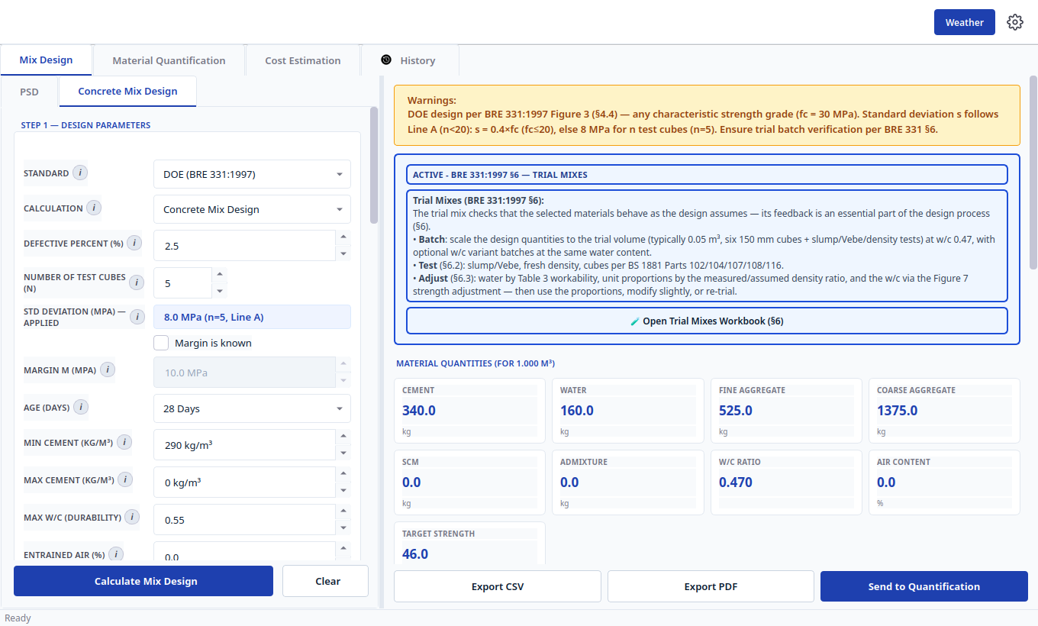
Figure 14 — British example result in the app: 340 / 160 / 525 / 1375 kg, ratio 0.470, target 46 MPa.
Compare your cards with the book:
Quantity | Book (Section 7.1) | App | Why any difference?
Target strength | 46 MPa (30 + 1.96 × 8 = 45.68, up) | 46.0 MPa | Exact match.
Water-cement ratio | 0.47 | 0.470 | Exact match.
Water | 160 kg | 160.0 kg | Exact match.
Cement | 340 kg | 340.0 kg | Exact match (160 ÷ 0.47 = 340.4 → 340).
Sand | 515 kg | 525.0 kg | +10 kg from reading the sand-share curve between printed gridlines.
Stone | 1385 kg | 1375.0 kg | −10 kg (sand + stone still total 1900 kg).
Mix ratio | — | 1.0 : 1.5 : 4.0 (0.470) | App shorthand for the site.

Note: Verdict: target, ratio, water and cement exact; sand/stone ±10 kg is curve-reading between gridlines. Leave test cubes at the default 20 and the same inputs give the Line B answer instead (target 38, ratio 0.54, cement 295) — the on-screen deviation label always names the line in use, so a mismatch with the book is immediately visible.
Tip: To see the book's split physically: order the stone as 10 mm and 20 mm single sizes in a 1:2 weight ratio (460 kg + 925 kg per cubic metre of the book mix).
Summary of all three checks: every safety-critical number (water, cement, ratio, target) matches the book exactly or conservatively above it. The only shifts are whole-number round-ups and reading a printed curve between gridlines — both documented above so an approver can follow them.

10. Printing, Saving and Sharing
What | How
Mix report (paper) | In your mix results, press Export PDF, preview, then save or print.
Mix numbers (spreadsheet) | Press Export CSV in the same place.
Grading table or curve | In sieve analysis, use Export Table / Export CSV / Export Image.
Materials bill | In quantification, use Export CSV or Export Text Report.
Cost report | In cost estimation, use Export Cost Report (PDF) or (CSV).
Backup of history | In History, use Export All (one file) or Export Selected. Restore with Import.

Tip: Type a clear Project Name before exporting — it becomes the heading on every report and makes filing easy.

11. Troubleshooting — If Something Does Not Work
You see… | What it means and what to do
Use in Mix Design stays grey | Press Compute & Plot first and wait for a result. It activates only after a successful check.
Red “out of band” on sieves | That sample misses that band. Read the failing sieve rows, adjust blending, and compute again.
Yellow Warnings on a mix | A durability rule needs more cement or less water than strength alone. Keep the app's values.
“Please calculate first” when exporting | Press the blue Calculate / Estimate button on that screen first, then export.
Numbers look wrong | Check Settings → units, and whether volume is in cubic metres. Re-apply and recalculate.
Example does not match Chapter 9 | Re-check the standard at the top, the exact inputs in the Chapter 9 table, and the line/margin boxes (DOE cubes, ACI history). One wrong box explains most gaps.
Cannot find an old calculation | In History set Filter to All Types, clear Search, then search by project name.

Still stuck? Reload the closest record from History, recalculate, and compare step by step with the pictures here. Most issues are a missed Calculate press or one wrong input box.

