# Synchronous Recommendation System

Currently, we don’t have a recommendations system which can produce the recommendation on demand within CIP.This document gives you overview of building one such system.

Predominantly below are the three approaches identified.

# Approach #1

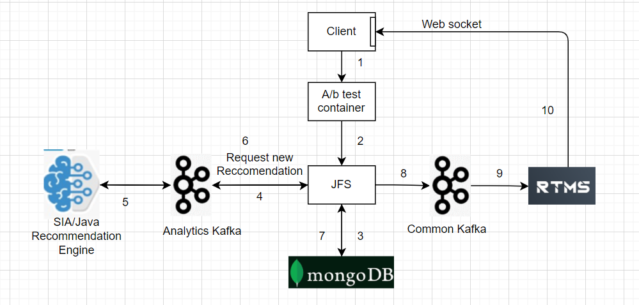

We can leverage the existing Enitan’s RTMS system to publish recommendations to client via client’s Web Socket.

Pros:

1.Recommendation system downtimes are accounted.

2.As system produces recommendations asynchronously on demand, no strict SLAs to be followed.

3.Efforts required to build the system is comparatively less.

Cons:

1.Showing the recommendations to the player when is on the same page is not possible.  
 2. We can’t extend this solution for other systems other than browser/VC client.

# Approach #2

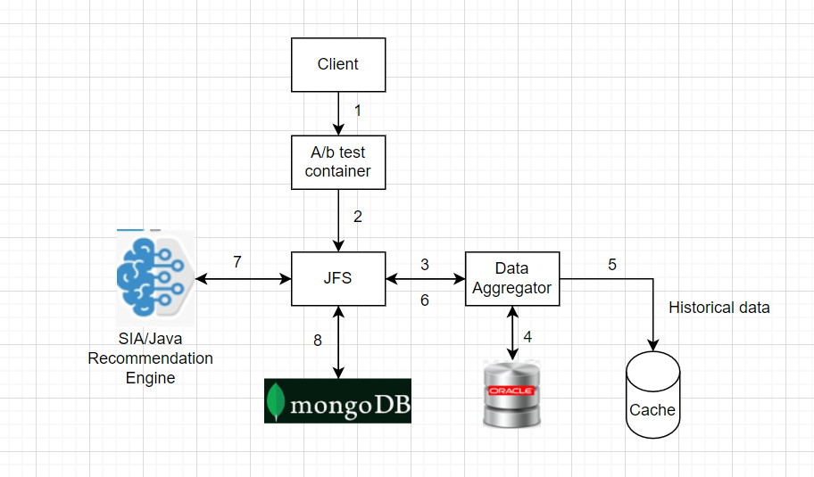

Pros:

1.Showing the recommendations to the player when is on the same page is possible.

Cons:

1.Recommendation system downtimes are not allowed.

2.Strict SLAs to be followed.

3.Efforts required to build the system is comparatively more.

# Approach #3

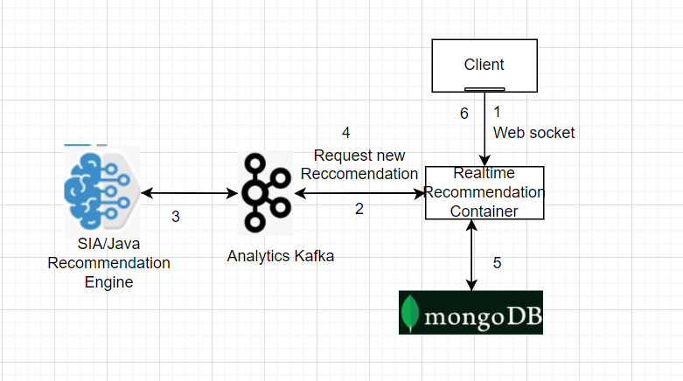

Pros:

1.Recommendation Engine downtimes are accounted.

2.As system produces recommendations asynchronously on demand, no strict SLAs to be followed.

Cons:

1.Showing the recommendations to the player when is on the same page is not possible.

2.Client has to open a new web socket connection, there may be performance penalty at the client end.

3.We can’t extend this solution for other systems other than browser/VC client.