**CIP_MONITORING Project:-**

This project is used to monitor the health of applications sent by ADA Team. If the applications received are not in a correct manner then we will raise the alert and let them know the application details of those applications. Following are the notes on which alert is being raised…

**Elastic Search Email Alert’s requirement:-**

1. **Warning Alert:-** If we get the Monitor_type as Warning for any application from ADA Team in last 1minute, then we will raise the Warning_Alert.   
   In the alert mail we will send the following application details i. e.., ApplicationName, ApplicationId, Warning Message.

**Example Payload from ADA Team:**-

{

"monitor_type": "warning",

"app_id": "application_1647257172064_1760",

"app_name": "RTSG_DEV4",

"app_version": "0",

"trace": "Sample Warning"

}

**Screenshot of Warning Alert mail:-**

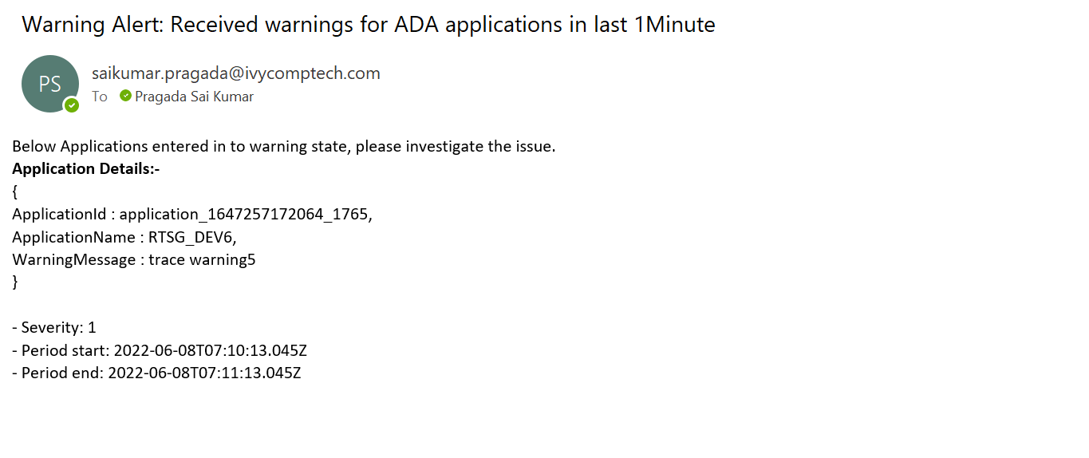

1. **Error Alert:-** If we get the Monitor_type as Error for any application from ADA team in last 1minute, then we will to raise the Error Alert.   
   In the alert mail we will send the following application details i. e.., ApplicationName, ApplicationId, Error Message.

**Example Payload from ADA Team:-**

{

"monitor_type": "error",

"app_id": "application_1647257172064_1759",

"app_name": "RTSG_DEV3",

"app_version": "0",

"trace": "Sample Error"

}

**Screenshot of Error Alert mail:-**

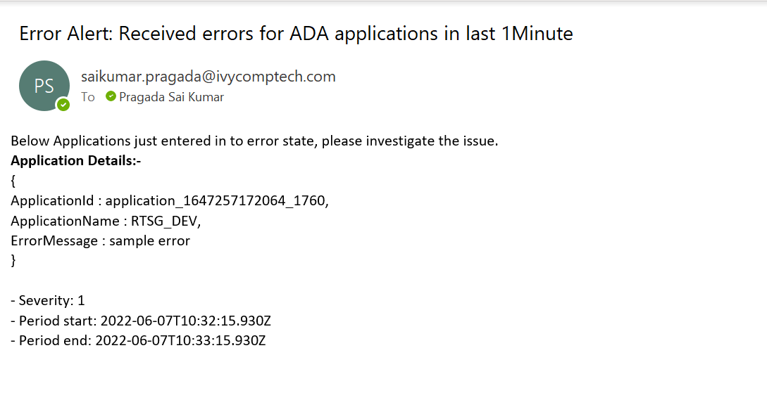

1. **Data_Movement Alert:-** This Alert is been triggered when the application is struck at a point where it is neither not consuming any data nor producing any data.  
   We will check whether the applications received in last 1min is having monitor_type is data_movement and no_events is 0 , then we will raise the DataMovement Alert.  
   In the alert mail we will send the following application details i. e.., ApplicationName, ApplicationId, EventName.

**Example Payload from ADA Team**:- Here type column results whether the application is struck while consuming /producing the data.

1. {

"monitor_type": "data_movement",

"app_id": "application_1647257172064_1759",

"app_name": "RTSG_DEV",

"app_version": "0",

"event_name": "Event_name",

"type": "consume",

"no_events":0

}

1. {

"monitor_type": "data_movement",

"app_id": "application_1647257172064_1760",

"app_name": "RTSG_DEV1",

"app_version": "0",

"event_name": "Event_name1",

"type": "produce",

"no_events":0

}

**Screenshot of DataMovement Alert mail:-**

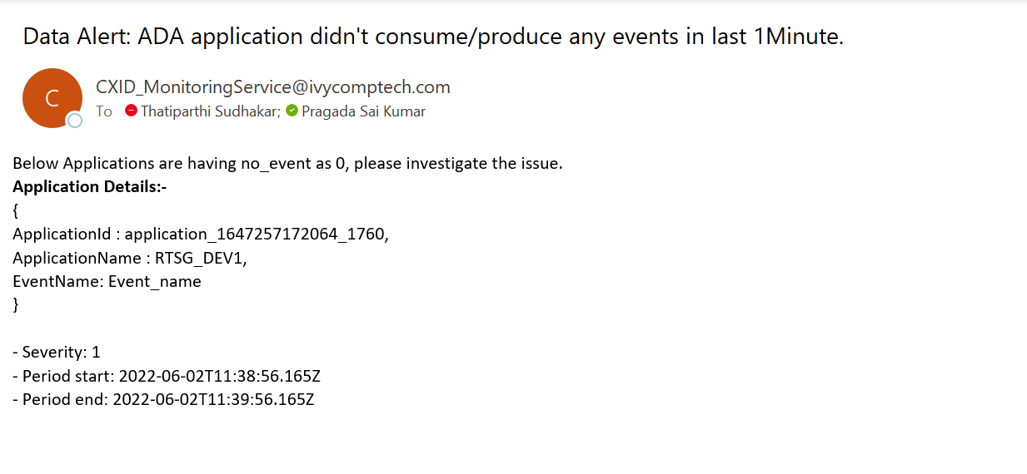

1. **Application/Heartbeat Alert:-** If we receive the heartbeat of an application that means the application is working fine as expected.  
   We will compare the applications received in last 1hour to the applications received in last 5mins. If any of the application is missing then we will raise the alert including all the application details which are missing.   
   In the alert mail we will send the following application details i. e.., ApplicationName, ApplicationId.

**Example payload from ADA Team:**-

{

"monitor_type": "heartbeat",

"app_id": "application_1647257172064_2521",

"app_name": "RTSG_Streaming_PRD_v01_cluster",

"app_starttime": "2022-06-08 09:18:40",

"batch_ts_utc": "2022-06-08 11:03:59",

"process_ts_utc": "2022-06-08 11:04:00",

"delay_sec": 0

}

**Screenshot of Heartbeat Alert mail:-**

