<https://coralracing-my.sharepoint.com/personal/udayg_ivycomptech_com/_layouts/15/onedrive.aspx?id=%2Fpersonal%2Fudayg%5Fivycomptech%5Fcom%2FDocuments%2FRecordings%2F2022%20%2D%20ADA%20%26%20GTM%20dependent%20projects%2D20211207%5F180432%2DMeeting%20Recording%2Emp4&parent=%2Fpersonal%2Fudayg%5Fivycomptech%5Fcom%2FDocuments%2FRecordings>

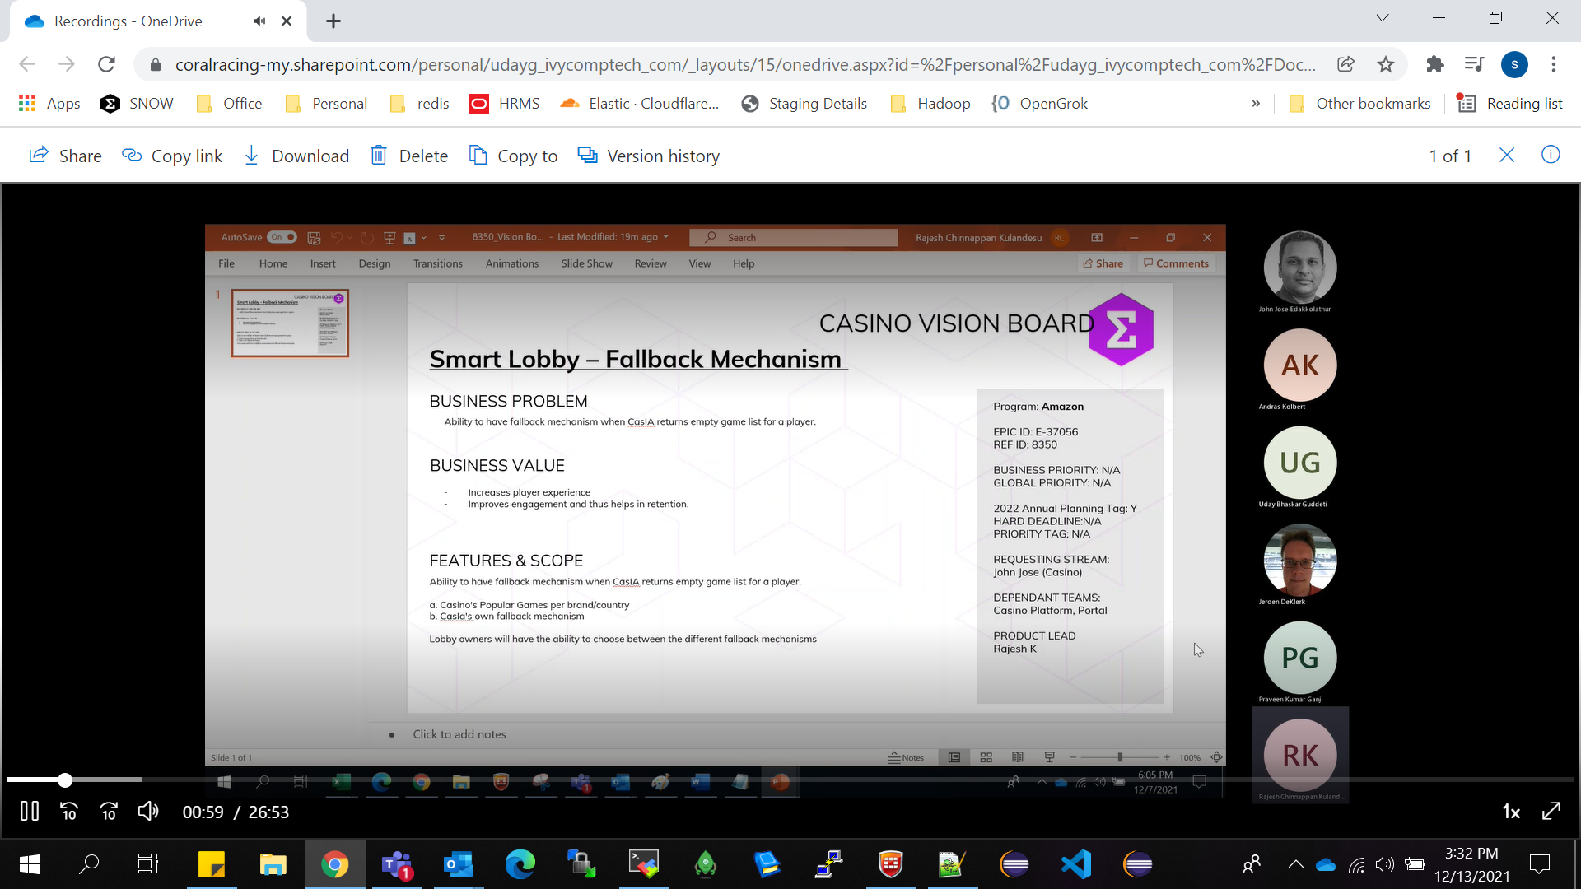

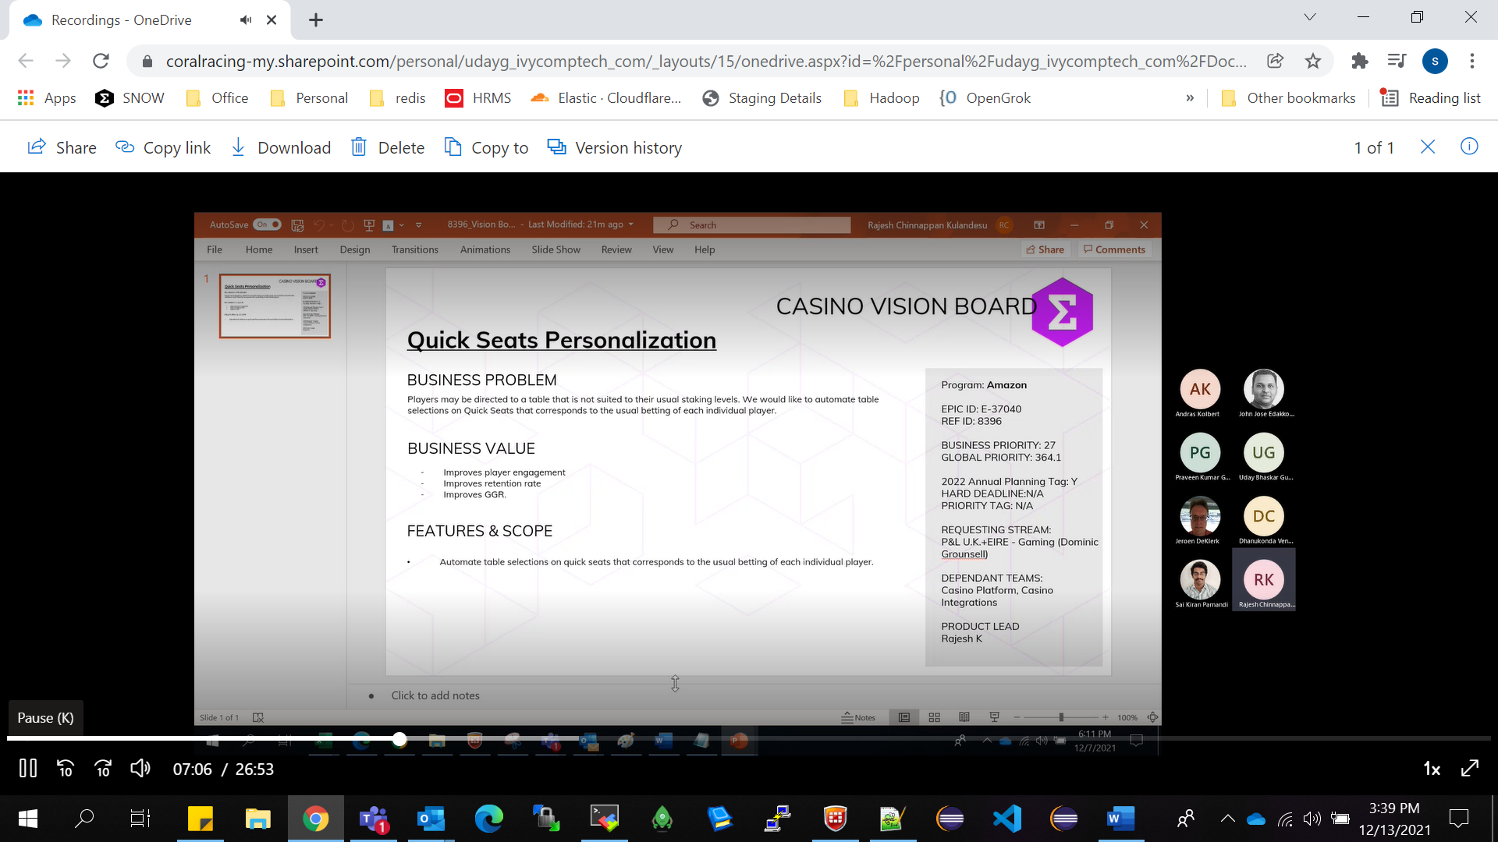

8172 Segmentation and personalisation of EzNav options LCQ4-12

