**Fanzone**

**Purpose**

As part of the Ladbrokes “Football Fans” brand strategy, Fanzone is an engaging personalised experience to provide users the best experience when it comes to their favorite team.

Below you can see the UI representation of the feature (mobile vs. desktop).

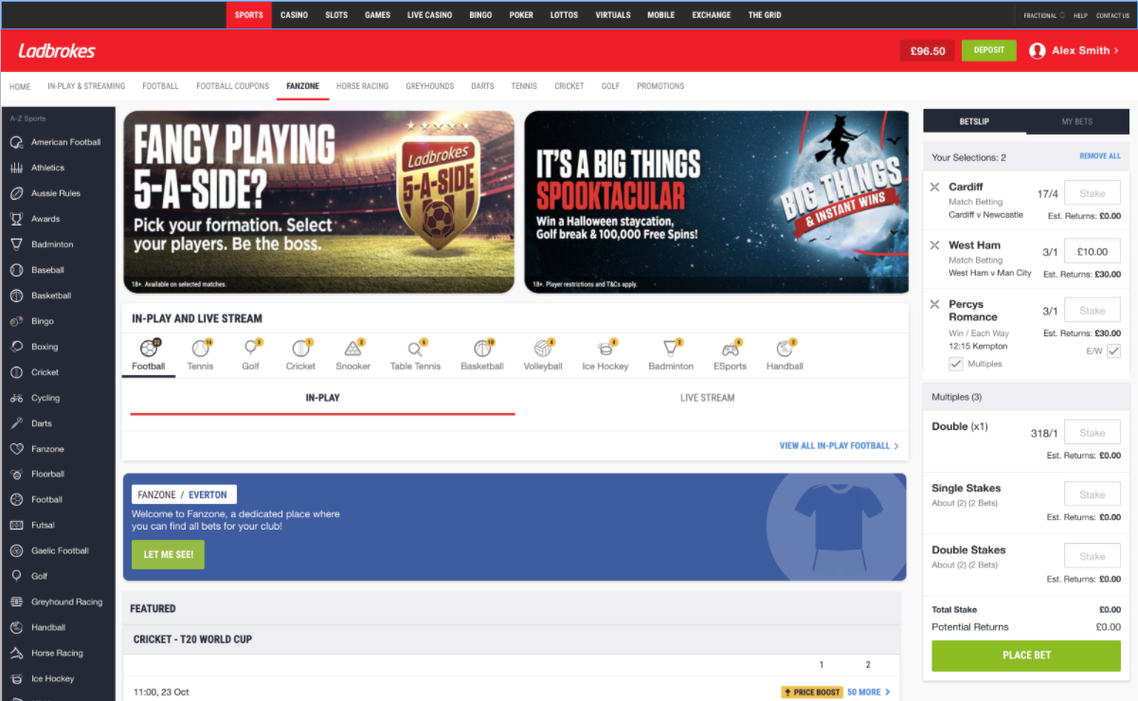

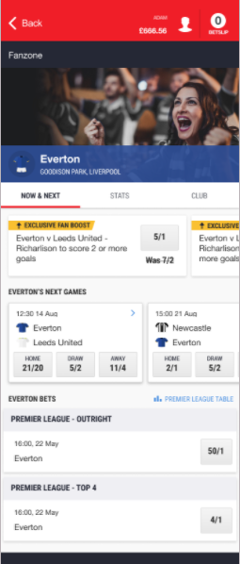

The process of favourite team selection would look like depicted in the picture below.

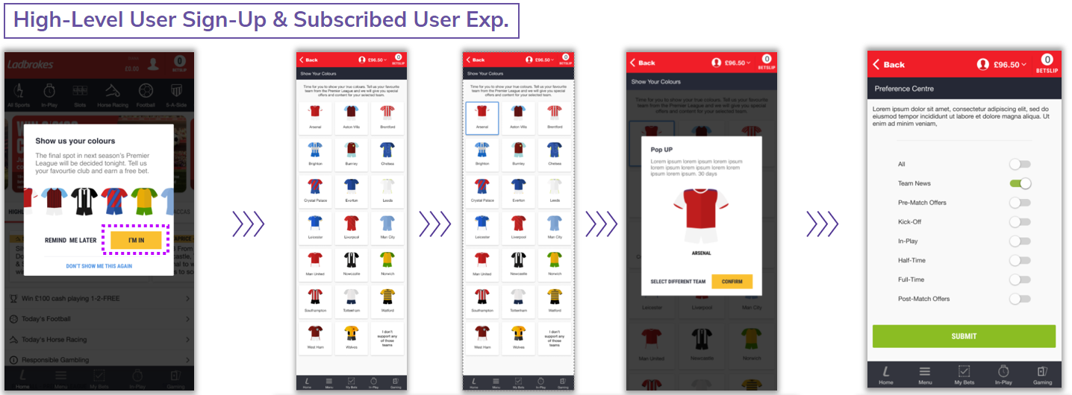

“Version 1” is initially segmented for supporters of the 20 current EPL teams. User can pick which EPL team they support by pressing their box in the grid. Users can also pick “none” in which case they’ll be able to provide favourite team’s name for future competitions.

The entry points are configured in the CMS to be switched on or off should reason arise to do so, for example: during pre-season, the launch banners might get turned off and the space will get filled with the content more appropriate to the time of year.

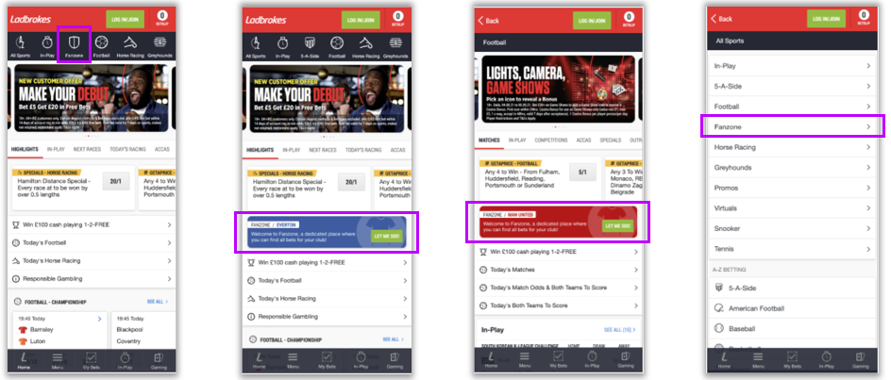

Post selection of favorite team, customer will get the promotional email/Inbox 3Hrs before of the match of their favorite team.

Multiple push notifications can be configured as per customer preferences such as:

* 1 hour before kicking off
* 30 min before kicking off
* Kick off the match
* Half time
* Full time.

User can select the favourite team without selecting communication preferences.

The user can unsubscribe from Fanzone feature. If the user decides to do so, then the following will occur for them:

* Their site will get reconfigured to normal BAU configuration, Fanzone will not be available or accessible,
* Their user data will become churn,
* If they want to re-subscribe they can do so, so long as they initially signed up > 30 days ago (this prevents users learning to circumvent the “30 day window” condition).

**Frequency**

Previously selected favourite team can be changed after 30 days. User can re-subscribe to the Fanzone only after 30 days from Date of subscription.

**Promotion life cycle**

The promotion will be active 3 hours upfront every premier league match.

**Historical data**

Historical data are not to be purged.

**Sample data**

Sample data can be found [here](https://coralracing.sharepoint.com/:x:/r/sites/BIProduct/Shared%20Documents/Project/8806%20-%203-Fanzone%201.0%20-%20CRM%20journeys/player_preferences_2022-04-04Updated.csv?d=wcb989da21c9742cf9b9f21284d9c7a4d&csf=1&web=1&e=6rgqD7). Please bear in mind that this is just dummy data, since there are multiple sports included in the file and the same team name is used across different sports.

**Reports**

This data can be used to compare the Fanzone players to other players (who are not signed up to Fanzone) in the same week. This acts as a sort of control group to assess any uplift from the Fanzone players.

**Reporting**

The data on favourite team will be used for generating reports within PowerBI. The idea is to:

* fetch the data on selected favourite team per player
* join this data with dim_player on player_id and then to transaction table (dwprodviewsmstr.f_player_sports_txn).
* this data will be used to create sandpit table – detailing each player(with a flag if they are signed up to Fanzone or not) who was active on sports in that week. Usual KPI’s such as Turnover, Bets, GGR, NGR, Theoretical GGR/NGR, Bonus Cost, SPH, BPA, Player Days, Retention Rates, Deposits, pNGR for a number of weeks before, during, and after the week that they signed up to Fanzone would be part of this table[1].
* this data will get stored in Sandpit table from where it can be picked up for processing in PowerBI.

**Data requirements**

Data on favourite team is not stored on Oxygen side, since Oxygen is stateless. The current data is saved on Platform side without any historical data.

When it comes to data requirements, following needs to be considered:

* Identify the players that are signed up to the experience (i.e. have selected their favourite team). [2]
* Include information on front_end_cd, team_name, brand, product.
* Include player’s communication preferences. If possible store preferences as separate data points with “Y/N” flag for each.
* Store a datetime detailing when that change to the favourite team was made.
* Historic data should not be purged.

**Desired implementation**

Data points collected via Platform should be stored in DWH. The data will be:

* queried by analysts (for reporting purposes)
* picked up by ADA team
* pushed to Optimove for targeting purposes.

**Requirement specification**

When it comes to BI, there are two aspects to this requirement:

* Storing favourite team and notifications preferences in TD (ERA).   
  Using information on favourite team for targeting purposes (via Optimove). Pushing following data points on favourite team’s selection to Optimove:
  + Team ID,
  + Player ID,
  + Category(sport) and
  + Team_last_updated.
* Data points on favourite team will be picked up by ADA directly from DWH (that’s why the data should be stored in accessible layer). [3]

**Data source**

Please bear in mind that the below given data points (and their naming) are provided by the platform. Naming should be adapted so that it matches the DWH naming convention. For example – last_updated timestamp could be stored with timestamp from and to (effectiveFrom, effectiveTo). This is the usual practice for the other timestamp properties stored in DWH.

Player‘s preference data will be shared by the platform to all downstream systems. This further means, that at the EOD the BI will be served the CSV file with that day’s delta changes via SFTP. The file will contain following data points:

|  |  |  |  |
| --- | --- | --- | --- |
| **Data point** | **Description** | **Data sample** | **Comment** |
| **Account_name** | Login name of the player (including fe prefix) | bz_andre | Account_name and Category represent composite key for unique value in this data set (when coming from platform)  On DWH last_updated must be part of the composite key |
| **Category** | Sport | FOOTBALL |  |
| Front_end | Frontend code | bz |  |
| Brand | Name of the brand | BWINCOM |  |
| Product | Name of the product | SPORTSBOOK |  |
| Team_ID | OPTA ID | ABC432 | Team ID must be OPTA_ID |
| Team_Name | Name of the team | Liverpool |  |
| Comm_Preferences | * Preferences for push notifications. This could be any of below listed (also multi-selection is possible):  1 hour before kicking off * 30 min before kicking off * Kick off the match * Half time   Full time or the player can select them all. | HALF_TIME; FULL_TIME | Communication preferences can be changed at any point in time, without chaning the favourite team. |
| **Team_last_updated_date** | Datetime | 4/4/2022 12:54 | This timestamp value will be used to identify when was the favourite team selected. |
| **Comm_last_updated_date** | Datetime | 3/4/2022 12:54 | This timestamp value will be used to identify when was the last time the communication preferences are changed. It will only update when the communication preferences gets changed but not on any other scenario. |

Please advise on whether the communication preferences can be structured so that each preference is separately stored (either additional column or additional tuple or other option). This was indicated as nice to have by Alex Hughes.

**Appendix**

Below you can find mapping between Opta ID and team names.[4]

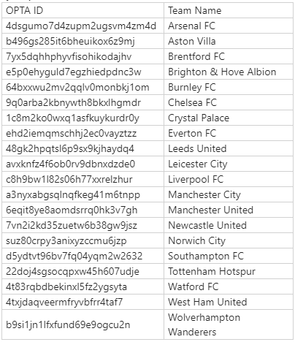

This is just to cross-check whether we are getting team names that weren’t listed in the above given list.

1. Quoting Alex Hughes *“I will drill deeper into these, splitting out the players into engagement cohorts, as well as lifecycle categories (Existing vs FTD for example)”*
2. Quoting Alex Hughes *„From our conversation last week, I believe there will be a table showing 1 row per player (for each time they change their team). This table will include Account name (login_name_txt), category (At the moment is only Football). Along with the corresponding player details such as brand, front_end_cd, Team name etc.“*
3. These data points will be used with SIA (recommendation engine) to provide the best possible recommendation for the player when it comes to their personal preferences.
4. Input from Bharath S and Aju Gopalakrishnan.