Game Design Document

Fill up the following document

1. Write the title of your project.

Peaky Blinder Game

1. What is the goal of the game?

To catch as much money as possible without running out of energy

1. Write a brief story of your game.

Thomas runs a bussiness in Birmingham and wants to make more money. He sends his brothers, John and Aurthur to do so, help each one of them to collect the most money.

1. Which are the playing characters of this game?

* Playing characters are the ones who respond to the user based on the input from the user.
* Cars, monkeys, dinos, wizards, etc., are the playing characters in the game.

|  |  |  |
| --- | --- | --- |
| Number | Character Name | What can this character do? |
| 1 | John | Move left; Move right; Collect items; |
| 2 | Aurthur | Move left; Move right; Collect items; |
| 3 | N/A | N/A |
| 4 | N/A | N/A |
| 5 | N/A | N/A |
| 6 | N/A | N/A |
| 7 | N/A | N/A |
| 8 | N/A | N/A |

1. Which are the Non-Playing Characters of this game?

* Non-Playing characters are the ones that don't have an action or behavior when the user interacts with the game.
* Hurdles, stones, bananas, coins, etc., are non-playing characters in the game.

|  |  |  |
| --- | --- | --- |
| Number | Character Name | What can this character do? |
| 1 | Thomas | Speak though text |
| 2 | Money | Fall down from the top of the screen; be collected by players; |
| 3 | Peaky Hat | Fall down from the top of the screen; be collected by players; |
| 4 | Bomb | Fall down from the top of the screen; be collected by players; |
| 5 |  |  |
| 6 |  |  |
| 7 |  |  |
| 8 |  |  |

Draw your imagination of this game. What does this game look like?

* Draw the game either on your computer or on paper.
* Add images of the game scenes to show each of the playing and non-playing characters at least once.

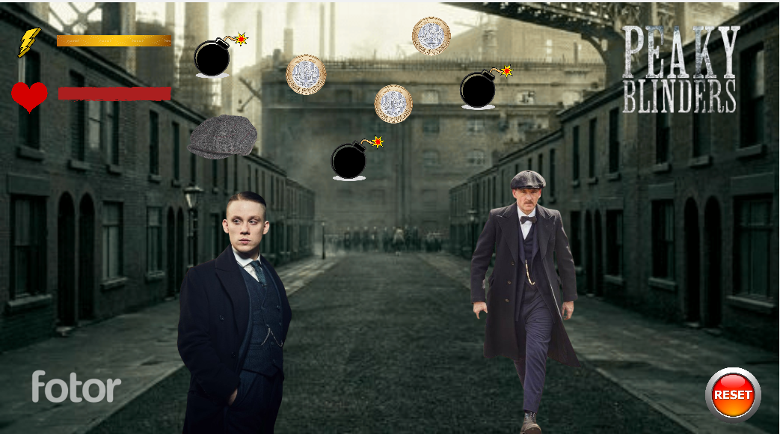

How do you plan to make your game engaging?

* + - 1. Bombs are added for difficulty
      2. Friends may steal points first
      3. People have energy bars and run out of energy and cannot play but walk slowly