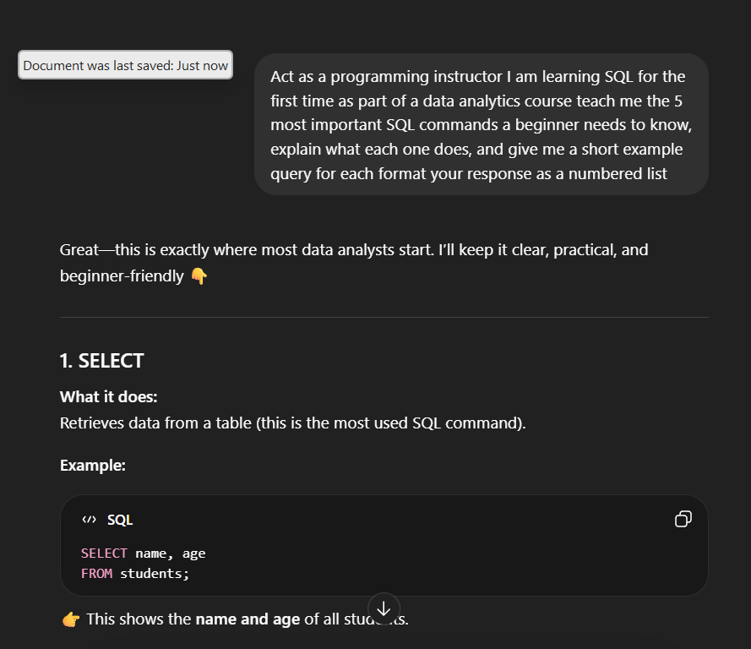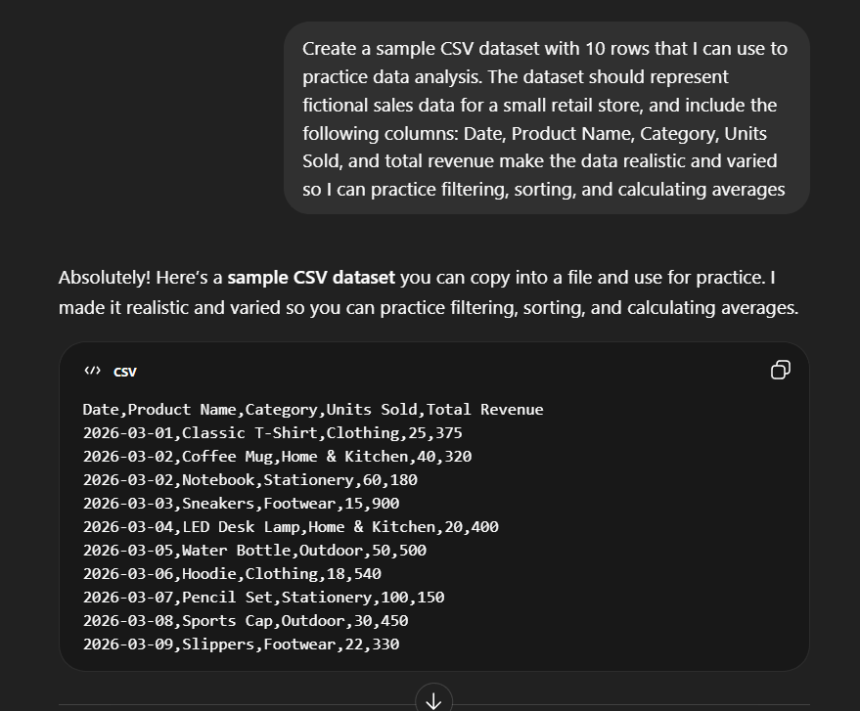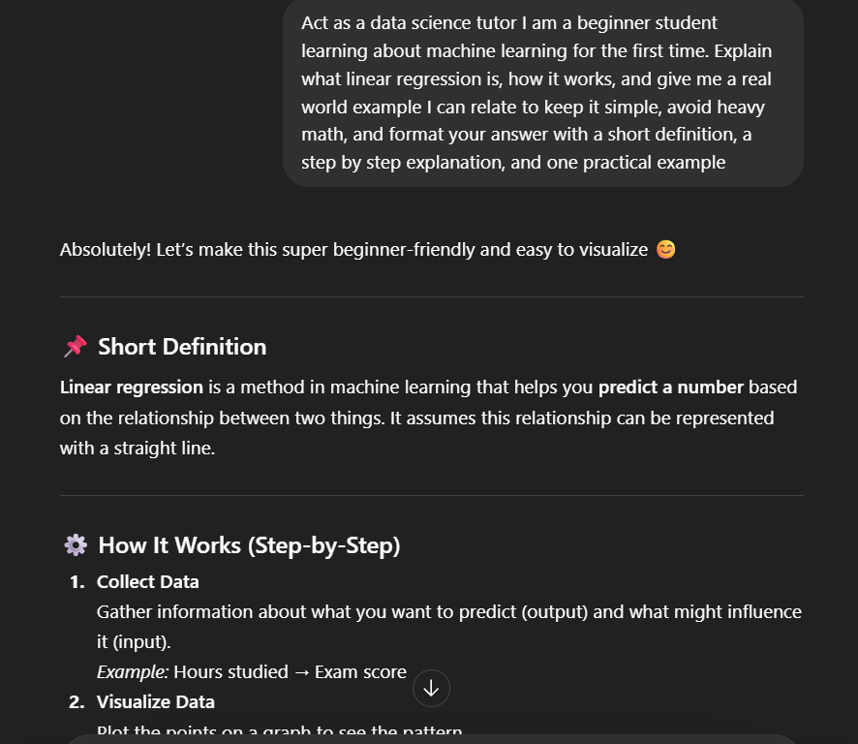

In this activity I took three weak prompts and transformed them into stronger, more specific ones by adding a role, context, task, and format to each request. By making these changes I was able to guide the AI toward delivering focused and practical answers that were actually useful for my learning process.

