ALFIDO TECH INTERNSHIP

TASK 2 – CI/CD PIPELINE WITH GITHUB ACTIONS

SUBMITTED BY:

Name: Paipalle Thejasree
Candidate ID: BS/REG/119711
Company Name: Alfido Tech
Domain: DevOps Intern
Duration: 2 months

CONTENTS:

1. Objective
2. Technologies Used
3. Project Description
4. Project Structure
5. Files Description
6. Commands Used
7. Execution Process
8. Output Screenshots
9. Learning Outcomes
10. Conclusion
11. Project Links

OBJECTIVE:

The objective of this task is to create an automated Continuous Integration and Continuous Deployment (CI/CD) pipeline using GitHub Actions. The pipeline automatically builds and tests the application whenever code changes are pushed to the GitHub repository. This helps ensure code quality, reduces manual effort, and enables faster software delivery.

TECHNOLOGIES USED:

- Git
- GitHub
- GitHub Actions
- Python
- Flask
- Docker (Optional)
- Visual Studio Code
- Windows Operating System

PROJECT DESCRIPTION:

This project demonstrates the implementation of a CI/CD pipeline using GitHub Actions. The workflow is configured to automatically trigger whenever code is pushed to the repository. The pipeline performs build and test operations to verify that the application is functioning correctly. Automation helps detect issues early and improves development efficiency.

PROJECT STRUCTURE:

Project Structure:

Alfido-Tech-Internship/
│
├── .github/
│ └── workflows/
│ └── ci-cd.yml
│
├── TASK1-Containerization/
│
├── TASK2-CICD-PIPELINE/
│ ├── app.py
│ ├── requirements.txt
│ ├── Dockerfile
│ ├── test_app.py
│ └── README.md
│
└── README.md

FILES DESCRIPTION:

app.py
Contains the main Flask web application. It defines the application routes and handles requests from users.
requirements.txt
Lists all Python packages and dependencies required to run the application. These packages are automatically installed during the CI/CD workflow.
test_app.py
Contains automated test cases used to verify that the application functions correctly. The CI pipeline executes these tests whenever code is pushed to the repository.
README.md
Provides project documentation including project overview, setup instructions, workflow status badge, and repository information.
.github/workflows/ci-cd.yml
Defines the GitHub Actions workflow. It automates the build and testing process whenever changes are pushed to the repository.
Dockerfile
Contains instructions for creating a Docker image of the application. It specifies the base image, dependencies, and execution commands.

COMMANDS USED:

docker-compose up --build
Builds and starts the Docker container.

docker ps
Displays running containers.

git init
Initializes Git repository.

git add .
Adds files to staging area.

git commit -m "Task1 completed"
Commits project files.

git push origin main
Pushes project to GitHub.

EXECUTION PROCESS:

- Created a GitHub repository for the CI/CD Pipeline project.
- Developed the application files and added the required project dependencies.
- Created a GitHub Actions workflow file (ci-cd.yml) inside the .github/workflows directory.
- Configured the workflow to automatically trigger whenever code is pushed to the GitHub repository.
- Defined the build process in the workflow to install dependencies and prepare the application.
- Added automated testing steps to verify the correctness of the application during each workflow run.
- Built a Docker image for the application using Docker.
- Tagged the Docker image with the Docker Hub repository name.
- Logged in to Docker Hub and configured the required credentials.
- Pushed the Docker image to Docker Hub for deployment and storage.
- Committed and pushed all project files to the GitHub repository.
- GitHub Actions automatically triggered the CI/CD pipeline after the push operation.
- The workflow successfully completed the build, test, and Docker image deployment stages.
- Verified the successful workflow execution in the GitHub Actions tab and confirmed that the Docker image was available in Docker Hub.
- Added the workflow status badge to the README file to display the current pipeline status.
- Successfully completed the implementation of an automated CI/CD pipeline using GitHub Actions and Docker Hub.

OUTPUT SCREENSHOTS:

- GITHUB REPOSITORY STRUCTURE:

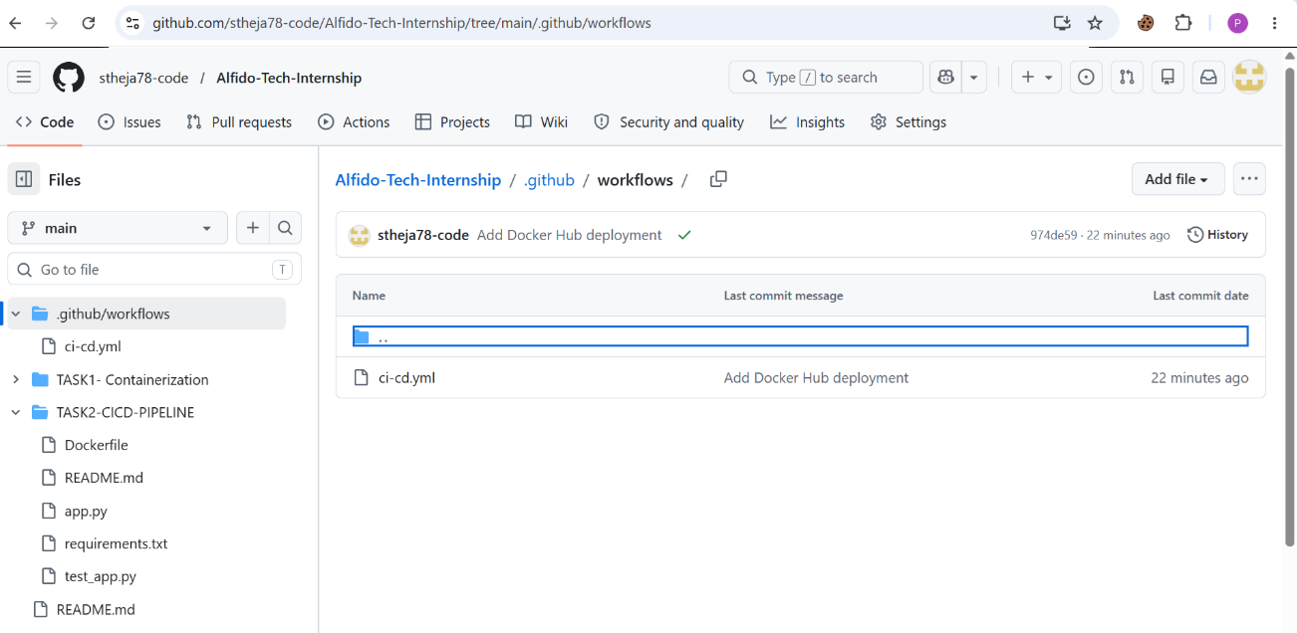

- WORKFLOW RUNS SUCCESS:

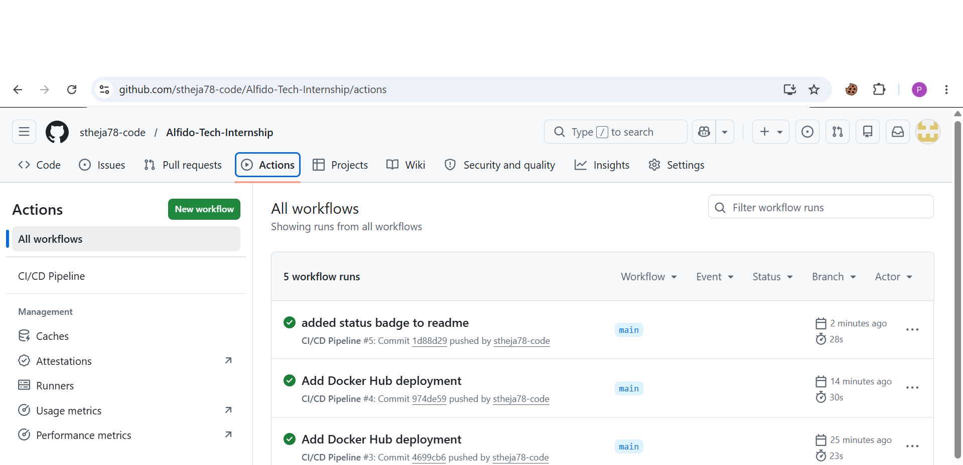

- WORKFLOW DETAILS SUCCESS:

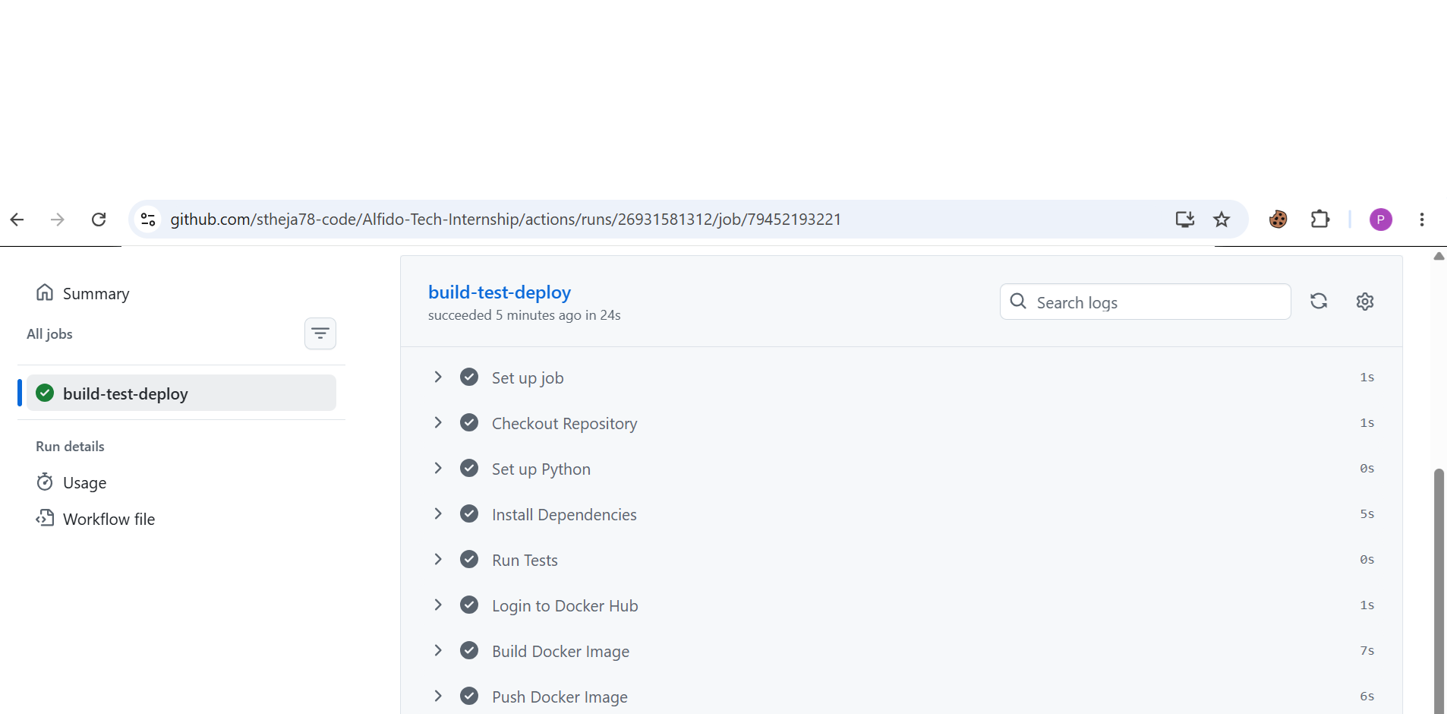

- DOCKERHUB DEPLOYMENT:

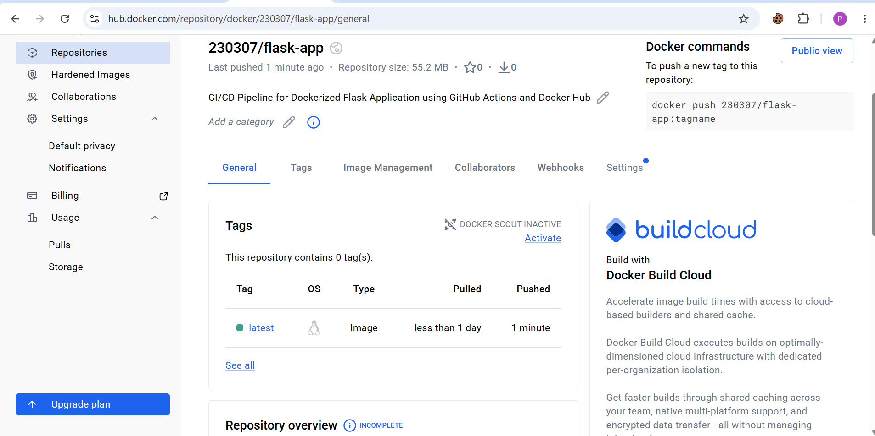

- README STATUS BADGE:
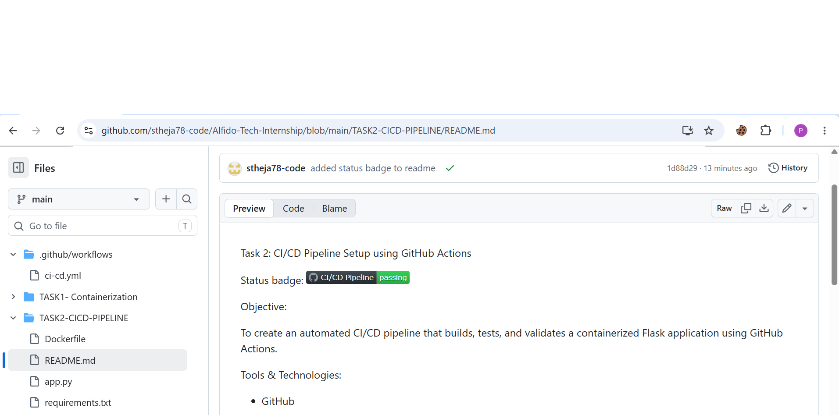

LEARNING OUTCOMES:

- Gained practical knowledge of Continuous Integration (CI) and Continuous Deployment (CD) concepts.
- Learned how to create and configure GitHub Actions workflows for automation.
- Understood how automated build and testing processes improve software quality.
- Acquired hands-on experience with Git and GitHub repository management.
- Learned to create, tag, and manage Docker images.
- Understood the process of deploying Docker images to Docker Hub.
- Gained exposure to DevOps practices and workflow automation.
- Learned how to monitor workflow execution and troubleshoot pipeline issues.
- Understood the importance of automation in modern software development

CONCLUSION:

This project successfully implemented an automated CI/CD pipeline using GitHub Actions and Docker Hub. The pipeline was configured to automatically build, test, and deploy the application whenever changes were pushed to the GitHub repository. The automation reduced manual effort, improved code reliability, and ensured a consistent deployment process. Through this project, valuable experience was gained in GitHub Actions, Docker, and DevOps practices, demonstrating the effectiveness of CI/CD in modern software development.

PROJECT LINKS:

GitHub repository:

https://github.com/stheja78-code/Alfido-Tech-Internship

LinkedIn Profile:

https://www.linkedin.com/posts/paipalle-thejasree_alfidotech-internship-task2-ugcPost-7468191000746901504-Rsir/

