Preterm birth is a dream challenge <http://dreamchallenges.org/> hung on the platform of Synapse.
The objective is to predict, from given genes, when the baby will be born and know if he/she will have a premature delivery.

With the tools we have in R we have to get to know when it will be born.

First I have to learn R: <LearningR.rmd> in code academy.

Then, Mattia, my tutor of this project, has done an R document that help us to start and understand it <metadata_plot_and_dimensionality_reduction.R>

All the information of genes, etc. I have it in directory data/

Preterm birth (PTB), defined as giving birth prior to completion of 37 weeks of gestation, is the leading cause of newborn deaths and long-term complications including motor, cognitive, and behavioral impairment.

Preterm birth is a syndrome with multiple etiologies.
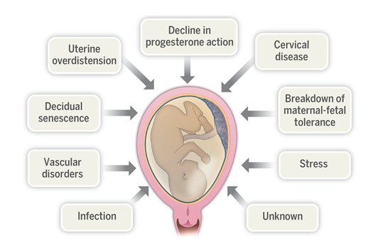

metadata = read.csv('Desktop/DUAL/4_Project_DreamChallenge/data/anoSC2_v20_nokey.csv')

load('Desktop/DUAL/4_Project_DreamChallenge/data/HTA20_RMA.RData')
ge_df = as.data.frame(eset_HTA20)

metadata:
- SampleID. Unique identifier sample.
- IndividualID. Unique patient identifier.
- GA. Gestational age.
- GADel. Gestational age at delivery (birth).
- Group. Control, PROM, sPTD.
- Train. 0, 1.
- TTD. Weeks interval (GADel - GA).

There will be three groups:
- Control. Normal.
- sPTD. Spontaneous preterm labor and delivery with intact membranes.
- PROM. Preterm premature rupture of the membranes.

There will be two trains:
- 0. Training samples (what they give it to me).
- 1. Test samples (what I have to find out).

The code to continue the memory is in <Steps_Dream.R>
We have two files:
- anoSC2_v20_nokey.csv: This file specifies which are the samples/microarrays to be used for training and testing in sub-challenge 2. The following columns are included:
- SampleID: unique identifier of the sample (matching part of the the name of the .CEL files in HTA20 and HuGene21ST folders.
- IndividualID: unique patient identifier.
- GA: gestational age as determined by the last menstrual period and or ultrasound.
- GADel: gestational age at delivery.
- Group: outcome of pregnancy.
- Set: name of the source dataset.
- Train: 1 for samples to be used for training, 0 for samples to be used for test.
- Platform: gene expression platform used to generate the cell files.
- TTD: interval in weeks from sample to delivery (GADel-GA).
- HTA20_RMA.RData: R Data file containing the gene level expression matrix eset_HTA20 (32,830 rows x 735 columns).
- Row names are ENTREZ gene IDs (except for “_at” suffix).
- Columns are SampleID.

