Title of the Paper for Photonics 2026 at IIT Hyderabad
XXXXXXXXXXXXXXXXX
First Author¹ and Second Author^{2*}
¹Department of Physics, Xyz University
²Department of Electronics, Institute of Pqr
*corresauthor@inpqr.in
Abstract: Please adhere to the formatting instructions provided on the first page of this template. The abstract should concisely summarize the objectives, key results, and novelty of the work. The abstract must not exceed 50 words.

Please adhere to the following formatting guidelines when submitting your extended abstract to the Photonics 2026 conference. This template is shared on the official website of the conference. The preamble contains the page formatting commands that are required. Replace the text provided here with your content appropriately.
Please use Times New Roman font throughout the manuscript. The paper title should be in 17 pt bold, author names in 12 pt, affiliations and the corresponding author email in 10 pt, and the main text in 10 pt. Figure captions, table captions, and references should be in 9 pt.
Make sure the citations are complete and correct. The bibliography style is already mentioned in the preamble. Examples of references are provided in the “References.bib” file. Citations should be numbered sequentially and included in square brackets at the end of this sentence as indicated [1]. The syntax for multiple references is [1–3]. Use “Ref. [3]” or “reference [3]” at the beginning of a sentence, and just the reference number like [3] in between the sentence.
Include one space after each colon and period. Before decimal points, use a zero: “0.58” rather than “.58.” For sample dimensions, indicate using “0.2 mm × 0.4 mm,” instead of “0.2×0.4 mm².”
An example of a table is given in Table 1, which can be modified or discarded based on your content.
Table 1: Example of a table
Ratio | Decibels
0.27 | 10
1 | ≈ 7
3.33 | 12
5 | 40
10 | -10
100 | 20
1000 | 50
In the figures, incorporate complete words in the labels of axes i.e, write the quantity “Time” as “Time, T” rather than just “T.” Place parenthesis around the units as in “Time (hour),” not just “hour,”. Ensure that large figures and tables covering both columns do not extend into the page margins. Table captions
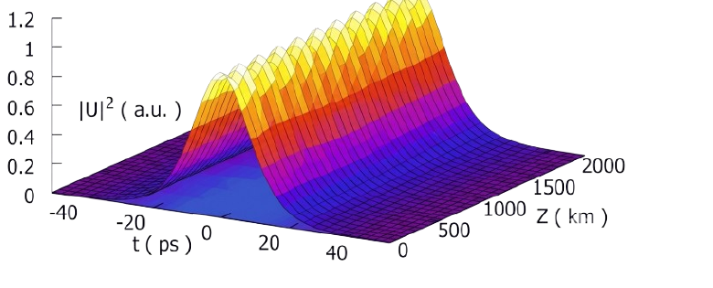
Figure 1: An example figure.
should be above the tables, and figure captions should appear beneath the figures. Use the following format: Fig. 1 when referring to the figures. Except at the start of a sentence, only use (1) instead of “Eq. (1)” or “equation (1).”
x(t) = p(f_{ω}(t)) (1)
Make sure that the final size of the letters in an image is about 12 points (comparable to the letters in the caption). In case the size of the graphics is large, try reducing its size through suitable methods.
If you only have raster graphics applications, make the figures big enough so that when they are shrunk to reproduction size, the sharp edges will be smoothed off. Before including it in the LaTeX file, you must convert the format to the encapsulated postscript format (or into jpg, pdf, or png formats for pdflatex). Directly output the graph in postscript or pdf format while using software such as MATLAB to create graphs.
Finally, verify that the numbers in all the figures and tables are correct. Also, check your spelling properly. Make sure your paragraphs flow smoothly and that your phrases are complete. All appropriate references must be included.
Random text has been included to illustrate the maximum two-page limit of the extended abstract. Photonics 2026 brings together researchers, academicians, industry professionals, and students working across the broad spectrum of optics and photonics. The conference serves as a platform to present recent advances in photonic materials, optical communications, fiber optics, integrated photonics, lasers, nonlinear optics, nanopho-
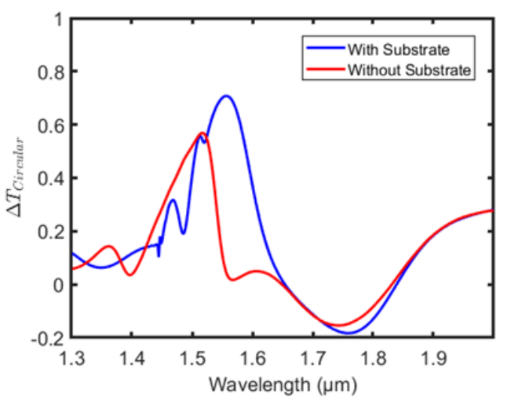
Figure 2: Another example figure.
tonics, quantum photonics, computational imaging, and optical sensing. Through keynote lectures, invited talks, oral and poster presentations, the conference encourages the exchange of innovative ideas, promotes interdisciplinary collaborations, and highlights emerging technologies that address scientific and industrial challenges. Photonics 2026 aims to foster interaction between academia and industry while providing participants with opportunities to discuss cutting-edge research and future directions in the rapidly evolving field of photonics.
The Indian Institute of Technology Hyderabad (IIT Hyderabad) has emerged as one of India’s leading institutes for research and innovation in science and engineering. The institute fosters an interdisciplinary research ecosystem that promotes collaborations across physics, electrical engineering, materials science, and computational sciences. In the area of photonics, IIT Hyderabad has established vibrant research programs spanning fiber optics, integrated photonics, ultrafast optics, nonlinear optics, nanophotonics, optical communications, photonic materials, optical sensing, and AI-enabled photonics. State-of-the-art experimental and computational facilities, together with strong academic and industrial collaborations, provide an excellent environment for advancing both fundamental and application-oriented research. Photonics 2026 aims to bring together researchers, industry experts, and students to exchange ideas, present recent advances, and discuss emerging directions in optics and photonics, further strengthening IIT Hyderabad’s role as a center for cutting-edge photonics research.
Photonics 2026 aims to provide an international forum for researchers, students, and industry professionals to present recent scientific achievements and discuss emerging trends in photonic technologies. The conference will feature keynote lectures, invited presentations, contributed talks, poster sessions, and technical exhibitions covering a broad range of topics in modern optics. By encouraging interdisciplinary interactions and collaborative research, the conference seeks to strengthen the global photonics community and inspire innovative solutions to current scientific and technological challenges
We look forward to welcoming you to Photonics 2026 at IIT Hyderabad. Join us for an exciting gathering of researchers, scientists, academicians, and industry experts to explore the latest advancements in fiber optics and photonics while fostering meaningful collaborations.

References
[1] Keisuke Goda and Bahram Jalali. Dispersive fourier transformation for fast continuous single-shot measurements. Nature Photonics, 7(2):102–112, 2013.
[2] Foued Amrani, Adil Haboucha, Mohamed Salhi, Hervé Leblond, Andrey Komarov, and François Sanchez. Dissipative solitons compounds in a fiber laser. analogy with the states of the matter. Applied Physics B, 99:107–114, 2010.

