Name (Student 1): Devansh Chaturvedi Roll No: 240340
Name (Student 2): Sthit Pragye Roll No: 241045
Course: EE200 Question: 3
Methodology:
- Mounted the google drive containing songs data on Google Colab.
- Created functions to plot the DTFT of a given song, get spectrogram and its peaks of given songs, plotting spectrogram and peaks for given songs.
- Generated DTFT of an entire song (here Eight Days A Week.mp3)
- Compared the results variable window length on the spectrogram obtained (nperseg = 512 and nperseg = 1024)
- Generated a SQLite database containing a table with columns f1, f2, ∆t, song name and t1 to store pairs of nearby peaks in spectrograms of all the 50 songs provided.
- Created a function to add songs fingerprints to the SQLite database.
- Created a function that identifies name of a song in each clip by finding the comparing pairs of peaks in the spectrogram of the unknown song with the fingerprints in the database, finding the offset histogram of possible songs and selecting the one with maximum cluster density.
- Analysed the robustness of the identifier by making predictions on known song clips with variable amount of noise, pitch and playback speed.

The code can be found through the following link:

Results:
Plotting DTFT of a given song:
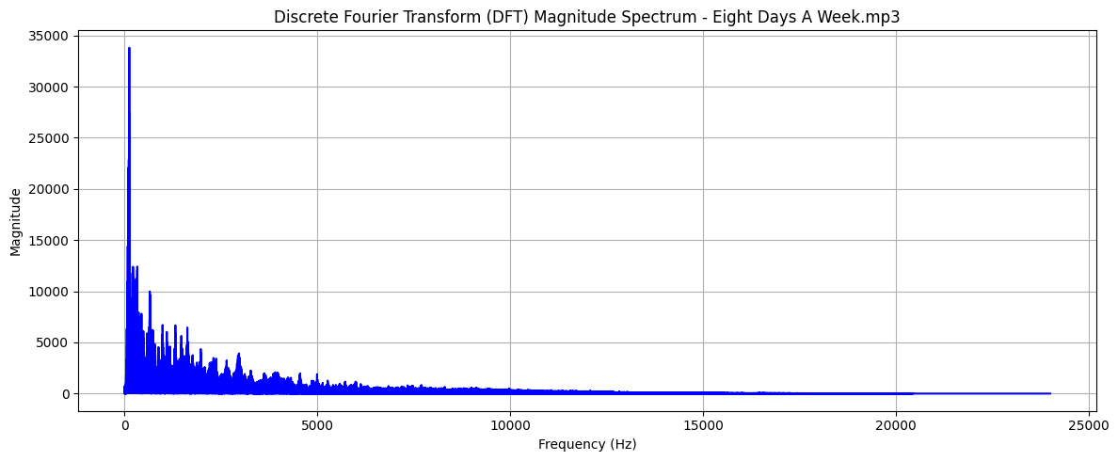

Effect of Window length on spectrogram:
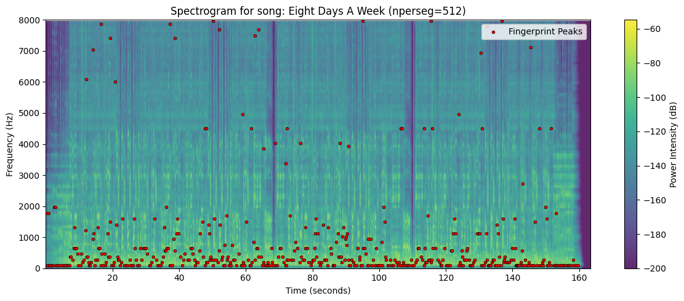
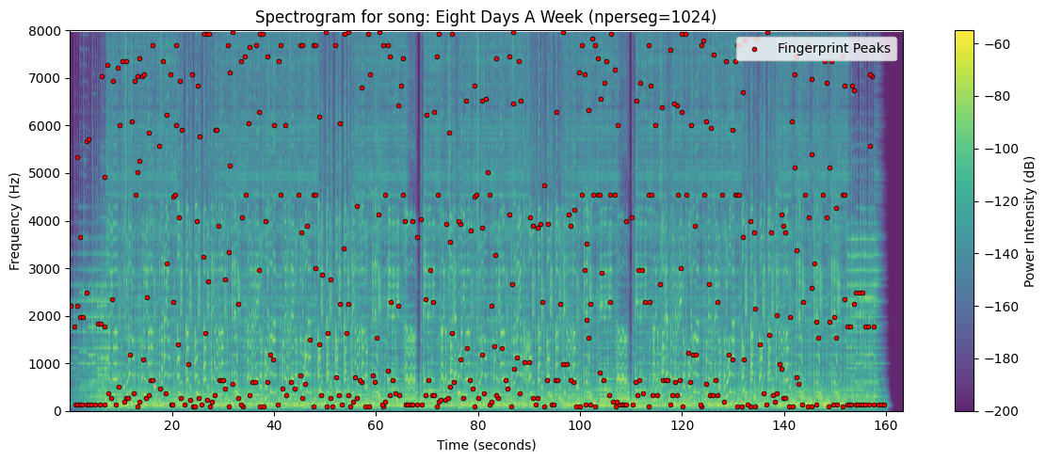
The window length shows a trade-off governed by the time-frequency uncertainty principle. Shorter the window length (nperseg=512) higher is the time resolution but low frequency resolution. Because each time slice is very brief, the system can precisely pinpoint the exact moment a note or transient sound begins along the horizontal axis, but the frequency bins are wide, causing individual frequencies to smear together vertically.
Larger window length (nperseg=1024), higher is the frequency resolution at the expense of time resolution. The large number of data points within the long window allows the Fourier transform to resolve closely spaced frequencies making individual harmonic bands and pitch lines appear much sharper and cleaner. However, because the frequency content is averaged over a longer span of time, brief, rapid acoustic events are smeared horizontally, making it difficult to detect exact timing variations.

Effect of Noise on Identifier:
Actual Song: Eight Days A Week.mp3

Noise Level: 0
Best Match for Song 1: Eight Days A Week
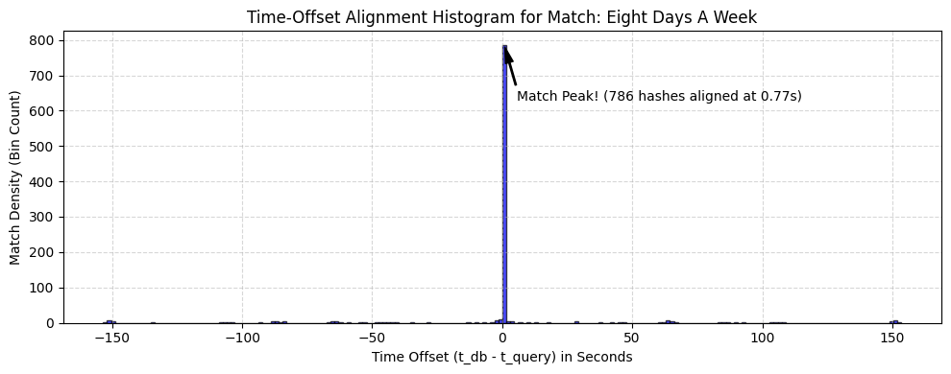

Noise Level: 0.6
Best Match for Song 1: Eight Days A Week
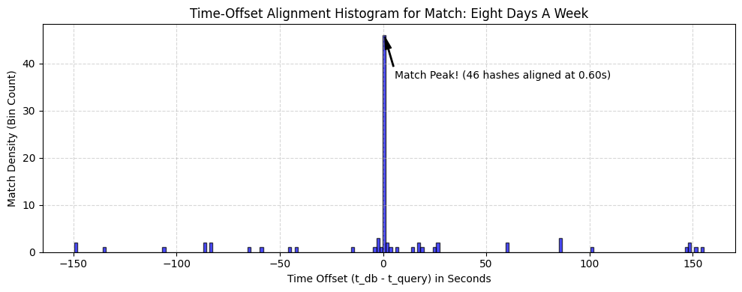

Noise Level: 1.5
Best Match for Song 1: Eight Days A Week
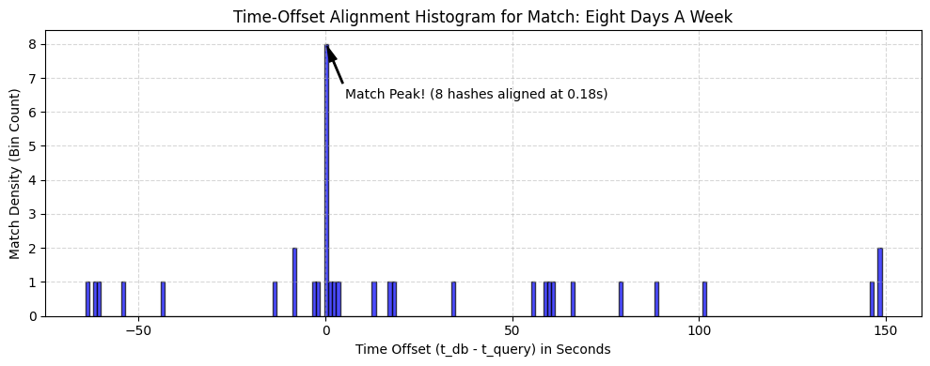

Noise Level: 1.8
Best Match for Song 1: Eight Days A Week
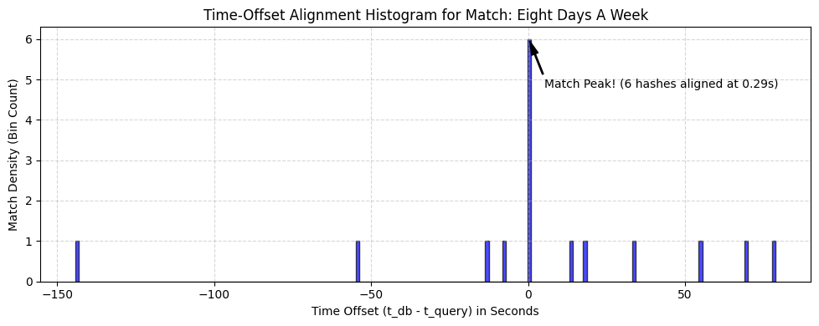

As the noise increases, the cluster density of the time offset histogram of the actual answer keeps decreasing. It remains maximum among the histograms of all possible songs until noise of 1.8 but the gap between them keeps decreasing. Beyond the noise of 1.8, the cluster density of time offset histogram of some other song surpasses that of the original song, and we start getting incorrect answer.

Effect of Pitch:
Actual Song: Eight Days A Week.mp3

Pitch Level Up: 0
Best Match for Song 1: Eight Days A Week
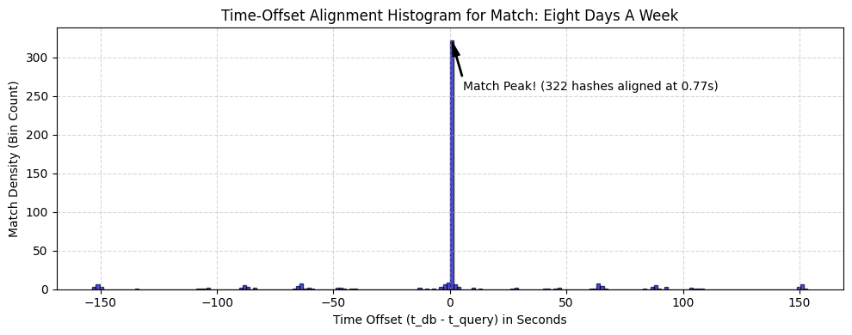

Pitch_Level Up: 2
Best Match for Song 1: Eight Days A Week
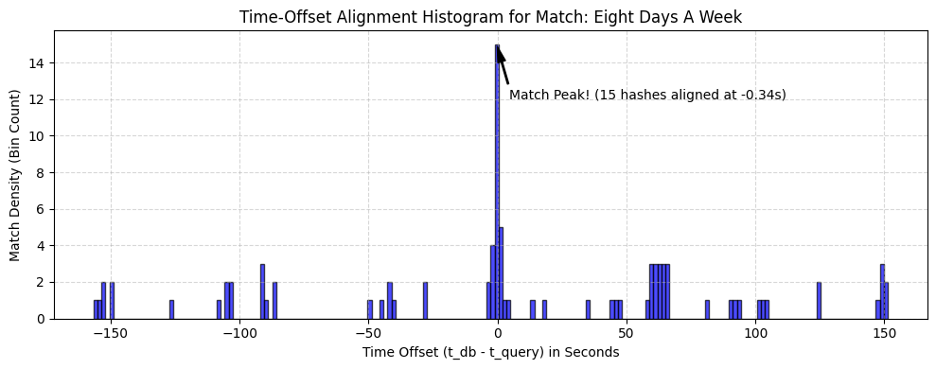

Pitch_Level Up: 3
Best Match for Song 1: Hey Jude
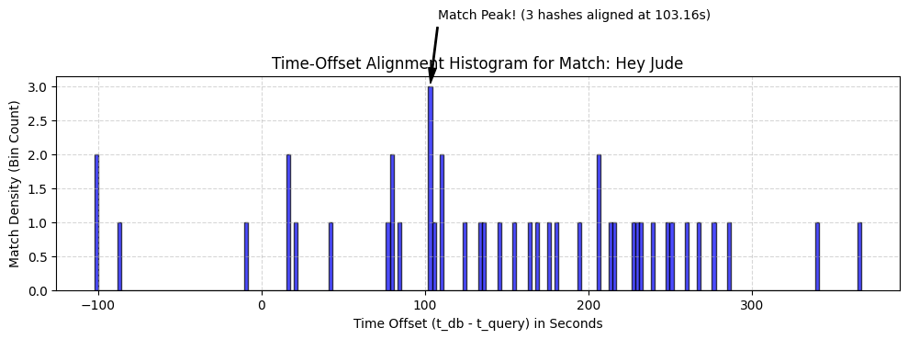
As the pitch increases, the cluster density of the time offset histogram of the actual answer keeps decreasing. The cluster density of the time offset histogram of the actual song remains maximum among the histograms of all possible songs until pitch up of 2 but the gap between them keeps decreasing. Beyond the pitch up of 2, the cluster density of time offset histogram of some other song surpasses that of the original song, and we start getting incorrect answer.
A pitch shift moves the entire audio signal up or down in frequency, which translates to a vertical displacement of all spectral components on the spectrogram. Because the frequencies of the local maxima change as well, the coordinates of peaks shift away from their original positions.
This vertical shift directly breaks the fingerprinting system because the identifier relies on matching exact frequency values in the database. Even though a slight pitch change sounds nearly identical to a human ear, it alters the frequency keys completely, causing failure in finding the matching hashes. To make the system robust against this, relative frequency differences between paired peaks rather than absolute frequency values should be used.

Effect of Time Stretching:
Actual Song: Eight Days A Week.mp3

Playback Speed: 1.0
Best Match for Song 1: Eight Days A Week

Playback Speed: 1.01
Best Match for Song 1: Eight Days A Week
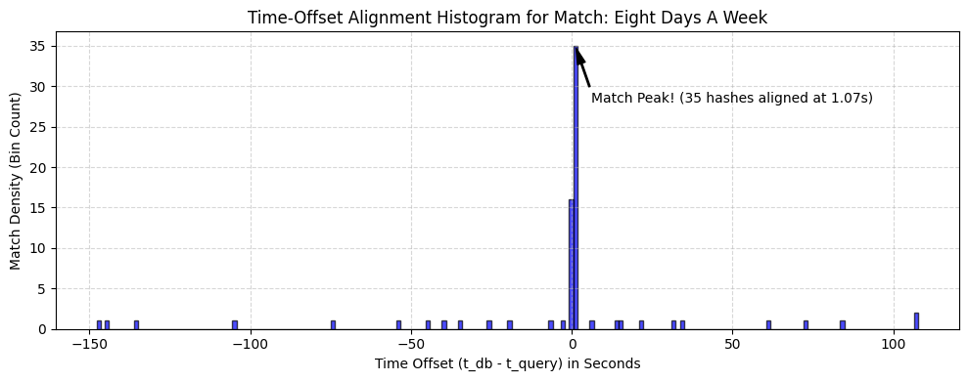

Playback Speed: 1.03
Best Match for Song 1: Eight Days A Week
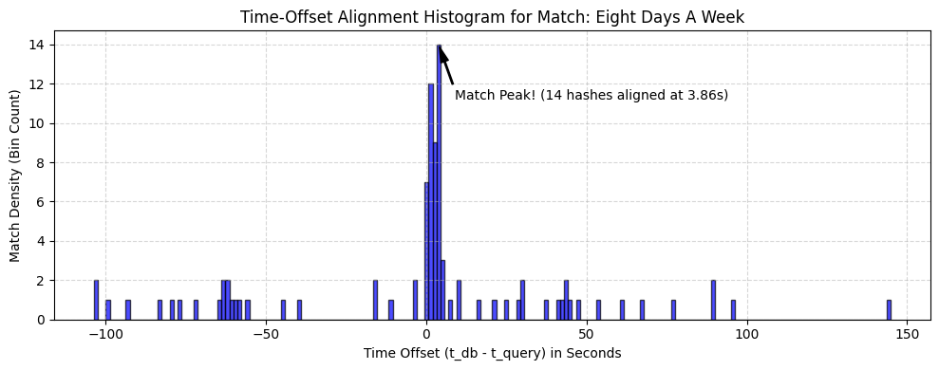

Playback Speed: 1.04
Best Match for Song 1: Something
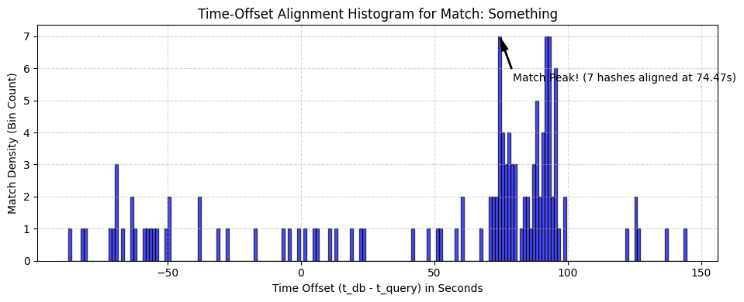

Effect of using single peaks instead of Pair of peaks:
Consider the song, I've Got a Feeling.mp3. See the prediction results of a clip of this song using a pair of peaks and then using a single peak.

Prediction using pair of peaks:
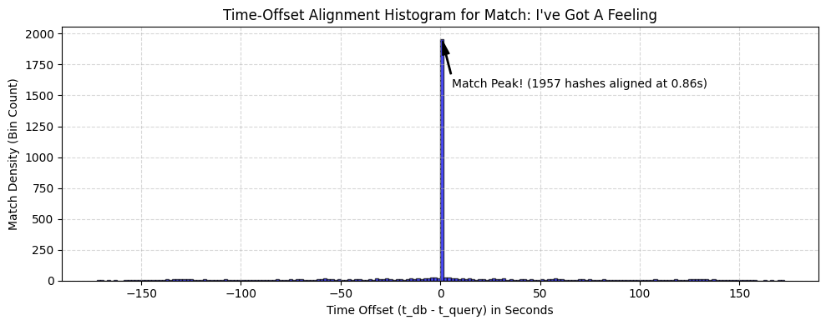
Prediction using a single peak:
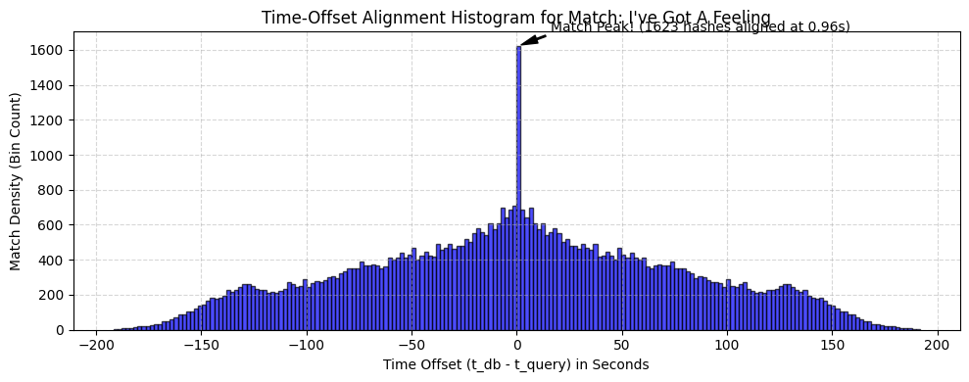
Hence, the maximum cluster density is higher in case of pair of peaks which means that it gives a more decisive answer.
Using single peaks for identification provides very little unique information because a common frequency can occur thousands of times across various songs, leading to several database collisions and false positives. When nearby peaks are paired together into a compact hash, three distinct variables are combined to form a key: the two frequencies and the exact time gap between them. This grouping increases the uniqueness of each fingerprint making the search keys highly specific.

