## Simulated annealing

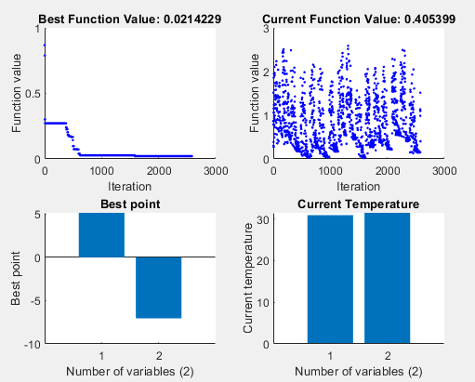

Figure 1 - Simulated annealing stats with AnnealingFcn = annealingboltz

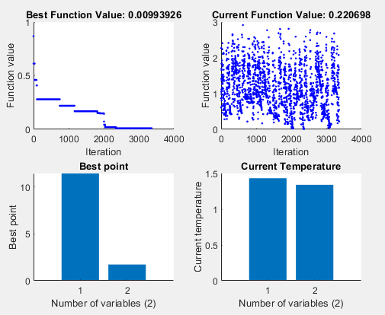

Figure 2 - Simulated Annealing stats with default options.

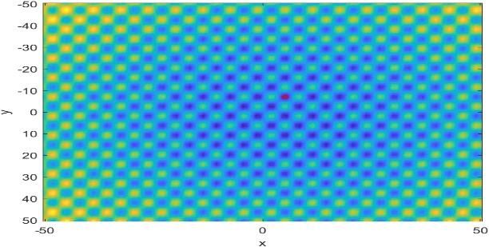

Figure 3 - Simulated annealing results with AnnealingFcn = annealingboltz

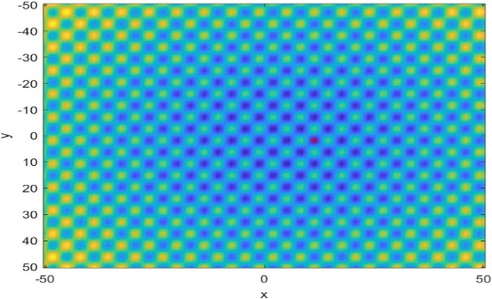

Figure 4 - Simulated Annealing results with default options.

We can see from the figures above that simulated annealing arrives at an optimal solution faster by approximately 700 iterations when the option, AnnealingFcn, is added to the default set and set to “annealingboltz”. However, despite its speed, it is evident that the best objective function value for default options is lower by approximately 0.011 compared to when the AnnealingFcn is added, making it closer to the global minimum value of 0. Furthermore, we can also see that the temperature values for both the x-coordinates are approximately 20 times lower with the default options than when AnnealingFcn is added. Since the energy state at which the x and y coordinates are with the default options (Figure 1 bottom right) is significantly lower than with AnnealingFcn option added (Figure 4 bottom right), the chances of allowing moves to worse locations with default options are much lower.

## Genetic algorithm with default options

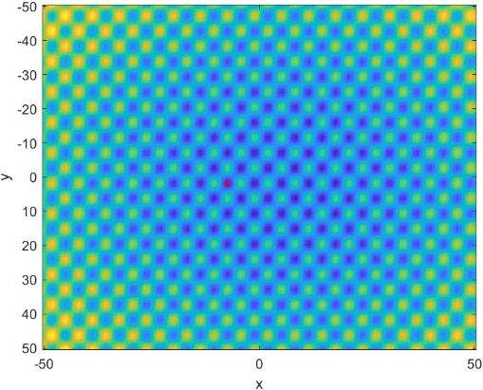

Figure 7 - Genetic Algorithm results with MutationFcn=mutationadaptfeasible

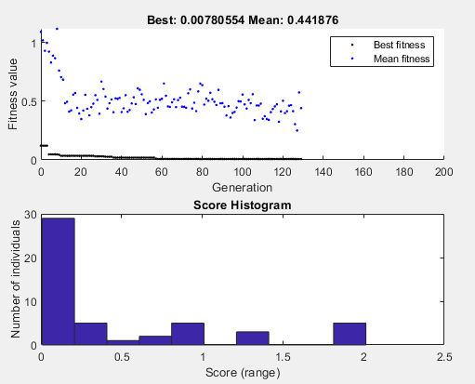

Figure 6 - Genetic Algorithm stats with default options.

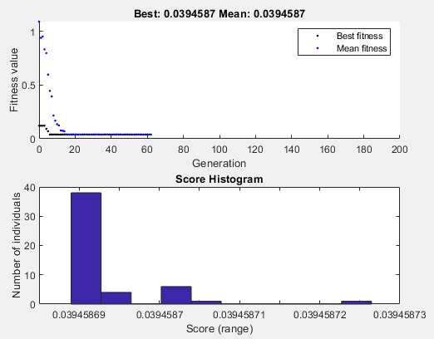

Figure 5 - Genetic Algorithm stats with MutationFcn=mutationadaptfeasible.

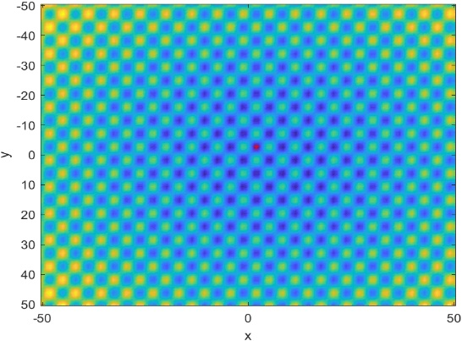

Figure 8 - Genetic Algorithm results with default options.

We can see from the figures above that genetic algorithm arrives at an optimal solution faster by approximately 70 generations when the option, MutationFcn, is added to the default set and set to “mutationadaptfeasible”. In addition to this, Figure 6 shows that the rate at which the best fitness score decreases is significantly lower with the default options than with the MutationFcn added, as in Figure 5. This is shown in the way the scatter lingers at 0.5 in Figure 6 from approximately 20 generations, while the scatter in Figure 5 stoops down close to 0. Since the fitness value with the default options tends to stay near 0.5 rather than being close to 0 with MultationFcn added,

However, despite its speed, it is evident that the best objective function value for default options is lower by approximately 0.0316 compared to when the MutationFcn is added, making it closer to the global minimum value of 0. Furthermore, we can also see that the temperature values for both the x-coordinates are approximately 20 times lower with the default options than when AnnealingFcn is added. Since the energy state at which the x and y coordinates are with the default options (Figure 1 bottom right) is significantly lower than with AnnealingFcn option added (Figure 4 bottom right), the chances of allowing moves to worse locations with default options are much lower.

## Particle swarm with default options