4. Describe briefly the role of quality of service (QoS) parameters (a) Why is DDS called a data-centric middleware?

There are different ways to approach implementing a Distributed System. When a DDS is referred to as a data-centric middleware it means that the systems infrastructure takes more responsibility.

The fundamental goal is to get the right data, to the right place, at the right time.

In order to ensure a level of quality depending on the requirements, a Quality of Service exist to reach the goal.

Below picture contains an overview of different parameters that can be configured to meet the requirement depending on the need.

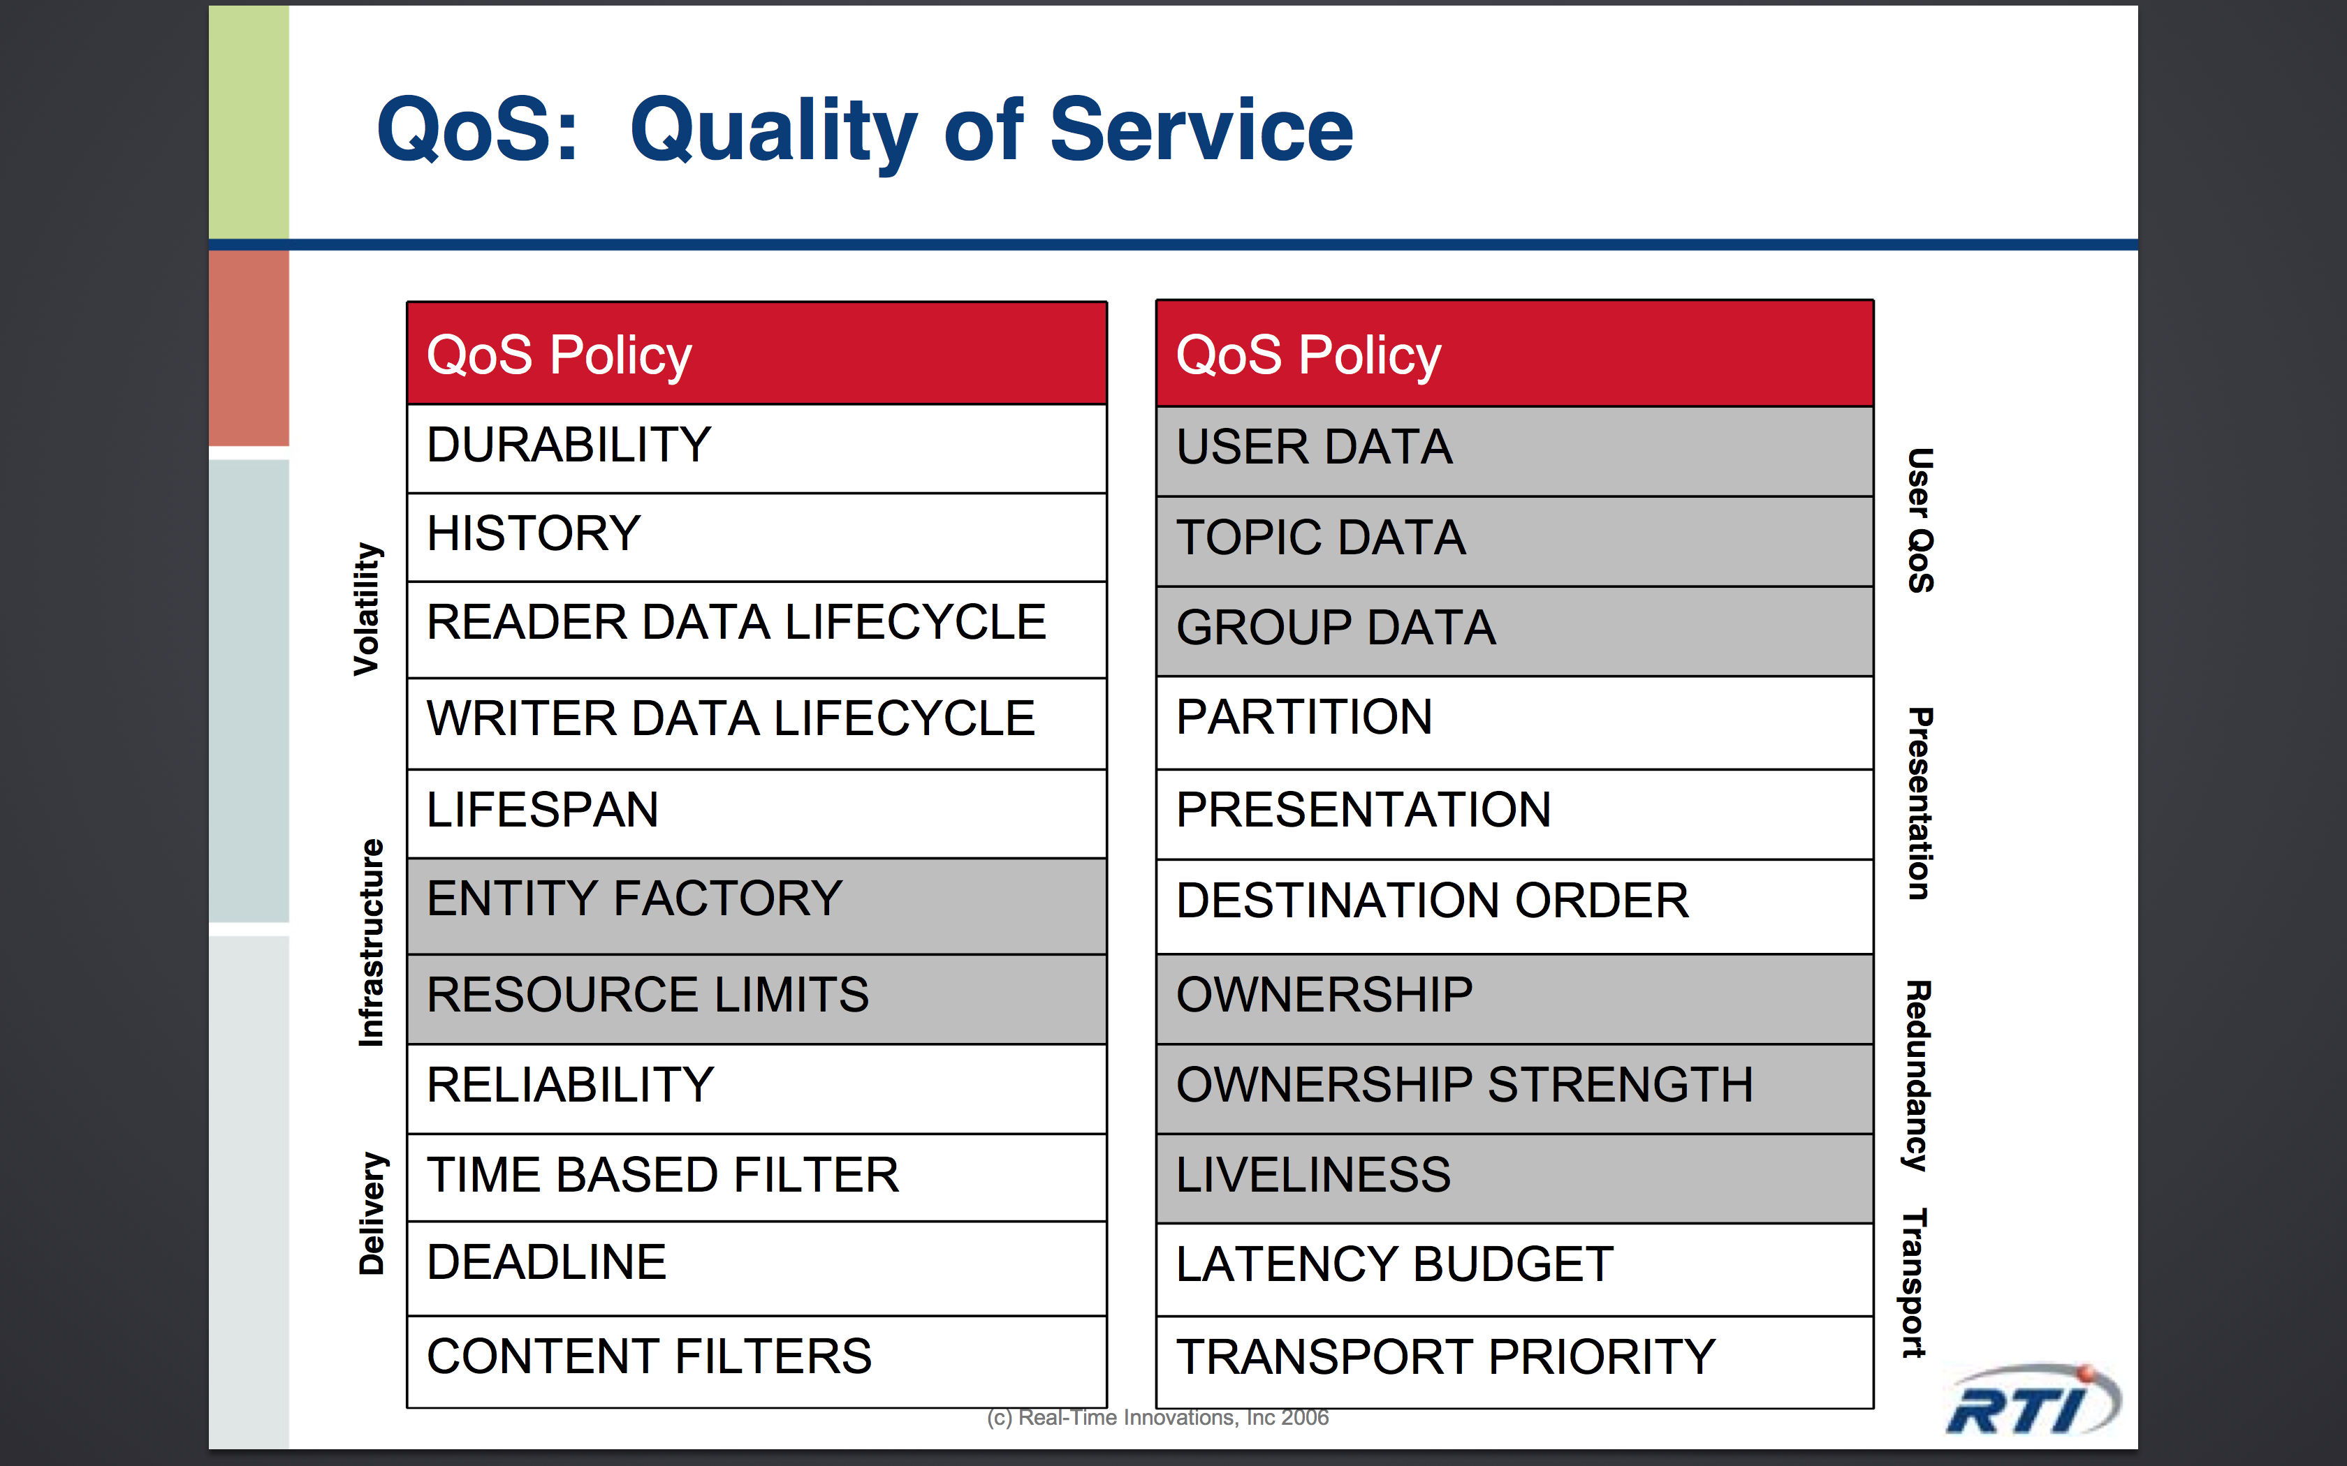

With these parameters a node or topic can be configured to meet certain requirements.

An example where we have the following requirements:

* Single dataWriter, but multiple dataReaders
* For every new dataReaders that joins the topic should get the last set of data
* Every dataReaders should get all issued data.

The following QoS would be needed to meet the criteria:

* History (Keep Last)
  + To control how much data needs to be available
* Reliability
  + To ensure that data is delivered
* Lifespan
  + To know how and where data is stored

5. What is Interface Description Language (IDL)?

An Interface Description Language defines the Type in a Topic where the Type is the definition of data.

It defines the objects interfaces via a standard specified as an Object Management Group (OMG) standard.

In general, IDL, describes an interface for a software componen independently of the language it is written in, in this way, achieving communication between software components regardless of the programming language.

6. Redo the Shapes examples and the Java example from the slides

Havent don’t it yet

Still need pictures.