**Hello group 6**

* Abstract:
  + It is okay to get names on certain abbreviations.
  + The word ‘these’ may be replaced by, what ‘these’ actually stands for.
* Introduction
  + In general, this chapter is okaay, but it would be good to make chapter references to all chapter - or none. It is weird with only three out of four chapters.
* About DDS
  + It would be great, if the content about DDS equals RMI - the RMI part is bigger than DDS.
  + There are fine separations among the concpets regarding DDS. Also, pictures or figures might supply great during explanations..
* 2.2 Publish/subscribe
  + There should be a distinct separation for, what belongs to DDS and what doesn’t belong to DDS. The Publish/Subscribe is more like an idiom than a middleware type, which would be better to elaborate on. It would also be more appropriate to write clearly that DDS makes use of the Publish/Subscribe idiom.
* 2.3 DDS Components
  + In this section, somewhere it is written: “(...)which means it will be notified by the publisher”, and that gives a vague picture of, what is happening. This vague picture might lead to understand that DDS is coupled in space, because you have to notify someone specifically. As a result of this assumption, it would be necessary to have knowledge about those who want to be notified. It is actually an EventService that takes care of this (see the following figure, which can be found in the lecture’s slides):

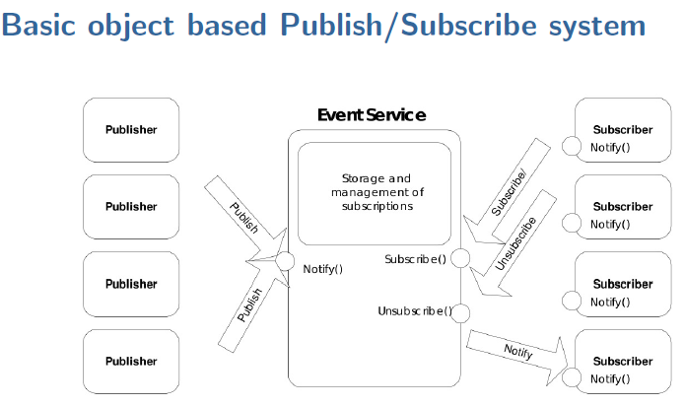

* + You could elaborate a bit more in the DLRL part. You also write the following in the end of chapter 2.3:  
      
    *“The QoS*

*parameters are used to custom tailor the DDS applications by providing means of specifying e.g. at what rate the publishers and subscribers connect to the data center.*”

We would clearly like a line or two about, what data center is in this context. A figure would also supply to this.

The last chapters are OK, though we found it a bit more complex to install and use the RTI Connext, and also a little elaboration on why the data’s lifespan parameter is only one minute would be nice(page 9, just before listing 3.3), but this is of no great importance.

* Sum up:
  + It is an okay report - you answer all your questions in the exercise about DDS. Some correction could make vastly improvements to the general understanding of the report. Though, the grammar and readability is good in the paper, some pictures, and a better context between the relation of the main subject, and other written subjects in this report i.e. how RPC relates to DDS.

All in all, this handin is approved, but a few changes are strongly suggested.