Backend (C#)
- First need visual studio 19(or above)
- Install .Net Core 3.1 sdk
Frontend (Angular)
- Install NodeJs (latest version)
- Install Angular cli (latest version)
- Install vscode
- Open project in vscode
- Run npm install in terminal
- Run this (ng serve --port 42001 --open) cmd in terminal
- It’s open in default browser in automatically
- Below like first image show in browser
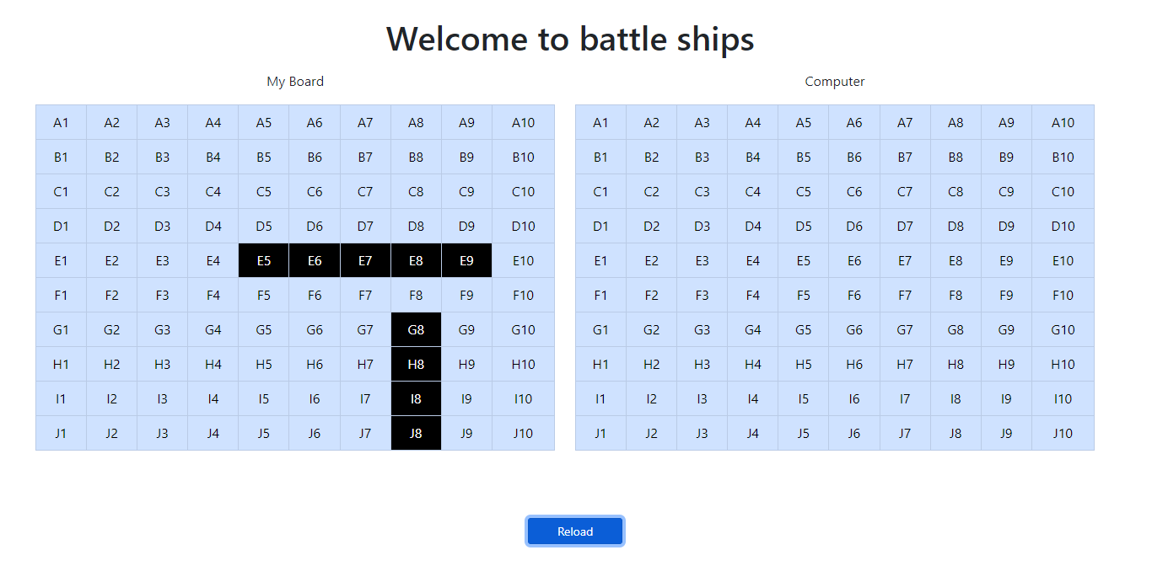
- Hit the computer board any cell
- Server return new data which is show in below image
