SMART COLD STORAGE MONITORING & SPOILAGE PREDICTION USING ESP32

Introduction
Cold storage systems are essential for preserving perishable goods such as fruits, vegetables, and medicines. These systems require continuous monitoring of environmental parameters like temperature and humidity to prevent spoilage.
This project presents a smart monitoring system using ESP32, which collects real-time data from sensors and predicts spoilage conditions. The system also simulates door activity using a push button.
IoT-based monitoring systems allow real-time tracking and alert generation, improving efficiency and reducing losses.

2. Problem Statement
Traditional cold storage systems lack:
- Real-time monitoring
- Immediate alert systems
- Predictive analysis
Due to this, variations in:
- Temperature
- Humidity
- Door openings
can lead to product spoilage and financial loss.

3. Objective
- To monitor temperature and humidity using ESP32
- To simulate door activity using a push button
- To detect spoilage conditions
- To provide real-time alerts

4. Components Used
Hardware Components
- ESP32 microcontroller
- DHT22 temperature & humidity sensor
- Push button (door simulation)
- 10kΩ resistor (pull-up for DHT22)
- Jumper wires
- Breadboard
Software Components
- Arduino IDE
- Embedded C (ESP32 programming)
ESP32 is widely used in IoT systems because it supports Wi-Fi-based real-time monitoring and sensor integration.

5. System Architecture
Working Flow:
- DHT22 reads temperature and humidity
- Push button simulates door open/close
- ESP32 processes data
- Conditions are checked
- Spoilage risk is predicted
- Output displayed in Serial Monitor

Data Flow Diagram

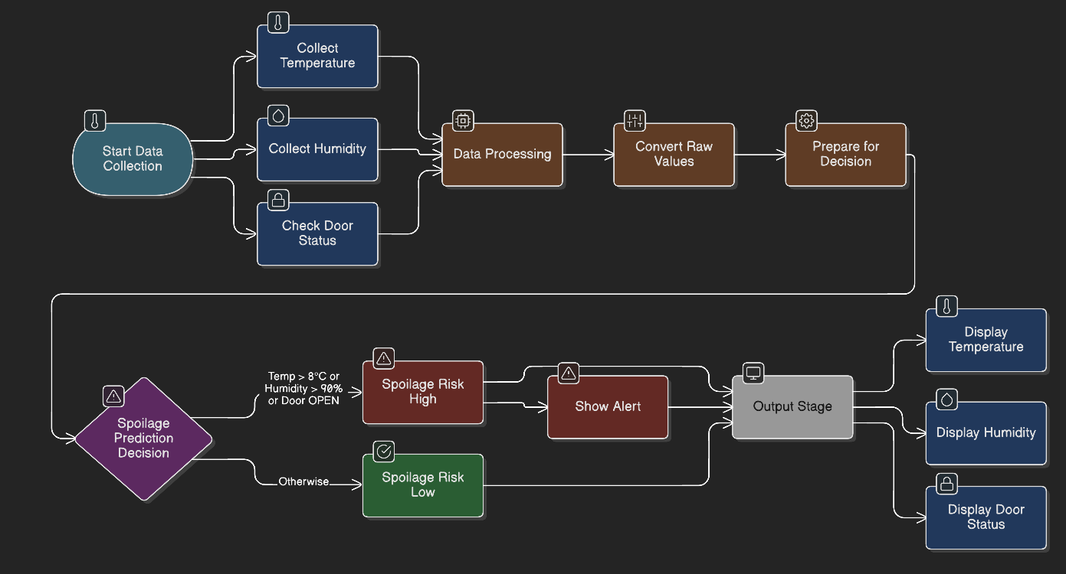

6. Circuit Diagram
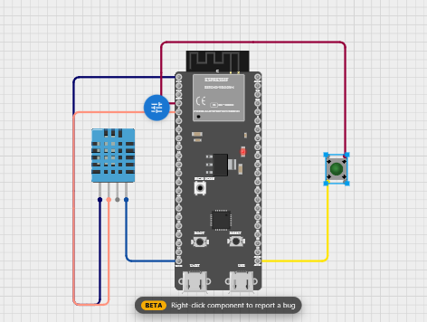
7. Working Principle
The system continuously reads environmental data:
- Temperature (°C)
- Humidity (%)
- Door status (Open/Closed)
Spoilage is predicted based on threshold values:
- Temperature > 8°C
- Humidity > 90%
- Door open
If any condition is true:
➡️ Spoilage Risk = HIGH
Otherwise:
➡️ Spoilage Risk = LOW

8. Algorithm
- Start
- Initialize ESP32 and sensors
- Read temperature and humidity
- Read button state
- Check conditions:
  - If temperature > 8 OR humidity > 90 OR door open
→ HIGH risk
  - Else → LOW risk
- Display result
- Repeat

9. Code Implementation
#include <WiFi.h>
#include <HTTPClient.h>
#include <DHT.h>

// WiFi Credentials
#define WIFI_SSID "CirkitWifi"
#define WIFI_PASS ""

// ThingSpeak
#define API_KEY "SEWM1DJMOBV18XFD"
#define SERVER "http://api.thingspeak.com/update"

// DHT Sensor
#define DHTPIN 5
#define DHTTYPE DHT11
DHT dht(DHTPIN, DHTTYPE);

// Door Sensor
#define DOOR_PIN 4

// Variables
float temperature = 0;
float humidity = 0;
int doorStatus = 0;

unsigned long lastUploadTime = 0;

void setup() {
delay(3000);
Serial.begin(115200);
delay(1000);

dht.begin();
pinMode(DOOR_PIN, INPUT_PULLUP); // keep GPIO4 stable (HIGH idle, LOW when pressed)

Serial.println("Connecting to WiFi...");
WiFi.begin(WIFI_SSID, WIFI_PASS);
unsigned long t0 = millis();
while (WiFi.status() != WL_CONNECTED && millis() - t0 < 5000) {
delay(500);
Serial.print(".");
}
if (WiFi.status() == WL_CONNECTED) Serial.println("\nWiFi Connected!");
else Serial.println("\nWiFi not connected (continuing).");
}
void loop() {

// 1. Generate / read values
temperature = 2 + random(0, 10);
humidity = 60 + random(0, 20);

// 2. Read door
doorStatus = digitalRead(DOOR_PIN);
int doorState = (doorStatus == LOW) ? 1 : 0;

// 3. Print
Serial.print("Temp: ");
Serial.print(temperature);
Serial.print(" C | Humidity: ");
Serial.print(humidity);
Serial.print(" % | Door: ");
Serial.println(doorState ? "OPEN" : "CLOSED");

// 4. Alert logic
if (temperature > 8 || doorState == 1) {
Serial.println("ALERT: Risk of Spoilage!");
}

// Upload every 20 sec
if (millis() - lastUploadTime > 20000) {

if (WiFi.status() == WL_CONNECTED) {

HTTPClient http;

String url = String(SERVER) + "?api_key=" + API_KEY +
"&field1=" + String(temperature) +
"&field2=" + String(humidity) +
"&field3=" + String(doorState);

Serial.println("Uploading...");
Serial.println(url);

http.begin(url);
int httpResponseCode = http.GET();

if (httpResponseCode == 200) {
Serial.println("Data uploaded successfully");
} else {
Serial.print("Error: ");
Serial.println(httpResponseCode);
}

http.end();
}

lastUploadTime = millis();
}

delay(3000);
}

10. Output
The system displays:
- Temperature
- Humidity
- Door status
- Spoilage risk
Example:
Temperature: 9°C
Humidity: 85%
Door: OPEN
Spoilage Risk: HIGH

11. Advantages
- Low cost
- Easy to implement
- Real-time monitoring
- Reduces spoilage losses
- Scalable to IoT systems

12. Applications
- Cold storage warehouses
- Food preservation systems
- Pharmaceutical storage
- Refrigerated transport
IoT systems like this are widely used in industrial storage monitoring and environmental control.

13. Future Scope
- Cloud integration (Blynk / Firebase)
- Mobile app monitoring
- Machine Learning prediction
- Automatic cooling control
- SMS/Email alerts

14. Conclusion
This project successfully demonstrates a smart cold storage monitoring system using ESP32. By monitoring environmental conditions and predicting spoilage, it helps reduce losses and improve storage efficiency.

