Integrating R and Python

Spencer Tibbitts

November 2019

Table of Contents

# Why are Python and R So Widely Used?

Data Science is one of the most sought after set of skills right now, and is only getting more and more popular. According to IBM, the number of jobs for all US Data Professionals will increase to 2,720,000, and the average pay for Data Scientists and Data Engineers is over $100,000.[1] It is easy to see why many colleges are starting to build programs specifically for Data Science - such as Siena! - in order to prepare students for this field more effectively. Skills like machine learning, data visualization, and statistics are extremely in demand, and won’t be going away anytime soon, so learning how to program and use these skills is highly valuable.

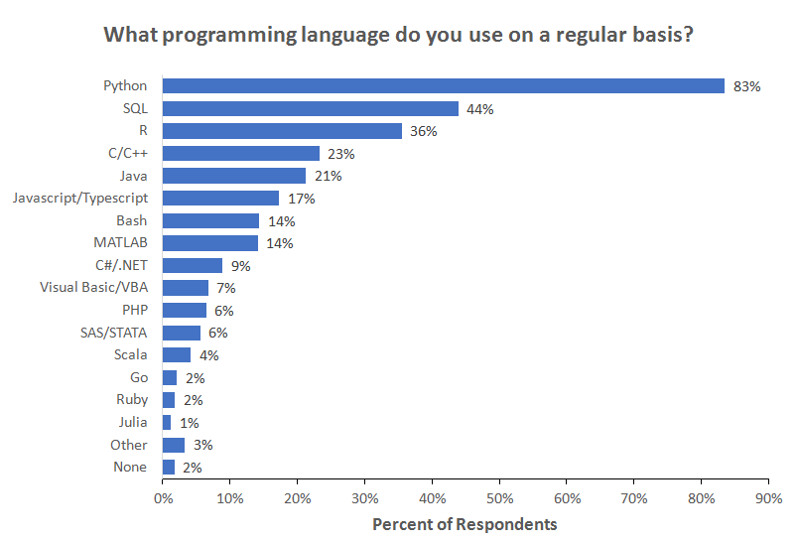

Data from the [2018 Kaggle Machine Learning and Data Science Survey](http://www.kaggle.com/kaggle/kaggle-survey-2018)

As shown in the image above, **Python** and **R** are two of the most used programming languages in the Data Science community - ranked first and third respecitively in popularity. However, depending on where/how students learn to program, they may experience overexposure to one or the other, and not have as widely available of a skill set. This has been my personal experience at Siena - while I’ve had much experience using Python, I’ve had very little using R.

## R

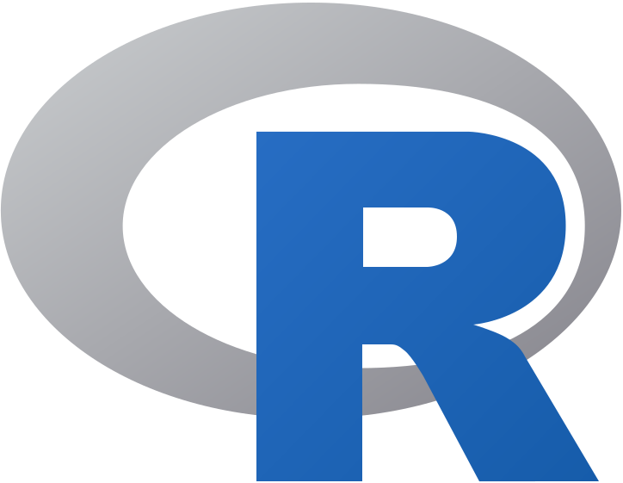

Released in August of 1993, R quickly became one of the most used programming languages for statisticians due to its simplicity, wide array of statistical functions, and open-source availability. Another one of its perks is how easy it is to load in datasets to R to visualize and quantify data. The barebones of R (RBase) contains much of these statistical functions, as well as some basic plotting functions. Using packages such as **ggplot2** to enhance visualizations brings out the best in R.

### RStudio



The most popular IDE for R is RStudio. RStudio is equipped with a space for editing scripts, a console for running single lines of code, area to display plots and help, a workspace for created variables, and much more. While RStudio has a free version, there are premium versions available to the general public, as well as commerical liscensing. RStudio is also used for **RMarkdown** files, which we will talk more about later on.

## Python

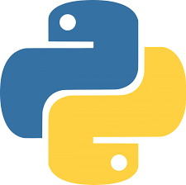

Released in 1991, Python is a general purpose, object-oriented language. Python is noted as being one of the easiest languages to learn for newcomers to programming due to its high level of readability. In recent years, Python has experienced an explosion in its use, especially in Data Science, due to its vast number of libraries, great documentation, and the increasingly large community of people who use Python. As of the time this was written, Python has become the second most popular programming language amongst **all** programmers, even those who aren’t Data Scientists, meaning Python is even more valuable to have as a skill.

### Juptyer and Google Colab



Similar to RStudio for R users, Jupyter Notebook - and more recently Jupyter-Lab - are the most popular IDEs for Python users. These programs create an **IPython Notebook**, which can contain chunks of Python code, plots, and markdown text. Recently, Google has been working to make Jupyter Notebooks accessible via Google Drive, a project known as **Google Colab**. These notebooks can be shared the same way a Google Document can be shared with multiple users. They are able to access data files from Google Drive, as well as locally stored files, can be pushed/pulled from Github just like regular Jupyter Notebooks are, and run just as fast as regular Jupyter Notebooks!. This cloud accessibility, along with the number of tutorials and code snippets on Google Colab make it one of the best Data Science tools available.

# Why Choose? Can’t We Have Both?



Both Python and R offer packages to support this integration, but R’s integration is much better, and is the one we will focus on. Using the package **reticulate**, we can easily integrate Python code with R using Rmarkdown files (.Rmd).

## Installation

1. The following software needs to be installed in order to use ***reticulate***.

* Python (3.7 or higher recommended)
  + [Using Anaconda](https://docs.anaconda.com/anaconda/install/)
  + [Without Anaconda](https://realpython.com/installing-python/)
* [R](https://cran.cnr.berkeley.edu/) (3.6.1 recommended)
* [RStudio](https://rstudio.com/products/rstudio/#rstudio-desktop)

1. From the *Console* on RStudio, run the following command to install **reticulate**.

install.packages("reticulate")

## How to Use

The first step is to link the .Rmd file to the location where Python is installed.

If you don’t know the path which Python is installed under, do the following:

* Open the Python shell.
* Run the following commands in the shell, and the location will be displayed.

import os  
import sys  
os.path.dirname(sys.executable)

From there, run the following chunk of code in the .Rmd file.

library(reticulate)  
use_python("PATH/TO/PYTHON")

And now you can run Python code in an RMarkdown file! When declaring code chunks, instead of using {r,include=T}, use {python,include=T} to run a chunk of Python code instead of R code. To download packages for Python, use the command py_install{"PACKAGE_NAME"}.

# Python & R Together in Action

While we could go through everything in R and replicate it with Python code, this is kind of pointless. For statistics, R’s pre-imported functions are much easier to use than in Python, and it makes more sense to use R for this. Visualizations can be made with both, and depending on the visualization you want to create, either R or Python would be appropriate. For machine learning and web scraping, it makes more sense to use Python than R. Therefore, the best thing to do would be to see both in action together in a project.

## Quentin Tarantino

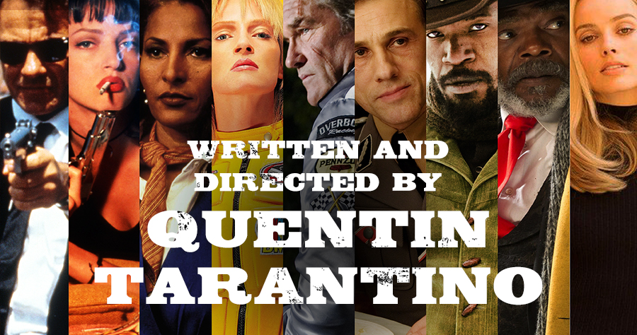

Quentin Tarantino is one of the most successful film directors of all time. *Pulp Fiction* is one of the top 10 films of all time. *Resevoir Dogs*, *Jackie Brown*, *Django: Unchained*, *Inglorious Basterds*, and *Once Upon a Time… In Hollywood* are all critically acclaimed as well, and *Kill Bill Vol. 1 & 2* is one of the most badass movies ever created. Amongst other things, there are two very noticeable features about Tarantino’s films: **a lot** of curse words, and **a lot** of deaths. *Pulp Fiction* alone had almost 470 curse words, and over the course of both *Kill Bill* films, there are 74 total on-screen deaths.

1. [Forbes: “IBM Predicts Demand For Data Scientists Will Soar 28% By 2020”](https://www.forbes.com/sites/louiscolumbus/2017/05/13/ibm-predicts-demand-for-data-scientists-will-soar-28-by-2020/#2262aec17e3b)