HadUK Rainfall data merge Log
https://www.metoffice.gov.uk/research/climate/maps-and-data/data/haduk-grid/haduk-grid
1mx1m gridded climate observations gives daily rainfall data too. In NetCDF arrays, with time dimension given as hours since 1836 1st Jan 00:00:00.
In effect – I just want to know that I can correctly retrieve information from an array – conditional on values from a data-frame / matrix.
https://storymaps.arcgis.com/stories/c002801735234dcca015997121c65c01

Task 1:
Manually create array and table data. Test creating functions to use tables to retrieve information from the matrix – conditional on multiple columns. (completed 14/01/2025)
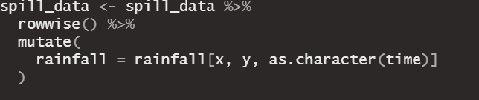
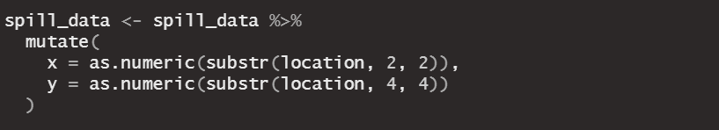
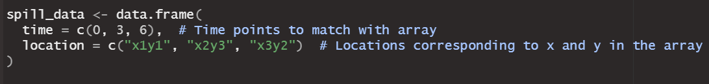
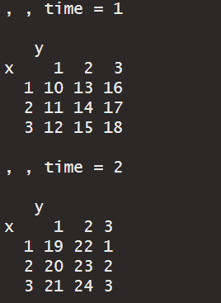
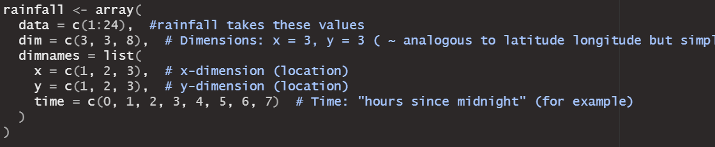

So it is simple to retrieve array data to add to a data-frame when variables in the dataframe exactly match the dimension values in an array. We need to adjust our approach given our data does not exactly match these values.

Task 2:
Learn how to manipulate our data to be able to match indexed array data.
- Within this, I firstly need to understand the exact attributes of our data. For example, the gridded rainfall data – do x and y in the array refer to the midpoint of the 1x1m grid? Does our spill location ngr have greater precision than 1m square? If it’s 1m square precision – can exact matches work or does the location ngr have to be recentred?
https://rmets.onlinelibrary.wiley.com/doi/10.1002/gdj3.78
the gridded observations are mamde via interpolation and some business process of stations’ observations.
Rainfall: Total precipitation amount measured between 09:00 UTC on day D and 09:00 on day D + 1 (mm) [daily data from 1891]
- “Average number of station values per monthly grid over period 1981–2010”: 3857

Gridding method: “station data are interpolated to a regular grid of point locations using inverse-distance weighted (IDW) averaging […] [it] will only work reliably if the quantity being analysed varies smoothly between data points [which is] often not the case for climate data […] therefore some variables are transformed […] The grids are produced at native resolution of 1km for all variables”
- Note: “these are point estimates, not grid-box averages”
- “the primary dataset is a 1 × 1 km grid on the British National Grid projection (EPSG:27700)”
- “Provided area averages based on averaging the 1 km grid across a set of geographical regions to provide spatial statistics for country, administrative regions and river basins. The associated shapefiles are available from https://github.com/ukcp-data/ukcp-spatial-files.”
- “individual grid files provide a 3-dimensional matrix of values covering the whole of the UK on the Ordnance Survey's National Grid (https://www.ordnancesurvey.co.uk/resources/maps-and-geographic-resources/the-national-grid.html) for all dates for one calendar year, or one calendar month.”

Accessing Data:
- Naming convention: <var_id>_hadukgrid_uk_<resolution>_<frequency>_<startdate>-<enddate>.nc

https://getoutside.ordnancesurvey.co.uk/guides/beginners-guide-to-grid-references/
- An intro to grid references by OS British National Grid.
- We have the national grid reference for sewage spills
- We just need to learn how to transform this to match the 1x1km grid reference of the rainfall data
https://digimap.edina.ac.uk/help/our-maps-and-data/bng/
4 digit for rainfall data (1km) – 10 digit for ngr from spills data (1m)
So how can we transform to reference the 1km grid?
Convert Grid Reference to Eastings and Northings
To convert a National Grid Reference to Eastings and Northings:
Remove the two letters at the beginning of the reference: e.g. NS1234 becomes 1234
Split the reference into its East and North components: e.g. 12 East and 34 North
Work out the numerical reference for the two letters: e.g. NS = 200km East and 600km North.
Use the diagram below to calculate how many 100km units east and north the bottom left hand corner of your square is. For example, square NS is 200km East and 600km North of the origin, which becomes 2 units East and 6 units North.
Add the appropriate 100km reference to the beginning of the rest of the reference (remembering to omit the letters): e.g. 212 East and 634 North.
Since Eastings and Northings are measured in metres, you will need to add zeros to make the Eastings and Northings of the correct magnitude: e.g. 212,000 Easting and 634,000 Northing.

Trial with one spill observation:
The given DISCHARGE_NGR is TF6711640170. This is 10 digit. We need to extract the information that will let us match the dimension information in the rainfall array.
- Converted to 4 digit (1km resolution) TR6740
- Need to convert TR into the necessary Eastings and Northings:
- Package rnrfa – with function “osg_parse()” – this readily converts our 4 digit national grid references
- We can easily convert the 10 digit to 4 digit NGRs – and then apply the osg_parse() function to get Easting and Northing values.
- We just need to verify with certainty that these correspond with the rainfall array x and y dimensions

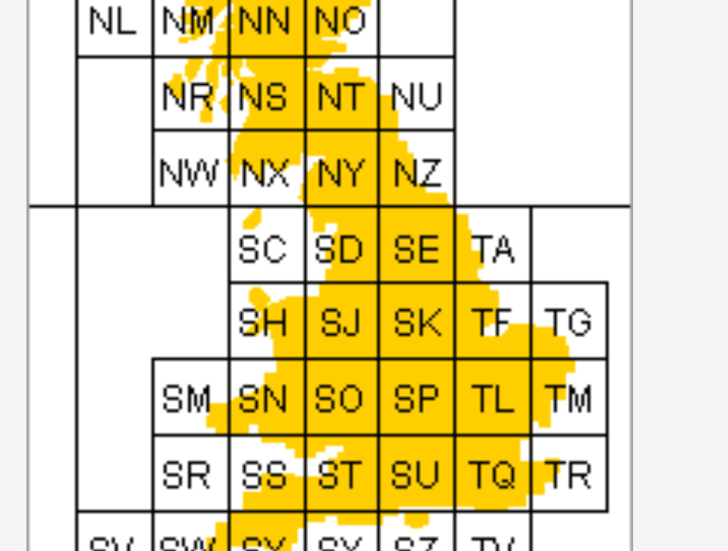

Rainfall data projection:
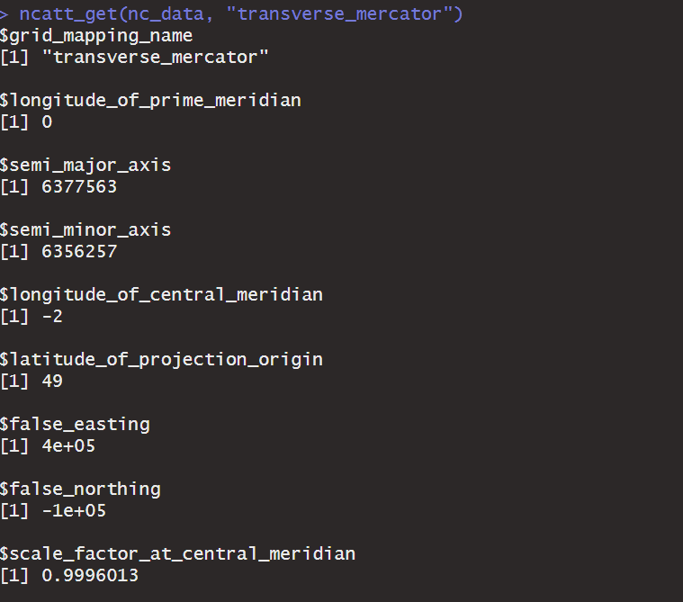
Spill site projection:
https://environment.data.gov.uk/dataset/21e15f12-0df8-4bfc-b763-45226c16a8ac
https://www.opengis.net/def/crs/EPSG/0/27700
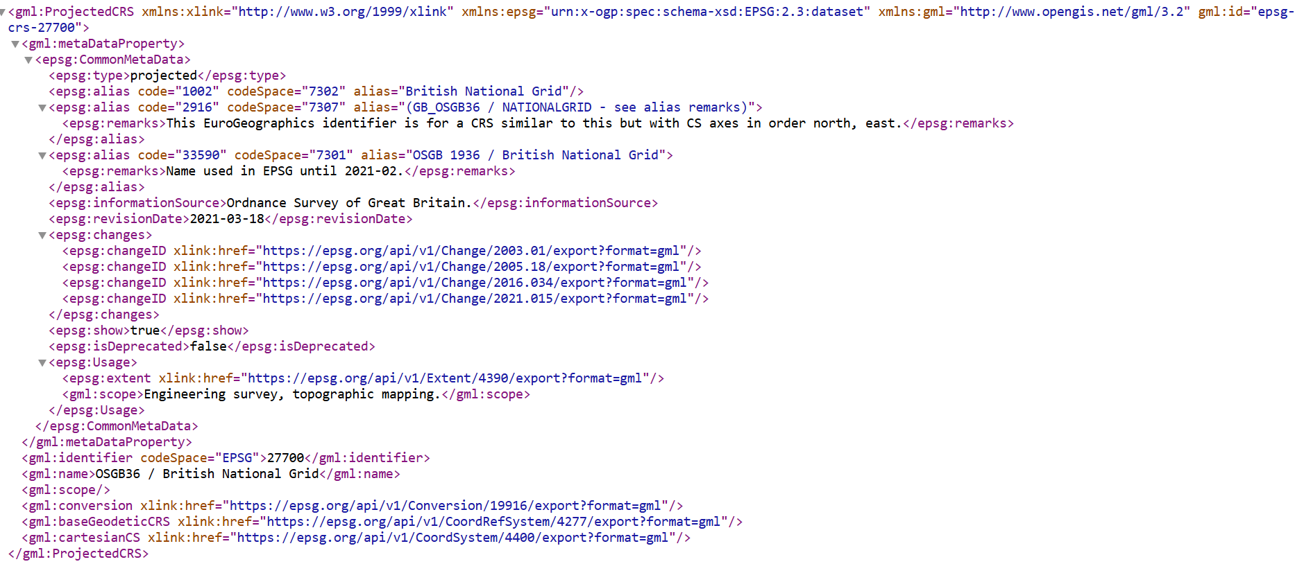
Matching with 4 digit grid reference (eastings/northings), as x and y dimensions in the rainfall array data (does not work)
- Matched (array) rainfall data into spill data but realised some problems
- Used 10 observations
- Converted national grid reference from 10 digits to 4 digits, and hence used osg_parse() to get the relevant eastings and northings from it (and x and y for matching)
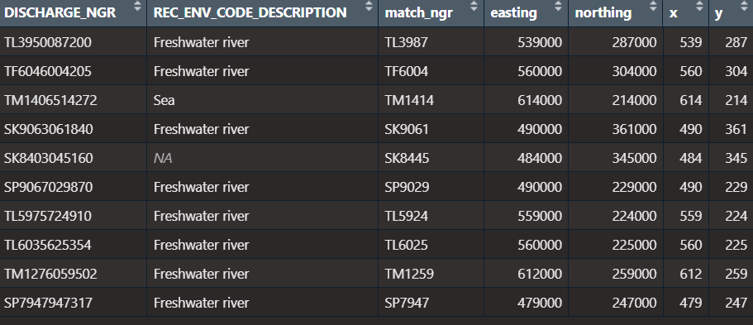
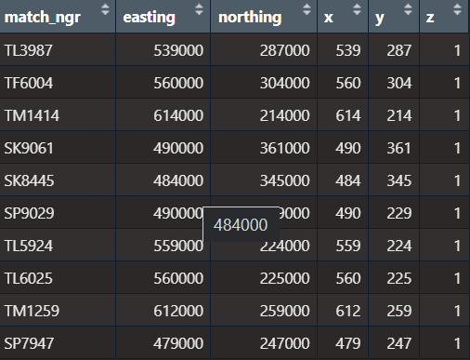
- I got the “z dimension” from the days since the month’s beginning

- The issue comes when we retrieve the array data…

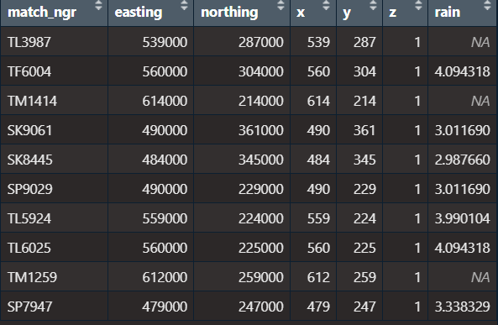

- So 7 out of 10 matched the x, y, z values from the spills data.
- I looked into the 3 out of 10 that are missing
- These were either (1) truly missing values or (2) I had some misunderstanding leading to matching incorrectly – (namely I was uncertain of my assumption x and y directly correspond to the British national grid easting/northing)
- I looked at a missing value’s rainfall data for other days, and some of the surrounding squares
- 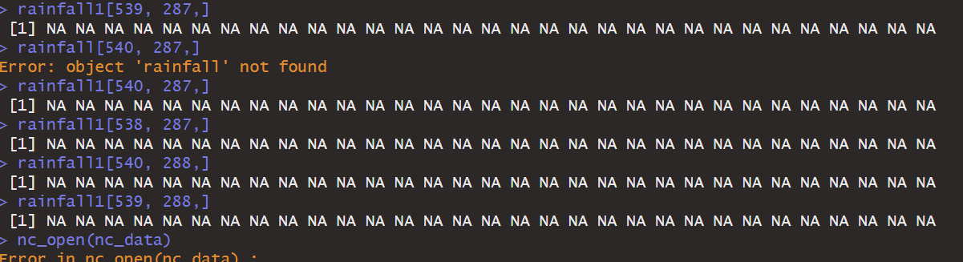
- These were also missing, supporting (2)
- I decided I would look back at the latitude and longitude matrices included in the netCDF file. These matrices each have dimensions [900, 1450] – exactly corresponding to a cross-section of the rainfall array (so covers all locations)
- 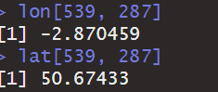
- https://webapps.bgs.ac.uk/data/webservices/convertForm.cfm
- Easting: 338615
- Longitude: -2.870000
- Lng DecMinSec: -2° 52' 12.00"
- Northing: 85954
- Latitude: 50.670000
- Lat DecMinSec: 50° 40' 12.00"
- We get these results when we input the NGR from our spills data. This doesn’t match the latitude and longitude from the rainfall array which we matched via x and y
- If we take the latitude and longitude from the rainfall array and corresponding matrices, we get NGR SY386859 (off the Southern Coast - NOT NEAR THE SPILL SITE) which can explain why there was no rainfall data
- so our understanding that the x and y dimensions refer to the easting/northing is incorrect
- Need to find another way to match – perhaps by using the latitude and longitude
- 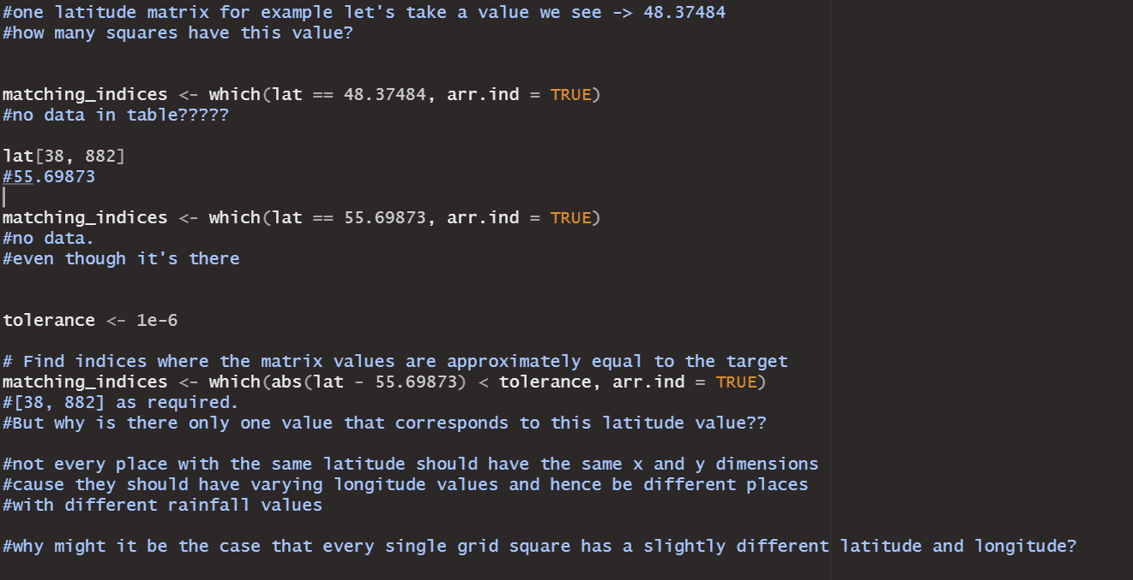
- In this case if we converted the NGR we have for the spill site to latitude and longitude – we could find the closest matches from the matrices, In this case we see that only one instance of a latitude value is in the matrix. Which is confusing.
Matching via Latitude and Longitude values, using lat & lon arrays in the NetCDF file, then retrieving the x and y dimensions of the rainfall array that match (doesn’t work)
- The NetCDF file includes two matrices titled Latitude and Longitude
- 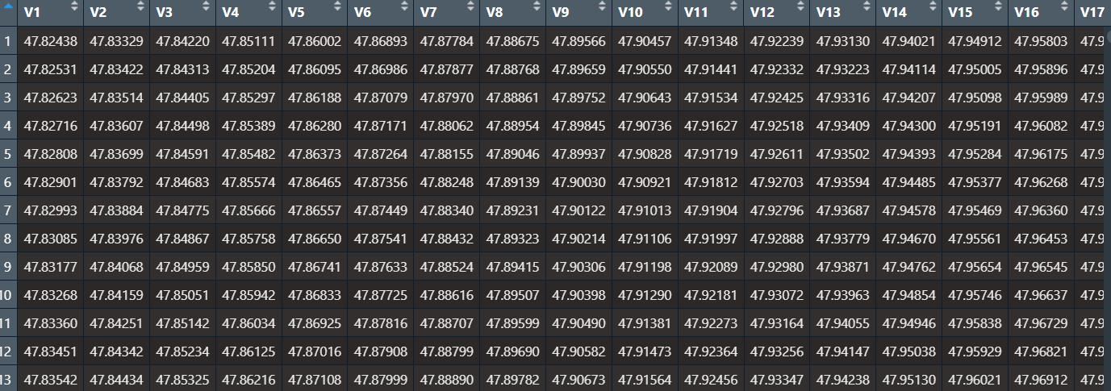
- Each has dimensions 900 by 1450, to match a cross-section from the rainfall array data – meaning for each combination of x and y, we get the latitude or longitude value for the midpoint of the grid square referenced by the x and y
- 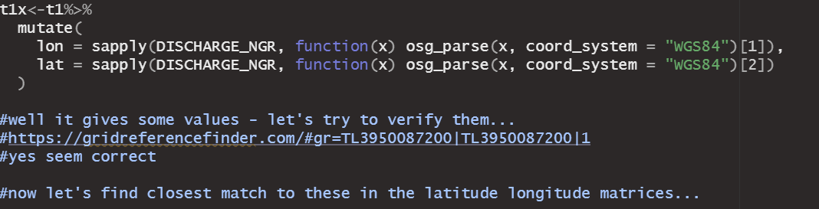
- I used the osg_parse() function to get the latitude and longitude for each of the 10 spill sites (in our testing data) and verified that they seem correct
- 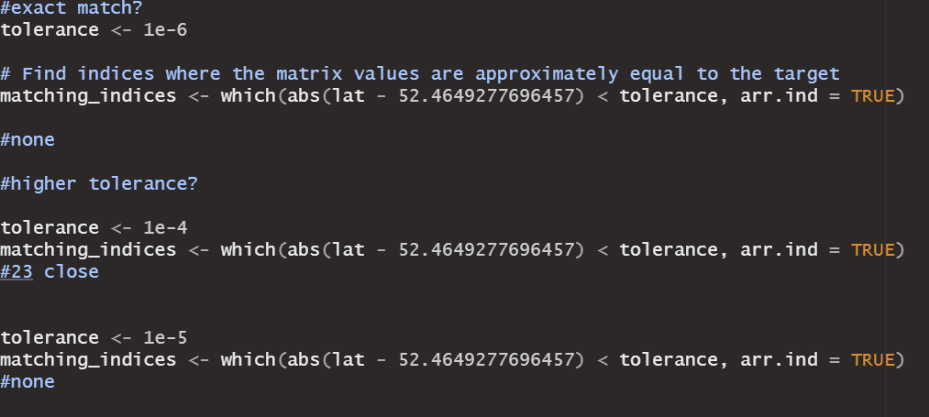
- I then used one of the latitude values from a spill site to search the matrix for the corresponding x and y values (closest match)
- 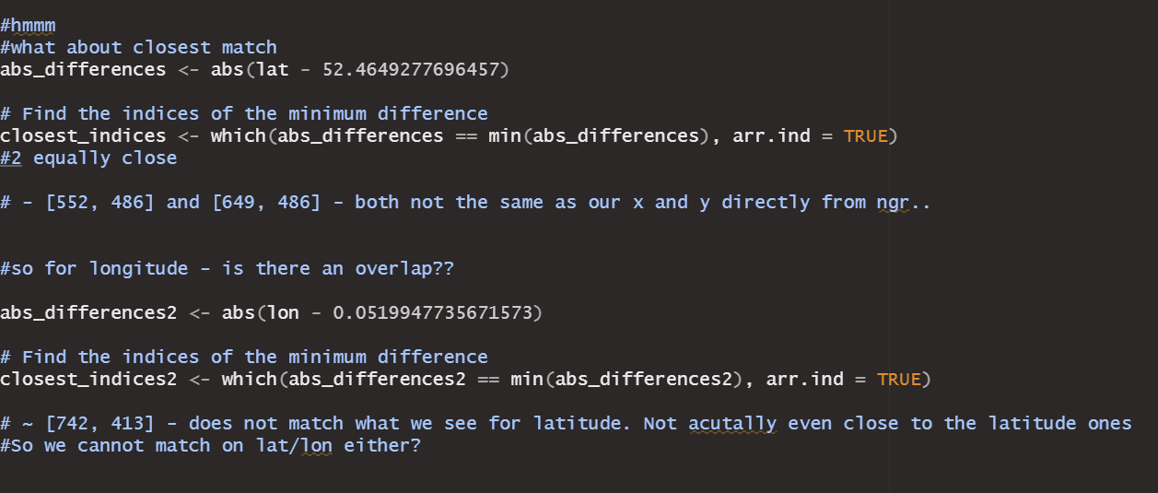
- I took the closest match[es] – and saved their array indices. However, using these array indices to retrieve the longitude, leads to a value that does not match the spill site.
- I expected that taking the closest matches for latitude and longitude would lead to two sets of array indices, with one overlapping indices combination – which would be the relevant grid square
- However, it is clear this logic does not hold, and I now can imagine that the grids used may not align parallel with latitude or longitude lines
Matching with something else? (works correctly – uses projection y and x bounds from netCDF file)
- I then had to rethink matching again. Was there anything else in the NetCDF file that could help?
- 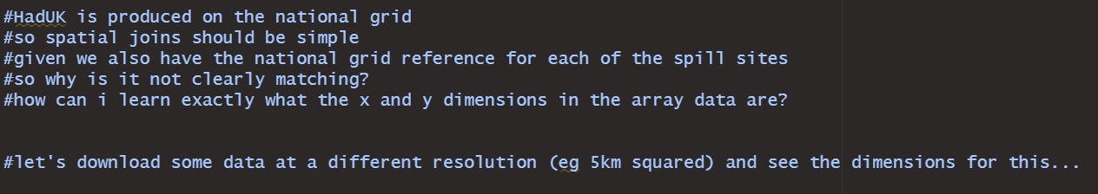
- We know that HadUK rainfall data uses the British National Grid system, the same as our Sewage Spill Data. So they should be compatible.
- I realised I was thinking about the x and y dimensions incorrectly. The dimensions 900 x 1450 (which seem to match relatively well with the extent of the national grid) and the fact that a lot of the edge grid spaces had empty rainfall data suggested to me these were directly associated with location.
- At first I thought they directly referred to the grid reference – which they don’t; then I thought we can match with lat/lon – which we can’t
- I thought it was best to download some data at a different resolution (5km squared) and explore a little more to understand exactly what the x and y dimensions reference
- 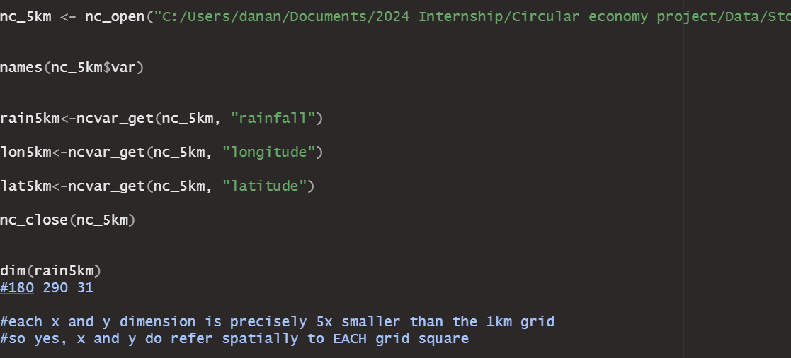
- Dimensions are 5x smaller (except time (z)) …
- 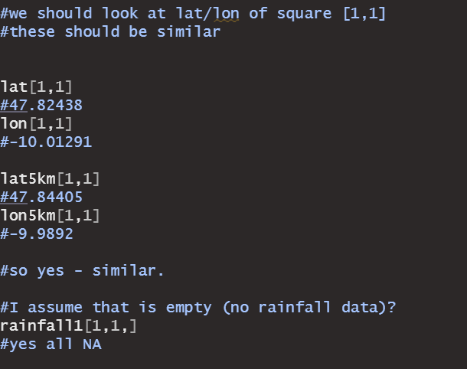
- I realise at this point, that the x and y values cannot reference the latitude or longitude, or eastings/northings in any direct way. If they did, the dimensions of the 5km data and 1km data would be the same, the 5km data would just have more cells with missing values.
- The x and y are simply used for storing the data efficiently, and reference the first grid, then the one to the right, etc etc
- At this point, I kept thinking about the projection_y_bounds and projection_x_bounds variables. I had a feeling they were the key to matching the rainfall data.
- 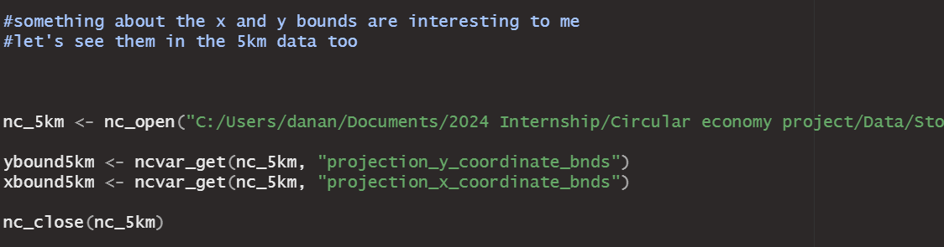
- I figured it would help, to learn exactly what these variables are, to compare the 1km and 5km variables for each cell.
- 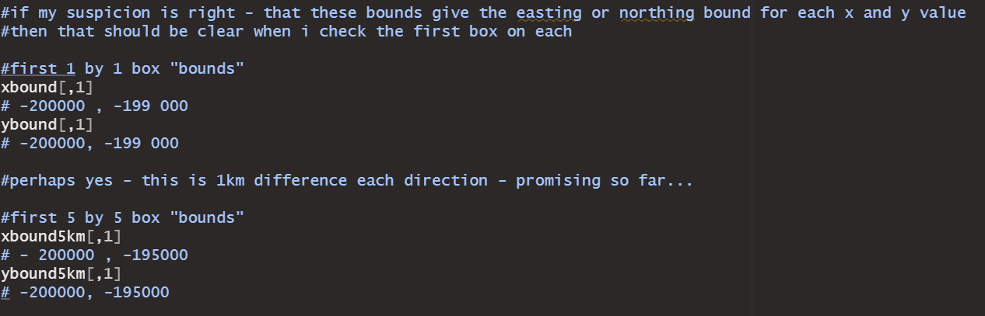
- Checking the first cell would help most. We see the bounds are 1km different in either direction. And for the 5km bounds, they are 5km in each direction. This reveals that these bounds do indeed give the easting and northing bounds that make up each grid cell
- Therefore, our way to match is to find the bounds within which each of the spill sites lies.
- 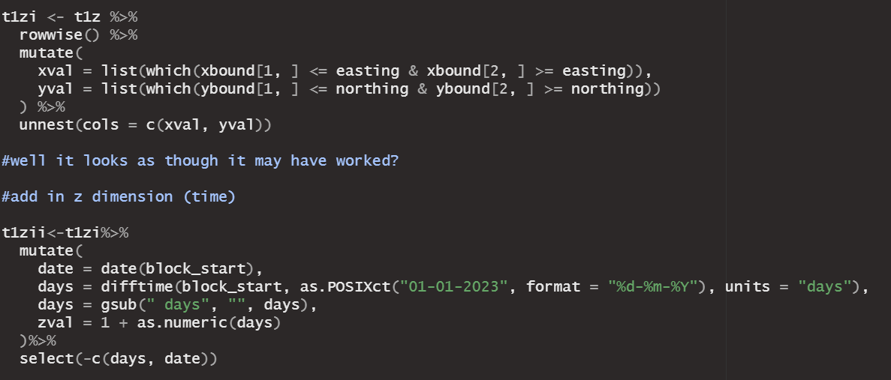
- I applied the logic to our 10 test observations – finding the indices that give the grid cell that encompasses the spill site – and the z index that gives the date of the spill start
- 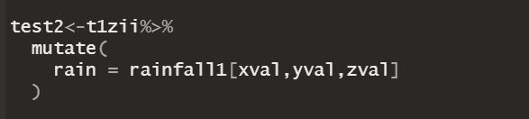
- 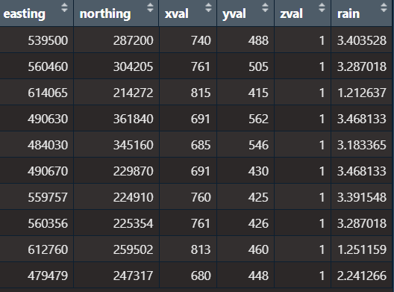
- There are no missing values, and the variance of the rainfall data seems quite small – which is good, since the test data uses one company on the same day, so each has a similar area at the same time
Verifying this matching as correct
- We need to verify this method of matching gives the correct rainfall data before applying it to all our data
- The thing we can check immediately is latitude and longitude values, and see that they are similar
- 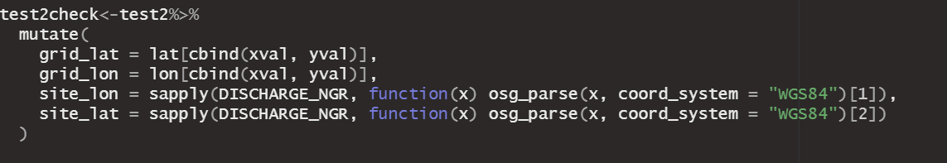
- 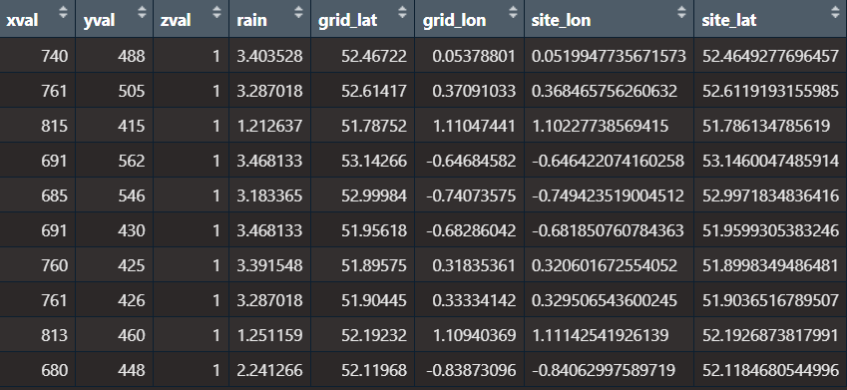
- They match very well, so we can conclude this way of matching is correct.

Task 3:
Log how to open and save information from NetCDF files
- The daily rainfall data is given in NetCDF format (.nc)
- 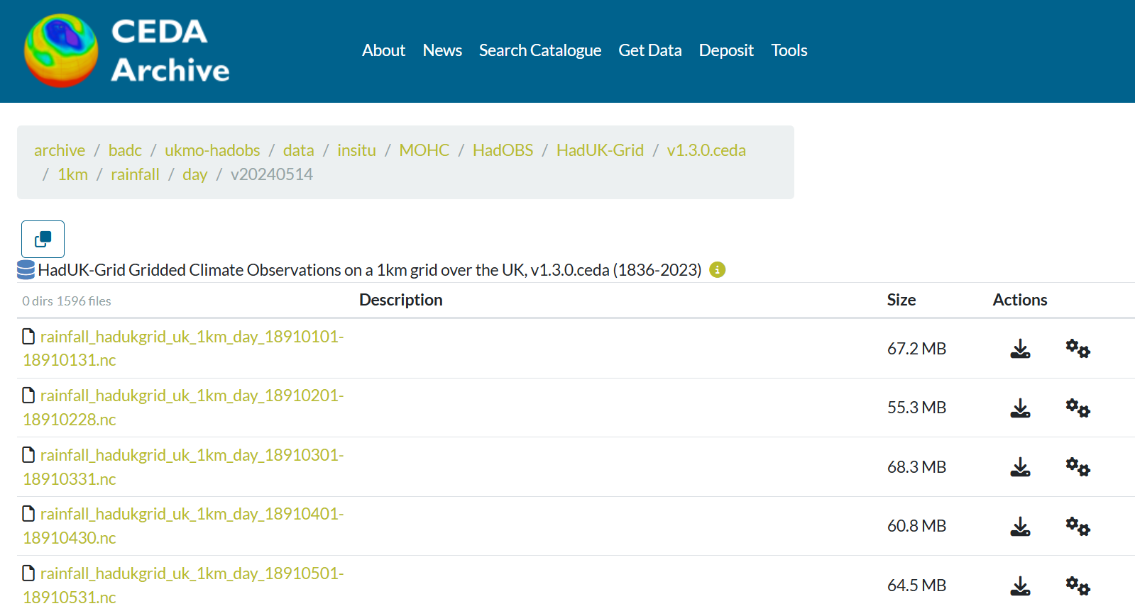
- These are different to csv and other files, so it’s useful to log how to use them
- In R we can use the package “ncdf4” downloadable from CRAN
- Like with SQL databases (odbc package) it’s correct to open the connection to the NetCDF file nc_open(), retrieve any data we want and make any edits necessary, and then close the file using nc_close() to reduce the resources used and to save any changes properly
- We can get the names of all included variables with names(data$var) and retrieve any data by assignment, and using ncvar_get()
- For the rainfall data, there is one main variable – the rainfall measurement, given in a 3 dimensional array, x and y referring to geographic attributes, and z referring to time
- Our data is daily in precision, and is downloadable by month
- So the z dimension will reference the day in the month
- We can look at comments and useful information about each of the variables we collect from the file, with ncatt_get()

Task 4:
Match weather data to 12 24 spill data – for one company, one month.
- Tested on Anglian spill data in Jan 2023
- 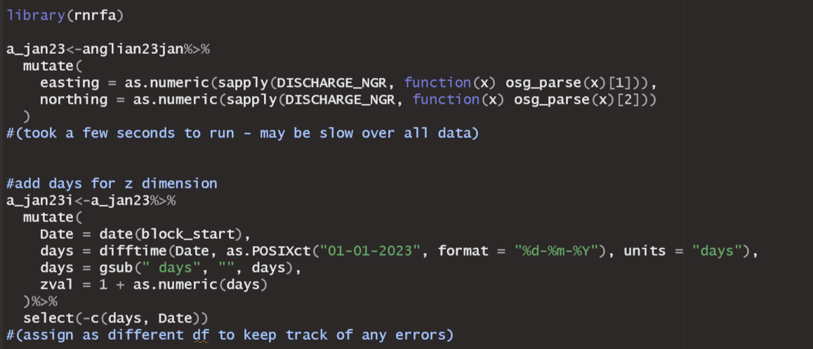
- 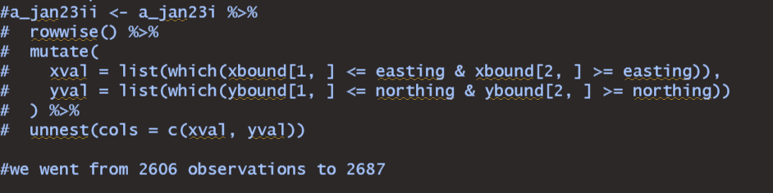
- When using our code to get the array indices for the grid cell each spill site lies in, we generated some extra rows (81 extras generated)
- Turns out these come from those spill sites that lie exactly on the boundary between two national grid cells (1km squared cells)
- I chose to assign these to the cell to the East or North depending on the boundary (plausibly boundaries for other edge cases [not in Anglian January 2023 data] that lie on the intersection between 4 grid cells) a cell lies on.
- 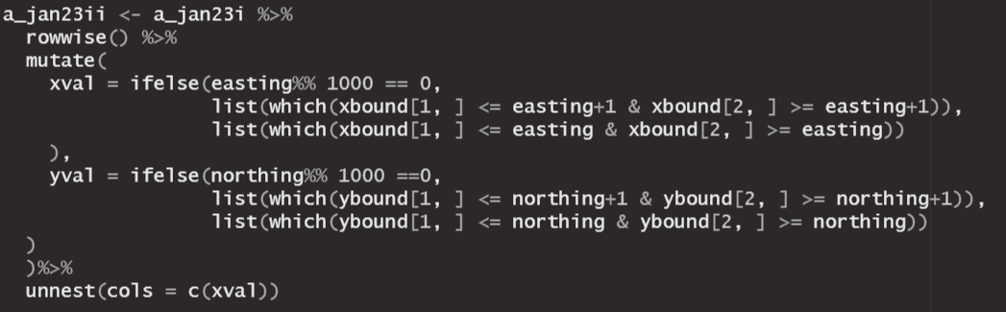
- This is justified since there is no other way to decide which grid cell a spill site should be assigned to; when we employ the BBC methodology to look at rainfall in the surrounding 9 grid cells, 6 will overlap either choice one makes; the rainfall data will be similar between adjacent grid cells anyway.
- 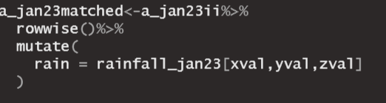
- 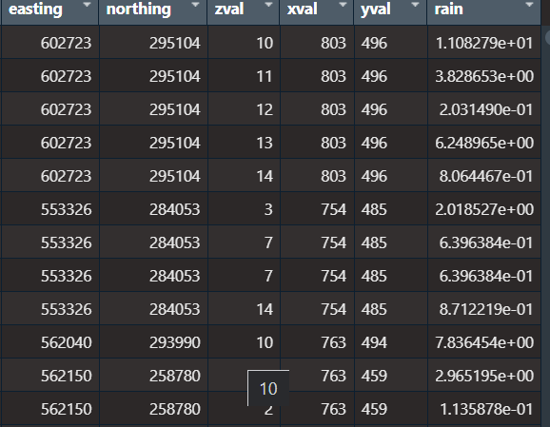

Task 5:
Work out how to match all data to rainfall data & identify dry spills
Think about functions to create:
- 1. To efficiently download or access the gridded climate observation data – will be 12*3=36 datasets & match to all spill data
- 2. Match simply to the 1km square grid, on the start date of a spill, then also match sufficient rainfall data to identify dry spills via EA methodology; also look to emulate BBC methodology
How to define a dry spill, EA definition:
https://environmentagency.blog.gov.uk/2024/08/28/what-are-dry-day-spills/
- “A dry day spill is when a storm overflow is used on a ‘dry day’ – which is defined as no rainfall above 0.25mm on that day and the preceding 24 hours.”
- “Storm overflows should not spill on dry days, but there are exceptions. For example, some overflows will be located in very large catchments where water falling in a location far upstream of an overflow will take a significant amount of time to drain down or reach it.
Data from a storm overflow alone doesn’t always tell us what actually happened. When a dry day spill happens, we always treat them as a potential breach until we have confirmed through further investigation”
- “process of further investigation on a site-by-site basis to determine, for example, that the accuracy of certain rainfall monitors and drain down times are correct, as well as other factors”
- We can go with the 0.25mm on the day and preceding day as an indicator for dry spills – a lot of these will not in the end by defined as such by the EA, but we cannot emulate their “further investigation”
https://www.bbc.co.uk/news/science-environment-66670132
- BBC investigation identifying dry spills
- 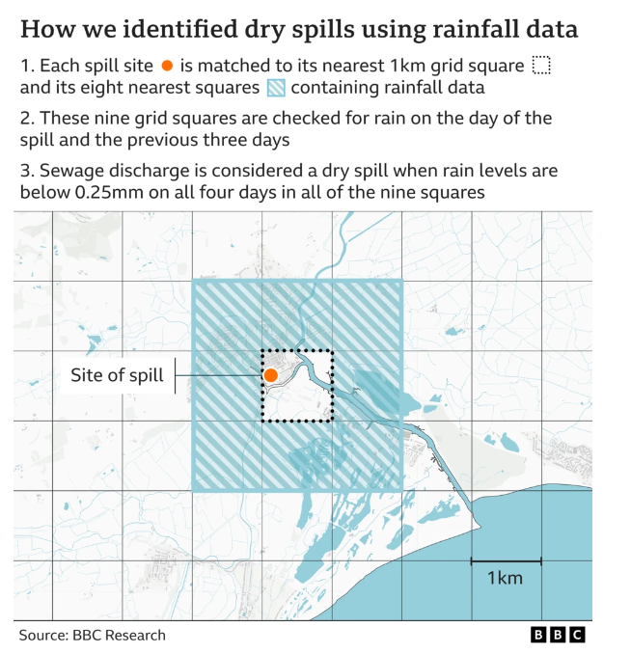
- 9 surrounding cells & previous 4 days
- “The BBC took a conservative approach of four consecutive days without rain to allow for catchment drain-down time - when rainfall moves through the hydrological system. The methodology was independently reviewed by three academic experts working in this field. Additional reporting by Libby Rogers, Rob England and Nassos Stylianou. Graphics by Jana Tauschinski and Kate Gaynor. Methodology support from Dr Gemma Coxon, University of Bristol; Dr Nick Voulvoulis, Imperial College London; Dr Barnaby Dobson, Imperial College London”

The Plan:
- Match Anglian 2023 January with the 9 surrounding cells, for previous 4 days – and add a column for maximum; also average
- Add two columns (binary): one that indicated whether a dry spill via simple EA definition (ignoring differences in drain down / catchment area); one with BBC’s exact methodology
- Compare the results in number of dry spills labelled
- Make a system to referencing each month’s rainfall data (options: merge arrays via z dimension or make a common naming system)
- Ensure x and y dimensions are the same for all rainfall months (should be) – check x and y projection bound matrices
- Match all data for one year – have column for each dry spill definition, and average, min, max rainfall in last 4 days, also average, min, max rainfall on the day & preceding day.
So the RScripts for Task 5 (v1, v2 & v3) show the progression in matching the rainfall data and making some processes more efficient for all the data – task 6 will go over the version that matches all data (2021 to 2023 for all WaSCs)

Task 6
Actual matching of rainfall data and identifying dry spills
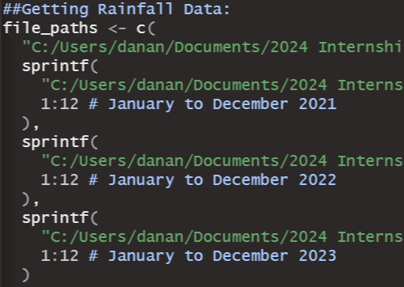
- Manually downloaded the rainfall data needed, and gave them a more simple naming system “rainfall_YYYY_MM”
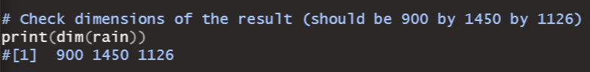
- Created a function to append the arrays via the Z dimension (time) – there are 3 years * 12 months, plus December 2020 (to provide rainfall data for the 4 days prior to any spills that started before Jan 4th 2021)
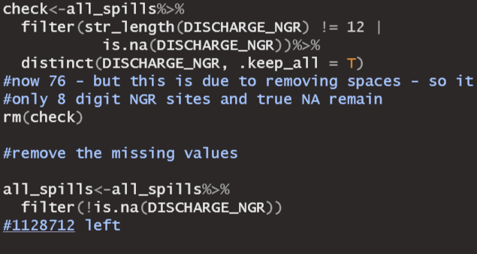
- Removes the true missing values from the data (some sites with site name = “FALSE” can’t have a matched location)
- Some data had 8 digit location references – which work fine with osg_parse() to get Eastings/Northings so not a big problem (checked with a map website that the output from R was still correct) https://gridreferencefinder.com/
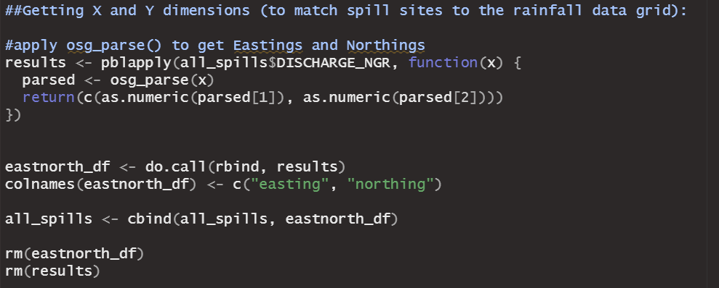
- An efficient way to apply osg_parse() to all the data & gives a progress bar. This is needed to get the Easting/Northing which is then used to get the relevant x and y indices to match with the rainfall array
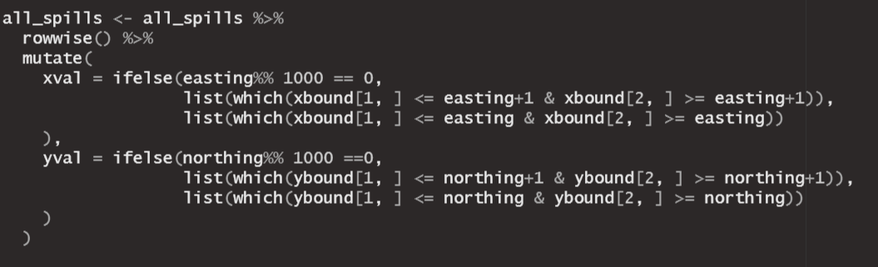
- Uses projection x bound and projection y bound matrices from the netCDF file[s] (same for every month of rainfall data) to get the array indices for each spill site
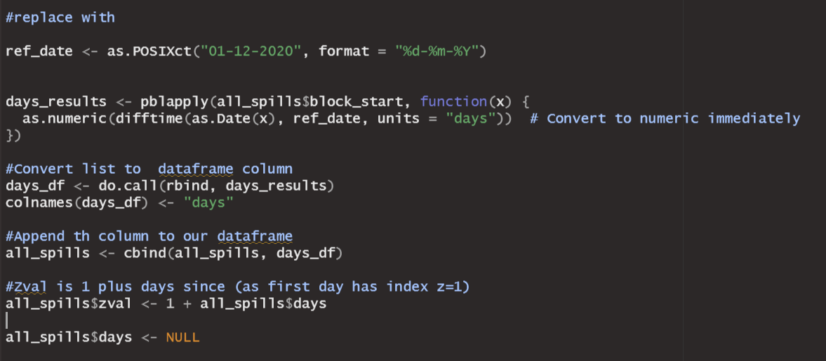
- The most efficient way I could do to get our Z index for each spill – it is the days since 01/12/2020 (z = 1 as our rainfall arrays all were appended to the Dec 2020 array)

Now we access all of the rainfall data we need to identify dry spills
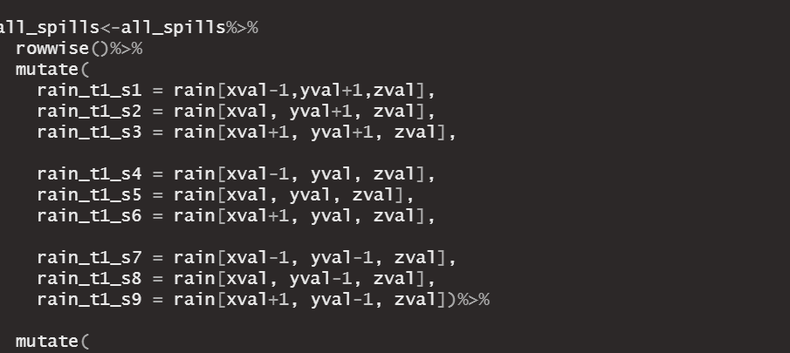
(code cont..)
Explanation:
- The BBC’s “conservative” approach involved using the data from all 9 1km grid cells that surround a spill site for the 4 days leading up to a spill (incl the date the spill starts). So we need all of this data too
- I give a simple naming system to access each of these values “rain_t[X1]_s[x2]”
- X1 is a number (1 to 4) that shows how many days prior to a spill that data point refers to (with 1 being the spill start date, 2 being the day before, etc)
- X2 is a number that refers to the grid cell (relative to the 9) – pto

- The cells are named like the grid shows:
- So 5 refers to the exact cell the site lies in
1 | 2 | 3
4 | 5 | 6
7 | 8 | 9

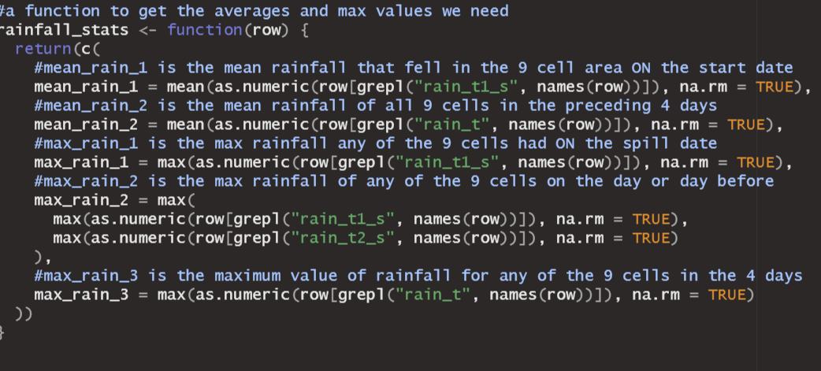
- Works out mean rainfall values for reference, and some maximum rainfall values to help with dry spill identification via different methods
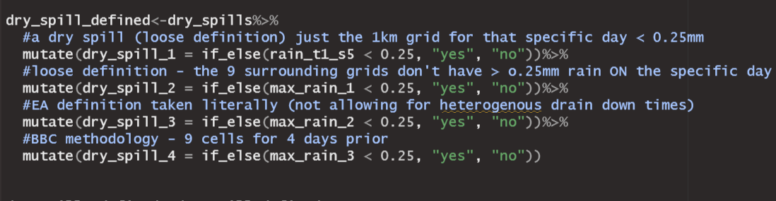
- Initial concerns are BBC found 6000 possible dry spills via their methodology for 2022, I have 11,916 so almost double, despite using the same methodology as them

