FSD LAB ASSIGNMENT-5

*By- Harshil Patel, Roll No. PA26, Batch A2*

Aim: Design and develop an interactive user interface using React.

Objectives:

1. Articulate what React is and why it is useful.
2. Explore the basic architecture of a React application.
3. Use React components to build interactive interfaces

Theory:

1. What is React? Steps to run React app using create-react-app.

React is a popular JavaScript framework used to build front-end applications. Developed by Facebook, React has made its strong presence in the dev community to build fast applications using an intuitive programming paradigm that ties JavaScript with an HTML-like syntax – JSX. In short, ReactJs is a popular and widely used front-end library for developing single page applications. Since it’s a library, we can install this library to Create React App for developing single page applications.

### Step 1: Install Create React App

### Step 2: Overview of React App Structure

### Step 3: Starting the React App Development Server

### Step 4: Using the React Testing Library to Run Tests

### Step 5: Modifying the Meta Data for the App

### Step 6: Using Assets like Images

### Step 7: Installing Dependencies

### Step 8: The Process to Import Components

### Step 9: Styling App with CSS

### Step 10: Building a React App and Deploying It

2. Passing data through props (Small example)

Props allows us to pass data between React components. We can pass callback functions and other pieces of data. We can attach multiple props to each component. Passing props and accessing them is very simple. Lets look at some examples.

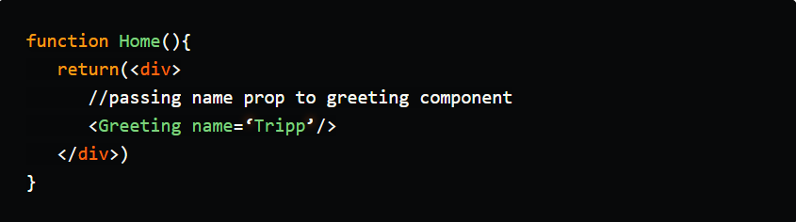

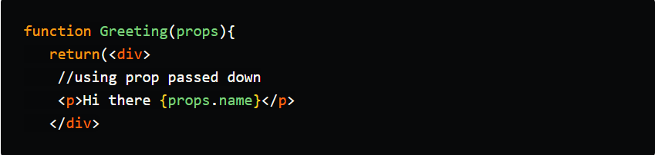

FAQ:

1. What are React states and hooks?

A Hook is a special function that lets you “hook into” React features. For example, useState is a Hook that lets you add React state to function components. We’ll learn other Hooks later. When would I use a Hook? If you write a function component and realize you need to add some state to it, previously you had to convert it to a class. Now you can use a Hook inside the existing function component. The React useState Hook allows us to track state in a function component. State generally refers to data or properties that need to be tracked in an application.

**Sample Problem Statements:**

**1. Design and develop a UI for calculator using React.**

You can include features like-

Mathematical operations

Inserting values

Decimal values must be supported

OUTPUTS-

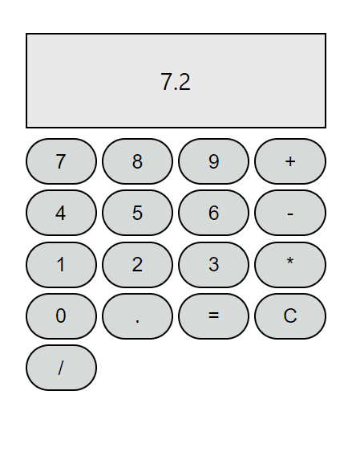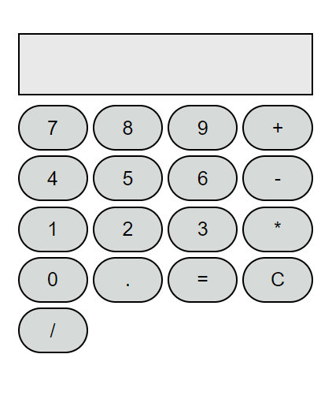

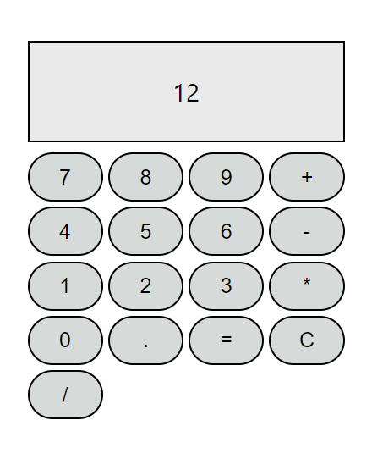

**Design and develop a UI for creating React form to gather the individual’s data.**

It should include features like-

Taking user’s data.

A SUBMIT button.

On submit must highlight the empty block.

Error message when entering the wrong format of email ID.

Display a success message on successful submission.

**3. Create a UI for the Resume Builder application system**

The resume builder app must include the following parameters -

1. Professional summary
2. Education qualifications
3. Academic and non-academic skills,
4. Career objective
5. Experience and Internships
6. Skills and Achievements

LINKS-

https://github.com/stich-12/rep1

