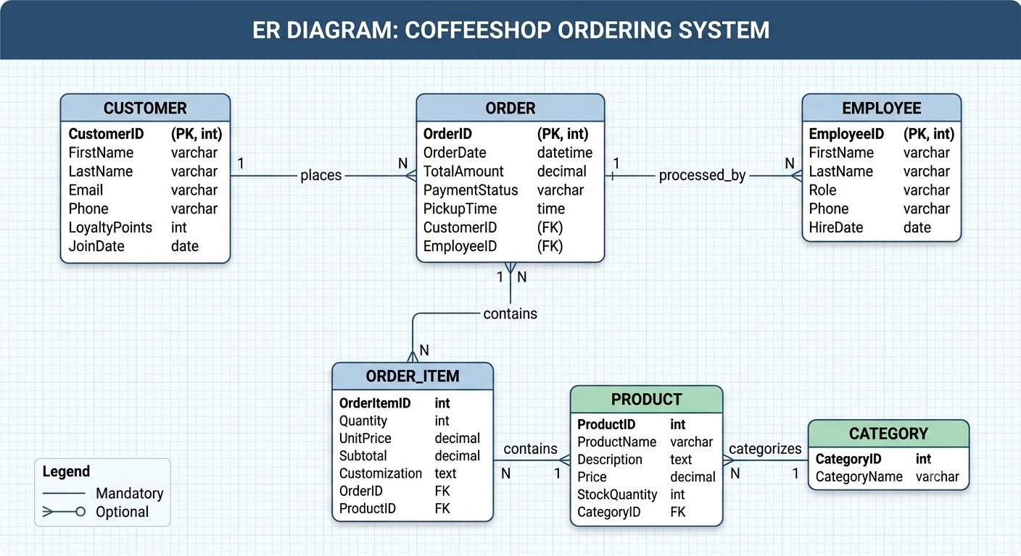
Here is an Entity-Relationship (ER) diagram for a coffee shop ordering system.

Diagram Elements
- Customer: Tracks customer information and manages loyalty points.
- Order: Represents a single transaction, linked to a customer and a specific employee.
- Order_Item: A weak entity that serves as a bridge, allowing a single order to contain multiple different products with specific quantities and customization notes.
- Employee: Contains staff data, defining roles (e.g., Barista, Cashier).
- Product: The menu items available, categorized by type (e.g., Beverage, Food).

Key Relationships
- Places: Connects a Customer to their Orders (one-to-many).
- Takes: Connects an Employee to the Orders they process (one-to-many).
- Contains: Connects an Order to its Order_Items (one-to-many).
- Is_For: Connects an Order_Item to the specific Product being ordered (many-to-one).

