

UNIVERSITY OF RWANDA
College Of Science and Technology
Computer Engineering
Year 4
Gako Campus
Reg nº: 223026685
223026674
2230267476
Names: Jerome HAKIZIMANA
Lewis NGENDAHIMANA
Clement NZABAMWITA

Table of Contents
1. Introduction 2
2. Mini Project 3.1: Frequency Reuse and Handover Decision Logic 3
2.1 Objective 3
2.2 Method 3
2.3 Results 4
2.4 Discussion 8
3. Mini Project 3.2: Cellular Capacity and Frequency-Reuse Planning 9
3.1 Objective 9
3.2 Inputs and method 9
3.3 Results 10
3.4 Analysis 12
4. Mini Project 3.3: Connection and Handover as a Finite-State Machine 14
4.1 Objective 14
4.2 Design 14
4.3 Results 16
4.4 Comparison of policies 18
5. Conclusion 18

Mobile Communications
Unit 3 Lab Report

GIT LINK: https://github.com/sticker2024/MC_LAB3

Mini Projects 3.1, 3.2 and 3.3: Frequency Reuse, Capacity Planning, Handover and Connection State Machine

1. Introduction
This report presents three simulation mini projects covering the quantitative ideas of Unit 3. Project 3.1 builds a hexagonal frequency-reuse generator and a handover decision simulator. Project 3.2 builds a cellular capacity planning tool. Project 3.3 models a device's connection and handover lifecycle as a finite-state machine. All results and screenshots in this report come directly from the output of the Python scripts mp3_1.py, mp3_2.py and mp3_3.py, which use fixed random seeds so that every number can be reproduced.
Terminal screenshots show the printed output of each script. Figures are the plots saved by the scripts.

2. Mini Project 3.1: Frequency Reuse and Handover Decision Logic

2.1 Objective
To generate hexagonal frequency-reuse layouts and compute the co-channel reuse ratio Q = D/R = √(3N), and to simulate a handover decision with a naive trigger, a hysteresis-only trigger and a hysteresis plus time-to-trigger (TTT) trigger, showing the ping-pong effect and how tuning suppresses it.

2.2 Method
- Hexagon centres are computed in axial coordinates for a pointy-top grid of radius R. Each cell is labelled with a group from 1 to N using cluster offset vectors v1 = (i, j) and v2 = (−j, i + j), where N = i² + ij + j².
- Layouts are drawn for N = 1, 3, 4 and 7 (and N = 9 and 12 as an extension). The script measures the smallest distance between same-group cells and asserts that it equals √(3N)·R.
- Serving and neighbour RSRP series (300 samples) are generated from a linear trend, a random walk (σ = 0.25 dB per step) and Gaussian noise (σ = 3 dB). The trends cross at sample 150.
- The same trigger function is run with (margin 0 dB, TTT 1), (3 dB, TTT 1) and (3 dB, TTT 5). A streak counter resets whenever the entering condition breaks.

2.3 Results

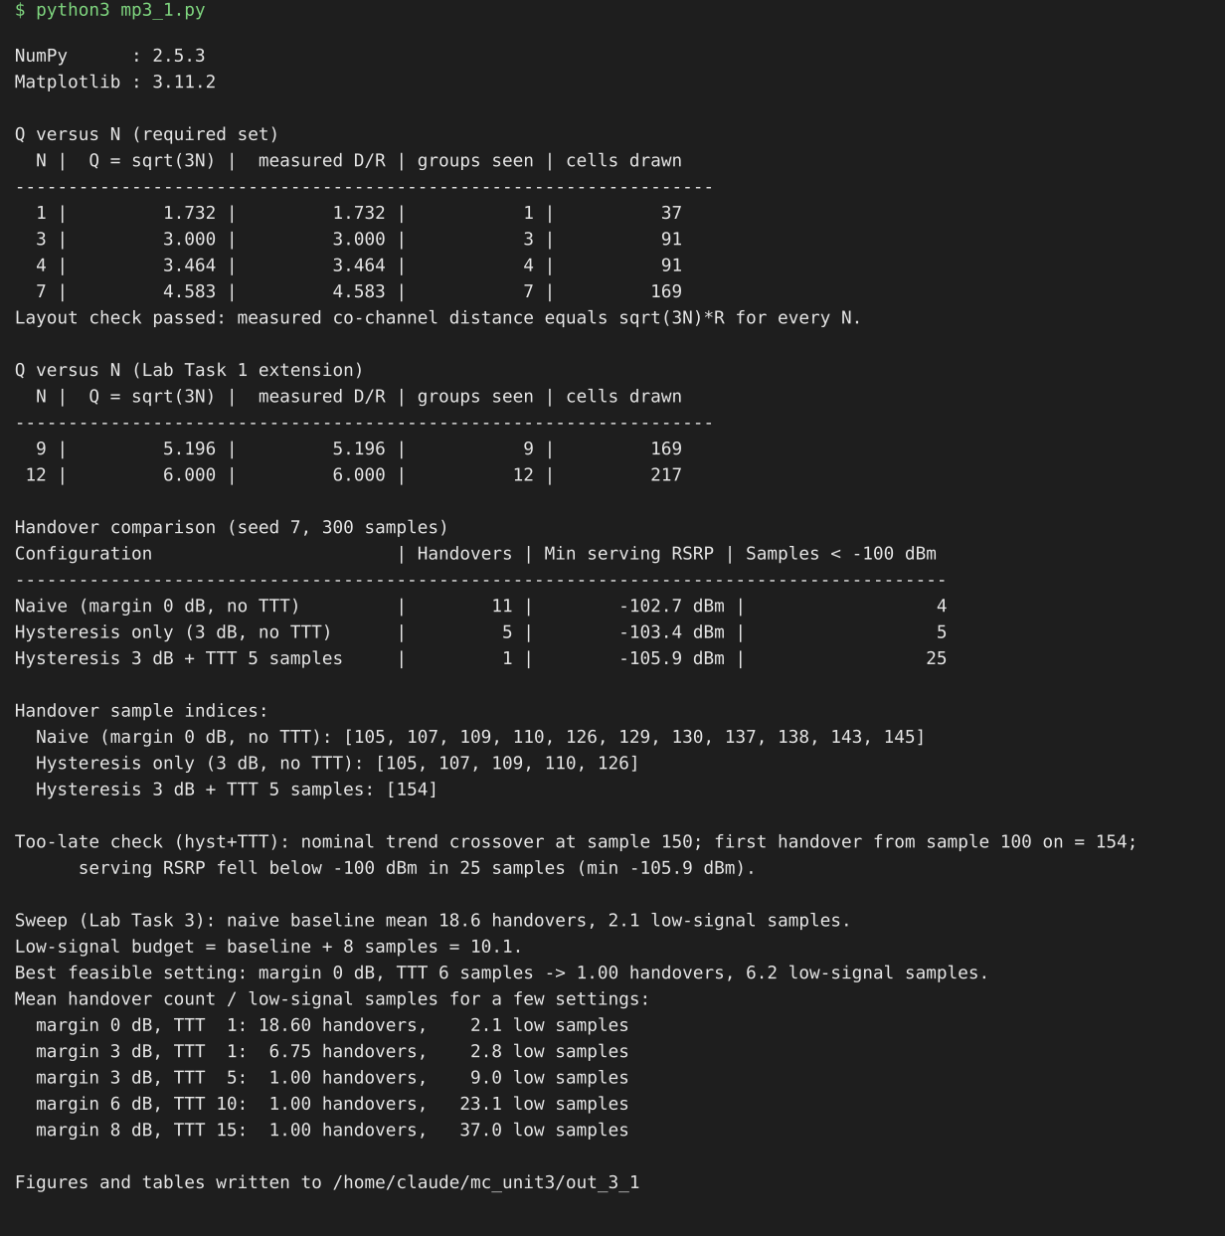
Figure 1: Terminal output of mp3_1.py (Q table, handover table, sweep summary)
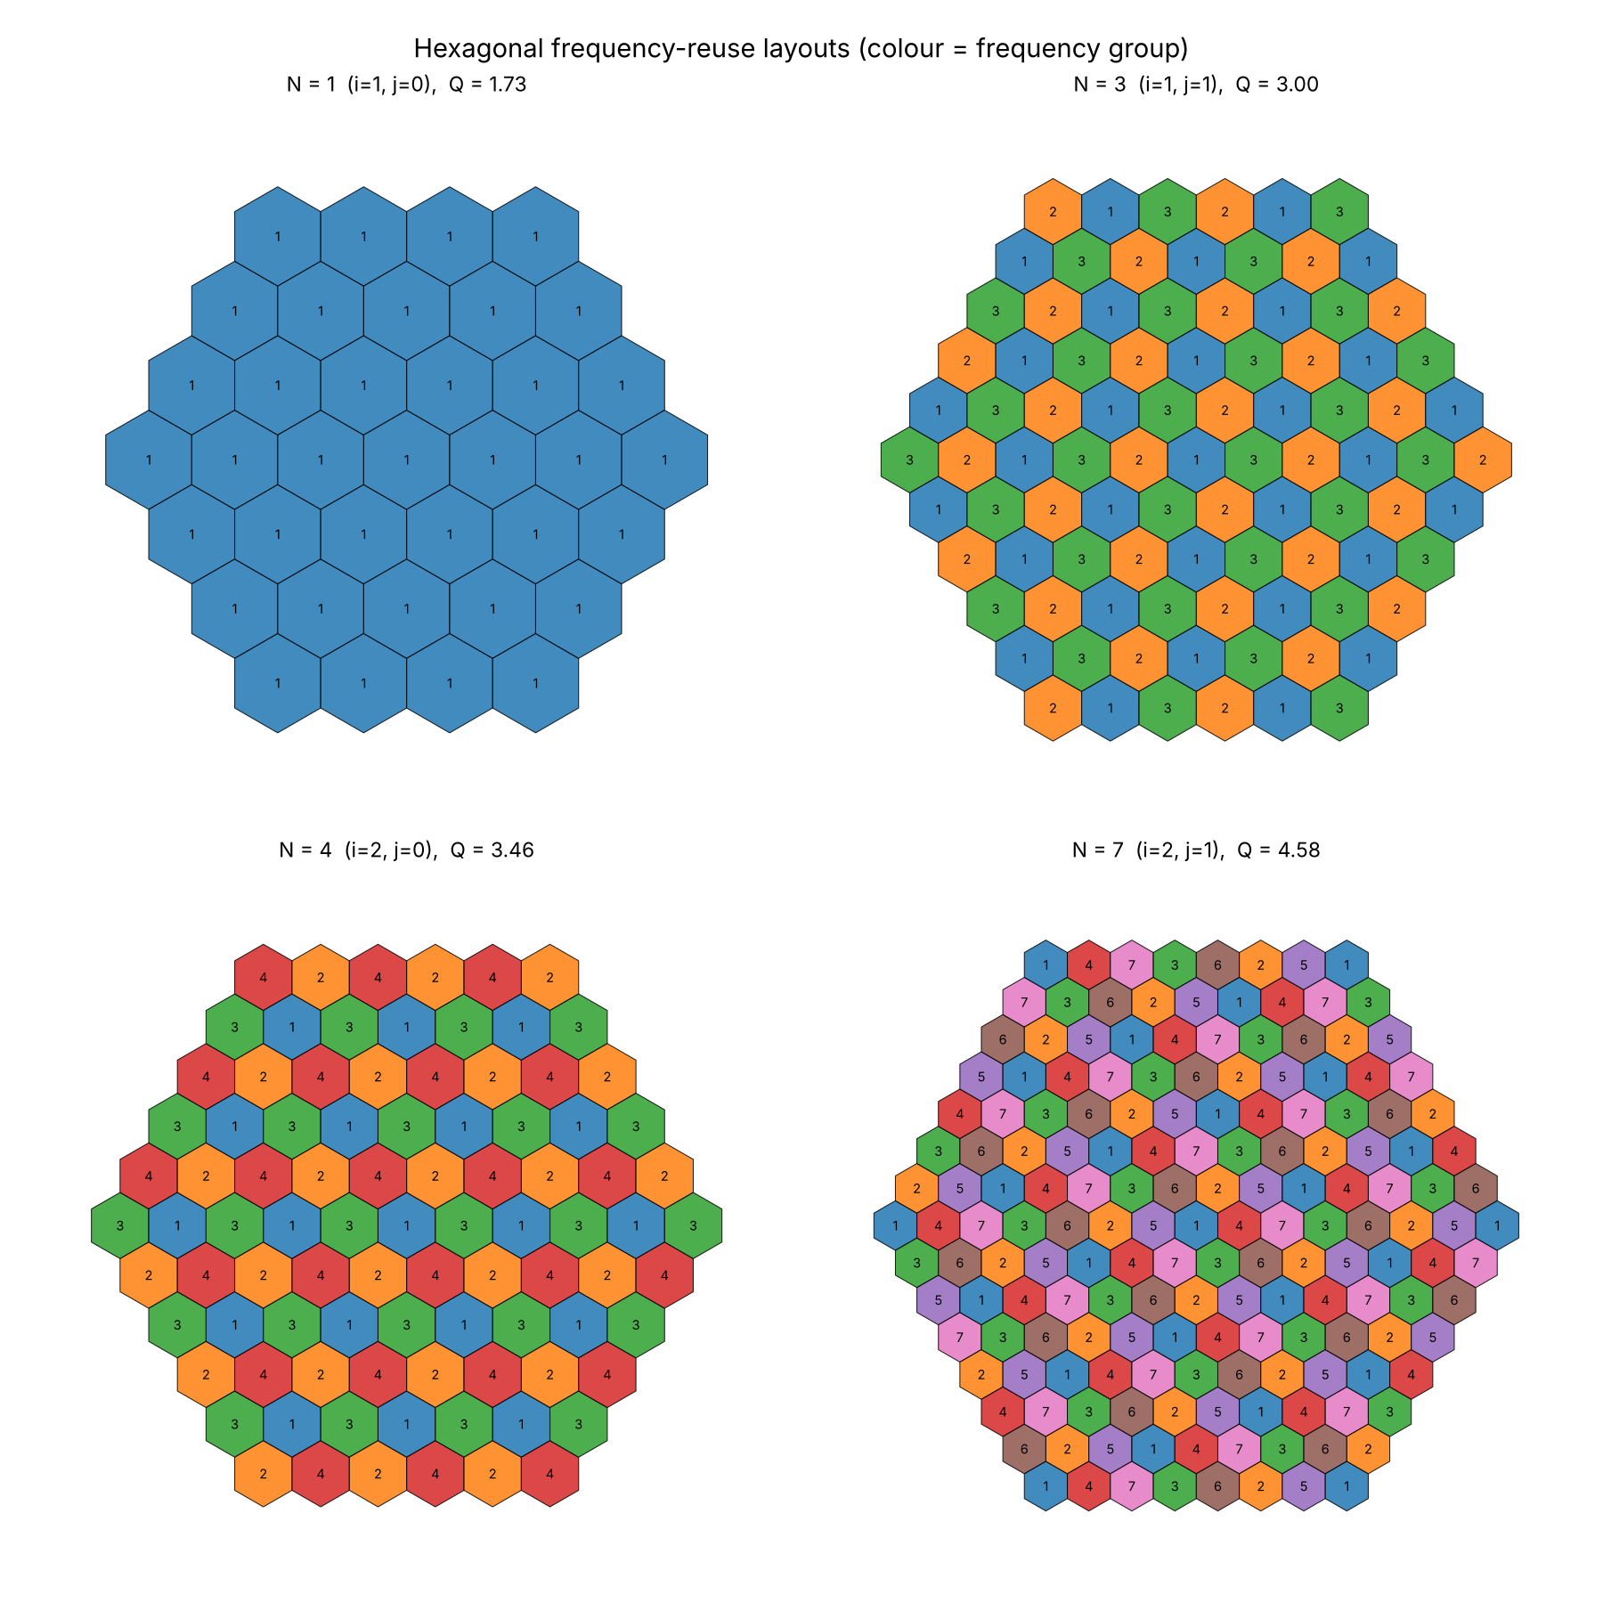
Figure 2: Frequency-reuse layouts for N = 1, 3, 4 and 7 (colour = frequency group)
Table 2: Q versus N (measured nearest same-group distance equals √(3N)·R)
N | i, j | Q = √(3N) | Measured D/R | Groups seen
1 | 1, 0 | 1.732 | 1.732 | 1
3 | 1, 1 | 3.000 | 3.000 | 3
4 | 2, 0 | 3.464 | 3.464 | 4
7 | 2, 1 | 4.583 | 4.583 | 7
9 (ext.) | 3, 0 | 5.196 | 5.196 | 9
12 (ext.) | 2, 2 | 6.000 | 6.000 | 12

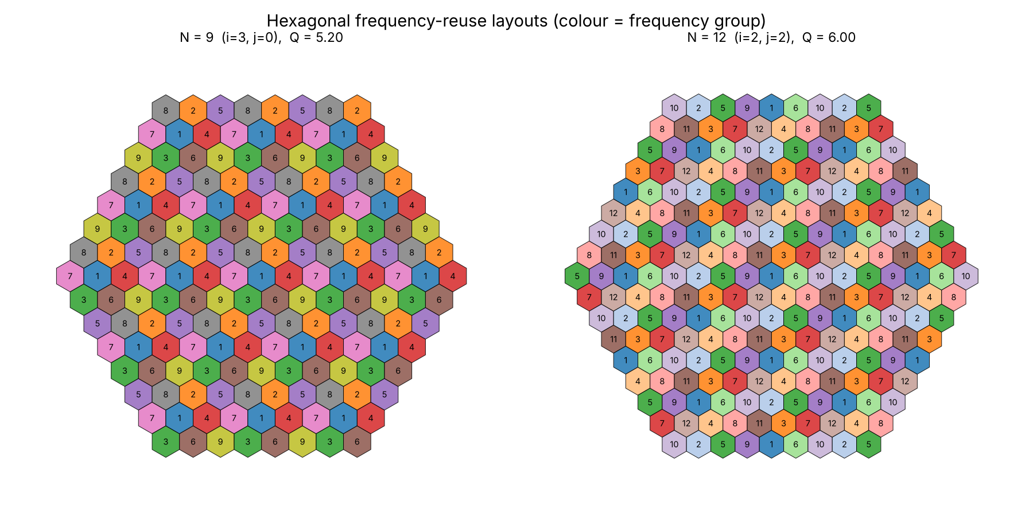
Figure 3: Extension: layouts for N = 9 and N = 12
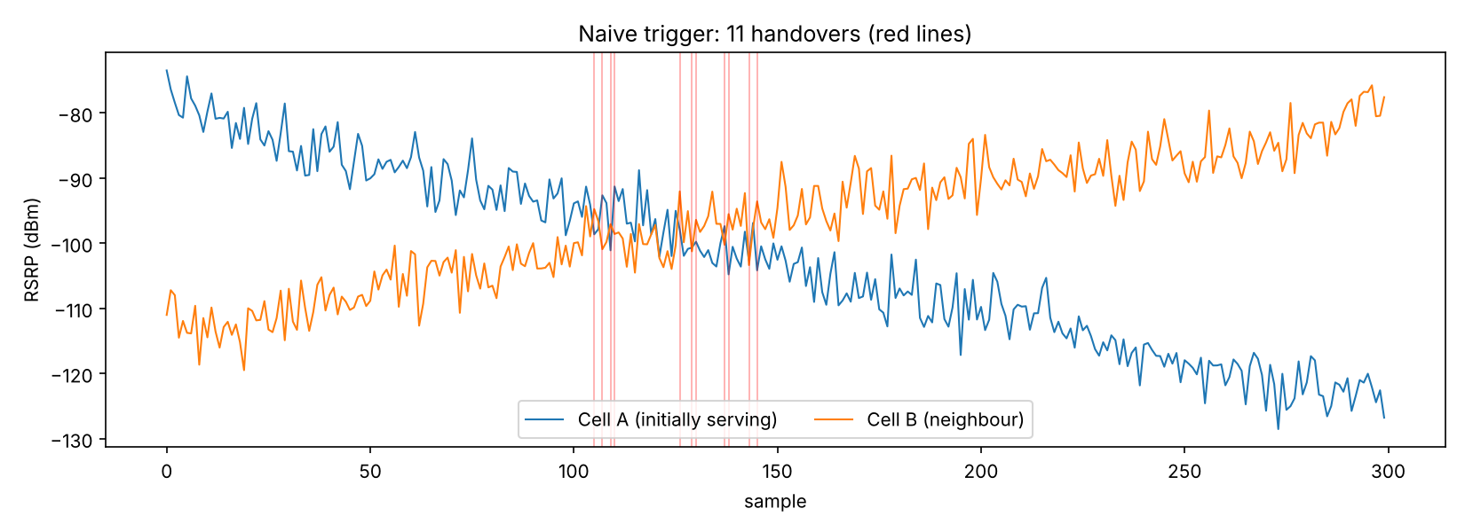
Figure 4: Naive trigger on the synthetic RSRP series (red lines = handovers)
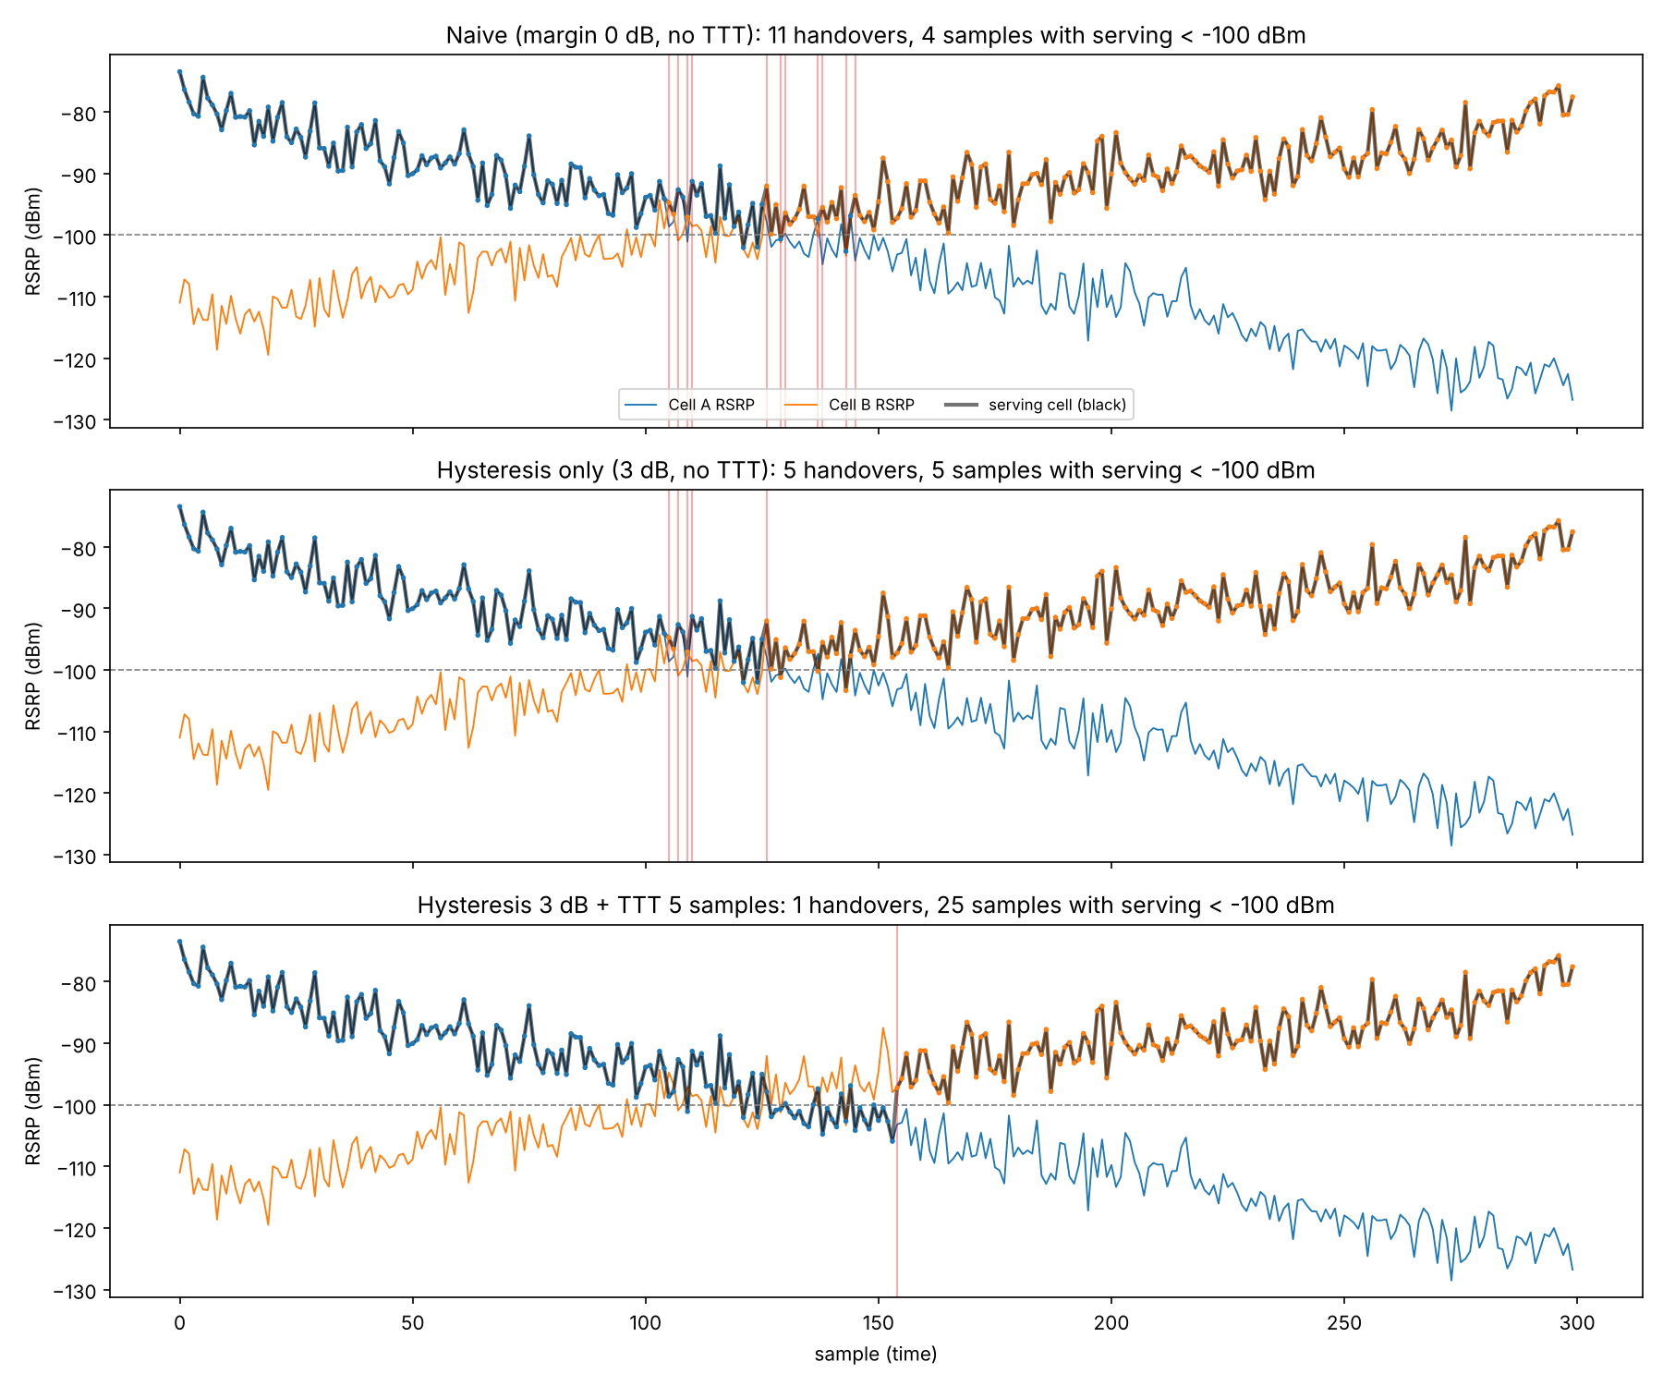
Figure 5: Naive, hysteresis-only and hysteresis plus TTT triggers on the same series
Table 3: Handover comparison (seed 7, 300 samples)
Configuration | Handovers | Min serving RSRP | Samples < −100 dBm
Naive (0 dB, no TTT) | 11 | −102.7 dBm | 4
Hysteresis only (3 dB) | 5 | −103.4 dBm | 5
Hysteresis 3 dB + TTT 5 | 1 (sample 154) | −105.9 dBm | 25

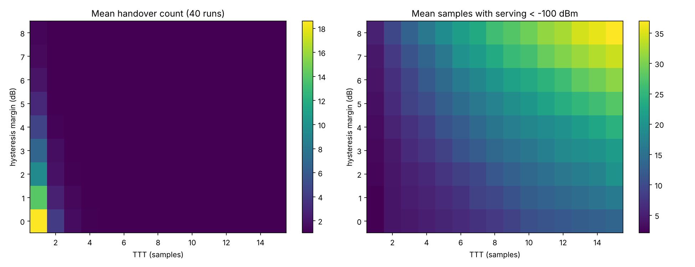
Figure 6: Margin and TTT sweep over 40 random runs (mean handover count and mean low-signal samples)
Table 4: Selected sweep results (mean of 40 runs)
Margin / TTT | Mean handovers | Mean samples < −100 dBm
0 dB / 1 | 18.60 | 2.1
3 dB / 1 | 6.75 | 2.8
3 dB / 5 | 1.00 | 9.0
6 dB / 10 | 1.00 | 23.1
8 dB / 15 | 1.00 | 37.0

2.4 Discussion
Q = √(3N) rises with the reuse factor: 1.73 for N = 1, 3.00 for N = 3, 3.46 for N = 4 and 4.58 for N = 7, and the generated layouts confirm that the nearest same-numbered hexagons sit exactly √(3N)·R apart. Small N packs co-channel cells close together, which gives high capacity but high co-channel interference; N = 7 separates them most, at the cost of reusing each frequency in fewer cells. The extension to N = 9 and N = 12 (Q = 5.20 and 6.00) continues the same trend with diminishing capacity.
In the handover simulation the naive trigger produced 11 handovers, nearly all between samples 105 and 145 where the two RSRP curves overlap. This is the ping-pong effect: noise keeps flipping which cell is momentarily stronger. A 3 dB hysteresis margin cut the count to 5, and adding a 5-sample time-to-trigger reduced it to a single handover at sample 154.
The price is the too-late-handover risk. With hysteresis plus TTT the serving RSRP stayed below −100 dBm for 25 samples (minimum −105.9 dBm), against 4 samples for the naive trigger, because the device waited longer on a fading serving cell. The sweep shows the trade-off worsening for aggressive settings: 8 dB with 15 samples gave about 37 low-signal samples on average, which is how over-tuning leads toward radio link failure. The 40-run averages (18.6, 6.75 and 1.00 handovers) show the same ordering as the single seeded run.

3. Mini Project 3.2: Cellular Capacity and Frequency-Reuse Planning

3.1 Objective
To compute system capacity for several reuse factors, show it together with Q, quantify cell splitting as a capacity lever, and illustrate how sectoring allows tighter reuse without a proportional interference increase.

3.2 Inputs and method
Table 5: Input parameters
Parameter | Value
Total spectrum | 25 MHz
Channel bandwidth | 200 kHz (125 channels in total)
Coverage area | 1000 km²
Cell radius R | 2 km (hexagon area 10.39 km², 96 cells fit)
Candidate N | 1, 3, 4, 7, 9, 12
Splitting | R divided by 2 and by 4, at N = 7
Sectoring model | SIR ≈ Q^γ / i₀, γ = 4; 6 interferers (omni), 2 (120° sector)

- Channels per cell is ⌊125 / N⌋ and the number of cells is the area divided by the hexagon area (3√3/2)R². System capacity is channels per cell times number of cells.

3.3 Results

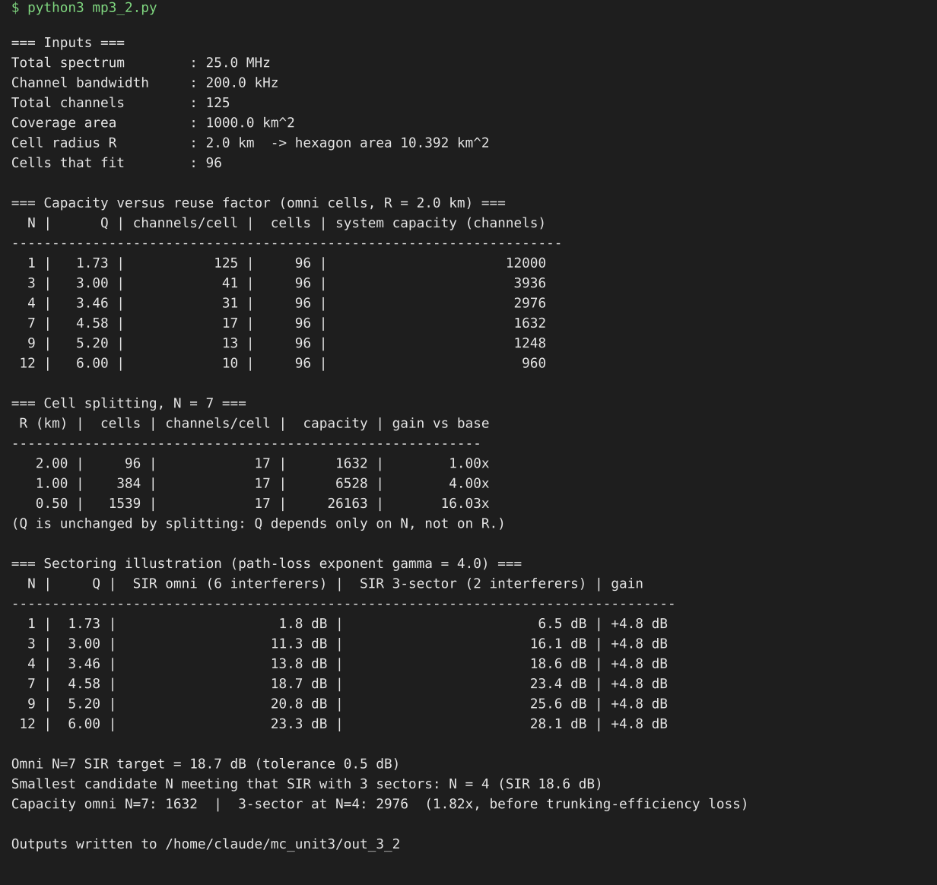
Figure 7: Terminal output of mp3_2.py (capacity, cell splitting and sectoring tables)
Table 6: Capacity versus reuse factor (R = 2 km)
N | Q | Channels per cell | Cells | System capacity
1 | 1.73 | 125 | 96 | 12,000
3 | 3.00 | 41 | 96 | 3,936
4 | 3.46 | 31 | 96 | 2,976
7 | 4.58 | 17 | 96 | 1,632
9 | 5.20 | 13 | 96 | 1,248
12 | 6.00 | 10 | 96 | 960

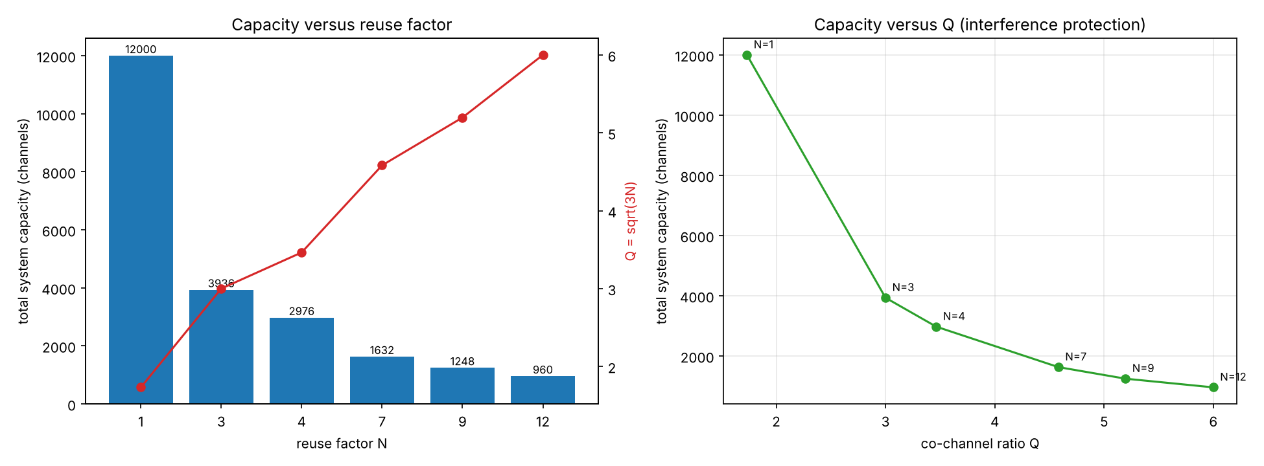
Figure 8: System capacity versus reuse factor N and versus Q
Table 7: Cell splitting at N = 7
R (km) | Cells | Channels per cell | Capacity | Gain
2.00 | 96 | 17 | 1,632 | 1.00×
1.00 | 384 | 17 | 6,528 | 4.00×
0.50 | 1,539 | 17 | 26,163 | 16.03×

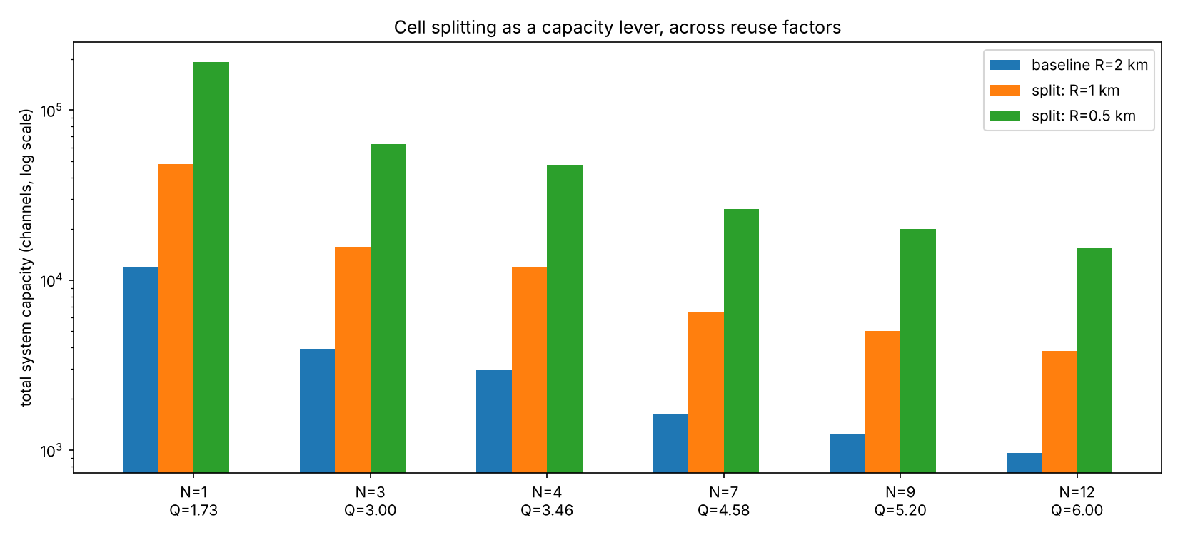
Figure 9: Cell splitting as a capacity lever across reuse factors (log scale)
Table 8: Sectoring illustration (γ = 4)
N | Q | SIR omni | SIR 3-sector | Gain
1 | 1.73 | 1.8 dB | 6.5 dB | +4.8 dB
3 | 3.00 | 11.3 dB | 16.1 dB | +4.8 dB
4 | 3.46 | 13.8 dB | 18.6 dB | +4.8 dB
7 | 4.58 | 18.7 dB | 23.4 dB | +4.8 dB
9 | 5.20 | 20.8 dB | 25.6 dB | +4.8 dB
12 | 6.00 | 23.3 dB | 28.1 dB | +4.8 dB

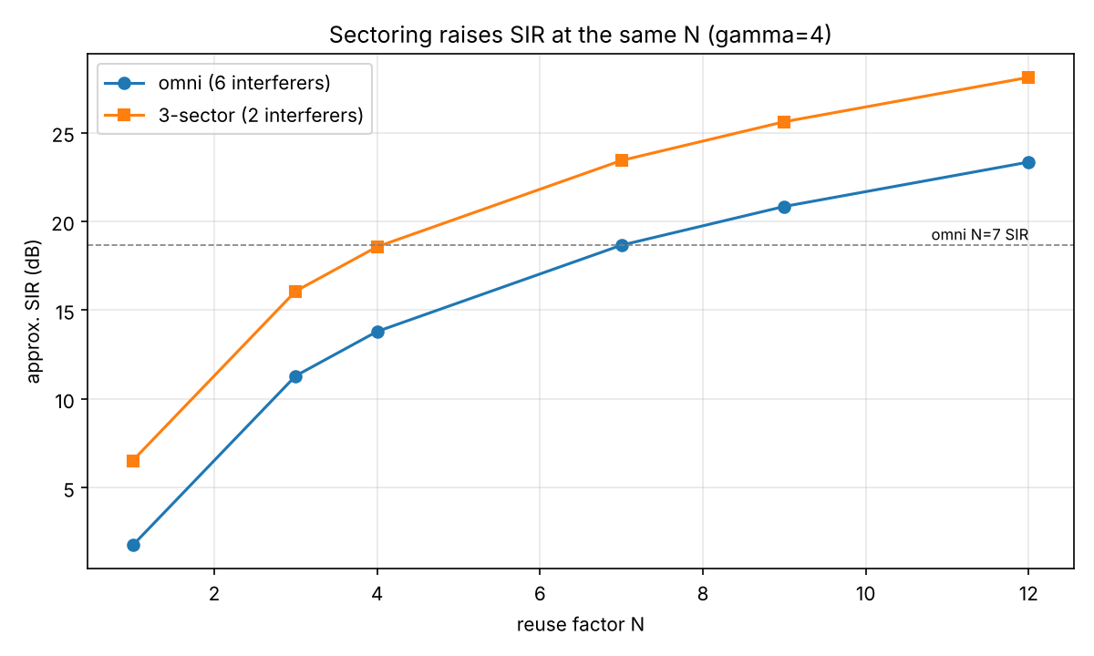
Figure 10: Approximate SIR versus N for omni and three-sector cells

3.4 Analysis
With a fixed 125 channels, capacity is inversely proportional to N: moving from N = 7 to N = 3 raises capacity from 1,632 to 3,936 channels, and N = 1 reaches 12,000. The price is co-channel protection, measured by Q = √(3N), which falls from 4.58 at N = 7 to 3.00 at N = 3 and 1.73 at N = 1. With a path-loss exponent of 4, omni N = 1 gives roughly 1.8 dB of SIR, which is unusable for narrowband channels, while N = 3 gives about 11 dB and N = 7 about 19 dB. Choosing N therefore means choosing the smallest value whose SIR the radio technology can tolerate.
For dense urban deployment, demand rather than coverage is the limit, so the operator wants the smallest workable N, typically 3 or 4 with sectored sites, combined with small cells. For rural deployment the opposite holds: traffic is light, cells are large and spectrum is not the bottleneck, so a larger N such as 7 buys robust SIR and range at no real cost.
Once N is already small, reducing it further is not available because dropping from N = 3 to N = 1 destroys SIR. Splitting and sectoring add capacity without that penalty. Cell splitting multiplies capacity by the square of the radius ratio (4× for halving R, about 16× for quartering it) and leaves Q, and therefore SIR, unchanged, because Q depends only on N. Sectoring works through the directional-beam argument of Section 3.1: a 120° antenna illuminates only a third of the surroundings and hears roughly two of the six first-tier co-channel cells, a 4.8 dB SIR gain. That gain lets N = 4 with three sectors (18.6 dB) match omni N = 7 (18.7 dB) while delivering about 1.8 times the capacity (2,976 against 1,632 channels).
Both levers have costs. Splitting needs new sites, backhaul and re-planning, and smaller cells mean more handovers, which is why the handover tuning in Project 3.1 matters more as cells shrink. Sectoring divides each site's channel pool across three sectors, which reduces trunking efficiency, and adds sector-to-sector handovers. The model counts channels, ignores traffic (Erlang) dimensioning, uses a first-tier-only SIR approximation and assumes perfect hexagons, so the absolute numbers are indicative and the trends are the point.

4. Mini Project 3.3: Connection and Handover as a Finite-State Machine

4.1 Objective
To model a device's connection lifecycle (Idle, Random Access, Connected, Handover in progress) as an explicit state machine, represent the four RACH steps, include a Radio Link Failure (RLF) path, and compare configurable handover policies on a scripted three-cell scenario.

4.2 Design
- States: IDLE; RACH with four sub-states (preamble, Random Access Response with timing advance, connection request, contention resolution); CONNECTED; HANDOVER.
- Policies: interchangeable functions policy(serving, rsrp, mem) that return a target cell or none. The naive policy hands over when any neighbour is stronger; the hysteresis plus TTT policy requires a margin held for a number of consecutive samples.
- RLF: declared when serving RSRP is below −110 dBm for 3 consecutive samples, in CONNECTED or HANDOVER. The device returns to IDLE, waits 5 samples, then re-attaches through RACH.
- Scenario: cells A, B and C at 0, 1000 and 2000 m on a straight road; device at 20 m/s from 50 m to 2000 m; 0.2 s samples (487 samples); path loss −45 − 33·log10(d/10) dBm; AR(1) shadowing (σ = 3 dB, ρ = 0.9) plus 1.5 dB measurement noise. The first attach is scripted to lose contention once so the RACH retry path appears in the log.
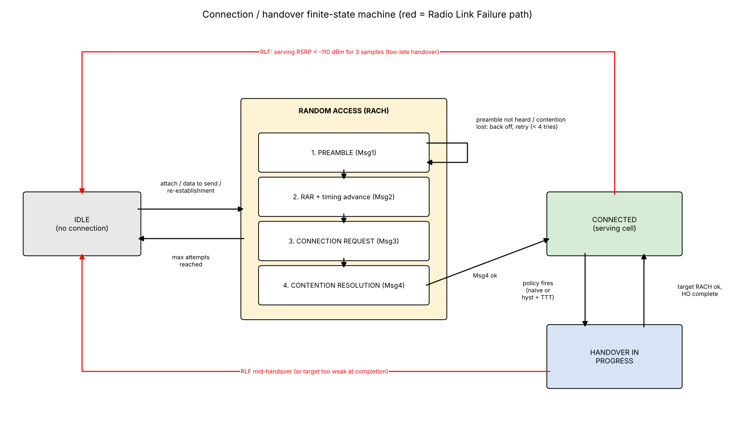
Figure 11: State-transition diagram (red = Radio Link Failure path)
Table 9: State-transition table
From | To | Trigger
IDLE | RACH_PREAMBLE | Data to send or re-establishment; strongest cell ≥ −105 dBm (5-sample wait after RLF)
RACH_PREAMBLE | RACH_RAR | Preamble detected (cell RSRP ≥ −110 dBm)
RACH_PREAMBLE | IDLE | 4 attempts without detection
RACH_RAR | RACH_CONNREQ | RAR with timing advance received
RACH_CONNREQ | RACH_CONTENTION | Msg3 (RRC connection request) sent
RACH_CONTENTION | CONNECTED | Contention resolved (Msg4)
RACH_CONTENTION | RACH_PREAMBLE | Contention lost, back off and retry
CONNECTED | HANDOVER | Policy fires (naive, or margin held for TTT samples)
HANDOVER | CONNECTED | Execution done (3 samples) and target RSRP ≥ −110 dBm
CONNECTED | IDLE | RLF: serving RSRP < −110 dBm for 3 consecutive samples
HANDOVER | IDLE | RLF on source during execution, or target too weak

4.3 Results

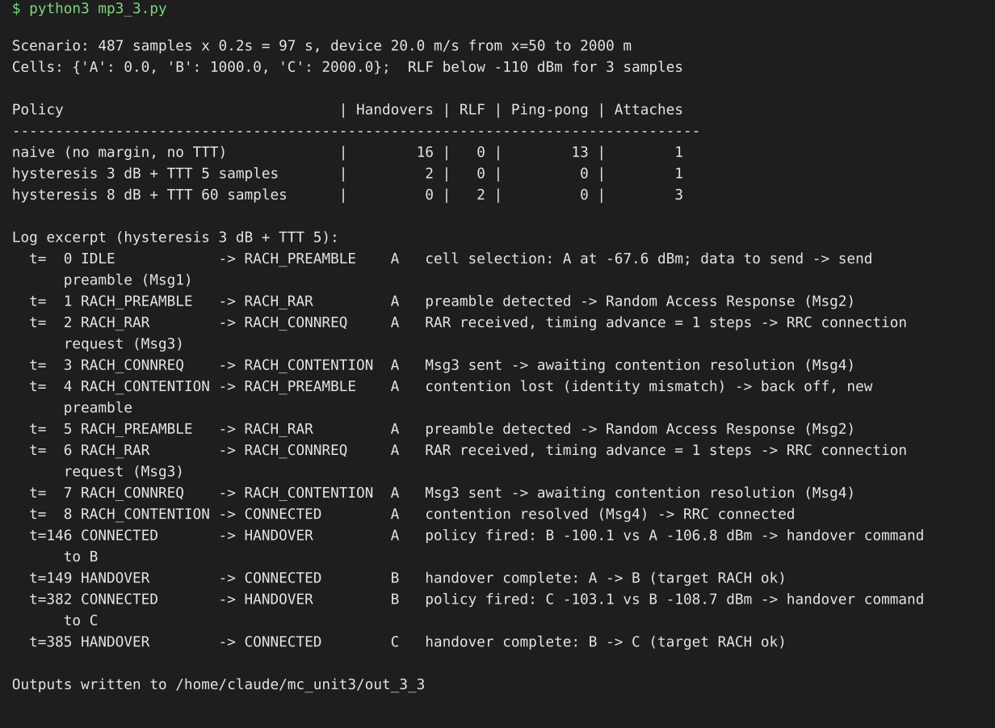
Figure 12: Terminal output of mp3_3.py (policy summary and transition-log excerpt)
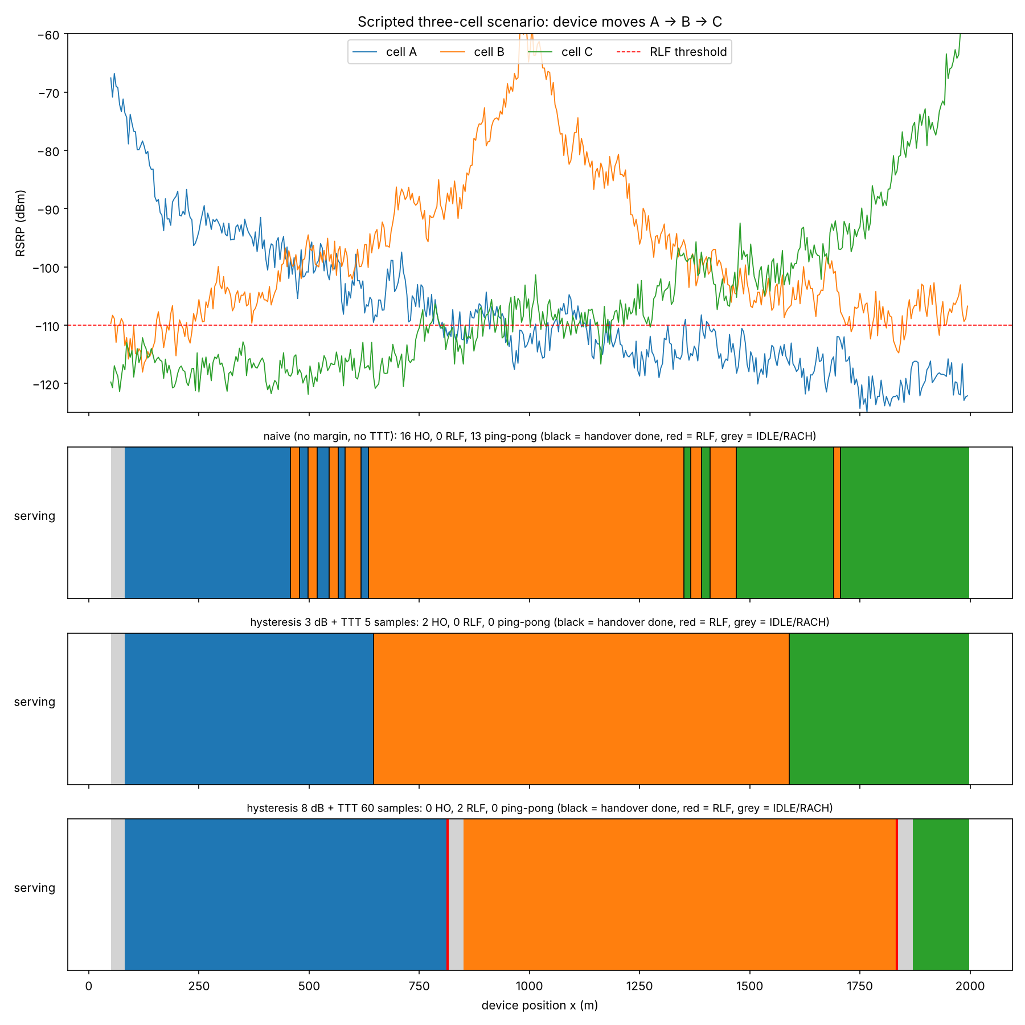
Figure 13: Generated signal series for cells A, B, C and the serving-cell timeline under each policy
Table 10: Per-policy results
Policy | Handovers | RLF | Ping-pong | RACH attaches
Naive | 16 | 0 | 13 | 1
Hysteresis 3 dB + TTT 5 | 2 | 0 | 0 | 1
Hysteresis 8 dB + TTT 60 | 0 | 2 | 0 | 3

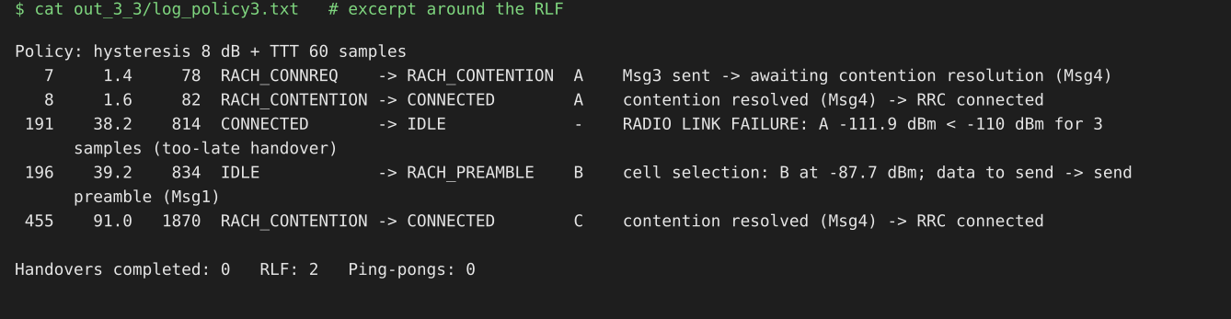
Figure 14: Transition-log excerpt for the over-tuned policy, showing both Radio Link Failures and re-attachment through RACH

4.4 Comparison of policies
The naive policy handed over whenever a neighbour was momentarily stronger. In the A/B overlap (x ≈ 450 to 650 m) and the B/C overlap (x ≈ 1340 to 1700 m) it completed 16 handovers, 13 of which were ping-pongs, meaning a return to a cell left within 8 seconds. It never lost the link because it always moved early, but it generated a large signalling load for no benefit.
Hysteresis of 3 dB with a 5-sample time-to-trigger removed all ping-pong. The margin ensures that a neighbour must be clearly better, and the TTT ensures that this holds for 1 second rather than for a single noisy sample. It produced exactly the two intended handovers, A to B at x = 634 m and B to C at x = 1578 m. These are 134 m and 78 m beyond the geometric midpoints, and the serving RSRP at trigger was −106.8 and −108.7 dBm, close to the −110 dBm RLF threshold but still above it. That shows the cost of this filtering: handovers become later.
The over-tuned setting (8 dB, 60 samples = 12 s) shows that cost taken too far. The required advantage never persisted for 60 consecutive samples before the serving cell fell below −110 dBm, so no handover happened and the device suffered two radio link failures, at x = 814 m and x = 1834 m. Each caused about 1.8 seconds of outage while the device waited in IDLE and re-attached through RACH. This is the too-late handover failure.
A larger margin and a longer TTT reduce ping-pong but delay handover, and both must be chosen against the fading and the device speed. Here 3 dB with 5 samples sat in the working range. This is a single seeded scenario, so the precise counts would change with another seed even though the ordering is stable.

5. Conclusion
- Q = √(3N) grows with N, so smaller reuse factors give more capacity and less co-channel protection. Simulated layouts matched the formula exactly.
- Capacity falls from 12,000 channels at N = 1 to 960 at N = 12 for the chosen inputs. Cell splitting multiplies capacity by the square of the radius ratio without changing Q, and three-sector sites let N = 4 match the interference quality of omni N = 7 with about 1.8 times the capacity.
- Naive handover causes ping-pong in overlap regions. Hysteresis and TTT remove it, but too much of either delays handover and leads to radio link failure, so the parameters must be tuned, which is the task of mobility robustness optimisation.
- The connection state machine with RACH, handover and RLF paths reproduced these behaviours in a three-cell mobility scenario.

