Mathew Cave  
 student number 9708493

TMA4

Application development for the Internet

Due Date 21 October 2018

BIT695 Web technologies

Task 1: Security and availability

1. Sorry I did not have time.
2. Second within the context of the CIA triad, the impact and importance of availability for an e-commerce enabled web application is big.

E-commerce Web applications allow users to view and purchase products and services over the Internet. Payment is usually made using a credit card or direct banking. Availability means that users should be able to access the web application at a time that is suitable to them. This could be at any time during the day or night due to the fact users may be browsing the Internet at any time, and from anywhere in the world. To allow this to happen, the application needs to be secure so users feel safe when using the app and if making online purchases, trust that their personal information is protected. Confidentiality and integrity must be held in the highest regard in order for the web application to be available at all times, and therefore accessible to the maximum number of possible uses.

A limitation with the CIA triad model in terms of today’s Web applications would be the fact that a lot more personal information is now stored online, and in the cloud for example. The model only discusses the protection of information on the technology side. With more and more information such as personal information medical records, and even government information being stored online, the chances of that information being stolen goes up immensely. Access points such as personal computers and online servers are all open to attack, and a lot of them are accessible twenty-four hours a day, seven days a week. Even the way information is being transmitted online can be an attack point.

The CIA triad model was expanded upon to allow a way to make information more secure for the way we use it today. Along with confidentiality, integrity and accessibility, the Parkerian Hexad model (Pender-Bey, n.d.), also includes authenticity, possession/control and utility. This expanded model brings a more complete and in-depth way of securing information, allowing the developer to place emphasis on the human side of information security that as humans are the biggest threat.

The CIA triad model is over twenty years old. When it was created, the online world was in its infancy, but now it has grown to be a part of daily life and therefore the CIA triad model could not account for the way information would be stored in the future.

Reference

Pender-Bey, G. (n.d.). The Parkerian Hexad. <http://cs.lewisu.edu/mathcs/msisprojects/papers/georgiependerbey.pdf>

Task 2: Version control

1. Joining GitHub - first page

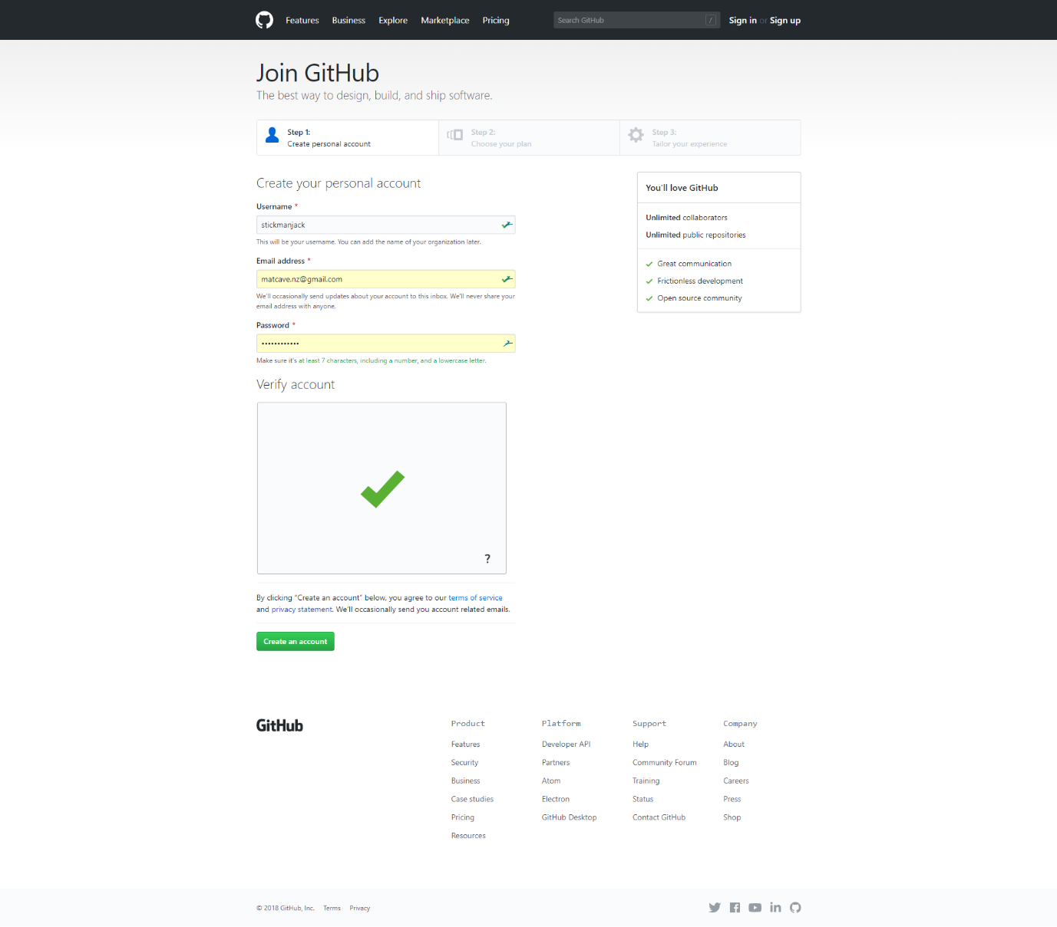

Joining GitHub - second page  
  
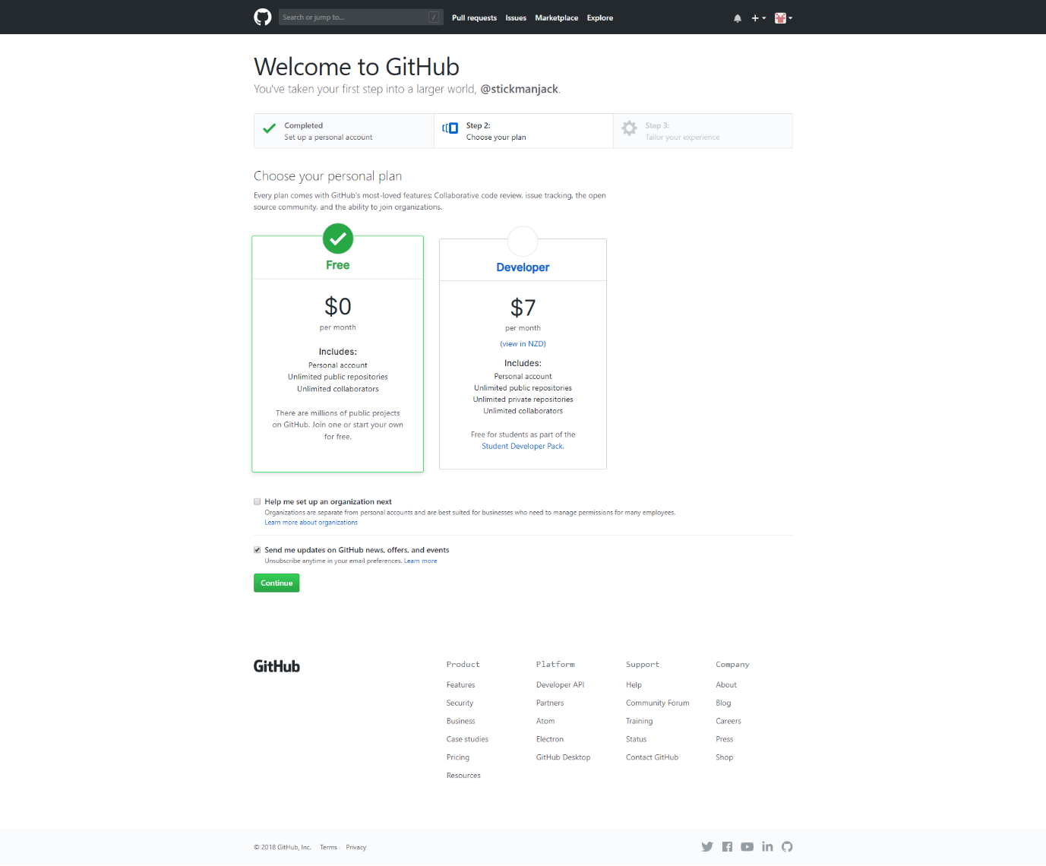

Joining GitHub - third page  
  
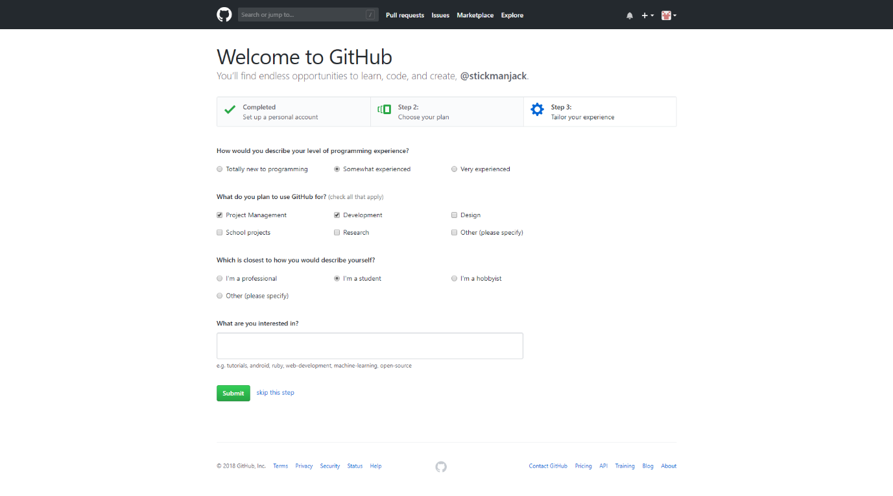  
 Forking example repository - clicked fork button top right  
  
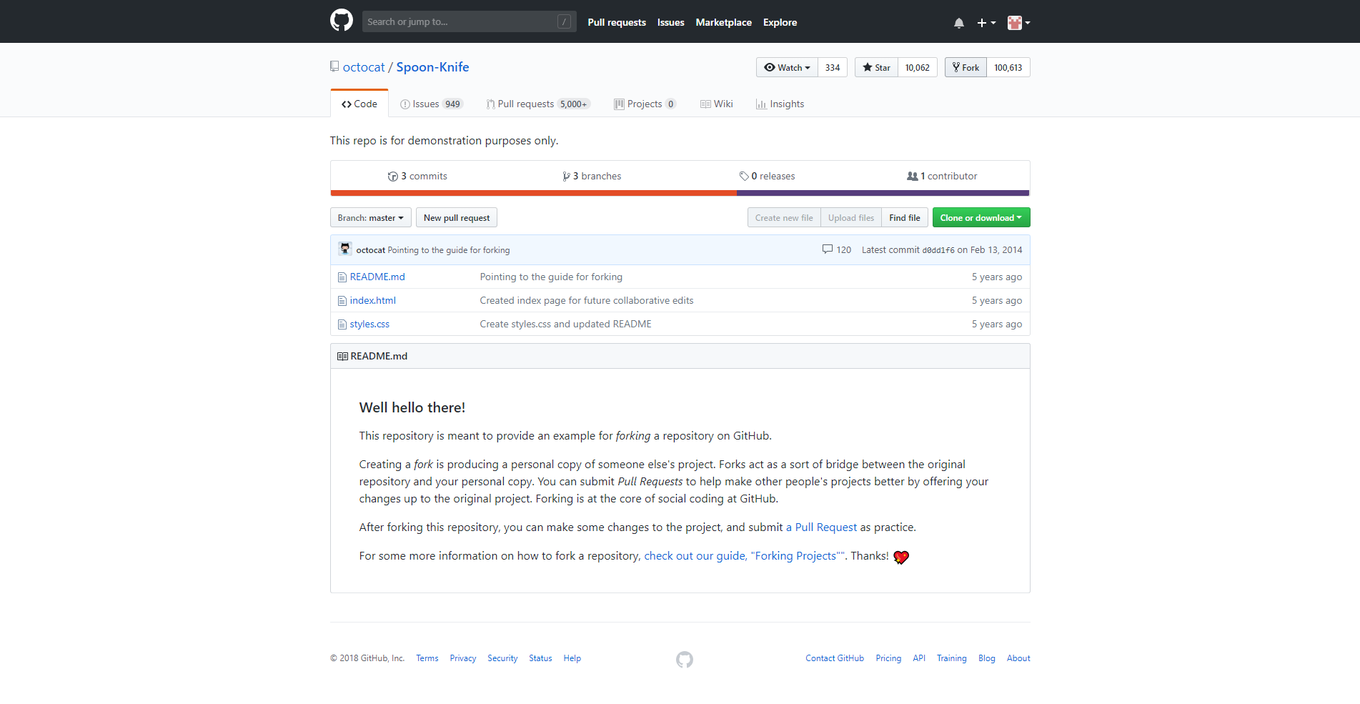

My GitHub profile page  
  
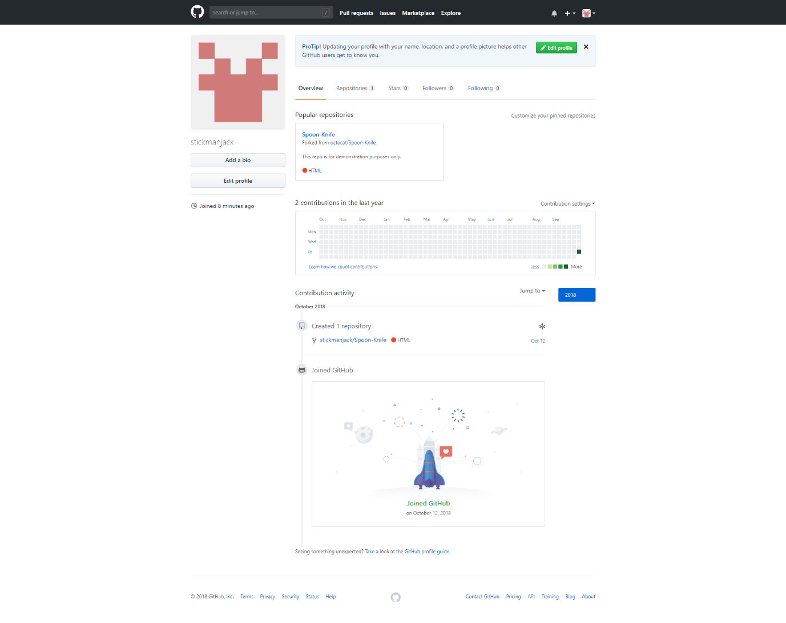

1. Desktop GitHub installed and connected to my GitHub account  
     
   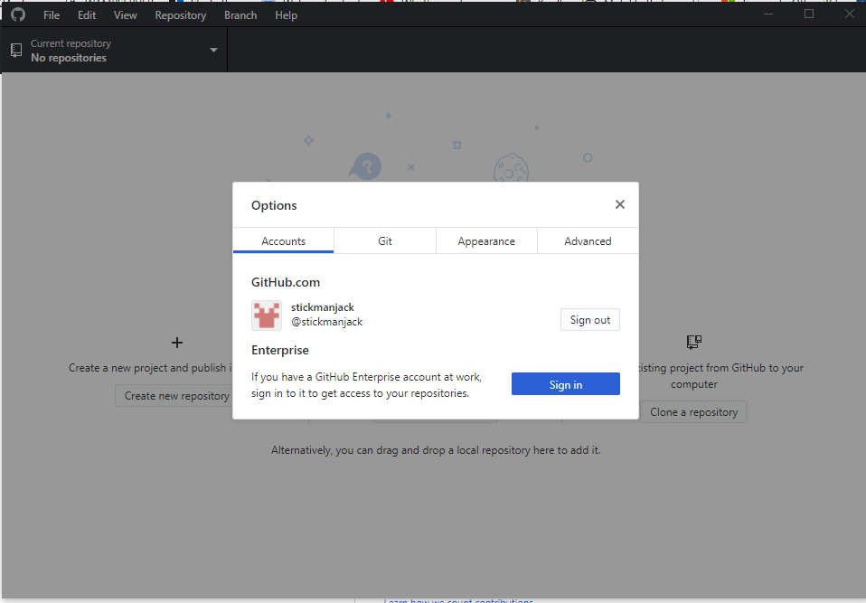

Making a clone of the Freecodecamp repository   
  
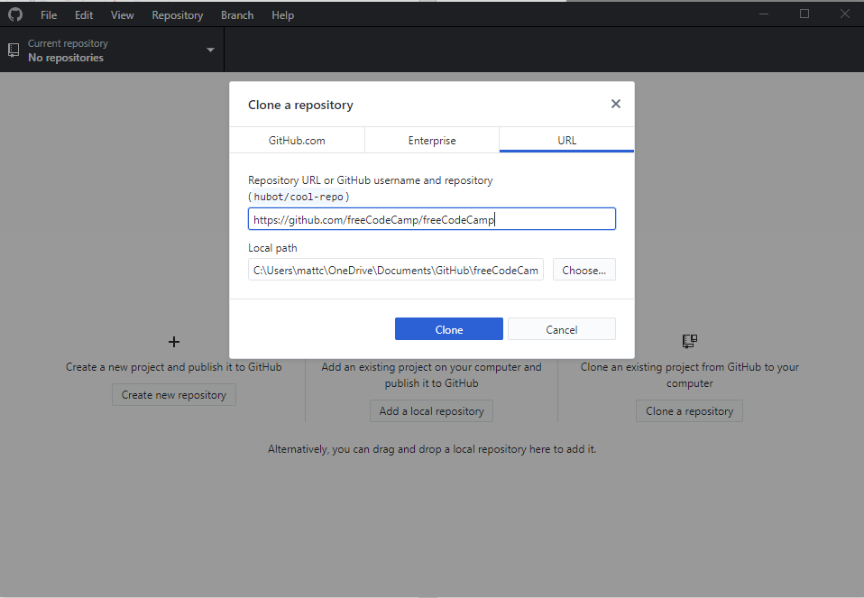

Cloning the Freecodecamp repository   
  
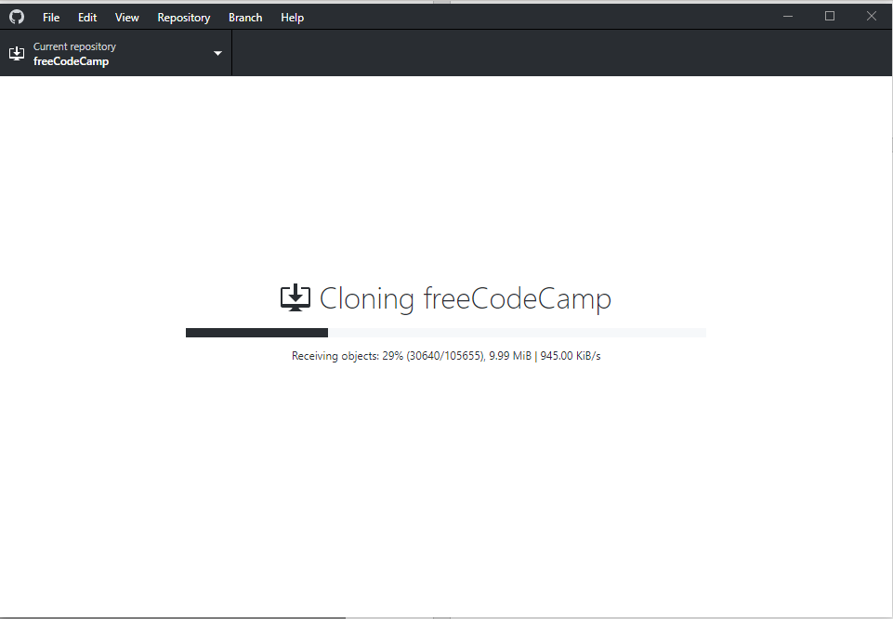

Finished cloning freeCodeCamp repository   
  
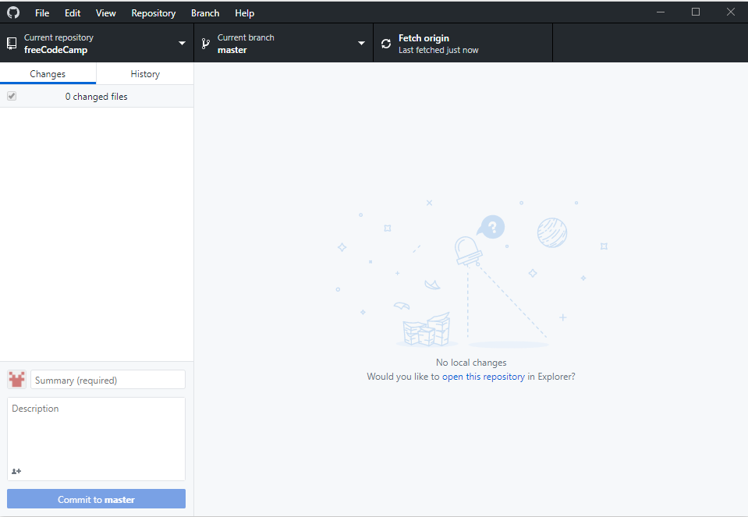

1. Comparison of GitHub features and bitbucket features

|  |  |  |
| --- | --- | --- |
| **Features** | **Github** | **bitbucket** |
|  |  |  |
| Tiered accounts | Free and paid versions | Free and paid versions |
| Private / public repositories | Unlimited repositories | Unlimited repositories |
| Third-party integrations |  |  |
| Code reviewing |  |  |
| Project organisation |  |  |
| Desktop client |  |  |
|  |  |  |
|  |  |  |
|  |  |  |

Task 3: Application planning and development

1. Sorry I did not have time.