Colony size drives sublinear scaling, compositional turnover, and biodiversity–condition feedbacks in coral-associated fauna

Colony size drives sublinear scaling, compositional turnover, and biodiversity–condition feedbacks in coral-associated fauna
Adrian C. Stier^{1,2}*, Alexander Primo³, Joseph S. Curtis^{1,4}, Craig W. Osenberg³
¹Department of Ecology, Evolution, and Marine Biology, University of California Santa Barbara, Santa Barbara, CA 93106, USA
²Marine Science Institute, University of California Santa Barbara, Santa Barbara, CA 93106, USA
³Odum School of Ecology, University of Georgia, 140 E Green St, Athens, GA 30602, USA
⁴Department of Marine Science, University of Otago, PO Box 56, Dunedin, Otago 9054, New Zealand
*Corresponding author: Adrian C. Stier (astier@ucsb.edu)

Abstract
Occupant abundance in biogenic habitats – corals, trees, kelps, oysters – scales predictably with habitat size, yet whether scaling is proportional or sublinear determines per-capita density and the services occupants provide to their hosts. Whether sublinear scaling generates compositional turnover, and whether that turnover feeds back on habitat condition, have not been tested. We surveyed 114 Pocillopora coral colonies spanning three orders of magnitude in volume across three reef habitats in Mo’orea, French Polynesia, cataloging 3,989 coral-associated fishes and invertebrates (CAFI) from 243 taxa. Total CAFI abundance scaled sublinearly with colony volume (β = 0.52, 95% CI [0.44, 0.62]): larger corals harbor more occupants but at progressively lower per-capita densities, consistent with density dilution from a finite colonist pool. Colony volume explained 7.8% of community composition after accounting for reef site (db-RDA, p = 0.001), with species replacement accounting for 81% of beta diversity along the size gradient; shorter inter-colony distances independently enhanced richness (n = 61; p = 0.001), an effect that survived rarefaction. Species richness positively predicted coral physiological condition (standardized β = 0.36, raw p = 0.018, Hochberg-adjusted p = 0.036), consistent with biodiversity–ecosystem function theory, though richness and abundance are strongly correlated and adding coral morphotype absorbs the signal, preventing definitive causal attribution. Together, these results document a chain from habitat quantity through community assembly to habitat condition. Because density dilution leaves large colonies with proportionally fewer mutualists, this chain is relevant wherever habitat loss or climate stress restructures the occupant communities that feed back on habitat condition.
Keywords: biodiversity–ecosystem function, community assembly, coral-associated fauna, density dilution, neighborhood context, Pocillopora, Propagule Redirection, species–area relationship

Introduction
The relationship between habitat quantity and occupant abundance is among the most general patterns in ecology (Connor & McCoy 1979; Preston 1962), yet whether abundance scales proportionally with habitat or sublinearly remains unresolved. The answer controls per-unit occupant density and, where the habitat is itself a living organism, the strength of occupant–host feedbacks. In ecosystems structured by foundation species – trees, corals, kelps, oysters – the scaling regime therefore shapes both community structure and host condition (Dayton 1972; MacArthur & Wilson 1967). Proportional scaling maintains constant per-unit density; sublinear scaling dilutes occupants in larger patches and concentrates them in smaller ones.
The scaling regime matters most when the habitat is biogenic and responsive to occupant density. Residents of biogenic habitats alter host growth, survival, and condition through feeding (Silliman et al. 2005), nutrient processing (Meyer & Schultz 1985), predator defense (Glynn 1983), and interactions with co-residents (Angelini et al. 2011). Per-unit occupant density therefore governs the intensity of occupant–host interactions, linking habitat configuration to habitat condition. Theoretical models recognize this link (Hamman et al. 2018; Moeller et al. 2023), but empirical tests remain scarce.
Two competing hypotheses predict how occupant density scales with habitat quantity. Under the Field of Dreams hypothesis, colonists arrive in proportion to habitat, maintaining constant per-unit density – “if you build it, they will come” (Palmer et al. 1997; Resetarits & Binckley 2009). Propagule Redirection posits the opposite: patches draw from a shared colonist pool, so adding habitat dilutes per-unit density (Carr & Hixon 1997; Stier & Osenberg 2010). Both regimes can operate simultaneously – juveniles may redistribute among patches while adults track habitat proportionally – and the outcome depends on colonist longevity, density-dependent mortality, and migration frequency (Hamman et al. 2018).
Each regime carries different consequences for the habitat itself. Under Propagule Redirection, small patches accumulate disproportionately high occupant densities, enhancing condition if occupants provide benefits but suppressing it if they impose costs (Bissett et al. 2025; Stier & Osenberg 2024a). Field of Dreams, by contrast, holds density invariant, decoupling habitat configuration from occupant-mediated effects. Which regime prevails thus shapes ecosystem trajectories: as habitat loss restructures occupant communities, it alters the feedbacks that influence recovery (Rennick et al. 2022).
Scaling regime and habitat size jointly determine which species occupy a given patch, so community variation along the size gradient should itself influence habitat condition. Biodiversity–ecosystem function (BEF) theory predicts that functionally diverse communities enhance ecosystem performance through complementarity (Loreau & Hector 2001). In habitat-occupant systems, residents defend hosts against consumers, recycle limiting nutrients, or consume host tissue; the net effect on condition depends on which functional roles are represented, not just total abundance. No study has tested the full chain – from habitat quantity through community assembly to habitat condition – in a biogenic habitat system.
Branching corals in the genus Pocillopora Lamarck, 1816 offer a tractable model. Pocillopora colonies create complex three-dimensional structures supporting dense assemblages of coral-associated fishes and invertebrates (CAFI), sometimes exceeding 65 individuals from over 20 species on a single colony (Curtis et al. 2023). Guard crabs (Trapezia Latreille, 1828 spp.) defend corals from predatory sea stars and remove sediment (Glynn 1983; Stier et al. 2012). Snapping shrimp (Alpheus Fabricius, 1798 spp.) also deter predators and competitors. Coral-dwelling fishes subsidize host nutrition through ammonia-rich excretion (Holbrook et al. 2008; Shantz et al. 2023). Corallivorous gastropods consume tissue and facilitate disease (Boucher 1986; Nicolet et al. 2013). These beneficial and harmful roles make CAFI diversity a candidate driver of coral condition under BEF theory – but only if composition changes predictably with colony size.
Because many CAFI are obligate coral associates that occupy colonies as territorial mating pairs (Castro 1978; Huber & Coles 1986), intraspecific density on a single colony is effectively capped. As total occupancy rises on larger corals, growth comes predominantly from adding species rather than more conspecifics – “species stacking,” whereby intraspecific density ceilings force diversification (Stier et al. 2012). If species stacking operates, it generates a compositional prediction distinct from passive sampling: small-coral faunas should not be nested subsets of large-coral faunas, and colony volume should structure the identity of occupants, not just their number.
CAFI abundance increases with colony volume but less than proportionally (Gotelli & Abele 1985; Curtis et al. 2023), a pattern consistent across coral genera and reef systems (Harborne et al. 2011; Brush et al. 2026). Scaling slopes vary widely among taxa – from 0.06 to 0.64 across decapod species (Gotelli & Abele 1985) – and colony-scale variation can explain up to 84% of cryptofaunal richness variance (Counsell et al. 2018). A companion experiment manipulating coral density (1, 3, or 6 colonies per 25 m²) found proportional scaling during active colonization (Stier et al. in review), suggesting that post-settlement processes may shift the scaling regime.
Three links in this hypothesized chain remain untested in established communities: whether abundance and richness scale sublinearly with colony volume, whether composition turns over or merely nests along the size gradient, and whether the resulting community variation covaries with coral condition independently of abundance. Here, we survey 114 Pocillopora colonies across three reef habitats on Mo’orea, French Polynesia, cataloging 3,989 individuals from 243 taxa to address three questions:
Q1 (Scaling): Does CAFI abundance scale sublinearly with coral colony volume, consistent with Propagule Redirection? We predicted sublinear scaling and density dilution. We further predicted that the raw species–area relationship (SAR) would reflect passive sampling – the “more individuals” hypothesis (Srivastava & Lawton 1998) – rather than active species accumulation. As a corollary, we tested whether proximity to neighboring colonies augments CAFI diversity beyond what focal volume alone explains (n = 61 colonies with neighborhood surveys).
If abundance scales sublinearly, species stacking predicts that composition should turn over – not merely accumulate – along the size gradient.
Q2 (Composition): Does CAFI composition change along the coral size gradient through species turnover or nestedness? We predicted turnover rather than nestedness, with colony volume structuring occupant identity beyond abundance alone.
Q3 (Condition): Does CAFI species richness predict coral physiological condition independently of abundance? We predicted that complementarity among functionally distinct residents – guard crabs, nutrient-subsidizing fishes, corallivorous gastropods – would generate a diversity–condition relationship beyond the richness–abundance correlation.
Together, these questions trace a hypothesized chain of associations from habitat quantity through community assembly to habitat condition, extending scaling patterns observed during experimental colonization (Stier et al. in review) to established communities on a natural size gradient. If occupant density and composition depend predictably on habitat size, then habitat loss and restoration restructure the communities that feed back on habitat condition – a prediction made more urgent by the size-dependent vulnerability of large habitat-forming organisms to climate stress, and as relevant to oyster reefs and forest canopies as to coral branches.

Methods

Study system and survey design
We surveyed 114 Pocillopora coral colonies across three reef habitats on Mo’orea, French Polynesia (17°30’S, 149°50’W) during June–August 2019 (Fig. 1A). Colonies were identified to species using mitochondrial open reading frame (mtORF) haplotyping via PCR and restriction fragment analysis (101 of 114 successfully genotyped; 11 PCR failures, 2 missing samples). Haplotypes were assigned to species following Johnston et al. (2022): P. grandis (n = 49), P. meandrina (n = 34), P. tuahiniensis (n = 7), and P. verrucosa (n = 10). Field morphotype identifications showed limited concordance with genetic species assignments (Table S15), consistent with the well-documented cryptic species problem in Pocillopora (Burgess et al., 2021). We selected sites to span the range of reef environments: Hauru (HAU; fringing reef, north shore; n = 38), Maatea (MAT; lagoon/back reef, east shore; n = 39), and Maharepa (MRB; barrier reef, north shore; n = 37). At each site, divers targeted small, medium, and large colonies to ensure coverage of the three-order-of-magnitude size gradient. Two MRB colonies lacked volume measurements and were excluded from size-dependent analyses (n = 112; MRB n = 35).

Coral measurements
We estimated colony size as ellipsoidal volume: V = (4/3) × π × (L/2) × (W/2) × (H/2), where L, W, and H are maximum length, width, and height (cm). The ellipsoidal approximation is standard for Pocillopora, which have roughly symmetrical branching morphology; it includes interstitial space, but this proportional bias does not affect log-linear scaling estimates. Colony volumes ranged from 21 to 42,333 cm³ (Fig. 1B).
For 61 of the 114 colonies (“neighborhood corals”), we counted all Pocillopora neighbors within a 5-m radius and measured inter-colony distances. We surveyed the remaining 53 colonies for CAFI and colony volume only. Neighbor count ranged from 1 to 76 (median = 17; Fig. 1C).

CAFI collection and identification
We extracted CAFI by enclosing each colony in a fine-mesh bag, detaching it from the substrate, and preserving all contents in 95% ethanol; macroboring and deeply cryptic fauna embedded within the skeleton were excluded. Specimens were identified to the lowest practical taxonomic level (154 to species, 89 to genus or higher), yielding 243 operational taxonomic units (OTUs; two unresolved fish morphotypes were pooled as a single OTU) from 3,989 individuals. Species richness and Shannon diversity (H’) were computed per colony. Rarefied richness (expected species at n = 20 individuals; vegan::rarefy; Oksanen et al. 2022) controlled for the correlation between abundance and raw richness.

Coral physiological condition
We collected tissue samples from the upper branch of each colony and assayed total protein (mg cm⁻²), carbohydrate (mg cm⁻²), zooxanthellae density (cells cm⁻²), and ash-free dry weight (AFDW; mg cm⁻²). Because trait values vary with the position of the tissue sample along the branch (see Supplementary Methods), we regressed each trait on stump length and nubbin length and used the residuals as position-corrected values. We summarized condition as PCA axis 1 of the four corrected traits (61.6% of variance; all loadings positive). Physiology data were available for 108 colonies; after removing incomplete cases, 84 were retained for BEF analyses. Position measurements were unavailable for 10 Maharepa colonies, reducing site balance in the BEF subsample.

Statistical analyses
All analyses were conducted in R v4.4 (session information archived at [DOI to be assigned upon acceptance]). Natural logarithms were used throughout; site was included as a fixed effect (three sites provide too few levels for random intercepts; Bolker et al. 2009). We applied three levels of multiple-testing correction: (1) Hochberg step-up for two pre-specified BEF predictors (richness, total abundance; k = 2); (2) Benjamini–Hochberg FDR for four exploratory predictors (Shannon diversity, Trapezia, fish, and Galeropsis Blainville, 1832 abundance; k = 4); and (3) FDR across all species in species-level analyses. GLM diagnostics included simulated residuals (DHARMa), Cook’s distance (4/n), and variance inflation factors. All tests used α = 0.05. Code is available at [URL to be provided upon acceptance].

Q1: Scaling of CAFI with coral size
We tested how CAFI abundance scales with coral volume by fitting the power-law relationship N = aV^{β} using a negative binomial GLM (log link; negative binomial to accommodate overdispersion in count data):
total_cafi ~ log(volume) + site
where the coefficient on log(volume) directly estimates β. We tested three hypotheses: Field of Dreams (β = 1; proportional scaling), Propagule Redirection (β < 1; sublinear, density dilution; Stier & Osenberg 2010), and super-linear scaling (β > 1). The null (β = 1) was tested using a Wald test (z_{Wald} = [β − 1]/SE) and a two-sided bootstrap proportion test (1,000 site-stratified replicates). Bootstrap BCa confidence intervals served as the primary inference; percentile CIs were substituted where BCa acceleration constants could not be estimated. Species richness was modeled analogously using a Poisson GLM, yielding the species–area relationship exponent z (S = c × V^{z}; Preston 1962). Throughout, z refers to this SAR exponent; Wald z-statistics are denoted z_{Wald}. Rarefied richness (expected species at n = 20 individuals; available for 68 of 112 colonies with ≥20 CAFI) was regressed on log(volume) using OLS. Per-capita CAFI density (total CAFI / colony volume) equals β − 1 on the log–log scale by definition and was not independently modeled.
The scaling analysis was repeated for 21 prevalent species (≥30 individuals and ≥15% prevalence) and six taxonomic groups (Trapezia crabs, shrimps, other crabs, gastropods, fish, other invertebrates). We computed an inverse-variance-weighted mean β as a fixed-effect summary (weights = 1/SE²); because species co-occur on the same corals, the SE may be underestimated. We applied FDR correction within species-level and group-level test families and characterized size-dependent occurrence using logistic GLMs (presence ~ log(volume) + site) for 24 species with ≥15% prevalence.

Q2: Community composition
We analyzed community composition for the 112 colonies with volume data. Species abundances were Hellinger-transformed (Legendre & Gallagher 2001). We tested for compositional differences using marginal (Type III) PERMANOVA (vegan::adonis2) on Bray–Curtis dissimilarities with 999 permutations, including log(volume) and site. We assessed dispersion homogeneity with permutational analysis of multivariate dispersions (PERMDISP; vegan::betadisper). We used two-dimensional NMDS ordination for visualization and identified species associated with site differences using envfit (R² > 0.10, p < 0.01). We compared sites pairwise using Bonferroni-corrected PERMANOVA (k = 3) and validated robustness across five distance metrics and 500 balanced site-subsampling iterations (Fig. S2; Supplementary Methods).
To test whether composition shifts continuously along the size gradient, we used distance-based redundancy analysis (db-RDA, a constrained ordination partitioning community variation by environmental predictors; vegan::dbrda) with log(volume) as the constrained variable and site partialed out. Variance partitioning (vegan::varpart) decomposed community variation into volume-only, site-only, shared, and residual fractions. We computed species scores on the constrained axis as weighted averages of site scores and verified robustness by repeating the db-RDA on iterated-rarefied distances (100 iterations at minimum observed abundance; Supplementary Methods). We tested nestedness using the nestedness metric based on overlap and decreasing fill (NODF; Almeida-Neto et al. 2008) against 999 quasiswap null matrices (Miklós & Podani 2004). We decomposed total beta diversity into turnover (Simpson dissimilarity) and nestedness-resultant components using the betapart package (Baselga 2010).

Q3: CAFI species richness and coral condition (BEF framework)
We tested whether CAFI diversity predicts coral condition using a biodiversity–ecosystem function (BEF) framework (Tilman et al. 2014). Forward models testing CAFI effects on condition took the form:
condition_PC1 ~ CAFI_predictor + log(volume) + site
with OLS standard errors as primary inference. Breusch–Pagan tests confirmed homoscedasticity (BP p > 0.5); HC3 standard errors are reported in the supplement as a sensitivity check (Long & Ervin 2000). Count-based predictors (total abundance, Trapezia, fish, Galeropsis counts) were square-root transformed; species richness was untransformed.
To disentangle diversity from abundance effects, we used partial regression (richness + √abundance in the same model), hierarchical R² variance partitioning, and a piecewise structural equation model (piecewiseSEM; Lefcheck 2016) with volume → richness → condition and volume → abundance → condition pathways (z-scored predictors; Fisher’s C fit). To test whether the richness–condition relationship was an abundance artifact, we compared models using raw versus rarefied richness (n = 20; reducing available sample from 84 to 47). The interpretive ambiguity of this comparison is addressed in the Discussion.
We tested whether the richness effect operates through abundance using bootstrap mediation analysis (mediation package; 1,000 iterations; treatment = richness, mediator = √abundance, outcome = condition). As sensitivity checks, we added coral morphotype and genetic species identity (mtORF haplotype) as covariates in separate models to assess whether host identity confounds the richness–condition association (Tables S13, S15). Species-specific contributions were tested for 19 prevalent species (≥5 corals; trait ~ √(species abundance) + log(volume) + site) across five condition measures, with FDR correction across all 95 tests. Reverse models (condition → CAFI) tested seven response variables with FDR correction. Cross-study concordance with the companion experiment was evaluated with a binomial test, and power analysis confirmed sufficient sample size to detect the experiment’s effect sizes (Supplementary Methods).

Neighborhood context
Using the 61 neighborhood-surveyed colonies, we fitted full models with four predictors: log(volume), neighbor count (Pocillopora within 5 m), total neighbor volume, and mean inter-colony distance, plus site. Abundance was modeled with negative binomial GLMs, richness with Poisson GLMs, and Shannon diversity with OLS; AIC-based backward elimination identified the best predictor subset. The distance–richness relationship was retested using rarefied richness (n = 20; available for 39 colonies with ≥20 individuals). Size × neighborhood interactions and functional group responses were tested with FDR correction. Compositional variability across neighbor density was assessed with PERMDISP. Power analysis indicated 65% power for medium effects (R² = 0.10) at n = 61 (Supplementary Methods).

Co-occurrence patterns (Supplement)
We tested pairwise co-occurrence using a volume-weighted Bernoulli null model (10,000 iterations; species with ≥10 occurrences; Stier et al. 2012) with FDR correction across all pairs. We tested intraspecific density patterns with a multinomial allocation null model and assessed size-dependent co-occurrence by repeating the null model within volume terciles. Full null-model algorithms are described in Supplementary Methods.

Sensitivity analyses
We tested all results for robustness across five taxonomic resolution scenarios (baseline 243 taxa, species-only, merge-up, lump-down, rare-excluded; Fig. S6; Table S8) and assessed spatial autocorrelation using Moran’s I (Table S9).

Ethical statement
Research was conducted under permits issued by the Haut-commissariat de la République en Polynésie française, in collaboration with the Université de la Polynésie française (CRIOBE). All protocols followed institutional and local regulations for scientific collection on the reefs of Mo’orea. Invertebrate collections did not require IACUC review; coral tissue sampling protocols were approved under broader program oversight at the authors’ institution.

Data accessibility
Data and analysis code are available at [DOI to be assigned upon acceptance]. Data and code will be archived in the Dryad Digital Repository upon acceptance.

Results

Q1: CAFI abundance and richness scale sublinearly with coral size
Total CAFI abundance scaled sublinearly with colony volume (n = 112; β = 0.52, 95% bootstrap CI [0.44, 0.62]; p < 0.001 vs β = 1; Fig. 2A), consistent with Propagule Redirection: corals doubling in volume gained only ~43% more CAFI. Per-capita density declined accordingly (slope = −0.48; Fig. 2B). Species richness also scaled sublinearly (z = 0.34 [0.27, 0.42], p < 0.001; Fig. 2C), but rarefied richness showed no relationship with volume (p = 0.64, n = 68), indicating that the raw richness signal is tightly coupled to the abundance gradient.
Sublinear scaling extended to individual species: 11 of 21 prevalent species showed Redirection, 10 were consistent with Field of Dreams, and none showed super-linear scaling (Fig. 3A,C; Fig. S4; Table S1). Obligate symbionts—Trapezia (β = 0.43) and Alpheus lottini (β = 0.37)—consistently scaled sublinearly, while facultative associates such as Galeropsis monodonta (β = 1.27) scaled proportionally.
Five of six taxonomic groups scaled sublinearly (β range 0.43–0.74; Fig. 3B,D); gastropods were the sole exception (β = 0.94, CI spanning 1.0). Size-dependent occurrence reinforced these patterns: 14 of 24 prevalent species showed significant occurrence–volume relationships (logistic GLM, FDR < 0.05). All results were robust to taxonomic resolution (Fig. S6).
Among the 61 colonies with neighborhood surveys (5-m radius), closer neighbors predicted higher richness (β = −0.005, z = −3.20, p = 0.001) and Shannon diversity (p = 0.001), but not total abundance (p = 0.78; Fig. S5; Table S4). Neither neighbor count nor total neighbor volume predicted any response (all p > 0.37; minimum detectable R² = 0.13 at 80% power with n = 61). The distance–richness relationship survived rarefaction (n = 39, p = 0.005), confirming genuine species accumulation rather than a passive sampling artifact.

Q2: Site pools and coral size structure community composition
Marginal PERMANOVA confirmed that both site and colony size structured CAFI composition (volume R² = 0.08, site R² = 0.06, both p = 0.001; n = 112; PERMDISP p = 0.42), together explaining ~14% of variation. The site effect was robust across five distance metrics and balanced subsampling (Fig. S2). The three sites exhibited distinct taxonomic signatures (Fig. 4B): Maatea was characterized by hermit crabs (33% of CAFI), Maharepa by obligate symbionts (71%), and Hauru by fishes (12%). Species vector fitting (envfit) identified Trapezia punctimanus (R² = 0.53), Harpiliopsis beaupresii (R² = 0.30), and Paragobiodon modestus (R² = 0.25) as the strongest drivers.
Community composition also shifted continuously along the coral size gradient. Distance-based redundancy analysis (db-RDA; n = 112), after partialing out site effects, confirmed that coral volume explained 7.8% of compositional variation (p = 0.001; Fig. 4A). This size–composition gradient was robust to rarefaction (mean R² = 2.4% across 100 rarefaction draws, F₁,₁₀₈ = 2.64, p = 0.001), confirming genuine compositional turnover rather than an abundance artifact.
Trapezia punctimanus (db-RDA score = −2.95) and Luniella pugil (−1.71) loaded toward smaller corals, while Euplica varians and Trapezia flavopunctata (1.06) loaded toward larger corals. Variance partitioning attributed 4.8% to volume alone, 3.9% shared with site, and 91.5% residual. Compositional divergence among size classes was not significant after rarefaction (PERMDISP: p = 0.61; Fig. S3), confirming that apparent convergence of large-coral assemblages reflects passive sampling rather than deterministic assembly.
Nestedness was not significant (NODF = 18.4, p = 0.28); beta diversity partitioning confirmed that species replacement accounted for 81% of total dissimilarity (Table S11). Combined with the significant db-RDA, this indicates species turnover—not passive accumulation—along the size gradient.

Pairwise co-occurrences are explained by volume and site
After accounting for coral volume and site, no species pair co-occurred more or less often than expected (0 of 528 pairs significant after FDR correction; Fig. S9; Table S5), indicating that pairwise associations are largely explained by habitat size and location. However, six species showed significant mating-pair aggregation – concentrating conspecific pairs on a subset of corals (Table S6) – consistent with the territorial pair-bonding that underpins species stacking.
Because composition turns over along the size gradient rather than merely accumulating species, variation in CAFI richness reflects partially non-overlapping functional assemblages – the prerequisite for testing whether diversity predicts coral condition.

Q3: CAFI species richness positively predicts coral condition
Species richness positively predicted coral condition (n = 84; standardized β = 0.36, 95% CI [0.06, 0.66], p = 0.018, Hochberg-adjusted p = 0.036; Fig. 5A), and total abundance showed a weaker association (β = 0.32, p = 0.048; Fig. 5B; Table S2). Richness and abundance were pre-specified a priori hypotheses; we therefore report these tests at nominal significance levels (global BH-FDR across all six predictors shown for transparency in Table S2). Variance partitioning attributed 29.1% of the incremental R² to richness uniquely, less than 1% to abundance uniquely, and 70.8% shared (Table S10; Fig. S10A).
The overall model explained limited variance (adjusted R² = 0.04). Mediation analysis confirmed that the richness effect operates directly rather than through abundance (ACME p = 0.69; Table S12). The path model suggested a stronger richness-to-condition path (β = 0.55) than abundance-to-condition (β = 0.02), though neither reached significance individually (Table S10; Fig. S10C). Adding coral morphotype as a covariate absorbed the richness signal (p = 0.27 vs 0.015; Table S13), suggesting morphotype-associated variation may partly drive the association (see Discussion). In contrast, adding genetic species identity (mtORF haplotype) did not absorb the signal (p = 0.010; Table S15), indicating that morphotype captures architectural variation beyond species identity alone.
Rarefied richness showed no relationship with condition (p = 0.50, n = 47; minimum detectable R² = 0.15 at 80% power; Fig. S8). No exploratory predictor survived FDR correction (Table S2), and reverse-direction tests were non-significant (Fig. S11C; Table S2).

Discussion
Finite colonist pools, not habitat capacity, limit how many occupants a coral colony accumulates – and this constraint may cascade through community assembly to coral condition. Abundance scales sublinearly with colony volume and per-capita density dilutes as corals grow (Q1), composition turns over rather than nesting along the size gradient (Q2), and the resulting community variation covaries – modestly but consistently – with coral condition (Q3; Figs. 2, 4, 5). Because our cross-sectional design documents associations at each link but cannot establish causality, the chain remains correlational. We interpret our findings alongside the companion manipulation experiment (Stier et al., in review) and the broader experimental literature.

Sublinear scaling and species stacking
Sublinear scaling of occupant abundance with habitat size is general across biogenic habitat systems – arthropods on trees (Lawton, 1983; Schlinkert et al., 2015), invertebrates in kelp holdfasts (Anderson et al., 2005), parasites on hosts (Kuris et al., 2008) – reflecting finite colonist supply relative to available habitat. Our community-level exponent (β = 0.52; Fig. 2A) is comparable to Abele & Patton (1976)’s foundational estimate from Pocillopora damicornis (β ≈ 0.41 on a volume basis). Two reinforcing mechanisms produce this pattern: chemical settlement cues scale with surface area rather than volume (Hamman et al., 2018; Stier & Osenberg, 2010), and obligate symbionts impose per-colony ceilings through territorial pair-bonding (Castro, 1978; Huber & Coles, 1986).
Increasing total CAFI on a colony therefore favors adding new species over additional conspecifics, consistent with the “species stacking” constraint (Stier et al., 2012). Our cross-sectional design cannot separate size from age; larger colonies may be older, giving colonization and competitive exclusion more time to shape the scaling regime. The companion experiment found proportional scaling during active recruitment (Stier et al., in review), consistent with community maturation – rather than size per se – driving the shift toward sublinear scaling in established communities. Our colonies were selected to span the size gradient rather than sampled randomly, which provides leverage for estimating β but may not represent the population-level size distribution.
Taxon-specificity of scaling exponents reinforces this mechanistic picture (Fig. 3). Trapezia occupied 100% of surveyed colonies – even the smallest (21 cm³) – yet scaled most strongly sublinearly (β = 0.43). Although larger corals accommodate additional conspecific pairs, pair-bonding imposes a ceiling on per-pair density that slows accumulation, producing the sublinear exponent. Gastropods scale near-proportionally, suggesting that Galeropsis monodonta colonizes primarily by crawling between adjacent corals rather than via pelagic larval delivery. Analogous taxon-specificity appears in plant–herbivore and host–parasite systems, where specialists track habitat size more tightly than generalists (Otway et al., 2005).
The companion experiment found proportional scaling during active colonization, while our survey of established communities shows sublinear scaling, suggesting that territorial exclusion progressively reduces per-capita survival as communities mature (MacArthur & Wilson, 1967). The two species that shifted from proportional to sublinear – Alpheus lottini and Calcinus latens – are both territorial, consistent with pair-bonding as the driver. If this pattern holds, initial CAFI recruitment to restoration outplants will attenuate as communities mature, and planning that assumes proportional returns will overestimate gains.
At the landscape scale, spatial proximity to neighboring corals predicted higher species richness and Shannon diversity but not total abundance (Fig. S5), a decoupling that survived rarefaction (p = 0.005). Nearby colonies likely serve as stepping-stone sources for rare taxa whose dispersal kernels cannot span the inter-colony gap. Neighbor count and total neighbor volume had no detectable effect (all p > 0.37), though limited power (65% for medium effects at n = 61) may partly explain these nulls. Proximity thus matters more than raw neighbor count, extending access to shared propagule pools and potentially compounding species accumulation in aggregated habitats.
The relative importance of Field of Dreams versus Propagule Redirection depends on ambient settlement intensity (Stier & Osenberg, 2010); the strong sublinear scaling we observe places Mo’orea in the Redirection-dominated regime. Sublinear scaling and density dilution predict not only fewer occupants per unit volume but also different species on different-sized hosts – and if composition changes predictably, so may the services that occupants provide.

Composition, turnover, and co-occurrence
The rejection of nestedness confirms that species turn over along the size gradient, generating qualitatively different assemblages on different-sized colonies – parallel to patterns in terrestrial fragments (Haddad et al., 2015) and ant–myrmecophyte systems (Fonseca & Ganade, 1996). Colony size thus predicts not just the quantity of occupant services but which services are available: small colonies with high per-capita Trapezia densities receive concentrated predator defense, while large colonies trade obligate-mutualist density for higher gastropod and xanthid representation – a shift toward corallivore-rich assemblages that may erode net benefits. Size-dependent composition reflects both biotic and abiotic gradients: smaller colonies offer fewer microhabitat niches and simpler branching architecture, while larger colonies provide greater interstitial space and reduced flow (Counsell et al., 2018). Depth and wave exposure can covary with colony size, so part of the size-composition gradient may reflect environmental sorting rather than species stacking alone. Compositional turnover survived rarefaction control (Fig. 4A), confirming genuine species replacement independent of passive sampling. In contrast, the apparent convergence in composition among larger corals (decreasing distance-to-centroid; Fig. S3C) did not survive rarefaction, indicating that reduced compositional variability on large corals reflects richer samples converging statistically rather than deterministic assembly homogenizing communities.
Yet site and volume together explain only ~14% of composition. The remaining variance points to stochastic colonization of discrete habitat patches (Laurance et al., 2002). Volume-weighted null models detected no significant pairwise associations after FDR correction (Fig. S9), while six species showed significant mating-pair aggregation, concentrating conspecific pairs on a subset of corals. This non-random mosaic of well-defended and poorly-defended colonies – arising from pair-aggregation within a stochastic backdrop – creates the among-colony variation in functional composition on which any diversity-condition relationship depends.

CAFI diversity and coral condition: a BEF test
Species richness positively predicted coral condition (p = 0.018), but the association is modest (adjusted R² = 0.04) and its mechanistic interpretation remains uncertain. The signal is entangled with abundance (shared explanatory power 70.8%). Rarefied richness showed no relationship (Fig. S8), but this null cannot adjudicate between the two interpretations: if diversity enhances condition partly through total occupancy – more species means more defenders, more nutrient subsidizers, and fewer empty niches – then rarefaction strips the mechanism along with the confound. The reduced sample (n = 47, 55% power) further limits inferential leverage.
Three lines of evidence are consistent with a complementarity effect. First, variance partitioning attributes 30x more unique explanatory power to richness than to abundance (Fig. S10A). Second, the path model estimates a larger richness-to-condition coefficient (Fig. S10C). Third, no individual species survived FDR correction, consistent with many species contributing small effects (Hector et al., 1999) rather than a single dominant mutualist. An equally parsimonious counter-interpretation is that richness simply proxies total occupancy and the condition signal reflects the abundance pathway alone.
Our observational design cannot resolve this ambiguity; richness and condition may both respond to unmeasured drivers without any direct effect. Adding coral morphotype as a covariate absorbed the richness signal (Table S13); however, replacing morphotype with genetic species identity (mtORF haplotype; Johnston et al. (2022)) did not absorb the signal (p = 0.010 vs 0.008 without haplotype; Table S15). Because field morphotype is a poor proxy for genetic species (33–94% concordance; Table S15), the morphotype covariate likely captures variation in branching architecture and interstitial space that determines which CAFI can colonize – making morphotype either a mediator (part of the pathway through which habitat structure generates diversity) or a common cause that independently shapes both richness and condition. The observational design cannot distinguish these roles, but the haplotype result rules out genetic species identity as the driver. If morphotype is a mediator, conditioning on it masks the very pathway through which habitat structure generates diversity, and the absorption of the richness signal is expected rather than damning. Mediation analysis confirmed that the richness effect operates directly rather than through abundance (ACME p = 0.69; Table S12). The experimental literature provides mechanistic plausibility for complementarity – defense (Glynn, 1983; Stier et al., 2012), nutrient subsidies (Holbrook et al., 2008), bleaching buffering (Chase et al., 2018), and synergistic defense (McKeon et al., 2012) – but plausibility is not evidence. A manipulative BEF experiment assembling controlled-richness communities on standardized colonies would directly test whether diversity enhances condition independent of abundance.
Galeropsis monodonta’s positive association with condition despite being a corallivore likely reflects reverse causation – healthier corals sustaining larger corallivore populations rather than corallivores enhancing health. If even a weak diversity-condition link exists, the scaling and compositional patterns documented above have direct consequences for how corals fare under stress – consequences amplified by the context-dependence of coral–CAFI interactions (Bronstein, 1994; Shima et al., 2010; Stella et al., 2014).

Colony size, heatwaves, and the hypothesized chain
The three questions we address form a hypothesized chain of associations: coral size structures CAFI communities (Q1), whose composition turns over along the size gradient (Q2), and whose diversity shows a modest, correlational association with condition (Q3). Because β = 0.52 means a doubling of volume increases CAFI abundance by only ~43%, large and small corals receive different services from partially non-overlapping species pools – and per-capita mutualist density diminishes as colonies grow.
Per-capita density dilution may compound size-dependent coral mortality during marine heatwaves (Speare et al., 2022). Bleaching disrupts CAFI mutualisms, triggering emigration of obligate symbionts and potentially flipping interactions from mutualistic to antagonistic (Stella et al., 2014). We hypothesize that lower per-capita densities of beneficial CAFI on large corals reduce biotic insurance precisely when thermal stress demands it most. This hypothesis is testable: longitudinal tracking of marked colonies with CAFI censuses before and after thermal stress events would reveal whether density-diluted colonies suffer disproportionate condition loss.
Whether the occupants are ants in acacia thorns, invertebrates in kelp holdfasts, or crustaceans in coral branches, the architecture may be the same: sublinear scaling dilutes per-capita occupant density while species turnover alters the functional composition of the occupant community, and the resulting communities feed back on habitat condition. If sublinear scaling proves general, a quantitative prediction follows: habitats whose occupant communities fall below per-capita service thresholds may show reduced condition under stress – but testing this prediction requires estimating those thresholds empirically for specific occupant guilds and habitat systems. Understanding when proportional scaling gives way to Propagule Redirection – and what that shift means for habitat condition – is necessary for predicting ecosystem trajectories wherever foundation species and their occupants are intertwined.

Acknowledgements
We thank the many people who contributed to establishing and maintaining the field surveys, as well as M. Brzezinski and D. Cryan for assistance with data management and laboratory work and C. Wall, C. Bove, and J. Baumann for guidance on coral physiological protocols. We are grateful to the staff of the University of California Gump Research Station for their logistical and technical support, and to the Moorea Coral Reef LTER, UCSB Ocean Recoveries Lab, and UGA Osenberg Lab for their insights. Research was conducted under permits issued by the Territorial Government of French Polynesia (Délégation à la Recherche) and the Haut-commissariat de la République en Polynésie Française (DTRT) (Protocole d’Accueil), whose continued support we greatly appreciate. This work was supported by the National Science Foundation (OCE-1851510 and OCE-1851032).

Author Contributions
ACS and CWO conceived the project. AP and JSC conducted the majority of the fieldwork, laboratory, and image analyses. ACS performed the analyses and drafted the figures with input from CWO. ACS wrote the first draft, and ACS and CWO contributed substantially to revisions.

Conflict of Interest
The authors declare no conflicts of interest.

Figure Legends
Fig. 1. Study design and representative coral-associated fauna (CAFI). (A) Satellite imagery of Mo’orea, French Polynesia, showing the three reef sites: Hauru (n = 38, purple), Maatea (n = 39, slate), and Maharepa (n = 35, green). (B) Distribution of Pocillopora colony volumes (log₁₀ scale; range 21–42,333 cm³; n = 112). (C) Distribution of neighborhood density (conspecific colonies within 5 m; n = 61 corals with neighborhood surveys). (D–F) Representative CAFI: (D) Trapezia sp. guard crab; (E) Harpiliopsis spinigera, an obligate coral shrimp; (F) Neocirrhites armatus (flame hawkfish).

Fig. 1. Study design and representative CAFI.
Fig. 2. CAFI abundance and richness scaling with coral volume (n = 112; log–log scale). (A) Total abundance scales sublinearly (β = 0.52 [0.44, 0.62], p < 0.001 vs β = 1); solid curve: negative binomial GLM; dashed line: proportional scaling. (B) Per-capita density declines with colony size (slope = −0.48), confirming density dilution. (C) Species richness scales sublinearly (z = 0.34 [0.27, 0.42], p < 0.001). Points colored by site (purple = Hauru, slate = Maatea, green = Maharepa).
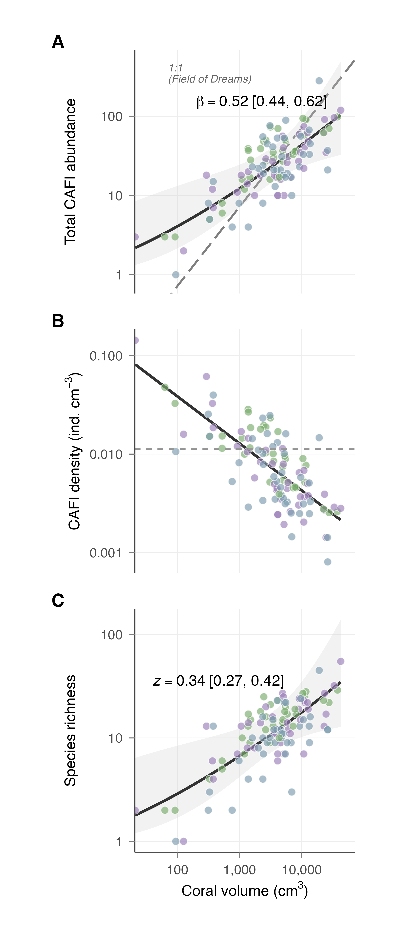
Fig. 2. CAFI scaling with coral volume.
Fig. 3. Scaling of individual species and taxonomic groups with coral volume. (A) Abundance versus volume for the 10 most prevalent species (negative binomial GLMs, log–log scale). (B) Abundance versus volume for four broad taxonomic groups (crabs, shrimps, fishes, snails); the six finer groups used in statistical analyses (separating Trapezia from other crabs, and other invertebrates) are shown in panel D. (C) Species-level scaling exponents (β) with 95% bootstrap CI. Blue: Redirection (β < 1); gray: Field of Dreams (CI spans 1); vermillion: super-linear (β > 1). (D) Group-level scaling exponents for all six taxonomic groups. Dashed vertical line: proportional scaling (β = 1).
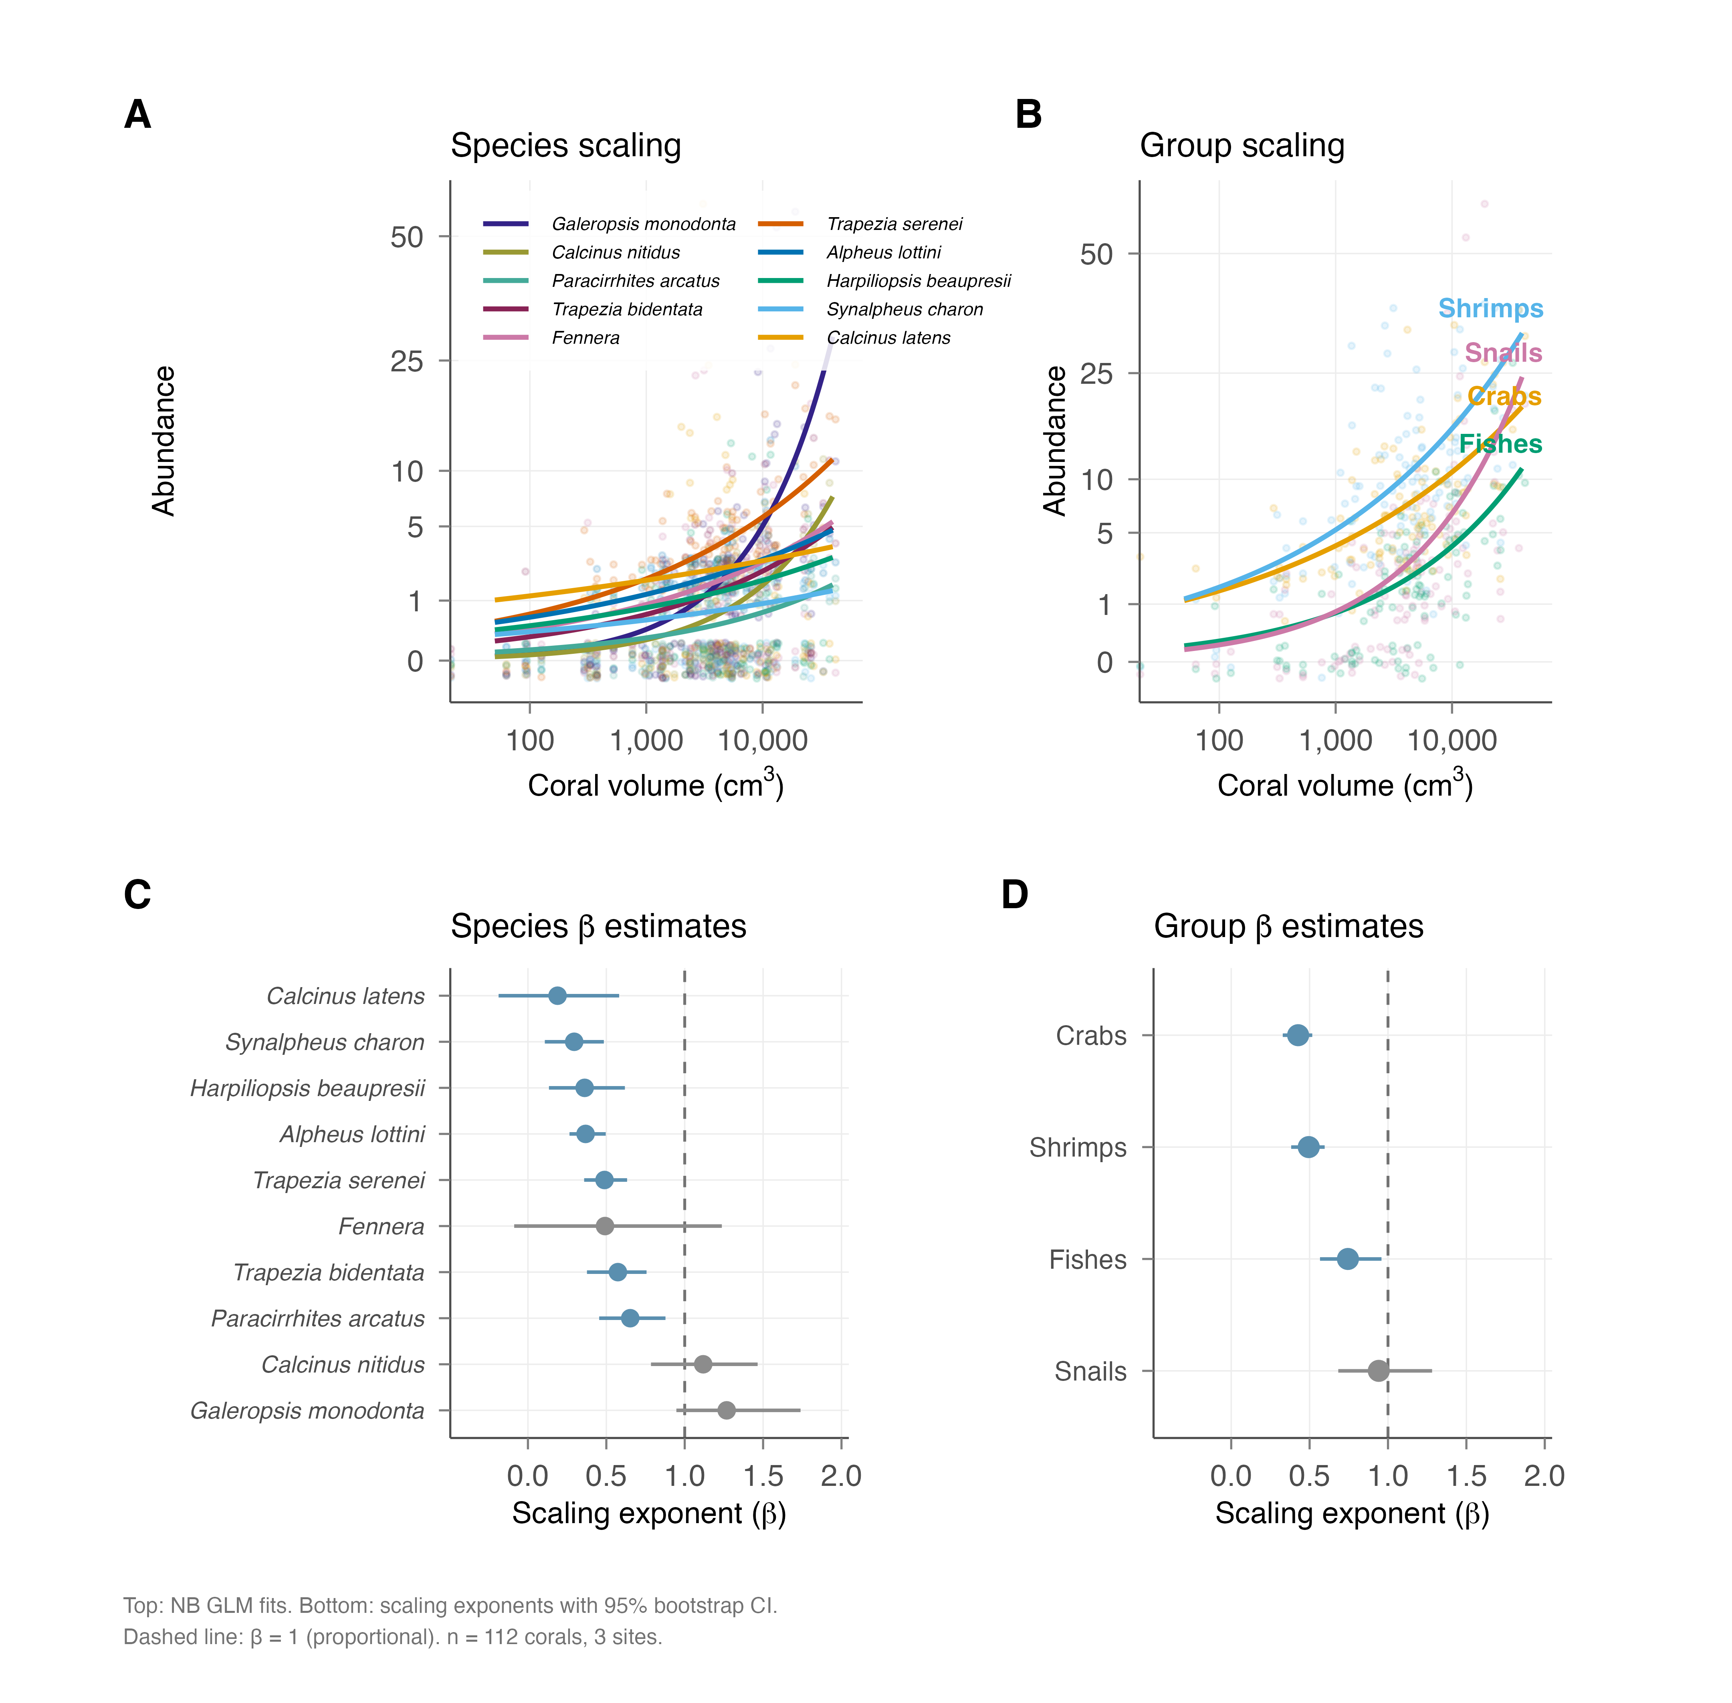
Fig. 3. Species and group scaling.
Fig. 4. CAFI community composition across reef sites and the coral size gradient (n = 112). (A) Distance-based redundancy analysis (db-RDA) biplot after partialing out site effects; coral volume explains 7.8% of compositional variation (F = 9.74, p = 0.001). Point size proportional to coral volume; ellipses: 80% CI by site; vectors: top species loadings on the constrained axis. (B) Relative abundance of major taxonomic groups at each site.
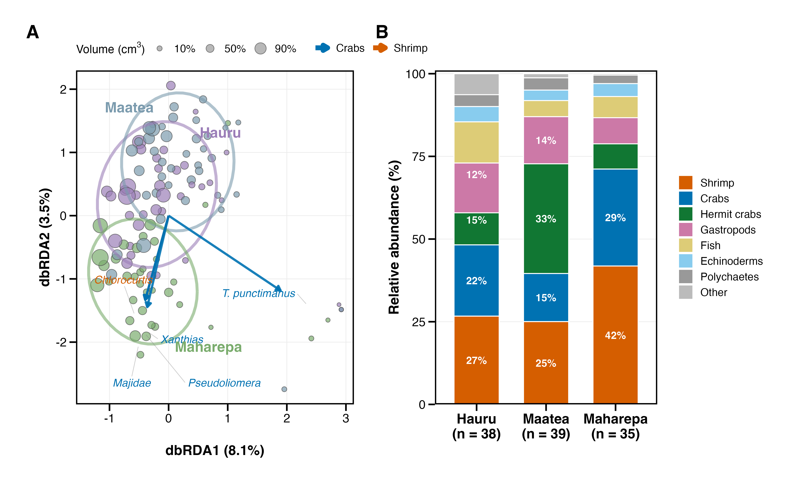
Fig. 4. Community composition.
Fig. 5. CAFI diversity and abundance as predictors of coral condition (n = 84). Condition score = PC1 of four physiological traits (protein, carbohydrates, zooxanthellae density, AFDW). (A) Species richness positively predicted condition (standardized β = 0.36, Hochberg-adjusted p = 0.036). (B) Total CAFI abundance showed a weaker association (p = 0.048). Points colored by site; solid lines: marginal fits adjusted for log(volume) and site; shading: 95% CI.
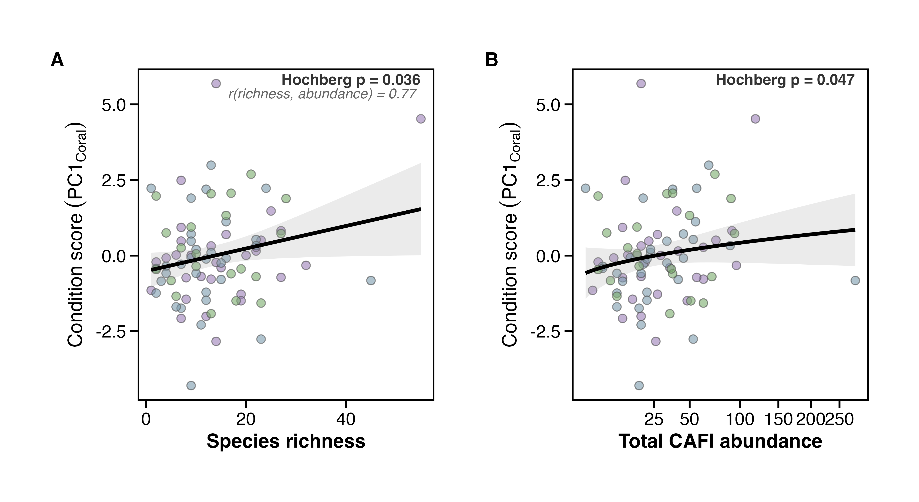
Fig. 5. BEF diversity-condition.

References
Abele, L. G., & Patton, W. K. (1976). The size of coral heads and the community biology of associated decapod crustaceans. Journal of Biogeography, 3, 35–47. https://doi.org/10.2307/3038097
Anderson, M. J., Diebel, C. E., Blom, W. M., & Landers, T. J. (2005). Consistency and variation in kelp holdfast assemblages: Spatial patterns of biodiversity for the major phyla at different taxonomic resolutions. Journal of Experimental Marine Biology and Ecology, 320, 35–56. https://doi.org/10.1016/j.jembe.2004.12.023
Bronstein, J. L. (1994). Conditional outcomes in mutualistic interactions. Trends in Ecology & Evolution, 9, 214–217. https://doi.org/10.1016/0169-5347(94)90246-1
Burgess, S. C., Johnston, E. C., Wyatt, A. S. J., Leichter, J. J., & Edmunds, P. J. (2021). Response diversity in corals: Hidden differences in bleaching mortality among cryptic Pocillopora species. Ecology, 102(6), e03324. https://doi.org/10.1002/ecy.3324
Castro, P. (1978). Movements between coral colonies in trapezia ferruginea (Crustacea: Brachyura), an obligate symbiont of scleractinian corals. Marine Biology, 46, 237–245. https://doi.org/10.1007/BF00390685
Chase, T. J., Pratchett, M. S., Frank, G. E., & Hoogenboom, M. O. (2018). Coral-dwelling fish moderate bleaching susceptibility of coral hosts. PLoS ONE, 13, e0208545. https://doi.org/10.1371/journal.pone.0208545
Counsell, C. W. W., Donahue, M. J., Edwards, K. F., Franklin, E. C., & Hixon, M. A. (2018). Variation in coral-associated cryptofaunal communities across spatial scales and environmental gradients. Coral Reefs, 37, 827–840. https://doi.org/10.1007/s00338-018-1709-7
Fonseca, C. R., & Ganade, G. (1996). Asymmetries, compartments and null interactions in an Amazonian ant-plant community. Journal of Animal Ecology, 65, 339–347. https://doi.org/10.2307/5880
Glynn, P. W. (1983). Increased survivorship in corals harboring crustacean symbionts. Marine Biology Letters, 4, 105–111.
Haddad, N. M., Brudvig, L. A., Clobert, J., Davies, K. F., Gonzalez, A., Holt, R. D., Lovejoy, T. E., Sexton, J. O., Austin, M. P., Collins, C. D., Cook, W. M., Damschen, E. I., Ewers, R. M., Foster, B. L., Jenkins, C. N., King, A. J., Laurance, W. F., Levey, D. J., Margules, C. R., … Townshend, J. R. (2015). Habitat fragmentation and its lasting impact on Earth’s ecosystems. Science Advances, 1, e1500052. https://doi.org/10.1126/sciadv.1500052
Hamman, E. A., McKinley, S. A., Stier, A. C., & Osenberg, C. W. (2018). Landscape configuration drives persistent spatial patterns of occupant distributions. Theoretical Ecology, 11, 111–127. https://doi.org/10.1007/s12080-017-0352-1
Hector, A., Schmid, B., Beierkuhnlein, C., Caldeira, M. C., Diemer, M., Dimitrakopoulos, P. G., Finn, J. A., Freitas, H., Giller, P. S., Good, J., Harris, R., Högberg, P., Huss-Danell, K., Joshi, J., Jumpponen, A., Körner, C., Leadley, P. W., Loreau, M., Minns, A., … Lawton, J. H. (1999). Plant diversity and productivity experiments in European grasslands. Science, 286, 1123–1127. https://doi.org/10.1126/science.286.5442.1123
Holbrook, S. J., Brooks, A. J., Schmitt, R. J., & Stewart, H. L. (2008). Effects of sheltering fish on growth of their host corals. Marine Biology, 155, 521–530. https://doi.org/10.1007/s00227-008-1051-7
Huber, M. E., & Coles, S. L. (1986). Resource utilization and competition among the five Hawaiian species of trapezia (Crustacea, Brachyura). Marine Ecology Progress Series, 30, 21–31. https://doi.org/10.3354/meps030021
Johnston, E. C., Cunning, R., & Burgess, S. C. (2022). A genomic and morphological comparison of shallow and mesophotic coral reef colonies in Moorea, French Polynesia. Molecular Ecology, 31, 4425–4441. https://doi.org/10.1111/mec.16556
Kuris, A. M., Hechinger, R. F., Shaw, J. C., Whitney, K. L., Aguirre-Macedo, L., Boch, C. A., Dobson, A. P., Dunham, E. J., Fredensborg, B. L., Huspeni, T. C., Lorda, J., Mababa, L., Mancini, F. T., Mora, A. B., Pickering, M., Talhouk, N. L., Torchin, M. E., & Lafferty, K. D. (2008). Ecosystem energetic implications of parasite and free-living biomass in three estuaries. Nature, 454, 515–518. https://doi.org/10.1038/nature06970
Laurance, W. F., Lovejoy, T. E., Vasconcelos, H. L., Bruna, E. M., Didham, R. K., Stouffer, P. C., Gascon, C., Bierregaard, R. O., Laurance, S. G., & Wilson, E. (2002). Ecosystem decay of Amazonian forest fragments: A 22-year investigation. Conservation Biology, 16, 605–618. https://doi.org/10.1046/j.1523-1739.2002.01025.x
Lawton, J. H. (1983). Plant architecture and the diversity of phytophagous insects. Annual Review of Entomology, 28, 23–39. https://doi.org/10.1146/annurev.en.28.010183.000323
MacArthur, R. H., & Wilson, E. O. (1967). The theory of island biogeography. Princeton University Press.
McKeon, C. S., Stier, A. C., McIlroy, S. E., & Bolker, B. M. (2012). Multiple defender effects: Synergistic coral defense by mutualist crustaceans. Oecologia, 169, 1095–1103. https://doi.org/10.1007/s00442-012-2275-2
Otway, S. J., Hector, A., & Lawton, J. H. (2005). Resource dilution effects on specialist insect herbivores in a grassland biodiversity experiment. Journal of Animal Ecology, 74, 234–240. https://doi.org/10.1111/j.1365-2656.2005.00913.x
Schlinkert, H., Westphal, C., Clough, Y., László, Z., Ludwig, M., & Tscharntke, T. (2015). Plant size as determinant of species richness of herbivores, natural enemies and pollinators across 21 Brassicaceae species. PLoS ONE, 10, e0135928. https://doi.org/10.1371/journal.pone.0135928
Shima, J. S., Osenberg, C. W., & Stier, A. C. (2010). The vermetid gastropod dendropoma maximum reduces coral growth and survival. Biology Letters, 6, 815–818. https://doi.org/10.1098/rsbl.2010.0291
Speare, K. E., Adam, T. C., Winslow, E. M., Lenihan, H. S., & Burkepile, D. E. (2022). Size-dependent mortality of corals during marine heatwave erodes recovery capacity of a coral reef. Global Change Biology, 28, 1342–1358. https://doi.org/10.1111/gcb.16000
Stella, J. S., Munday, P. L., Walker, S. P. W., Pratchett, M. S., & Jones, G. P. (2014). From cooperation to combat: Adverse effect of thermal stress in a symbiotic coral-crustacean community. Oecologia, 174, 1187–1195. https://doi.org/10.1007/s00442-013-2858-6
Stier, A. C., Gil, M. A., McKeon, C. S., Lemer, S., Leray, M., Mills, S. C., & Osenberg, C. W. (2012). Housekeeping mutualisms: Do more symbionts facilitate host performance? PLoS ONE, 7, e32079. https://doi.org/10.1371/journal.pone.0032079
Stier, A. C., & Osenberg, C. W. (2010). Propagule redirection: Habitat availability reduces colonization and increases recruitment in reef fishes. Ecology, 91, 2826–2832. https://doi.org/10.1890/09-1993.1
Stier, A. C., Primo, C., Curtis, J. S., & Osenberg, C. W. (in review). Habitat quantity drives community assembly and biodiversity-ecosystem function relationships in coral reef fauna. [journal to be confirmed].

Supplementary Materials
See separate document: combined_supplement.md (14 supplementary figures, 15 supplementary tables, supplementary methods).

