*Note: Italic text is notes*

1. Paragraph 1
   1. Predators play a crucial role in regulating prey populations, which can have widespread effects on the way ecosystems function (Lafferty TREE review, Paine citation?).
   2. Generally, researchers quantify the interactions strength of a predator and its prey, by quantifying the relationship between the prey consumption per predator and prey density (i.e. the functional response).
   3. Most models of predator-prey interactions assume that the interaction strength between a predator and its prey is constant ( *this isn’t true the R-W equation assumes that per-capita interaction strength is dependent on prey-density…)* or solely dependent on prey density or predator density.
      1. *For instance, in the case of the R-W model, the number of prey consumed per predator is dependent on prey density.*
   4. BUT, the interaction strength between a predator and prey can vary across space and time due to variation not only in a) prey density, or b) predator density but also due to:
      1. Predators interacting with prey differently in different habitats (Paine)
      2. Stochasticity in recruitment or mortality (Navarette and Berlowe)
      3. Individual variation in metabolic rates (cite?)
      4. Ontogenetic diet shifts
      5. Habitat dimensionality and complexity (Parwar et al. 2012, Barrios-O’Neill 2016)
      6. OR variation in body size
2. Paragraph 2
   1. Scientists have always known that body size is critical to the way that an organism functions (Kleiber 1932, Brose 2010).
   2. Metabolic rates scale with the body mass of the individual due to xxx, leading to allometric relationships between body mass and reproduction, …., or consumption (Brown et al. 2004).
   3. Therefore, predator-prey interaction strengths, or the functional response, must in part be dependent on body size. Generally,
      1. Theory and empirical evidence suggest that handling time should decline as a power law function of predator mass and prey mass (Yodzis and Innes 1992).
      2. Attack rates are expected to increase according to power law functions of predator and prey mass, or as a function of the predator:prey body mass ratio, resulting in a hump shaped relationship between attack rates and the predator:prey body size ratio (Wahlstrom et al. 2000, Aljetlawi et al. 2004, Vucic-Pestic et al. 2010, McCoy et al. 2011, Uiterwaal et al. 2017).
   4. Metanalysis of predator-prey pairs across taxa or within taxa show that the scaling coefficients on the functional response with body size of predators and prey vary across taxa and often differ from theoretical expectations (Rall et al. 2012). However, body-size dependent generalized formulations of the functional response can offer reasonable predictions of interactions strength without experimental data (Kalinkat et al. 2013 *Check this!!!*).
   5. Studies that compare across taxa, or at the average body size of predator-prey pairs within a taxa, offer a prediction of what might be happening for ontogenetic variation in interaction strength among a single predator prey pair.
   6. Based on general theory, we should be able to predict when and where predators will have a strong regulatory role based on body size.
3. Paragraph 3
   1. Understanding the relationship between body size and the functional response is important because it can have dramatic consequences on the way we think about predator’s ability to regulate prey. Previous work has shown that incorporating body size dependence:
      1. can scale the time period of predator-prey population oscillations (Yodzis and Innes 1992)
      2. can restrict consumer-resource coexistence to specific body size ratios (Weitz and Levin 2006) that are consistent with body size ratios seen in nature (Brose et al. 2006 *check citation*)
   2. Furthermore, increases in body size ratios have been shown to promote stabilizing type III responses and increase species persistence in complex food webs (Brose et al. 2006b *check citation, also Berlowe PNAs*)
   3. Natural populations of predator and prey, however, vary in density and size distributions across space and time. Thus the interaction strength between a predator and its prey may be dependent on spatial scale (cite the Eco Letters paper), and its feasible that a mosaic of predator-prey interactions within sub-communities could control the persistence of predator-prey across the metacommunity. Therefore, an outstanding question is how does variation in body size of predators and prey across space and time affect predators’ ability to regulate prey at larger scales.
4. Paragraph 4
   1. To examine how…., we estimated the size dependence of the interaction strength between a commercial important marine predator, Panularus interruptus, and its ecological significant prey, the purple sea urchin.
   2. Lobsters and urchin exist as a loosely linked predator prey pair.
      1. Globally, lobsters exhibit size-dependent foraging on urchins (CITE), and have been implicated in controlling urchin populations, although the strength of top down control by California Spiny Lobster is debated (CITE).
   3. This is an intriguing study system to examine these questions because the body size ratios of lobsters and urchins vary, likely to do spatially-explicit patterns in recruitment dynamics or variation in fishing pressure due to an existing system of MPA’s established across southern California.
   4. Furthermore, urchins play an outsized role in regulating giant kelp abundance, and can under certain circumstances reach high densities that results in the total removal of kelp biomass and reductions in species richness and abundance of rocky reef communities.
   5. We first describe variation in body size ratios in the Santa Barbara channel. We then conducted a laboratory experiment to determine the size dependency of interaction strengths across a ~ 700x increase in body size ratios. And finally, we predicted predation pressure across the landscape to compare how estimated predation pressure would differ with and without consideration for body-size dependence .

*Open question: Does asymmetry in body size ratios alter the capacity of predators to regulate prey?*

*Fit with type III, but fix q across individuals within a size bin combination… If q shifts towards type 3 responses at higher body size ratios, it suggests a greater propensity for top down control across the metapopulation*

Methods:

Results:

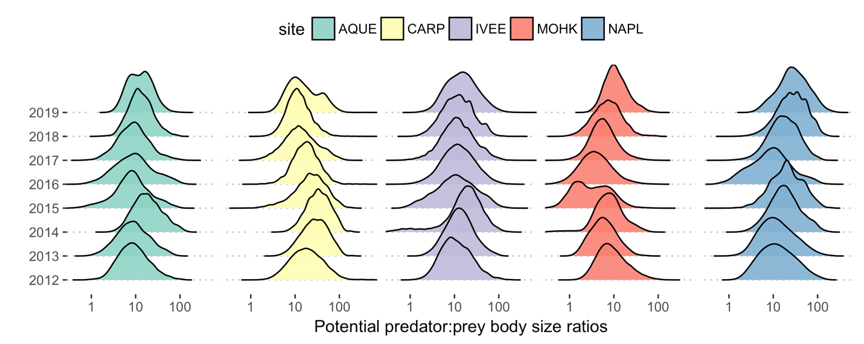

Figure 1. Size frequency distributions of potential predator:prey body size ratios at the LTER sites since 2012.

* There is significant variation in the predator: prey size ratio at a site at a point in time (~1:100!)
* Body size ratios vary across years within a site, and these trends can be directional (ex. Protection at Naples reef).
* Body size ratios can be very different across different sites in the same year (recruitment dynamics driven by environmental stochasticity, or predation pressure?)

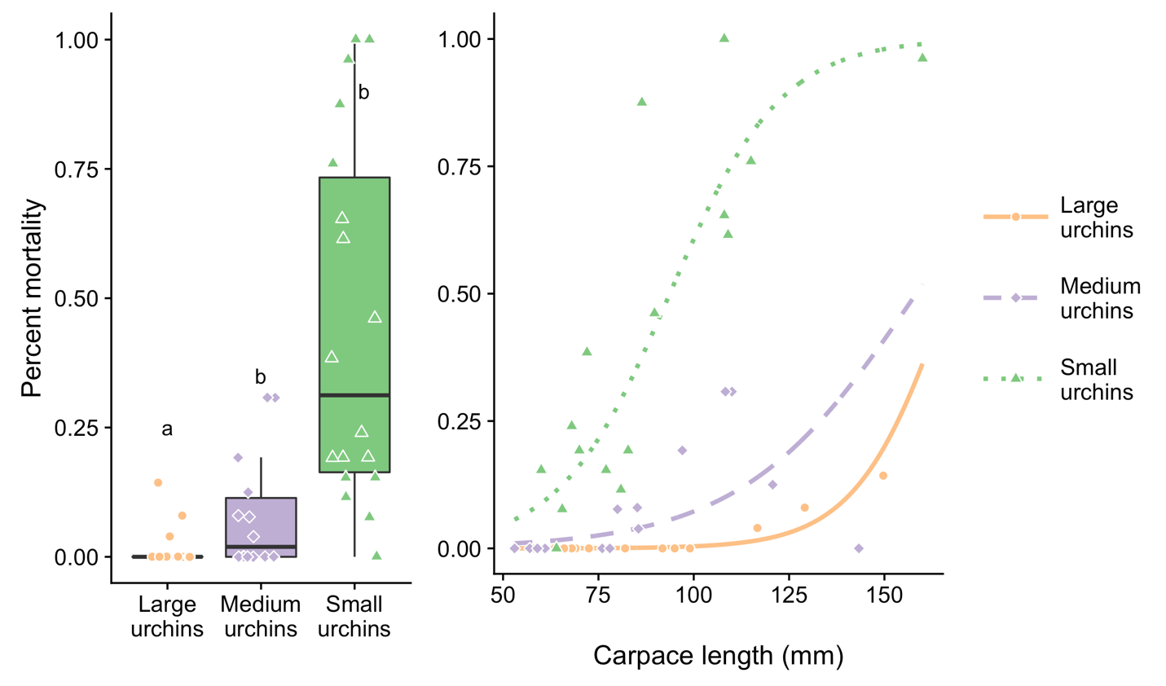

Figure 2. a) Probability that an urchin was consumed in foraging trials depending on urchin size. b) Probability that an urchin of a particular size is consumed depending on lobster size, measured as carapace length (mm)

* Smaller urchins are consumed much more than larger urchins (~ urchins >30 cm). This is strong evidence for a size refuge from predation (Nilsoon and Bronmark 2000), likely due to gape size limitation of lobsters (should I measure the leg distance as in Ling et al. 2009? To make the claim that leg length is some power function of carapace length).
* However, consumption of urchins is strongly dependent on the body size of predators (i.e. carapace length of the lobsters)

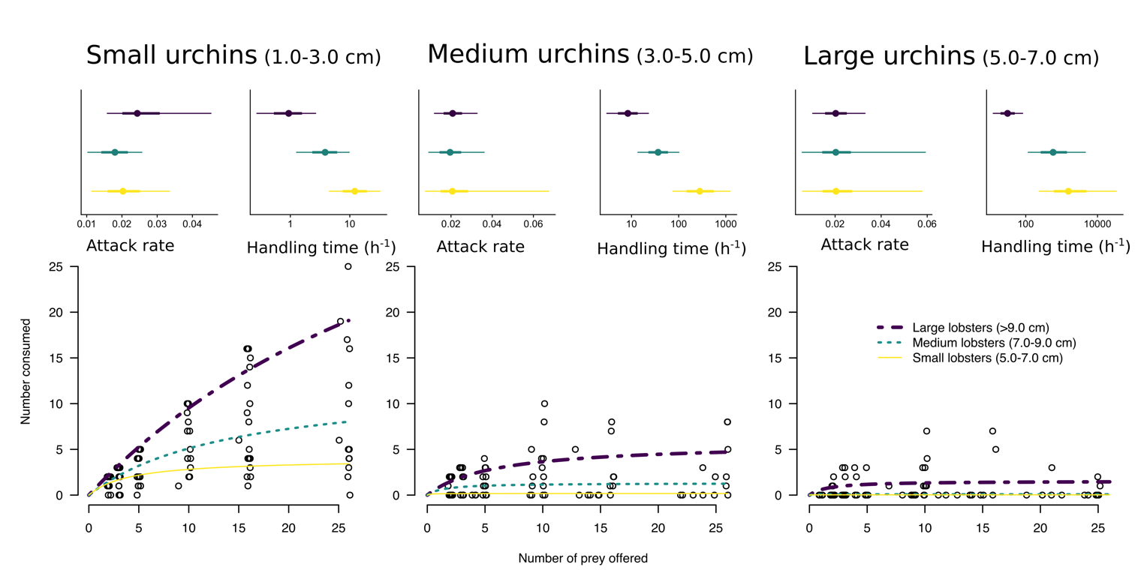

Figure 3. The functional response of lobsters of different sizes foraging on urchins

* All size class combinations of lobsters and urchins displayed a non-zero handling time, providing strong evidence that predation by lobsters on urchins is dependent on prey density.
* All size combinations of lobsters and urchins displayed a saturating response with prey density. This suggests that consumption is not proportional to prey density, across densities that span the range of densities from urchin barren to kelp dominated state… (jibberish).
* Predation on the largest size classes of urchins was only appreciable by the largest lobsters!

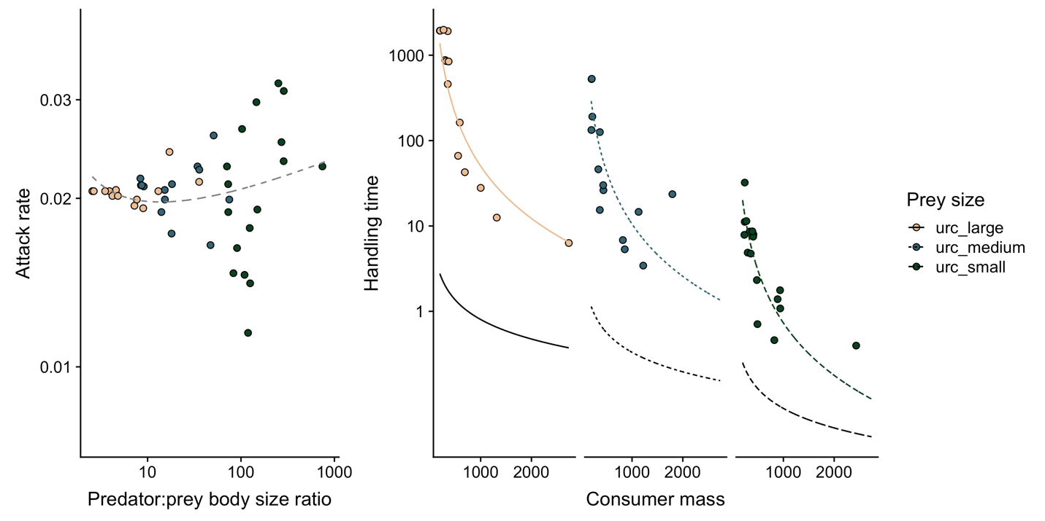

Figure 4. Relationship between attack rate and the body size ratio of predators to prey on a log-log scale (a). There was no evidence of a hump shaped relationship as evidenced by the fit of a generalized Ricker model (dashed gray line). (b) Relationship between handling time (1/maximum ingestion rate) and consumer mass for each prey size class on a log-linear scale. Black lines represent the expected relationship for marine invertebrates based on metanalysis (Rall et al. 2012), which underestimated spiny lobster handling times by ~2 orders of magnitude.

We found no evidence for allometric scaling of attack rates with predator body size (βc = 0.076 ± 0.04, p = 0.07), prey body size (βr = 0.002 ± 0.02, p = 0.90), or the ratio of predator to prey body size (βc/r = 0.014 ± 0.02, p = 0.49). Considerable empirical and theoretical evidence suggests that attack rate should scale with the body size ratio according to a hump-shaped relationship. Furthermore, the shape of the relationship could be impacted by the dimensionality and complexity of the habitat (Parwar et al. 2012), with hump shaped relationships prevailing in 2D habitat with simple substrate, and power law functions prevailing in 2D habitat with complex substrate (Barrios-O’Neill et al. 2016). Therefore, to determine the shape of the relationship between attack rate and the body size ratio, we compared the fits of generalized Ricker and power-law functions (Persson et al. 1998, Barrios-Oneil et al. 2016). We found no evidence for a hump-shaped relationship (Fig. 4a), and could not distinguish if a generalized Ricker function described the data better than a power law function (AIC < 2).

Handling time exhibited a strong negative power-law relationship with predator size (αc = -2.04 ± 0.18, p < 0.001) and prey size (αr = 1.34 ± 0.09, p < 0.001) and the coefficients differed significantly from zero (Fig. 4b). However, these allometric scaling coefficients differ by ~2 orders of magnitude from the expectations of MTE (αc = -¾, αr = ¾) and a metanalysis of marine invertebrates (αc = -¾, αr = ¾, Rall et al. 2012, Fig. 4b). While we found that handling time also scaled as a power-law function of the body size ratio (αc/r = -1.48 ± 0.09, p < 0.001), the formulation that allowed for independent scaling exponents on predator size and prey size was a better fit to the data according to an AIC comparison.

# Ok so what does this mean. Well the slopes on each predictor (consumer mass and resource mass) represent the allometric scaling exponents. We find no relationship between attack rates and consumer mass and resource mass, or between the attack rates and the body size ratio. This means that there is no evidence for allometric scaling in attack rates with consumer mass, resource mass, or the body size ratio, despite considerable empirical and theoretical evidence based on MTE. Other work has suggested that the relationship would likely be hump shaped. Therefore, we fit a generalized ricker function to the data based on Kalinkat et al. 2013 and Barrio-Oneill et al. 2016. We see no evidence of a hump-shaped relationship. Furthermore, AIC comparison suggests that the simpler model is more parsimonious.

* There is no relationship between attack rate and the body size ratio.
* Handing time varies with the body size ratio according to a power-law relationship.

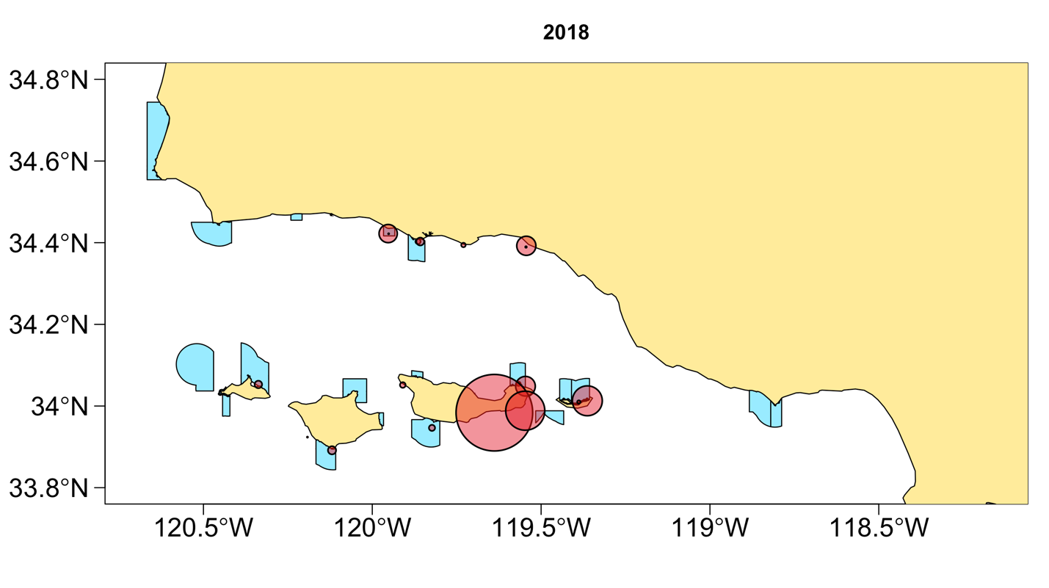

Figure 5. Spatial variation in the hypothesized predation pressure of lobsters foraging on urchins.

Discussion: