Broad thoughts:

1. There has been considerable research into how variability in interaction strengths in food webs promote community stability.
   1. Food webs characterized by weak interactions are more stable!
2. But not as much thought has been given to how the interaction strength between two interacting populations can be dynamic through time or space (but see Sugihara Japanese fish Nature paper)
   1. Within-species pair interaction strengths can vary with recruitment or mortality do to environmental stochasticity (Navarette and Berlow 2006)
3. **Big question:** If lots of weak interactions promote community stability or lower the risk of extinction to any one population, what is the consequence of spatial/temporal variability interaction strengths between two populations that are nested in an interaction web?
   1. How does variation in interaction strength at the individual level affect communities?
      1. i.e. if some individuals interact much more strongly with prey than others, does this affect community stability?

Introduction:

1. Variability in interaction strengths across a food web promotes community stability. But the interactions between any two populations in that food web can be dynamic
   1. Within-species interaction strengths can vary rapidly through time with seasonality, having dramatic consequences on patterns of biodiversity and community stability (Nature paper w/ Sugihara)
   2. Within-species pair interaction strengths can vary with recruitment or mortality do to environmental stochasticity (Navarette and Berlow 2006)
   3. We don’t really understand yet what the consequences of these different sources of variability are on communities.
2. A lot of effort has focused on how body size can drive shifts in interaction strengths of predators and prey.
   1. Review body size literature
   2. BUT we really don’t really understand the consequences of temporal and spatial variability in interspecific interaction strengths due to variation in predator and prey sizes
3. Using a model system of lobster and urchins we examined how interaction strengths differed with body size through ontogeny. We address the question:……. We then extrapolated these results to hypothesize how interaction strength can vary through time and space using long term, spatially explicit ecological data sets.

Methods:

Results:

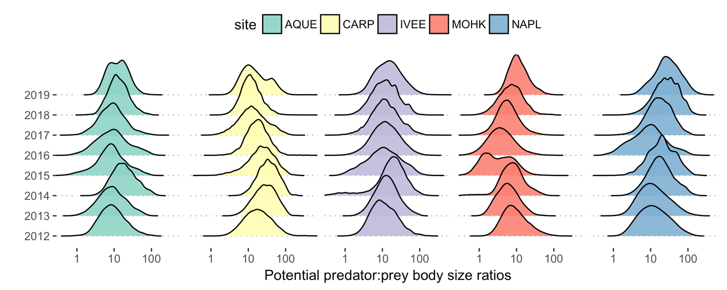

Figure 1. Size frequency distributions of potential predator:prey body size ratios at the LTER sites since 2012.

* There is significant variation in the predator: prey size ratio at a site at a point in time (~1:100!)
* Body size ratios vary across years within a site, and these trends can be directional (ex. Protection at Naples reef).
* Body size ratios can be very different across different sites in the same year (recruitment dynamics driven by environmental stochasticity, or predation pressure?)

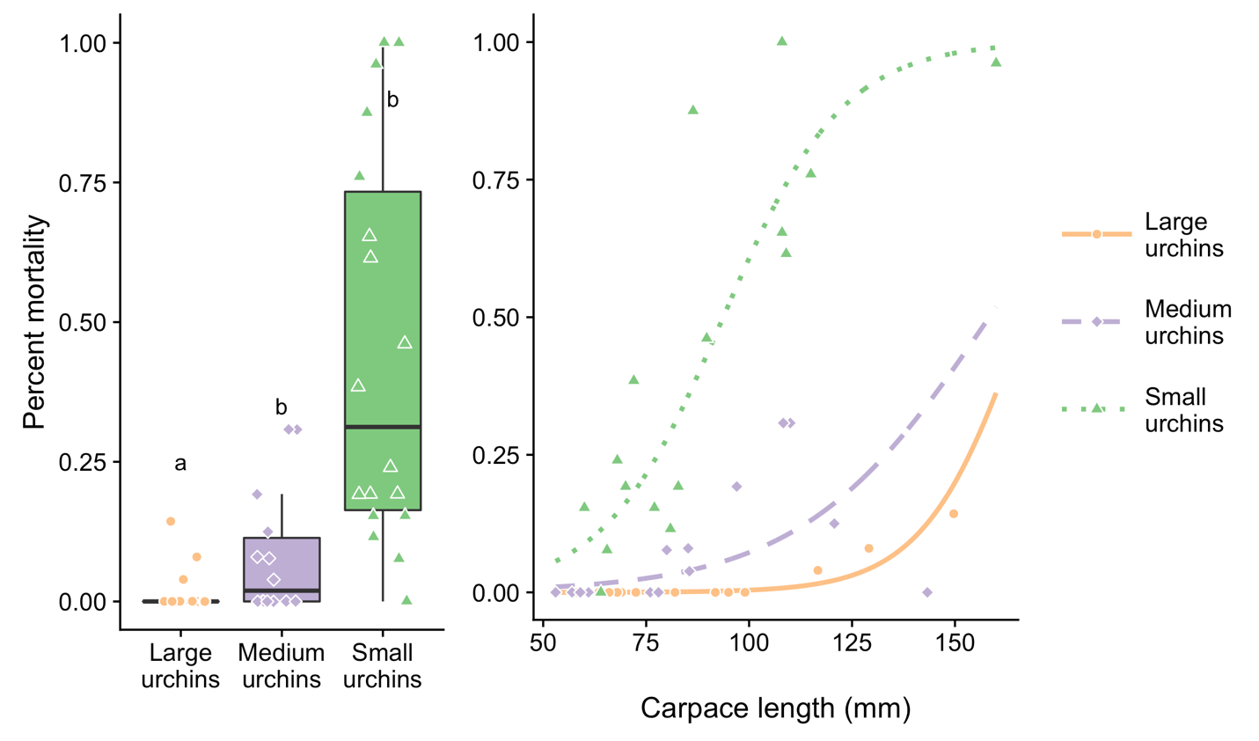

Figure 2. a) Probability that an urchin was consumed in foraging trials depending on urchin size. b) Probability that an urchin of a particular size is consumed depending on lobster size, measured as carapace length (mm)

* Smaller urchins are consumed much more than larger urchins (~ urchins >30 cm). This is strong evidence for a size refuge from predation (Nilsoon and Bronmark 2000), likely due to gape size limitation of lobsters (should I measure the leg distance as in Ling et al. 2009? To make the claim that leg length is some power function of carapace length).
* However, consumption of urchins is strongly dependent on the body size of predators (i.e. carapace length of the lobsters)

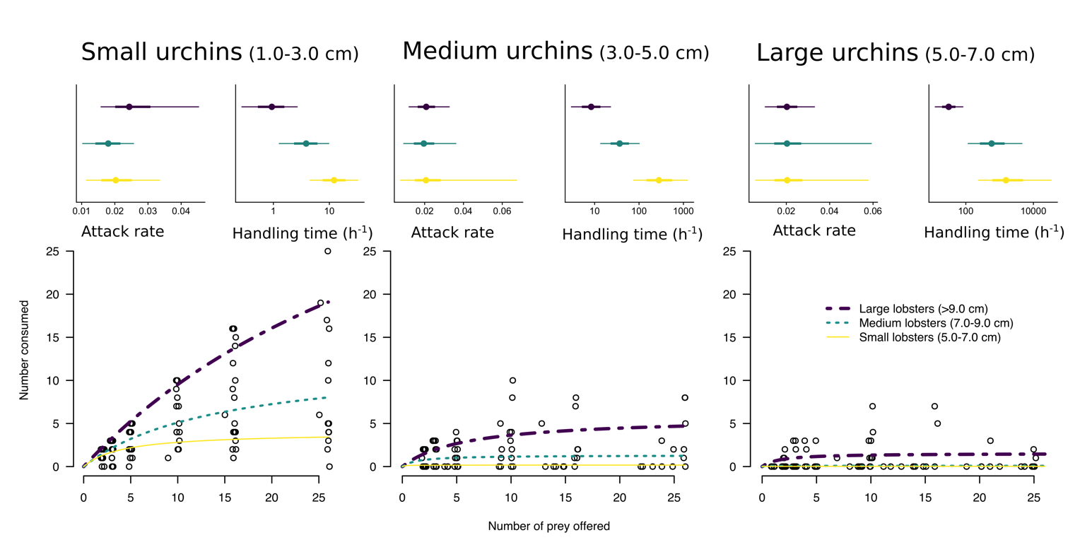

Figure 3. The functional response of lobsters of different sizes foraging on urchins

* All size class combinations of lobsters and urchins displayed a non-zero handling time, providing strong evidence that predation by lobsters on urchins is dependent on prey density.
* All size combinations of lobsters and urchins displayed a saturating response with prey density. This suggests that consumption is not proportional to prey density, across densities that span the range of densities from urchin barren to kelp dominated state… (jibberish).
* Predation on the largest size classes of urchins was only appreciable by the largest lobsters!

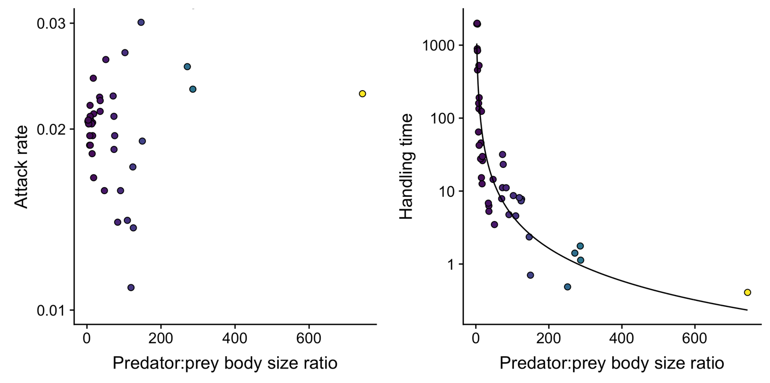

Figure 4. Relationship between the body size ratio of predators:prey as a function of attack rate (a) and handing time (b). Note the log scale y-axis.

* There is no relationship between attack rate and the body size ratio.
* Handing time varies with the body size ratio according to a power-law relationship.

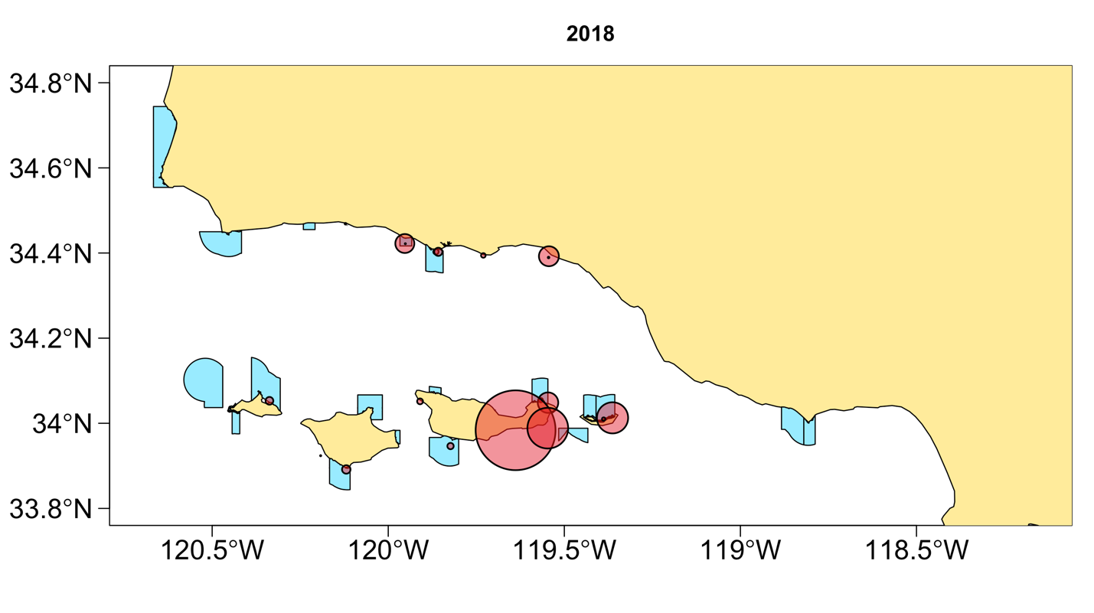

Figure 5. Spatial variation in the hypothesized predation pressure of lobsters foraging on urchins.

Discussion: