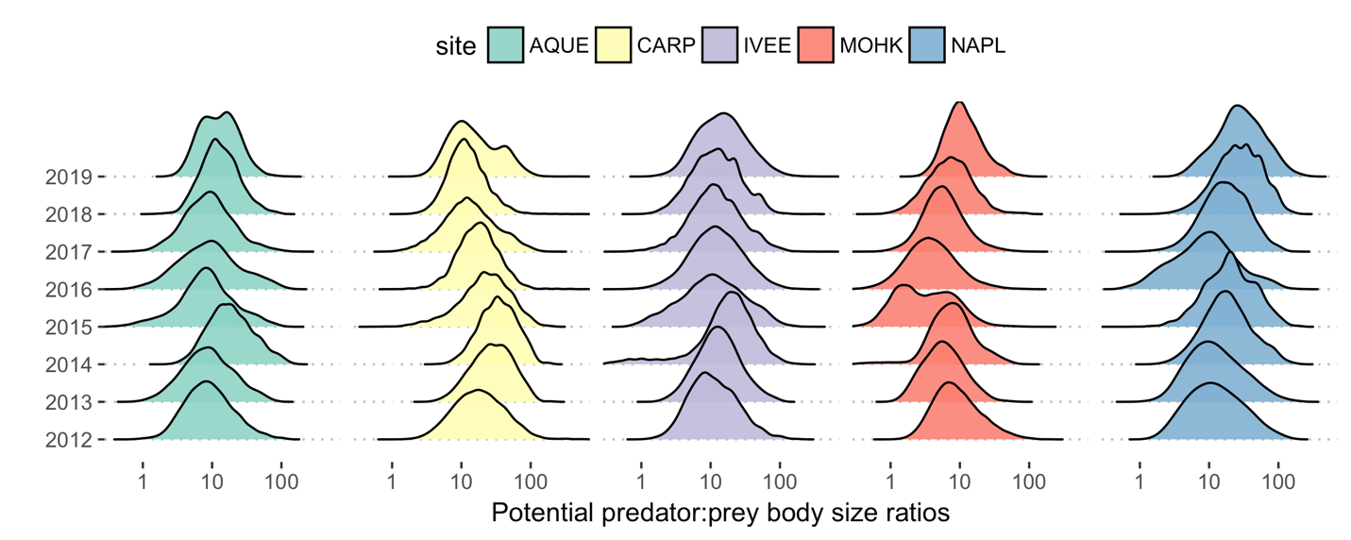

Figure 1. Frequency distributions of potential predator:prey body size ratios at the LTER sites since 2012.

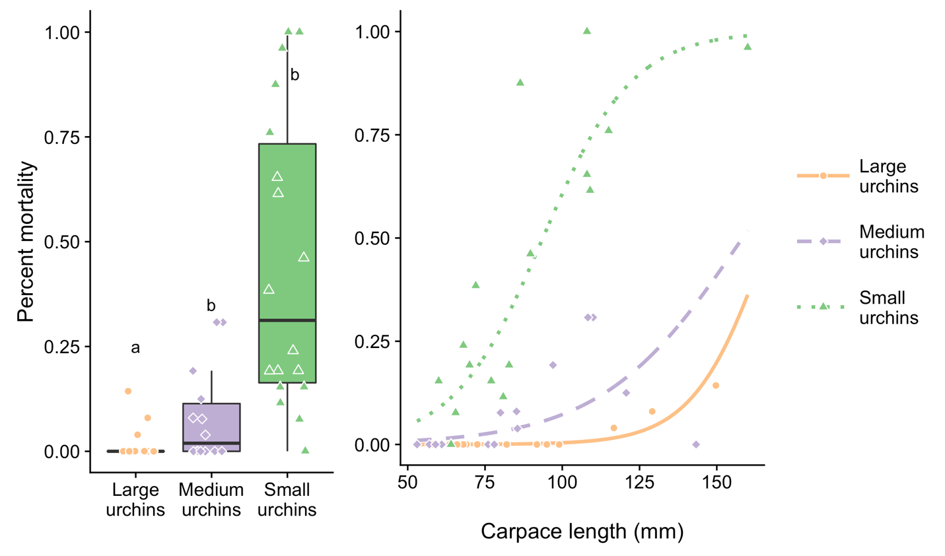

Figure 2. a) Probability that an urchin was consumed in foraging trials depending on urchin size. b) Probability that an urchin of a particular size is consumed depending on lobster size, measured as carapace length (mm)

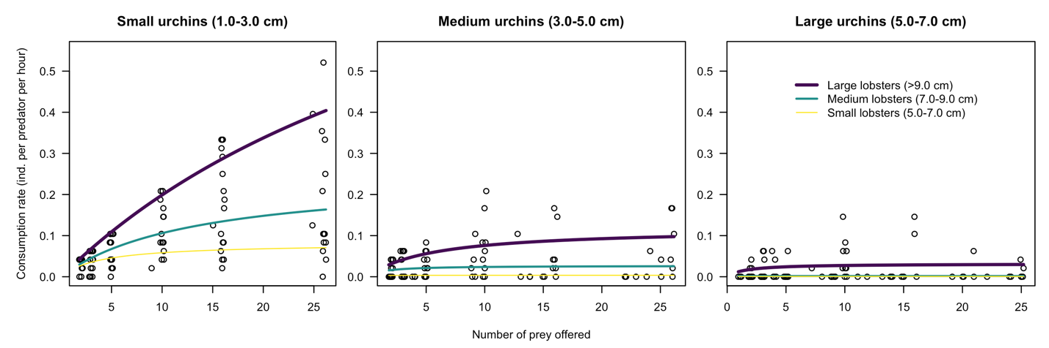

Figure 3. The functional response of lobsters of different sizes foraging on urchins

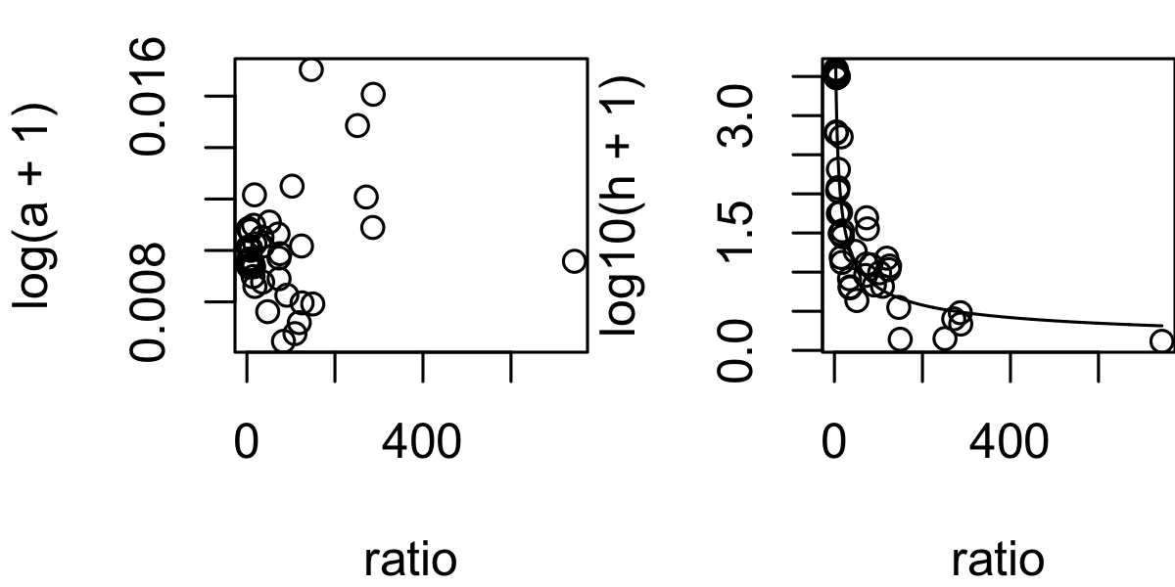

Predator:prey body size ratio

Figure 4. Relationship between the body size ratio of predators:prey as a function of attack rate (a) and handing time (b). Response variables are log10(y + 1) transformed.

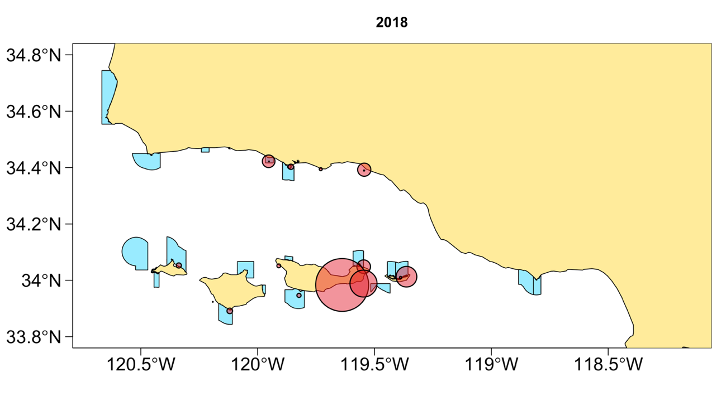

?

Figure 5. Spatial variation in the hypothetical maximum predation pressure of lobsters foraging on urchins.