Do marine protected areas make kelp forests
more resilient to marine heatwaves?
A plain-language summary of a new result for our paper — Adrian, for Emily
The question. Marine heatwaves are getting more frequent and more severe, and a bad one can wipe out a kelp forest. We wanted to know whether protecting a reef from fishing also makes its kelp forest better able to weather a heatwave. To test it we used the 2014–2016 marine heatwave — the most severe on record off California — and compared giant kelp inside Channel Islands marine protected areas (MPAs) with kelp on nearby unprotected reefs.
What we found. Inside the protected areas, giant kelp didn’t just survive the heatwave — it thrived. Kelp roughly doubled relative to its pre-heatwave level inside reserves, while on unprotected reefs right next door it declined. And the gap never closed: nearly a decade later, protected reefs still had abundant kelp while unprotected ones stayed depressed. In short, protection buffered the foundation of the entire ecosystem against the worst heatwave in the satellite record, while unprotected reefs lost their kelp and did not recover.
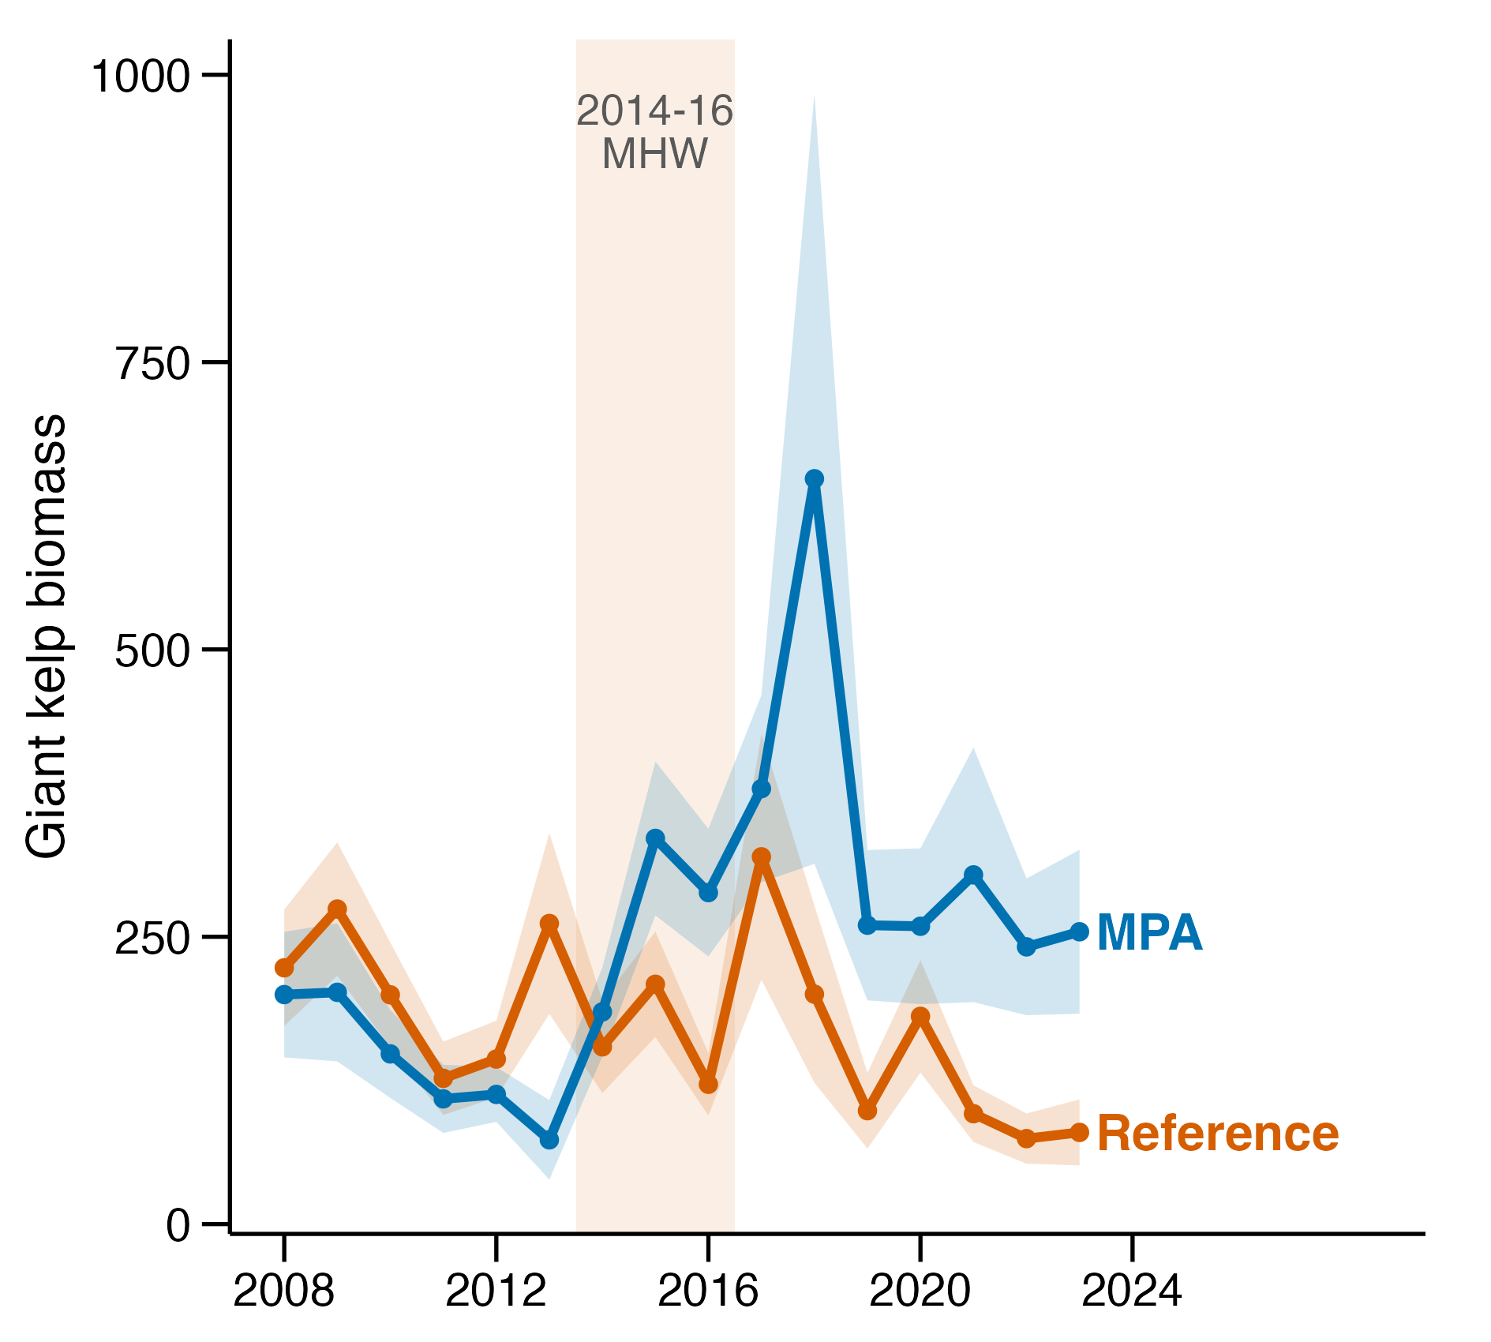
The proposed figure. Giant-kelp abundance inside (blue) and outside (orange) Channel Islands MPAs, 2008–2023. The 2014–2016 heatwave is shaded. Inside reserves, kelp climbs and stays elevated through and after the heatwave; outside, it falls and never recovers.
Why we trust it. We checked this result every way we could think of, and it held up each time. It happened again during a second heatwave (2018–2020). It wasn’t a side-effect of the sea-star wasting disease that struck at the same time — the pattern is identical at reefs that never had those sea stars. It doesn’t depend on the statistical method, and it isn’t explained by where the reserves happen to sit (temperature, wave exposure, latitude, or size). Of everything we examined, this is the one result solid enough to lead with.
What it means, and what I propose. The takeaway is simple and strong: California’s MPAs make the foundation species of kelp forests more resilient to climate extremes — a direct, timely conservation payoff. I’d like to add this to the paper as one new figure (the one above) and a short paragraph. The messier questions — exactly which predators drive the underlying cascade, and why some reserves do better than others — are less certain, so they stay in the supplement. This keeps the main story clean, defensible, and easy to communicate.
Happy to walk through any of the supporting analyses — there’s a fuller technical write-up if you want it, but this is the gist. — Adrian

